Github & Git Instructions

GitHub is a code hosting platform for version control and collaboration. It lets you and others work together on projects from anywhere.

Install git from <https://git-scm.com/download/win>

After creating a new repository for your project on github, copy the address :

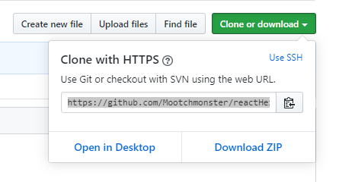

…and paste the address into your Github Bash:

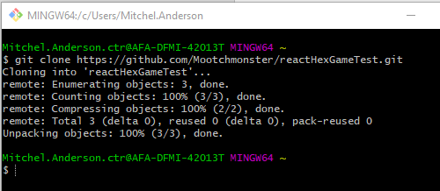

“ls” command will list the files in the directory.

After files have been created or modified “git status” can be used to see current changes.

“git add .” will add all created or modified or “git add *file.name file2.name*” will add only selected files

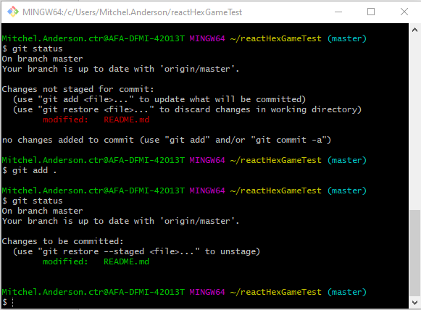

Commit

“git commit –m” to commit with messages

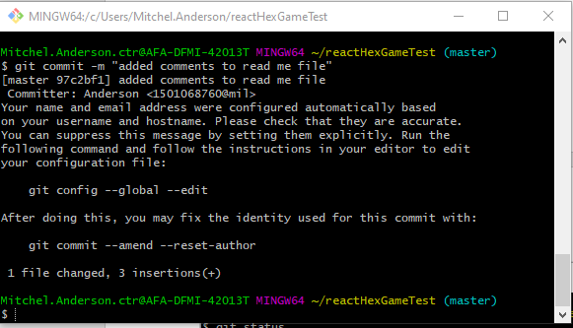

The code has still not been pushed to the github site. Use “git push origin master” to push to the master branch.

