Mooyeon Kim
NUID: 002527218
Professor Rolando Herrero
TELE 6550
8 December 2025
Project

2)
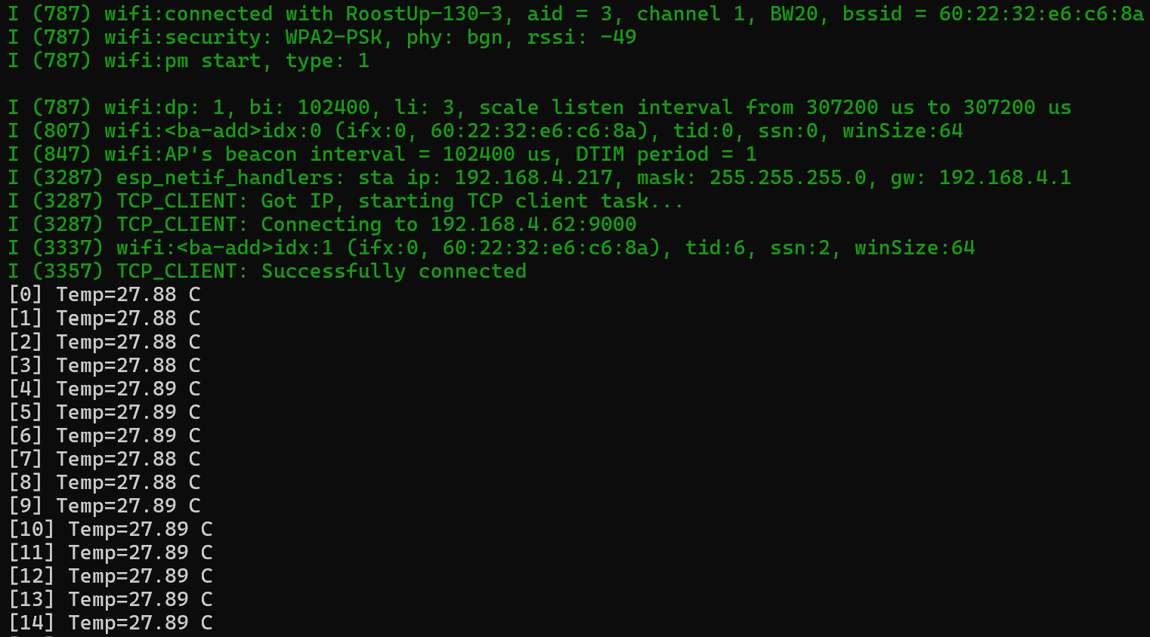
3) (Done by Jupyter Notebook)
