Assignment-2

Logistic Regression

In this question we have used an 80-20 train-test split to train our model on the dataset that was provided. Given below are the accuracies, weights and f-scores that were obtained with different learning rates and weight initializations. The features has been scaled using Normalization so that all the features range the same and doesn’t have any inherent advantage over the other. Normalization also changes the mean of each features to have similar mean and variance which are 0, 1 respectively.

Note that a bias term is also added into the weight matrix which explains the presence of 5 parameters in weight matrix.

Without Regularisation

Accuracy



Weights for Best Accuracy

Weight Initialisation:”0”



Weight Initialisation:”Uniform”



Weight Initialisation:”Xavier”



Weight Initialisation:”Gaussian”



F-Score



L1 Regularisation



Weights for Best Accuracy(learning rate=0.01)

Weight Initialisation:”0”



Weight Initialisation:”Uniform”



Weight Initialisation:”Xavier”



Weight Initialisation:”Gaussian”



F-Score



L2 Regularisation



Weights for Best Accuracy(learning rate=0.01)

Weight Initialisation:”0”



Weight Initialisation:”Uniform”



Weight Initialisation:”Xavier”



Weight Initialisation:”Gaussian”



F-Score



Conclusion

If we analyse our best accuracy case, and when we initialized our weights using Uniform distribution, we can see that the value of 4th parameter dwarfs in comparison to other parameters(excluding bias term) indicating the 4th parameter to of least importance whereas the 1st parameter having the highest magnitude can be assumed to influence the model the most. So in a nutshell, within a certain confidence, we can state that the 1st parameter is the most important while the 4th one is the least.

Neural Networks

Used an 80-20 train-test split to train the model. Below are the recorded accuracies and F-scores.Same were recorded with different configurations of the number of hidden layers, number of hidden neurons, activation functions, learning rates, and weight initializations (Gaussian, uniform, etc.).

Accuracy



F-Score



Error vs epoch graphs

Weight Initialisation:”normal”,Learning Rate:0.2

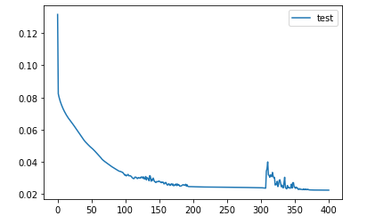

Weight Initialisation:”normal”,Learning Rate:0.3

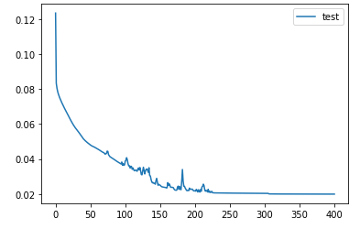

Weight Initialisation:”normal”,Learning Rate:0.4

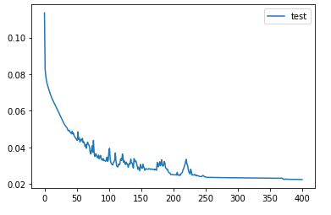

Weight Initialisation:”0”,Learning Rate:0.2

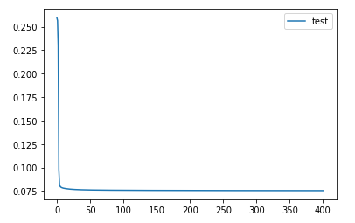

Weight Initialisation:”0”,Learning Rate:0.3

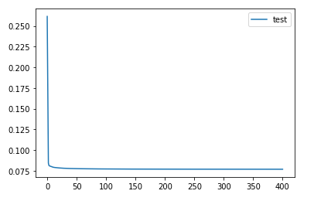

Weight Initialisation:”0”,Learning Rate:0.4

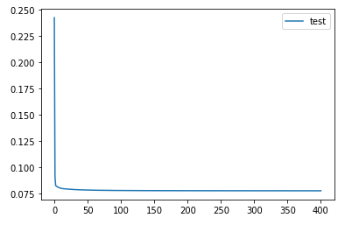

Weight Initialisation:”uniform”,Learning Rate:0.2

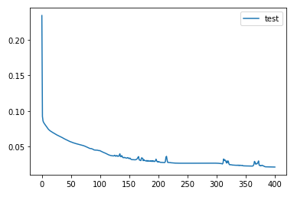

Weight Initialisation:”uniform”,Learning Rate:0.3

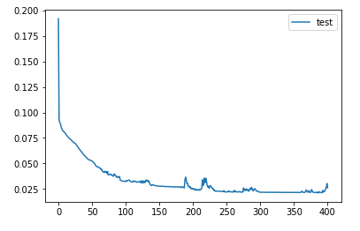

Weight Initialisation:”uniform”,Learning Rate:0.4

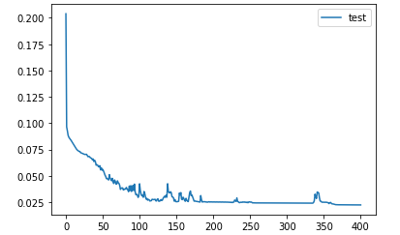

Weight Initialisation:”xavier”,Learning Rate:0.2

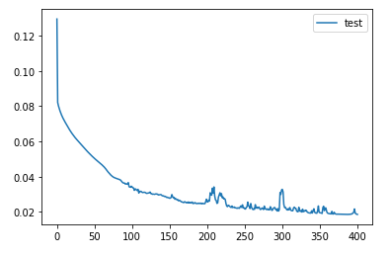

Weight Initialisation:”xavier”,Learning Rate:0.3

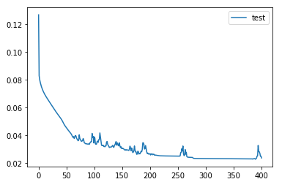

Weight Initialisation:”xavier”,Learning Rate:0.4

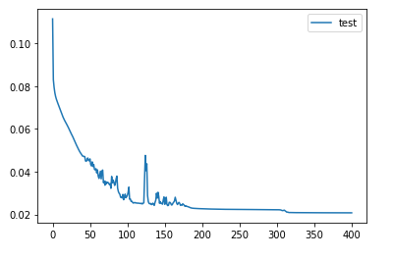

Weight Initialisation:”gaussian”,Learning Rate:0.2

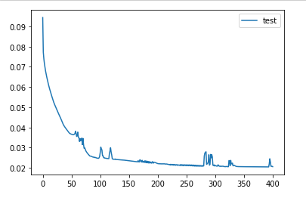

Weight Initialisation:”gaussian”,Learning Rate:0.3

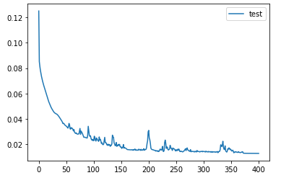

Weight Initialisation:”gaussian”,Learning Rate:0.4

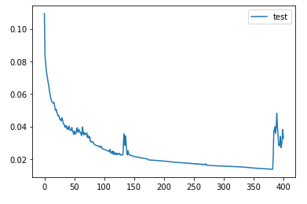

Other variations

Weight Initialisation:”gaussian”,Learning Rate:0.3,epochs:600

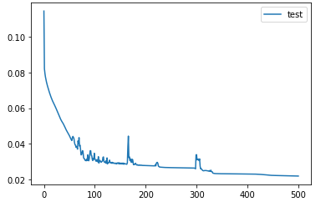

Accuracy



F-Score



Weight Initialisation:”gaussian”,Learning Rate:0.3,Different number of hidden neurons

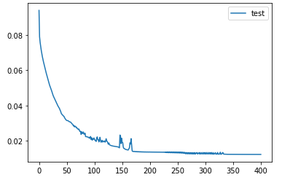

Accuracy



F-Score



Weight Initialisation:”gaussian”,Learning Rate:0.3,Different Activation Function(tanh)

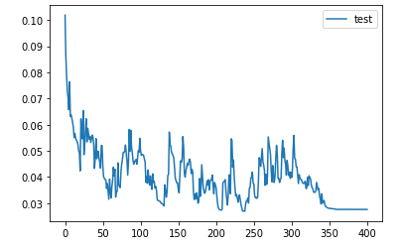

Accuracy



F-Score



Weight Initialisation:”gaussian”,Learning Rate:0.3,4 layers, Activation Function:Sigmoid

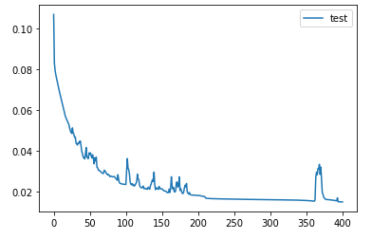

Accuracy



F-Score



Weight Initialisation:”gaussian”,Learning Rate:0.3,6 layers, Activation Function:tanh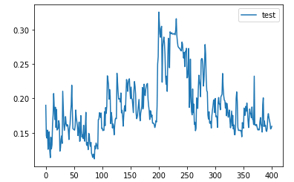

Accuracy



F-Score



Weight Initialisation:”gaussian”,Learning Rate:0.3,4 layers, Activation Function:tanh

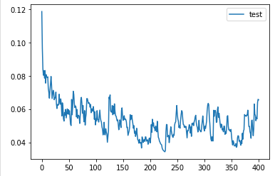

Accuracy



F-Score



Weight Initialisation:”gaussian”,Learning Rate:0.3,6 layers, Activation Function:sigmoid

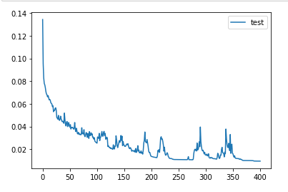

Accuracy



F-Score

