NAME: TJABAFU M.T
STUDENT NUMBER: 202322637
EE3400 LAB 01: introduction to electronic Measurements

INTRODUCTION TO ELECTRONIC MEASUREMENTS

Abstract:
This lab taught us how to use three important tools: the function generator, oscilloscope, and multimeter. We created electrical signals and learned to measure their size and power. We discovered how AC and DC settings change what we see on the oscilloscope, especially when adding a DC shift to a wave. We also measured sound and wall electricity, confirming how these tools help us understand electrical signals.
This lab introduces the fundamental tools of electronic measurement: the function generator, oscilloscope, and digital multimeter. The goal is to learn how to generate electrical signals, visualize them on the oscilloscope, and make accurate voltage measurements. Key concepts include understanding waveform characteristics, RMS voltage, and the difference between AC and DC signal coupling. This practical experience forms the essential foundation for all subsequent work in electronic instrumentation.
Lab theory:
Root-Mean-Square (RMS) Voltage
The RMS value of a periodic voltage is the equivalent DC voltage that would deliver the same average power to a resistive load. For a pure sine wave, the relationship is
$$V_{rms }=\frac{V_{pp}}{2\sqrt{2}}$$
Where $V_{pp}=2V_{p}$
Square Wave (50% duty cycle): $V_{rms }=\frac{V_{pp}}{2}$
Triangle Wave: $$V_{rms }=\frac{V_{p}}{\sqrt{3}}$$

When a DC offset (VDCVDC​) is added to an AC signal, the true RMS voltage is given by:
$$V_{rms }=\sqrt{{{(V}_{rms(ac) })}^{2}+{V_{DC }}^{2}}$$
A multimeter in AC voltage mode will typically only measure ${ V}_{rms(ac) }$, while an oscilloscope can compute the true RMS if set to DC coupling.

Waveforms are visual representations of how voltage changes over time. Common types include sine waves (smooth oscillations), square waves (instant transitions between high/low voltages), and triangle waves (linear ramping up and down). Voltage Measurements can be made in different ways. Peak-to-peak voltage (Vpp) represents the full amplitude range from lowest to highest point, best viewed on an oscilloscope. RMS voltage (Vrms) indicates the equivalent DC voltage that would deliver the same power, typically measured with a multimeter. Oscilloscope Input Coupling determines how the instrument processes incoming signals. DC coupling shows the complete signal including any DC offset, while AC coupling uses a capacitor to block DC components, centering the AC portion of the signal around zero volts. DC Offset refers to a constant voltage level added to an AC signal, shifting the entire waveform vertically without changing its shape. Triggering enables stable oscilloscope displays by synchronizing the horizontal sweep to a specific point on the waveform, making repetitive patterns appear stationary.
Experimental results:
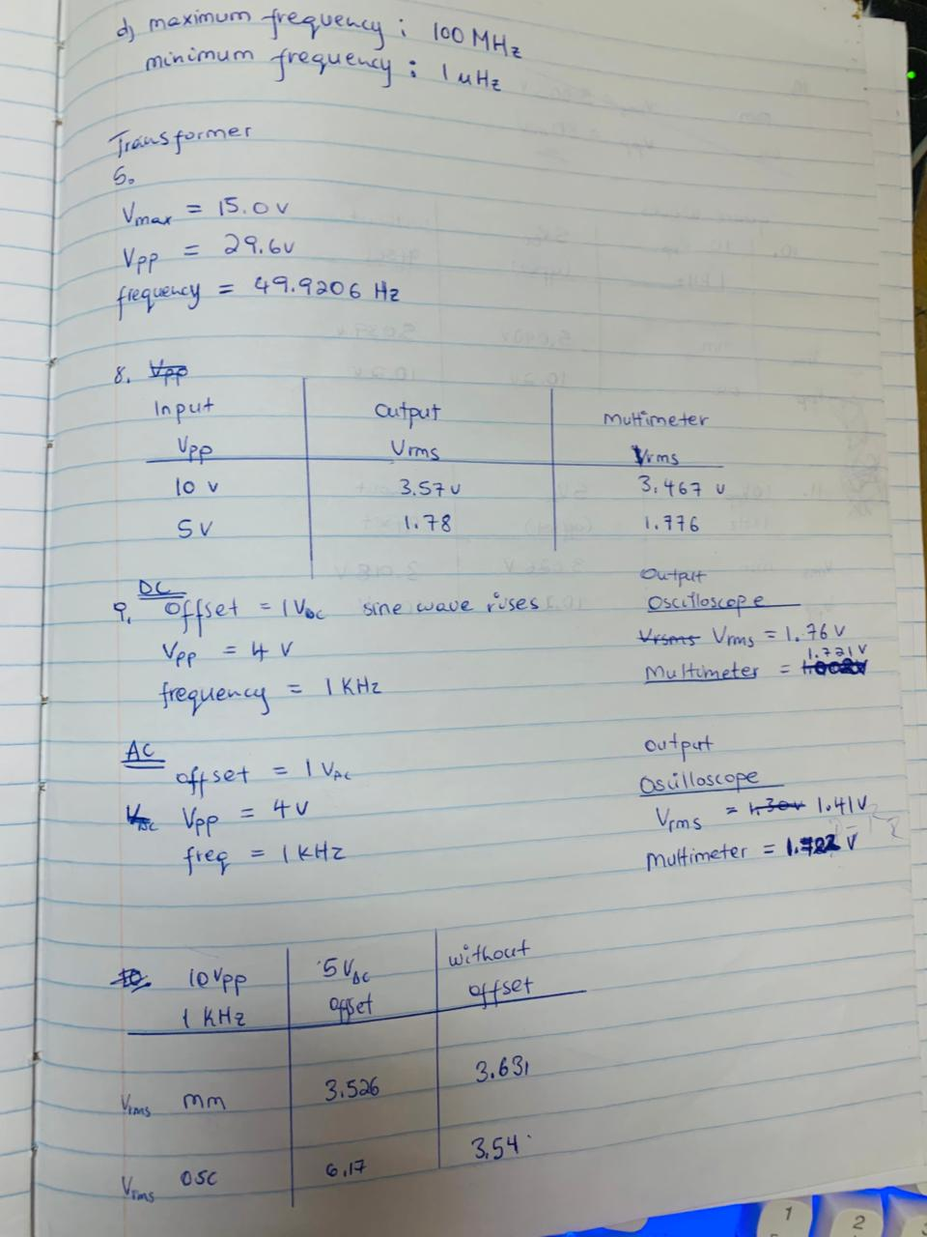
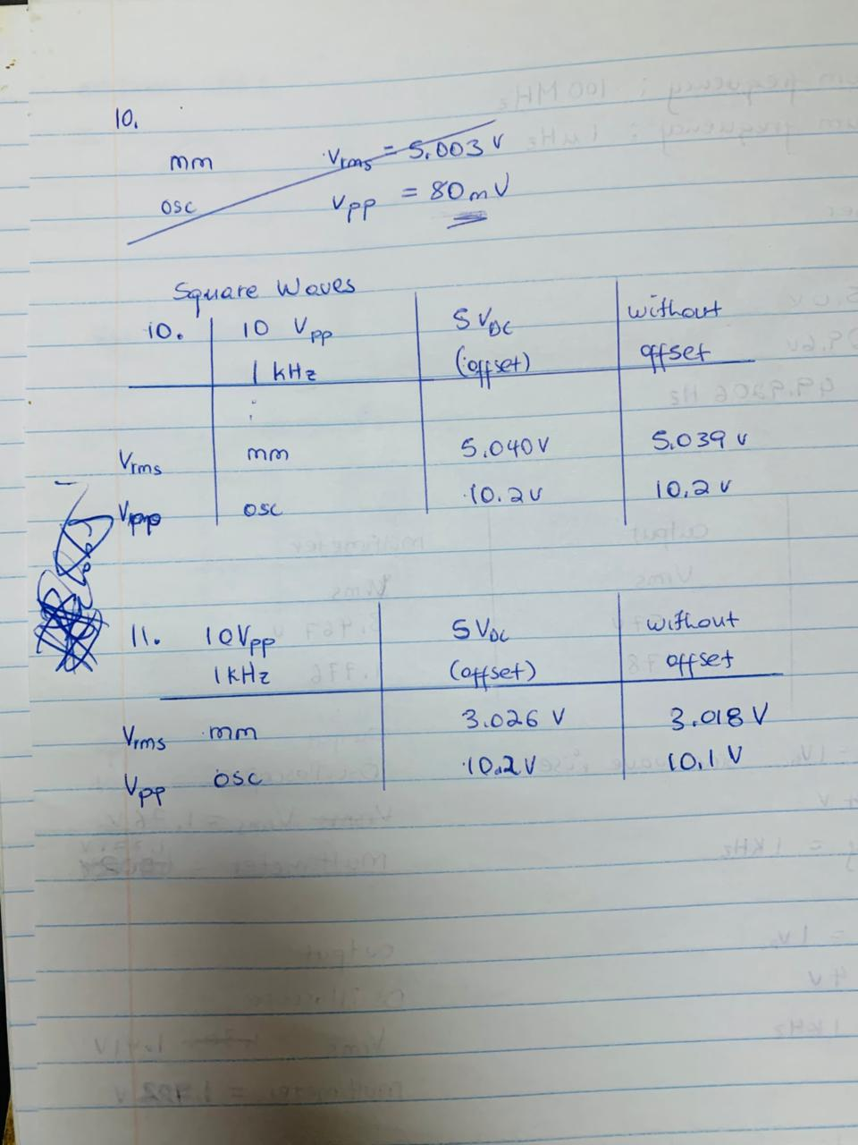
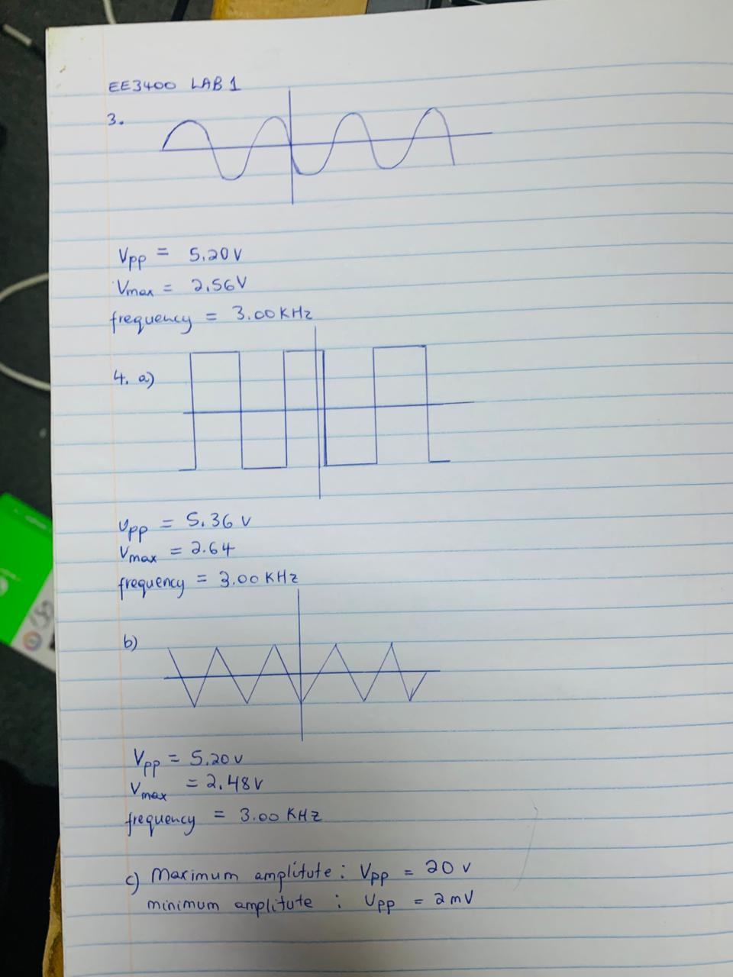
Calculations:
Mains Voltage Measurement (via Transformer)
The AC mains voltage (~50 Hz) was stepped down using a transformer and measured on the oscilloscope.
- Measured $V_{pp}=29.6 V$
- Measured Frequency, f=49.92 Hz (This is in excellent agreement with the expected 50 Hz standard).
RMS Voltage Measurements
The following measurements were taken to verify theoretical relationships.
Sine Wave (10 $V_{pp}$, no DC offset):
Theoretical $V_{rmr}$=10/(22)≈3.54
Measured (DMM): $V_{rms}$=3.57 V
Measured (Oscilloscope): $V_{rms}$=3.47V
Sine Wave with DC Offset (4$V_{pp}$, +1 V DC):
Theoretical True RMS: $V_{rms(true)}=\sqrt{({2\sqrt{2})}^{2}+1^{2}}=1.73V$
Measured (Oscilloscope, DC coupling): $V_{rms}$=1.76 V
Measured (DMM): $V_{rms}=1.72 V$
When the oscilloscope coupling was switched to AC, the RMS reading dropped to ~1.41 V, confirming it was displaying only the AC component.
Square Wave (10 $V_{pp}$, 50% duty cycle):
Theoretical$V_{rms}$=10/2=5.00 V
Measured (DMM): $V_{rms}$=5.04 V
Triangle Wave (10 $V_{pp}$):
Theoretical $V_{rms}=≈0.2887⋅10≈2.887 V$
Measured (DMM): ≈0.2887⋅10≈2.887 V
Measured (DMM): $V_{rms}$=3.08 V
% Error = | (Theoretical Value - Measured Value)|/ (Theoretical Value) × 100%
- Percentage Error: $\frac{∣50.00-49.92∣}{50}*100\%=0.16\%$

Waveform & Condition | Theoretical Vrms | Measured Vrms | Instrument | Percentage Error (%)
Sine (10 Vpp, no offset) | 3.54 V | 3.57 V | DMM | 0.85%
 | 3.54 V | 3.47 V | Oscilloscope | 1.98%
Sine (4Vpp + 1V DC) | 1.73 V | 1.72 V | DMM | 0.58%
 | 1.73 V | 1.76 V | Oscilloscope | 1.73%
Square (10 Vpp) | 5.00 V | 5.04 V | DMM | 0.80%
Triangle (10 Vpp | 2.89 V | 3.08 V | DMM | 6.57%

Discussion:
This lab showed that different wave shapes have different power (RMS) even when they are the same height (Vpp). investigation proved that AC coupling blocks DC voltage while DC coupling shows everything. The multimeter always measures total power including DC offset. All tools worked correctly for test signals and real electricity measurements. Each instrument has its own job.

Discussion Questions:
1,
-DC Coupling: Shows complete signal (AC + DC).
-AC Coupling: Blocks DC, shows only AC component.
-GND Coupling: Displays 0V reference for ground positioning
2,
The RMS voltage tells the equivalent DC voltage that would provide the same power. For a sine wave, our lab confirmed that for a 10Vpp sine wave, we measured ≈3.54V RMS.
3, Multimeter measures total power (wave + DC offset). Oscilloscope can measure two ways: DC mode (total power) or AC mode (wave only). The multimeter always includes the offset, while the scope's AC setting removes it, causing different readings.
4, The trigger helps freeze waves on the screen. Auto mode shows wavy lines even if they move. Normal mode only shows steady waves. Single mode captures one wave then stops. The scope can trigger on the full signal (DC) or just the wavy part (AC). Auto Level finds the trigger point automatically.

Conclusion:
This lab taught us how to use electronic instruments to create and measure different signals. We confirmed that waveforms like sine, square, and triangle waves have different power (RMS) values even when they are the same height (Vpp). We learned that AC coupling hides DC offset, and that multimeters and oscilloscopes measure signals differently. The tools worked successfully for both generated and real-world signals.

