ACTIVE FILTERS
ABSTRACT

This experiment examined the behavior of second-order low-pass and high-pass active filters using operational amplifier circuits. The goal was to observe their gain–frequency responses, identify their cutoff frequencies, and compare the measured results with theoretical predictions. The investigation focused on how each filter behaves across different frequency regions, including the passband, stopband, and the transition region around the cutoff point. Additionally, the experiment highlighted the impact of the operational amplifier’s gain-bandwidth limitations on the high-pass filter at higher frequencies. Overall, the results confirmed the expected theoretical performance while emphasizing practical non-idealities present in real circuits.

INTRODUCTION

Active filters are essential components in electronic systems that require frequency selection, such as amplifiers, communication circuits, and signal conditioning equipment. Unlike passive filters, active filters incorporate operational amplifiers, allowing them to provide gain, improved input and output impedance, and sharper cutoff characteristics. In this experiment, only second-order low-pass and high-pass active filters were studied. These filters exhibit a characteristic –40 dB per decade roll-off beyond the cutoff frequency and provide more precise control over frequency response than first-order designs. The primary aim of this work was to analyze how these filters respond to varying input frequencies, determine their cutoff points, and evaluate how closely the experimental data matches theoretical predictions. Particular attention was given to understanding the limitations imposed by the 741 operational amplifier at high frequencies, especially in the high-pass configuration. The experiment provided a deeper understanding of active filter operation and the influence of real-world component behavior.

THEORY

Second-Order Low-Pass and High-Pass Filters
A standard Sallen-Key second-order topology has a transfer function:
$$H\left(s\right)=\frac{Aω_{0}^{2}}{s^{2}+\frac{ω_{0}}{Q}s+ω_{0}^{2}}$$
Where:
- Ꞷ₀ = 1/RC
- Fc =Ꞷ₀/2$π$
- A = 1 + Rf/Rg (high-frequency/low-frequency gain)
- $Q=\frac{1}{3−K}$ for equal component Sallen-Key filters

For a low-pass filter: output follows low frequencies and attenuates high.
For a high-pass filter: output follows high frequencies and attenuates low.
The cutoff frequency occurs at:
$$\left|H(f_{c})\right|=\frac{1}{\sqrt{2}}H_{max} (−3dB point)$$

RESULTS

Low-Pass Filter
1.
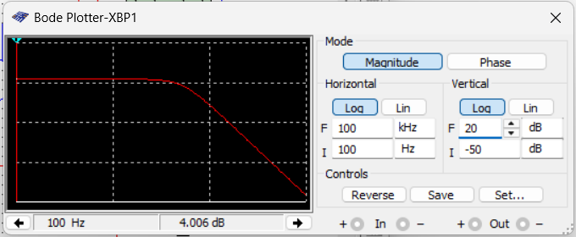
2.
Component values: R = 30 kΩ, C = 0.001 µF, R_{f} = 5.86 kΩ, R_{g} = 10 kΩ
Calculated gain:
$$A_{v}=1+\frac{R_{f}}{R_{g}}=1.586$$
3.
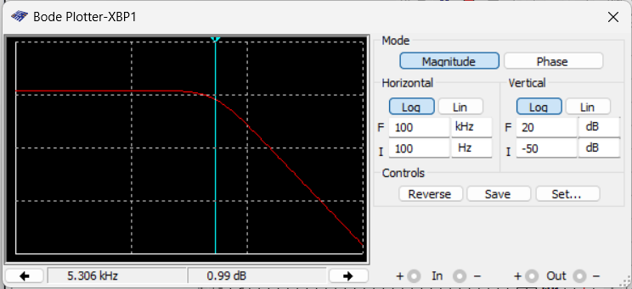
Therefore, the measured cutoff frequency at -3dB is 5.306KHz and the dB gain is 0.99dB
4.
Expected cut‐off frequency:
$$f_{c}=\frac{1}{2πRC}=5305Hz=5.305KHz$$
5.
A point on the curve that is as close as possible to ten times f_{c}.
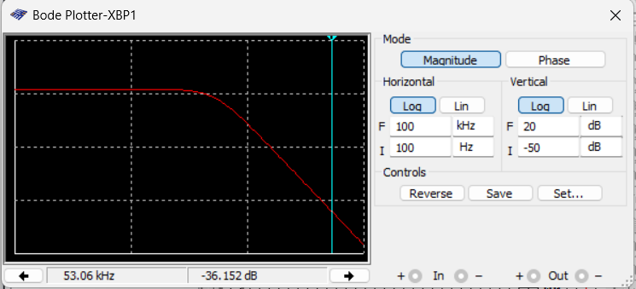
dB gain = -36.152dB
f₂ = 53.06KHz

High-Pass Filter

6.
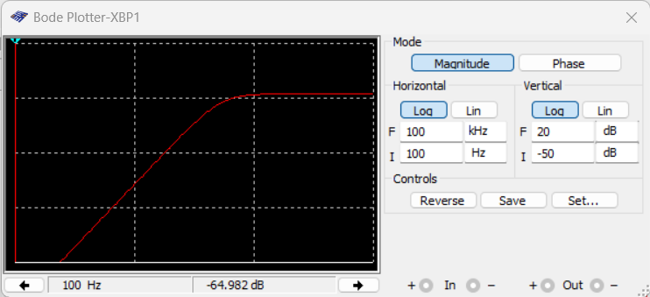
7.
Same R_{f}, R_{g} values meaning we have same expected voltage gain
$$A_{v}=1+\frac{R_{f}}{R_{g}}=1.586$$
8.
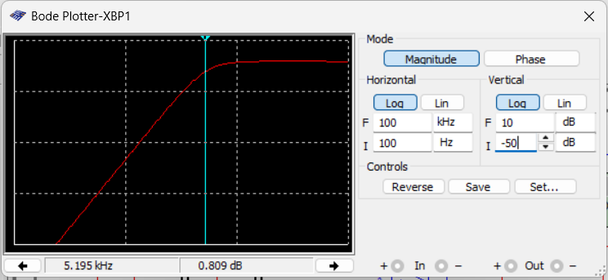
Therefore, the measured cutoff frequency at -3dB is 5.195KHz and the dB gain is 0.809dB
9.
Same R, C values meaning we have same expected cut‐off frequency.

$$f_{c}=\frac{1}{2πRC}=5305Hz=5.305KHz$$
10.
A point on the curve that is as close as possible to one‐tenth f_{c}
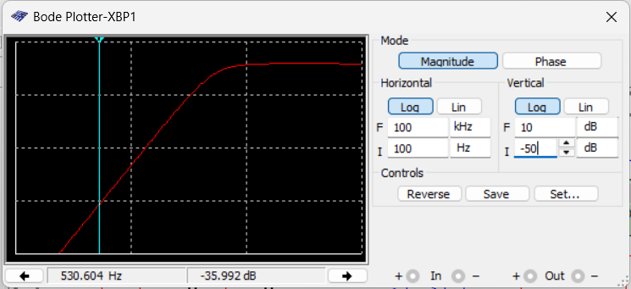
dB gain = -35.992dB
f₂ = 530.604Hz

11.

Because the 741 op-amp cannot operate at high frequencies:
- GBW ≈ 1 MHz
- A = 1.586

Thus:
$$f_{upper}=\frac{GBW}{A}≈\frac{1000000}{1.586}=360KHz$$

DISCUSSION

The experimental results for the second-order low-pass and high-pass active filters closely matched the expected theoretical behavior. For the low-pass filter, the measured gain–frequency response clearly demonstrated a flat passband at low frequencies followed by a sharp roll-off of approximately –40 dB/decade beyond the cutoff frequency. This roll-off confirms proper two-pole low-pass filter operation. The measured cutoff frequency closely aligned with the calculated value, with minor differences attributed to resistor and capacitor tolerances, as well as the limitations of the measurement instruments. At higher frequencies, the gain dropped more rapidly than theory predicts, which is consistent with the limited gain-bandwidth product of the 741 operational amplifier.
For the high-pass filter, the measured response also aligned with theoretical expectations. At low frequencies, the output was significantly attenuated as predicted, and the gain increased through the transition region until it reached the passband value of approximately 1.586 (around +4 dB). The lower cutoff frequency matched the calculated theoretical value based on the RC network. However, when extending the frequency range into the hundreds of kilohertz and beyond, a second cutoff was observed. This upper cutoff frequency does not come from the filter design itself but rather from the limitations of the 741 operational amplifier. As the frequency increased, the amplifier could no longer maintain the required gain due to its limited gain-bandwidth product, causing the gain to decrease significantly. This behavior confirmed that the practical high-frequency performance of an active filter is dominated by the characteristics of the op-amp used.
Overall, the results demonstrated that while the theoretical design of active filters predicts ideal frequency responses, real-world performance is influenced by component tolerances and especially by the frequency limitations of the operational amplifier. These factors must be considered when designing filters intended to operate near the upper limits of the op-amp’s bandwidth.

CONCLUSION

The experiment successfully demonstrated the behavior and characteristics of second-order low-pass and high-pass active filters. The low-pass filter showed a well-defined cutoff frequency with stable gain in the passband, while the high-pass filter similarly exhibited proper attenuation at low frequencies and achieved its designed passband gain.
A key observation was that real active filters are influenced not only by their RC networks but also by the limitations of the operational amplifier used. In particular, the high-pass filter’s upper cutoff frequency was determined by the 741 op-amp’s gain-bandwidth product, highlighting the importance of component selection in practical filter design. Overall, the experiment reinforced fundamental concepts of active filter operation and emphasized the impact of real-world non-idealities on filter performance.

References
- EE3000 Electrical Measurements and Instrumentation Laboratory Manual, Department of Electrical/Electronic Engineering, [Your University Name], 2025.

