NAME: TLOTLISO
SURNAME: MOKOTOI
STUDENT NUMBER: 202321234
COURSE CODE: EE3400
DATE: 26/09/2025

TITTLE: Introduction to electronic measurements.

AIM: To understand the basic operation of the function generator, oscilloscope, and multimeter, and to use the oscilloscope to observe signals created by various sources.
Abstract:
This experiment aimed to develop practical skills in using fundamental electronic measuring instruments, including the function generator, oscilloscope, and multimeter. Various waveforms—sine, square, and triangular—were generated and analyzed on the oscilloscope to study their characteristics. Signals from real-world sources, such as a stepped-down mains supply and sound waves from a microphone, were also examined. RMS voltages were measured using both the oscilloscope and multimeter, and the effect of DC offset was investigated through AC and DC coupling. The results confirmed the expected relationships between peak and RMS voltages and highlighted variations due to waveform type and coupling method. Overall, the lab provided a practical understanding of how these instruments are employed to generate, measure, and interpret electrical signals.
INTRODUCTION:
Electronic measurements are fundamental to both research and practical work in electrical and electronic engineering. Precise observation and analysis of signals are essential for designing, testing, and troubleshooting circuits. In this regard, three key instruments—the function generator, oscilloscope, and multimeter—are indispensable. The function generator produces various test signals, such as sine, square, and triangular waves, which are vital for simulating inputs in circuit analysis. The oscilloscope enables time-domain visualization of these signals, allowing detailed examination of their shape, frequency, amplitude, and response under different conditions. The multimeter provides direct measurements of voltage, current, and resistance, and in this experiment, it was used to determine the RMS voltage of AC signals.
This experiment introduces students to the operation of these instruments and demonstrates their application in analyzing signals from multiple sources, including a function generator, a step-down mains transformer, and a microphone. The practical relevance of this work is evident: oscilloscopes assist in diagnosing communication signals, function generators facilitate testing of amplifier circuits, and multimeters are used for routine maintenance and calibration of electronic systems. Mastery of these instruments equips students with foundational skills essential for advanced studies and professional practice in electronics.

Theory
Electronic measurements are a cornerstone of electrical and electronic engineering, enabling the observation, analysis, and validation of signals in both research and practical applications. For accurate circuit design, testing, and troubleshooting, engineers rely on fundamental instruments such as the function generator, oscilloscope, and multimeter. Each instrument plays a distinct role in the characterization of electrical signals.
The function generator is an active signal source capable of producing standard periodic waveforms, including sine, square, and triangular signals, over a wide range of frequencies and amplitudes. These signals serve as test inputs to simulate real-world conditions for circuits under study. Adjustments such as frequency, amplitude, and DC offset allow further control over the generated waveforms.
The oscilloscope is a time-domain measurement tool used to visualize electrical signals. By displaying waveforms on a screen, it allows direct observation of a signal’s shape, frequency, period, amplitude, and phase. Key features such as AC, DC, and GND coupling modes determine whether the oscilloscope displays only the alternating component of a signal, both AC and DC components, or a grounded reference line. Triggering functions—such as auto, normal, and single-shot modes—ensure stable waveform capture, particularly for transient or one-time events.
The multimeter provides numerical measurements of voltage, current, resistance, and, in this experiment, the root mean square (RMS) voltage. RMS voltage is defined as the effective value of an AC signal, representing the equivalent DC voltage that would deliver the same power to a load. For sine wave, RMS voltage is mathematically related to the peak voltage as:
$$V_{rms}=\frac{V_{p}}{\sqrt{2}}=0.707V_{P}$$
The relation for RMS and peak-peak voltage is given by:
$$V_{rms}=\frac{V_{pp}}{2\sqrt{2}}=0.3536V_{pp}$$

This relationship forms the basis for comparing theoretical predictions with measured values. However, differences in waveform type, the presence of DC offsets, and the chosen measurement instrument can lead to variations in the observed RMS values.

EXPERIMENTAL RESULTS:
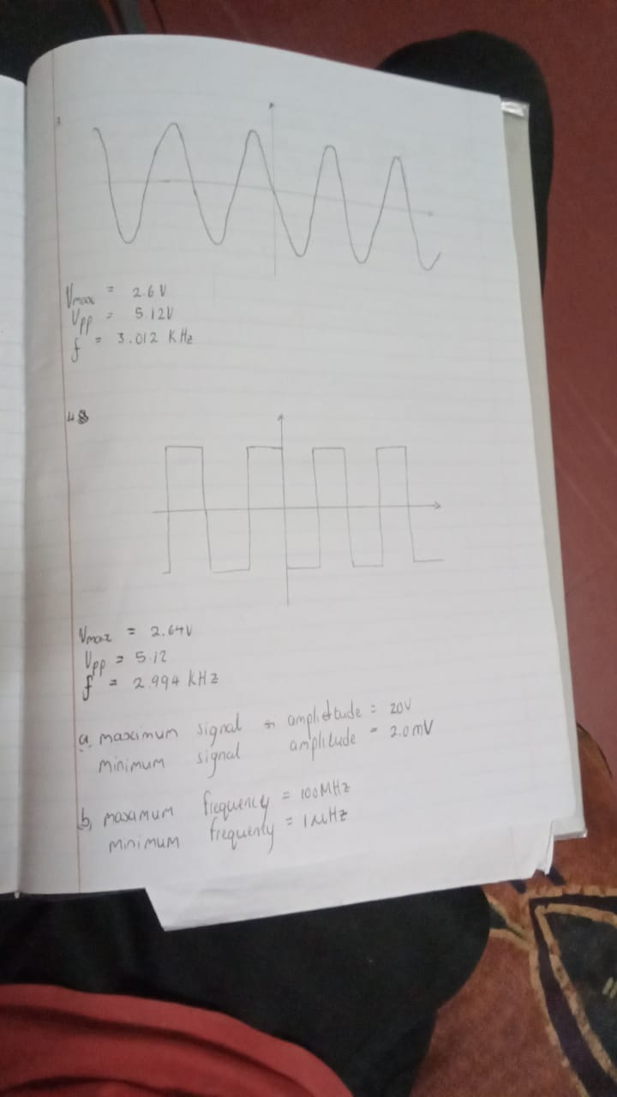
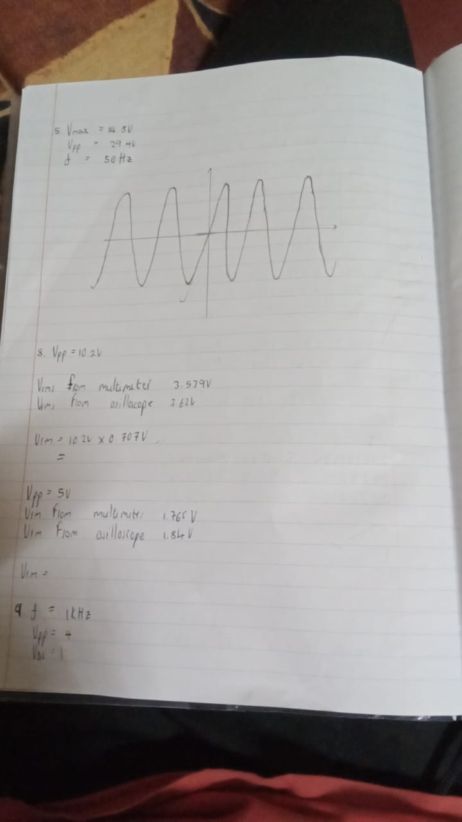
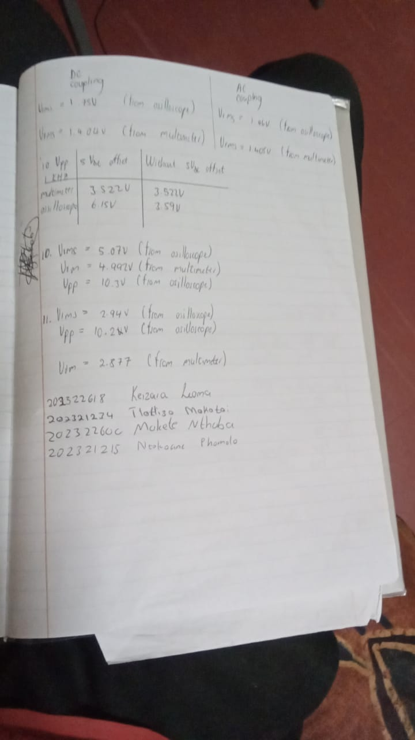
3.
$V_{max}=2.6V$
$V_{pp}={2V}_{max}=5.12V$
$f=3.012KHz$

4.
$V_{max}=2.64V$
$V_{pp}=5,12V$
$f=2.994KHz$

- Maximum signal amplitude = 20V
Minimum signal amplitude =2.0mV

- Maximum frequency = 100MHz
Minimum frequency = $1μHz$

5.
$V_{max}=14.5V$
$V_{pp}=29V$
$f=50Hz$

8.
For $V_{pp}=10.2V$
$V_{p}=5.1V$
$V_{rms }from multimeter=3.539V$
$V_{rms }from osilloscope=3.62V$
$V_{rms}=5.1V×0.707V=3.6057V$

For $V_{pp}=5V$
$V_{rms} from multimter=1.765V$
$V_{rms} from osilloscope=1,84V$

Discussion Questions:
1.
- AC coupling: Allows both the AC and DC components of a signal to pass to the oscilloscope. It is used to measure absolute voltages and DC offsets.
- DC coupling: Blocks the DC component of the signal and allows only the AC part to pass through to the oscilloscope. This is achieved by putting a capacitor in series with the input.
- GND (ground) coupling: is the process of measuring signal voltage levels with respect to the ground. The input signal is basically disconnected and connects the input amplifier to the ground. It is used to verify and set ground position before taking measurements.
2.
- RMS voltage of an AC waveform: is the amount of AC power that produces the same heating effect as DC power. An AC voltage basically of $V_{rms}$ produces the same heating effect in a resistor as a constant DC voltage $V_{rms}$.
- Mathematical definition of a periodic voltage signal v(t) with period T is given as:
$$V_{rms}=\sqrt{\frac{1}{T}\int_{0}^{T}{{[v\left(t\right)]}^{2}dt}}$$
Let $v\left(t\right)=V_{p}sin⁡(wt)$, where $V_{p}$ is the peak amplitude and $w=\frac{2π}{T}$
Computing the value inside the integral:
$${[v\left(t\right)]}^{2}={V_{p}}^{2}\sin^{2}(wt)$$
Using the identity: $\sin^{2}θ=\frac{1-cos⁡(2θ)}{2}$
$$→\sin^{2}\left(wt\right)=\frac{1-cos⁡(2wt)}{2}$$
Which implies:
$${[v\left(t\right)]}^{2}={V_{p}}^{2}\frac{1-cos⁡(2wt)}{2}=\frac{{V_{p}}^{2}}{2}(1-\cos\left(2wt\right))$$
Now we plug into the $V_{rms}$ equation:
$$V_{rms}=\sqrt{\frac{1}{T}\int_{0}^{T}{\frac{{V_{p}}^{2}}{2}(1-\cos\left(2wt\right))dt}}$$
$$=\sqrt{\frac{{V_{p}}^{2}}{2T}\int_{0}^{T}{(1-\cos\left(2wt\right))dt}}$$
Evaluating integrals:
$$\int_{0}^{T}{1dt=T}$$
Second integral:
$$\int_{0}^{T}{\cos\left(2wt\right)dt={[\frac{\sin\left(2wt\right)}{2w}]}_{0}^{T}}$$
Recall that $2wT=\left(2T\right)\frac{2π}{T}=4π$, and $\sin\left(4π\right)=0$
This implies: $\frac{{V_{p}}^{2}}{T}\int_{0}^{T}{(1-\cos\left(2wt\right))dt}=T-0=T$
So $V_{rms}=\sqrt{\frac{{V_{p}}^{2}}{2T}(T)}=\sqrt{\frac{{V_{p}}^{2}}{2}}=\frac{V_{p}}{\sqrt{2}}$
Since$V_{pp}=2V_{p}$ this implies;
$$V_{rms}=\frac{V_{p}}{\sqrt{2}}=\frac{V_{pp}}{2\sqrt{2}}=[\frac{1}{2\sqrt{2}}]V_{pp}$$
3. When there is a DC offset in a signal, the multimeter gives a different value for the RMS voltage than the oscilloscope because they measure different quantities due to their internal signal processing methods.
The multimeter always measures the true RMS, including any DC offset.
When set to AC coupling, the oscilloscope only displays and measures the AC portion of the signal.
4.
- Auto level mode: This is an automatic setup assistance feature, it continuously displays a waveform even if no trigger event occurs. This ensures the trace is always visible, which is useful for observing periodic signals quickly.
- Auto mode: There is always a waveform display regardless of whether the trigger condition is met. The scope automatically forces a trigger even if it does not detect it.
- Normal mode: The oscilloscope only sweeps if the input signal reaches the set trigger point. If the trigger condition is never met, the screen remains blank or shows previous waveform.
- Single trigger mode: The scope will pick the first rising edge it sees. The scope waits for the trigger condition to happen once, captures that single waveform, and then stops.

- DC Trigger Coupling: Both AC and DC components are used to detect the trigger. It is used for general purpose triggering.
- AC Trigger Coupling: The trigger circuit includes DC offset for triggering; full waveform stable. A capacitor is placed in the trigger path to block the DC component.
5.

Vertical (V/div) | 0.5
Horizontal (ns/div) | 50
Trigger mode | Single
Trigger Coupling | DC
Trigger Level (V) | 0.5
Trigger Type | Rising edge

Discussion:
The experiment was successfully completed, with the oscilloscope, multimeter, and function generator all utilized effectively to obtain results. Signals generated by the function generator were analyzed using both the oscilloscope and the multimeter. The oscilloscope clearly displayed the waveform shapes as voltage versus time plots, with the observed frequencies closely matching the values set on the generator. The multimeter provided RMS values for the signals, while the oscilloscope also enabled RMS calculations. Minor differences were noted between the two measurements, likely due to calibration variations in the instruments. Overall, the results were consistent with theoretical expectations. The contrast between AC and DC coupling was observed in the oscilloscope display, with AC coupling appearing as though the signal had shifted relative to the baseline. Additionally, differences between waveform types were evident: the sine wave appeared smooth and rounded, while the square wave exhibited sharp, well-defined edges.
CONCLUSION:
The objective of this experiment was to gain an understanding of how to operate the function generator, oscilloscope, and digital multimeter, and to observe various waveforms produced by the generator on the oscilloscope while comparing selected measurements with those obtained from the multimeter. The theoretical background provided clear expectations for parameters such as peak voltage and root mean square (RMS) values, as well as their interrelationships. The comparison between oscilloscope and multimeter readings showed only minor differences, likely due to instrument precision. Overall, the experimental results were consistent with theory and demonstrated the effectiveness of these instruments in signal analysis.

References:
Doebelin, E., 2003. Measurement Systems: Application and Design. 5th ed. New York: McGraw-Hill.

