EMI 3 – Active Filters
OBJECTIVES
1. Plot the gain‐frequency response and determine the cut‐off frequency of
second order (two‐pole) low‐pass and high‐pass active filters.
2. Plot the gain‐frequency response curve and determine the centre frequency
for active band‐pass and band‐stop filters.
3. Determine the quality factor (Q) and bandwidth of active band‐pass and
band‐stop filters.
4. Determine the roll‐off in dB per decade for a second‐order (two‐pole) filter.
5. Plot the phase‐frequency response of a second‐order filter.
EQUIPMENT
One function generator; One dual‐trace oscilloscope; One LM741 op‐amps; Breadboard;
Capacitors: two 0.001 μF, one 1 pF, two 0.01 μF, two 0.05 μF, one 0.1 μF Resistors: one 1 kΩ, one 5.86 kΩ, two 10 kΩ, one 13 kΩ, one 27 kΩ, two 30 kΩ, two 54 kΩ, one 100 kΩ
PROCEDURE
[You will need to plot the frequency response curves by making dB gain measurements at different frequencies between 100 Hz and 100 kHz and plotting the curves on semilog graph paper.]
The two‐pole Sallen‐Key Butterworth filters require a passband voltage gain of 1.586 to produce the Butterworth response. Therefore,
$$A_{V}=1+\frac{R_{1}}{R_{2}}=1.586$$
$$\frac{R_{1}}{R_{2}}=0.586$$
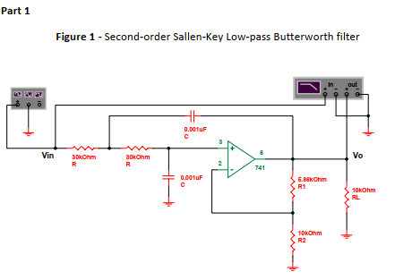
1. Set up the circuit of Figure 1 and measure the voltage gain in dB for frequencies
between 100 Hz and 100 kHz. Sketch the curve plot.
2. Calculate the expected voltage gain (A) on the flat part of the curve for the low‐
pass Butterworth filter based on the circuit component values in Figure 1.
3. Mark a point on the curve that is 3 dB down from the dB gain at low frequencies.
Record the dB gain and the frequency (cut‐off frequency, fc) on the curve plot.
4. Calculate the expected cut‐off frequency based on the circuit component values.
5. Mark a point on the curve that is as close as possible to ten times fc. Record the dB
gain and frequency (f2) on the curve plot.
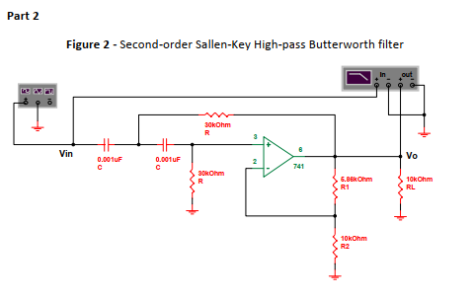
6. Set up the circuit of Figure 2 and measure the voltage gain in dB for frequencies
between 100 Hz and 100 kHz. Sketch the curve plot.
7. Calculate the expected voltage gain (A) on the flat part of the curve for the high‐
pass Butterworth filter based on the circuit component values in Figure 2.
8. Mark a point on the curve that is 3 dB down from the dB gain at high frequencies.
Record the dB gain and the frequency (cut‐off frequency, fc) on the curve plot.
9. Calculate the expected cut‐off frequency based on the circuit component values.
10. Mark a point on the curve that is as close as possible to one‐tenth fc. Record the
dB gain and frequency (f2) on the curve plot.
11. Take measurements up to 50 MHz and draw the resulting curve. Measure the
upper cut‐off frequency and record the value on the curve plot. Why is this the case?

