ABSTRACT
This experiment focused on the practical use of fundamental electronic measurement instruments, namely the function generator, oscilloscope, and digital multimeter. The primary objective was to develop familiarity with their operation and to apply them in the analysis of various signal types, including sine, square, triangular, and audio waveforms. Measurements were conducted on both artificially generated signals and real-world signals, such as those obtained from a stepped-down mains voltage. The experiment also illustrated methods for measuring root-mean-square (RMS) values and comparing results across different instruments, as well as examining the influence of DC offsets on signal representation. The findings demonstrated that the oscilloscope offers detailed visualization of waveform shapes and frequency characteristics, while the multimeter provides practical RMS voltage measurements. Overall, the experiment delivered essential hands-on experience with measurement techniques that are foundational for further study in electronics.
INTRODUCTION
Accurate measurement is a cornerstone of both the study and practical application of electronics. Instruments such as function generators, oscilloscopes, and multimeters are essential in laboratory settings and engineering practice. A function generator enables the creation of periodic signals such as sine, square, and triangular waves at controlled frequencies and amplitudes. The oscilloscope allows for the visualization of these signals in the time domain, offering insight into their amplitude, frequency, shape, and DC offset. The digital multimeter complements these instruments by providing numerical measurements of quantities such as root-mean-square (RMS) voltage.
This laboratory exercise was designed to help students become proficient with these measurement tools by generating and analyzing different waveforms, measuring RMS values, and observing the effects of DC offsets. The experiment also included real-world applications, such as measuring signals from a step-down transformer connected to the mains supply and analyzing audio signals captured by a microphone. Through these activities, students gained practical experience in setting up instruments, interpreting waveforms, and performing reliable electrical measurements. This foundational knowledge is vital for more advanced work in electronics and instrumentation.
THEORY
lectronic measurements depend on instruments that can generate, display, and quantify electrical signals. The principal instruments used in this experiment were the function generator, oscilloscope, and multimeter.
Function Generator
A function generator is an electronic device capable of producing various periodic waveforms, including sine, square, and triangular waves. These signals are characterized by parameters such as frequency, amplitude, and DC offset. Function generators are valuable for testing and analyzing circuits under controlled conditions. Additionally, they can introduce a DC offset to a waveform, shifting the signal above or below the zero-volt reference.
Oscilloscope
An oscilloscope is used to visualize how a signal varies over time. It provides critical information about a signal’s amplitude, frequency, phase, and shape. The vertical axis represents voltage, while the horizontal axis represents time. Oscilloscopes offer several coupling modes:
- DC coupling shows both AC and DC components of a signal.
- AC coupling blocks the DC component and shows only the alternating part of the signal.
- GND coupling sets the input to ground reference for baseline comparison.
Oscilloscopes also allow measurements such as peak-to-peak voltage, frequency, and phase relationships between signals.
Multimeter
A multimeter is a versatile instrument used to measure electrical quantities such as voltage, current, and resistance. In this experiment, the multimeter was primarily used to determine RMS voltage values. While the oscilloscope provides detailed information about waveform shape, the multimeter offers numerical values that are straightforward to record, though less descriptive of the waveform itself.
Root-Mean-Square (RMS) Voltage
For alternating signals, the RMS value represents the effective voltage, which corresponds to the DC voltage that would deliver the same power to a resistor.
In general, for any periodic signal v(t) with period T:
$$V_{rms}=\sqrt{\frac{1}{T}\int_{0}^{T}{{v(t)}^{2}dt}}$$
For a sinusoidal signal, the RMS value is related to the peak voltage Vp​ by:
$$V_{rms}=\frac{V_{p}}{\sqrt{2}}=0.707V_{p}$$
This relationship is fundamental in AC analysis because most measurement devices and power ratings are expressed in RMS values.
DC Offset
A DC offset occurs when an AC waveform, such as a sine wave, is shifted away from the zero reference voltage. For example, a sine wave with a 2 V peak and a +1 V offset will oscillate between –1 V and +3 V, rather than between –2 V and +2 V. This shift can influence RMS calculations and should be considered when interpreting measurement results.
In summary, the theory behind this experiment lies in understanding how instruments generate, measure, and interpret signals.
EXRERIMENTAL RESULTS
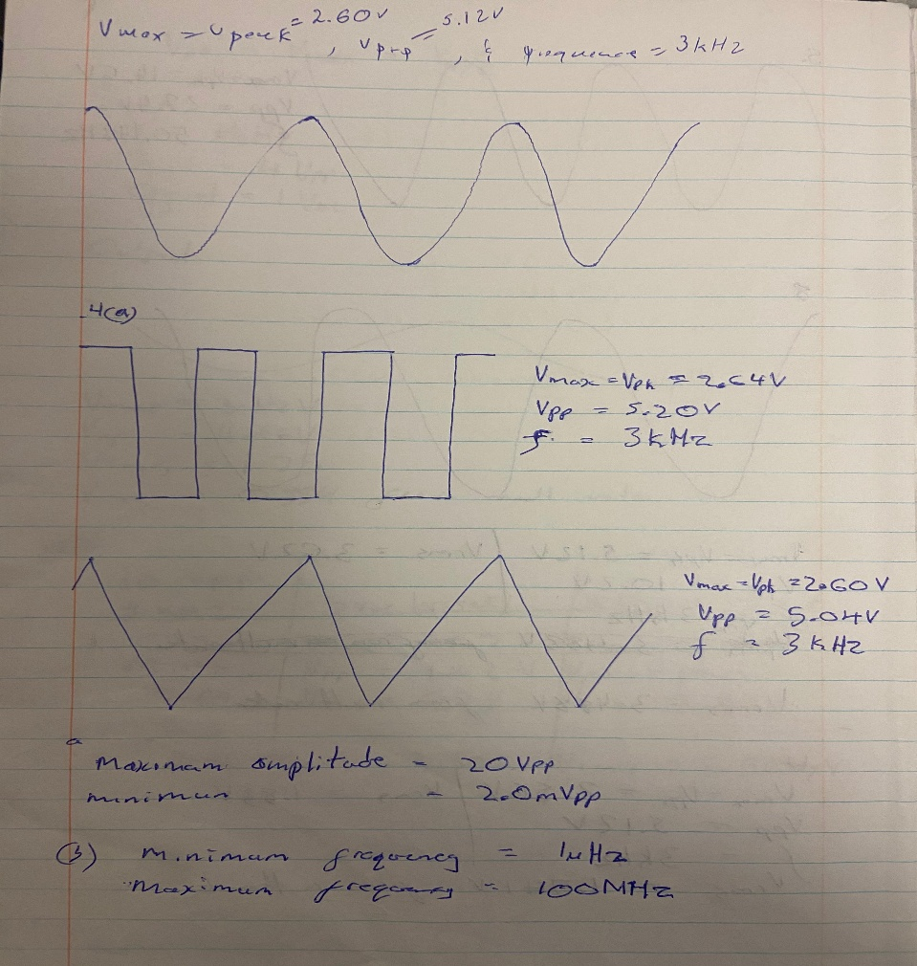
3...
3.
Vmax = Vpk = 2.60V
Vpp = 5.12V
f = 3KHz
4.
 | Square wave | Triangular wave
Vmax = Vpk | 2.64V | 2.60V
Vpp | 5.20V | 5.04V
f | 3KHz | 3KHz
(a)
Maximum signal amplitude = 20Vpp
Minimum signal amplitude = 2.0mVpp
(b)
Minimum signal frequencies =1μHz
Maximum signal frequencies =100MHz

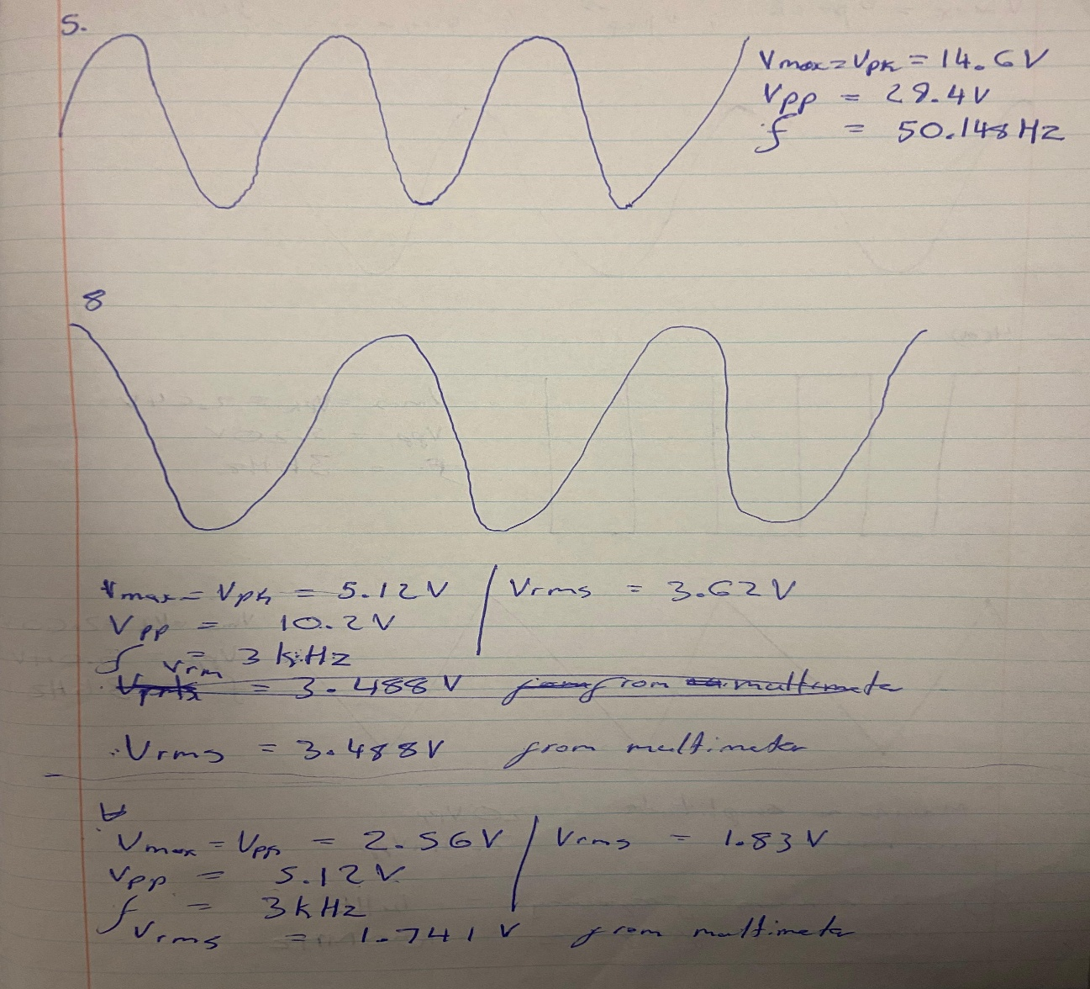
5.
(b)
Amplitude = Vpp = 29.4V
Frequency = 50.148Hz
8.
 | Before we change amplitude to 5Vpp | After we change amplitude to 5Vpp
Vmax =Vpk | 5.12V | 2.56V
Vpp | 10.2V | 5.12V
f | 3KHz | 3KHz
Oscilloscope Vrms | 3.62V | 1.83V
Multimeter Vrms | 3.488V | 1.741V

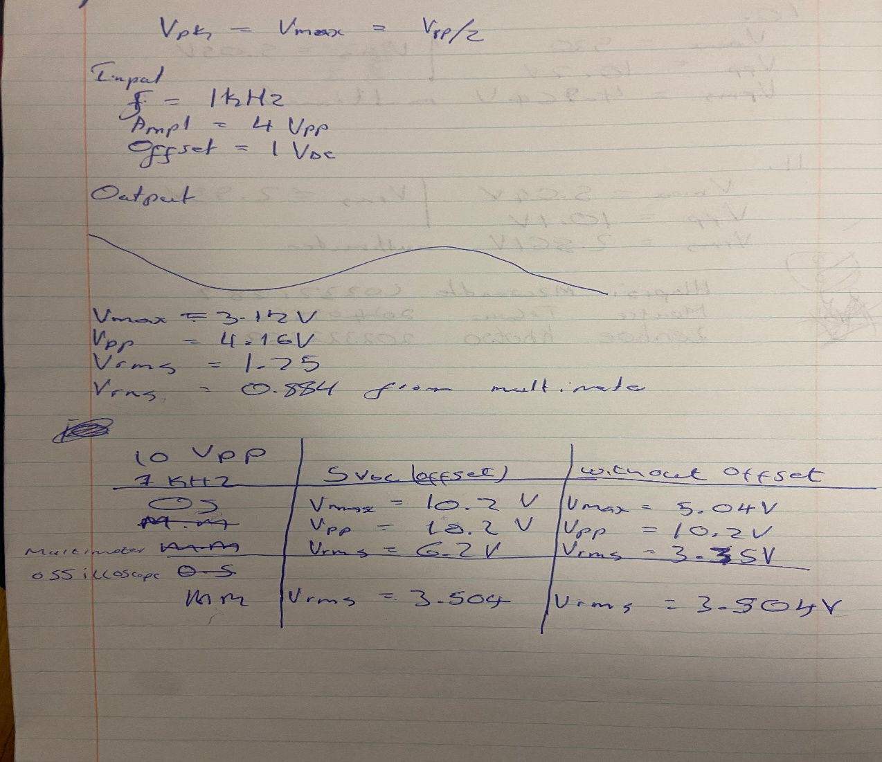
9.
9.
Input | Output
F = 1KHz | Vmax = 3.12V
Amplitude = 4Vpp | Vpp = 4.16V
Offset = 1 V_{DC} | Oscilloscope Vrms = 1.75V
 | Multimeter Vrms = 0.884V

10 Vpp sine wave
f = 1KHz | 5VDC offset | Without offset
Oscilloscope | Vmax = 10.2V | Vmax = 5.04V
 | Vpp = 10.2V | Vpp = 10.2V
 | Vrms = 6.2V | Vrms = 3.35V
Multimeter | Vrms = 3.504 | Vrms = 3.504V

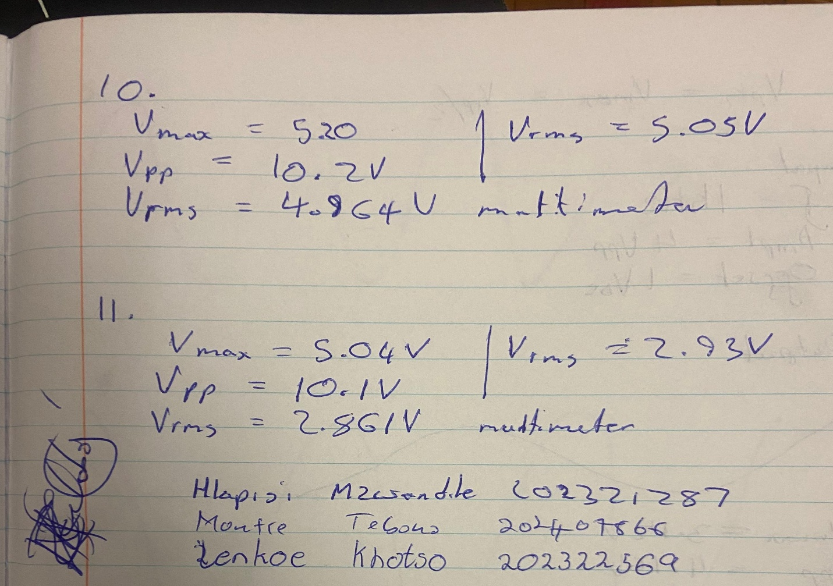
10 and 11.
- 10 Vpp, no DC offset
 | Square wave (10) | Triangular wave (11)
Vmax | 5.20V | 5.04V
Vpp | 10.2V | 10.1V
Oscilloscope Vrms | 5.05V | 2.93V
Multimeter Vrms | 4.964V | 2.861V

DISCUSSION
In this laboratory exercise, we developed practical skills in using the oscilloscope, function generator, and multimeter to measure and analyze a variety of electrical signals. Each instrument demonstrated distinct advantages and limitations in the context of signal measurement.
- On the oscilloscope, DC coupling shows the full signal, including both AC and DC parts. AC coupling blocks the DC part and only shows the alternating part of the signal, which is useful when the DC offset is not important. GND coupling connects the input to ground so that the screen shows a flat zero line. This helps to set a reference level for the signal.
- The RMS (Root Mean Square) value of a signal is the effective voltage that gives the same heating effect in a resistor as a DC voltage would.
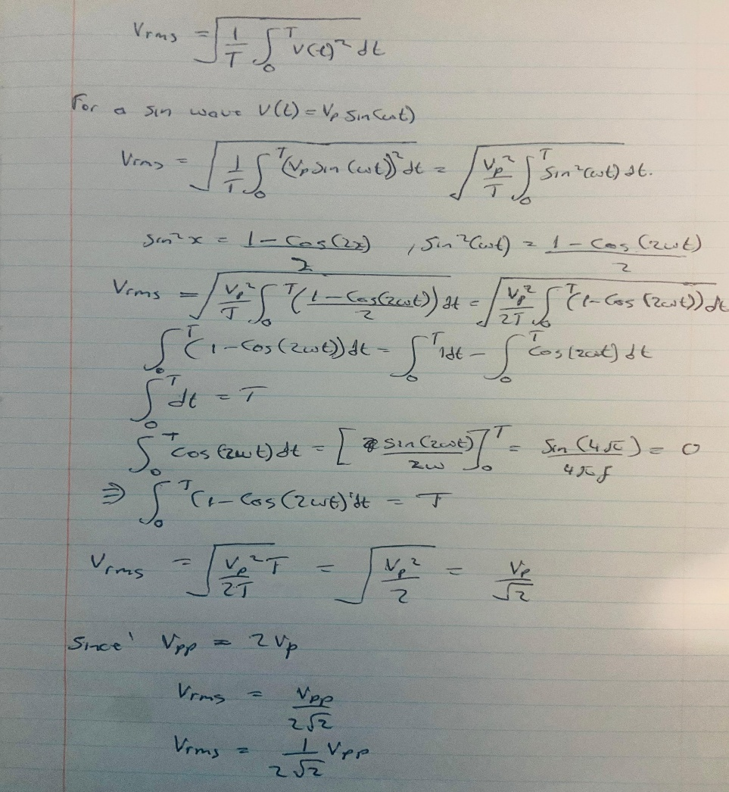

- When a signal has a DC offset, the oscilloscope and multimeter may give different RMS values. This is because the oscilloscope can be set to AC coupling, which removes the DC part and only measures the AC component. The multimeter, however, measures the total effective voltage, including both AC and DC. This is why their readings are different.

- Oscilloscope trigger modes

- Auto level automatically adjusts the trigger level for stable display.
- Auto mode keeps the screen updating even if there is no trigger event, so you can still see the signal.
- Normal mode only updates the screen when the trigger condition is met, which gives a stable picture of repeating signals.
- Single mode captures one event (a single pulse) and then freezes the display, useful for non-repeating or transient signals.
- AC trigger coupling blocks DC components and triggers only on the AC part.
- DC trigger coupling uses the full signal (AC + DC) for triggering.
- Settings to capture short pulses
To capture two short pulses of 100 ns width, 1 V amplitude, and separated by 10 ms, the oscilloscope settings should be:
- Trigger mode: Single (to capture the pulse once and hold it).
- V/div: About 0.5 V/div (so the 1 V pulse can be clearly seen on the screen).
- Time/div: Around 5 ms/div to see both pulses that are 10 ms apart. For the 100 ns pulse width, a faster time/div (like 50 ns/div) is needed to zoom in on the shape of the pulse.
CONCLUSION
Through this experiment, we gained experience in generating, observing, and measuring various electrical signals using the function generator, oscilloscope, and digital multimeter. We successfully produced sine, square, and triangular waveforms, and utilized the oscilloscope to examine their shapes, amplitudes, frequencies, and offsets. Additionally, we compared RMS voltage measurements obtained from the oscilloscope and multimeter, clarifying the reasons for any discrepancies when a DC offset was present.
The oscilloscope proved to be an effective tool for real-time visualization of signals, while the multimeter provided precise numerical RMS values. By working with both artificial signals from the function generator and real signals such as mains voltage, we developed practical skills in handling real-world electrical measurements.
Overall, this laboratory exercise enhanced our understanding of proper instrument usage, the significance of RMS values, and the impact of DC offset and coupling modes. These foundational skills are essential for more advanced studies in electronic measurements and instrumentation.

References:
- Author, EMI 1 – Introduction to Electronic Measurements, Lab Manual, Department of Electrical Engineering, [Your University], 2025.
- D. A. Bell, Electronic Instrumentation and Measurements, 2nd ed., New Delhi: PHI Learning, 2010.

