REPORT AND PRESENTATION
Project Title: NUL Smart Library System
Course: Data Structures and Algorithms
Institution: National University of Lesotho
Language Used: C++
Group members:
- Mzwandile Hlapisi 202321287
• Rearabetsoe Monyako 202321246
• Teboho Montle 202407866
• Kabelo Lekhanya 202402333
Date: 02/11/2025

Abstract
The NUL Smart Library System is a console-based C++ application that manages book borrowing, returns, reservations, and catalog searches for a university library.
It applies fundamental data structures and algorithms such as Binary Search Trees (BSTs), Hash Tables, Queues, and Linked Lists to simulate an efficient and organized digital library management system.

Objectives
- To design a simple library management system using core data structures.
- To efficiently index, search, and retrieve book information.
- To manage borrowing and returning processes.
- To implement reservation and waitlist functionality.
- To maintain a history of all transactions.

System Features

Feature | Description | Data Structure Used
Book Catalog | Stores and organizes books alphabetically. | BST
Fast Search | Quickly finds books by title. | Hash Table
Borrow/Return | Allows users to borrow or return books. | BST + Linked List
Reservations | Keeps track of users waiting for borrowed books. | Queue
Transaction Log | Records all borrow/return actions. | Linked List

System Design
Main Components:
- BST (Binary Search Tree):
  - Used for indexing and organizing books alphabetically by title.
  - Supports insertion, searching, and traversal.
- Hash Table:
  - Provides quick lookup of books by title using a hash function.
  - Resolves collisions via chaining.
- Queue:
  - Maintains waiting lists for books currently borrowed.
  - Operates on FIFO (First-In-First-Out) principle.
- Linked List:
  - Used to maintain transaction history (borrowed/returned books).

Implementation Summary
- Language: C++
- Input/Output: Console-based interface
- No STL vectors used (all ADTs implemented manually)
- Main Classes/Structures:
  - BST → Book indexing
  - HashTable → Fast lookups
  - Queue → Waitlists
  - TransactionList → Transaction history
  - LibrarySystem → Controls program flow and menu operations

Sample Outputs
Adding Books:
Enter book title: Data Structures
Enter author: Mzwaa
Book added successfully.
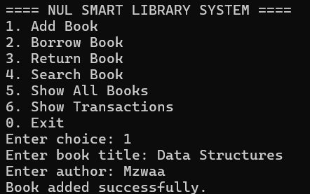
Borrowing Book:
Enter your User ID: 202321287
Enter book title: Data Structures
Book borrowed successfully.
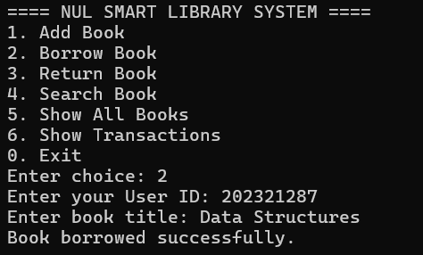

Returning Book:
Enter your User ID: 202321287
Enter book title: Data Structures
Book returned successfully.
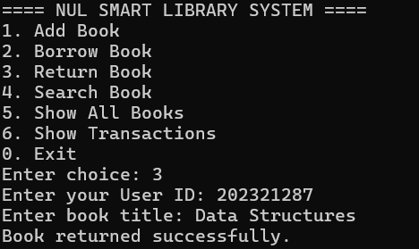

Search Books:

Enter book title to search: Data Structures
Book found – Title: Data Structures | Author: Mzwaa | Available: Yes

Enter book title to search: C++
Book not found.

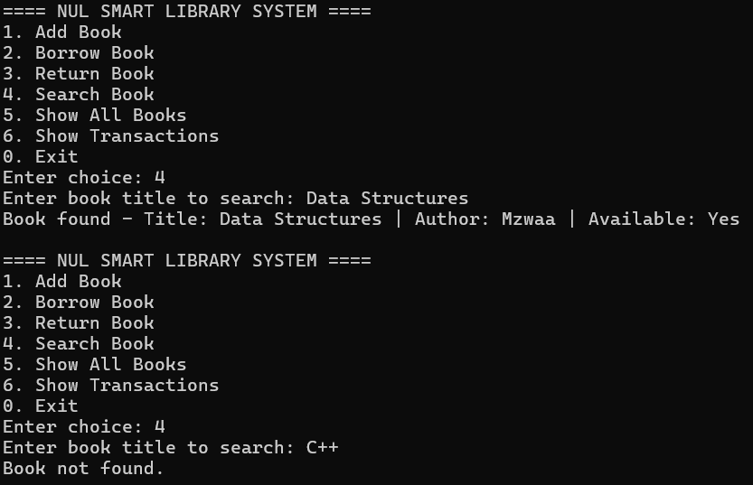

Library books:

--- Library Books ---
Title: Data Structures | Author: Mzwaa | Available: Yes
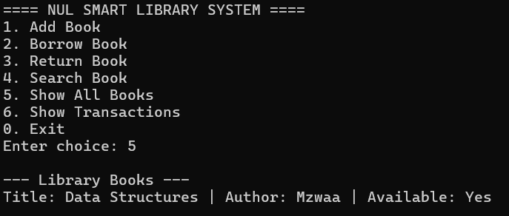
Transaction History:
--- Transaction History ---
User: 202321287 | Book: Data Structures | Action: Borrowed
User: 202321287 | Book: Data Structures | Action: Returned
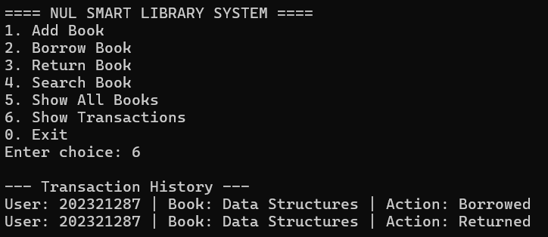

Data Structure Justification
Data Structure | Justification
BST | Efficient organization and traversal of books.
Hash Table | Fast access by book title (O(1) average).
Queue | Fair handling of waiting lists.
Linked List | Dynamic, simple storage of transaction logs.

Challenges
- Managing multiple data structures together efficiently.
- Avoiding STL containers while maintaining performance.
- Implementing proper memory management for all nodes.

Conclusion
The NUL Smart Library System successfully demonstrates the application of fundamental data structures to solve real-world problems.
The integration of BSTs, Hash Tables, Queues, and Linked Lists results in a simple yet powerful system capable of handling core library management operations efficiently.

Future Improvements
- Replace BST with AVL Tree for automatic balancing.
- Add file handling to save and load library data.
- Build a GUI version using C++ graphics.
- Add user authentication for security.

