5.
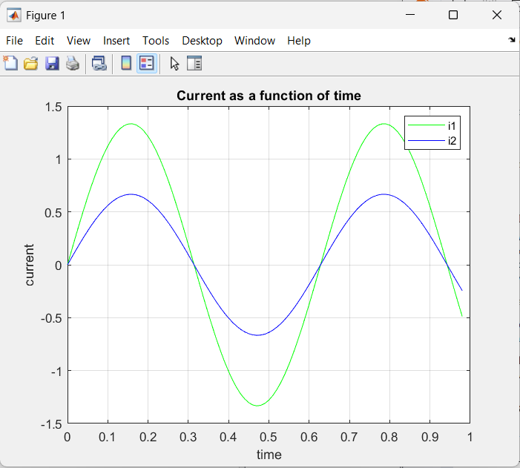
close all
clear all
clc

w = 10;
R1 = 1;
R2 = 1;
Rc = 1;

t = linspace(0,0.98,99);
i1 = (2*(Rc+R2)*sin(w*t))/((Rc+R2)*(R1+Rc)-(Rc)^2);
plot(t,i1,'g');
i2 = (2*Rc*sin(w*t))/((Rc+R2)*(R1+Rc)-(Rc)^2);
hold on;
plot(t,i2,'b');
grid on;
xlabel('time')
ylabel('current')
title('Current as a function of time')
legend('i1','i2');
print -dpng 'CurrentAsAFunctionOfTime.png'

