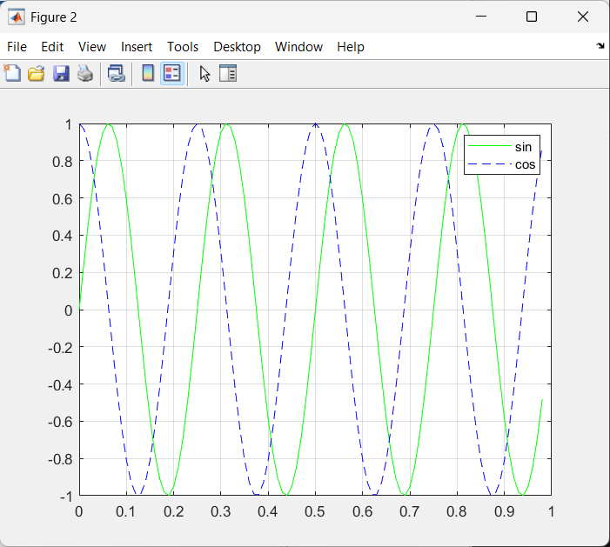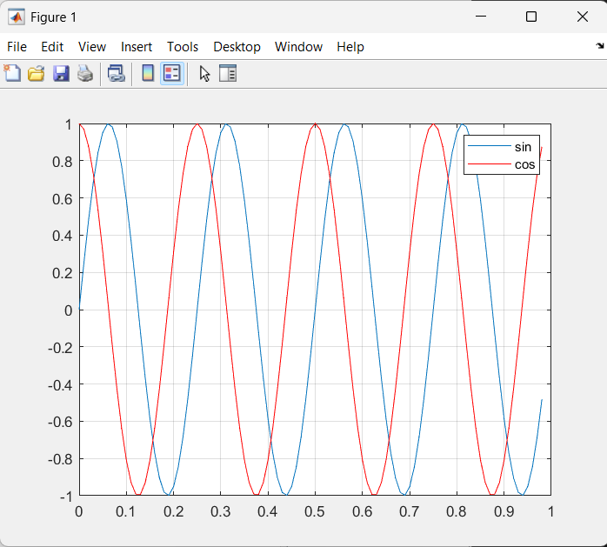
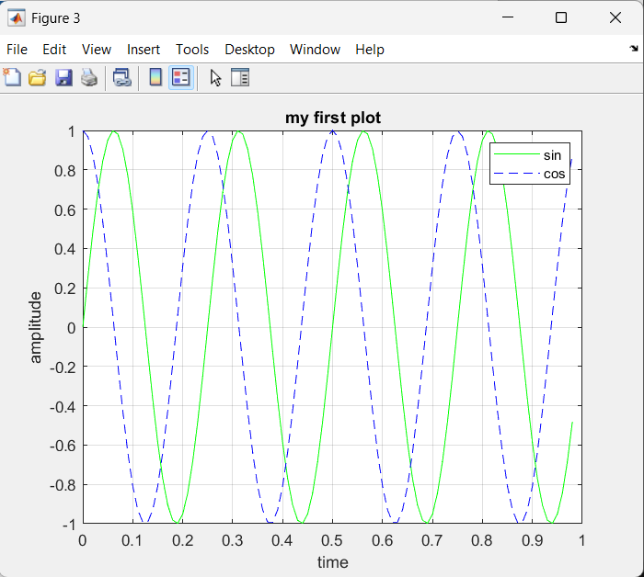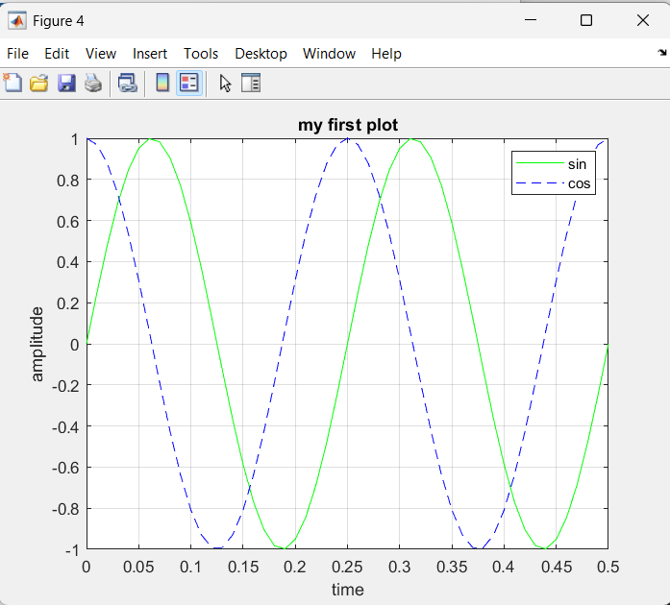
close all
clear all
clc
t = linspace(0,.98,99);
y1 = sin(2*pi*4*t);
plot(t,y1,'g');
y2 = cos(2*pi*4*t);
hold on;
plot(t,y2,'--b');
grid on;
xlabel('time')
ylabel('amplitude')
title('my first plot')
legend('sin','cos');
xlim([0 0.5])
print -dpng 'myFirstPlot.png'

