Loop Current Method: Alternative to nodal analysis but doesn’t work for all circuits - No signiﬁcant beneﬁts

Example
Consider the circuit from Example, with mesh currents defined.
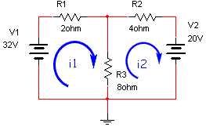
We can apply KVL to both loops
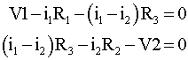
Since there are two equations and two unknowns we can solve by substitution or by matrix methods. To solve by matrix methods we rewrite the equations
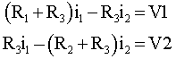
or
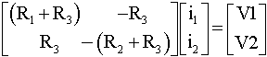
Solving for the two unknown currents we get
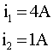

In the circuit of Figure 1,

- Find the current i_{o} using nodal analysis. (10 pts)
- Find the current i_{o} using mesh analysis. (10 pts)

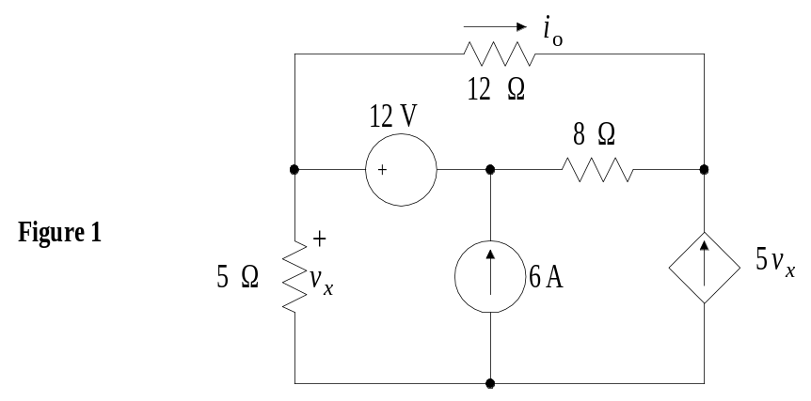

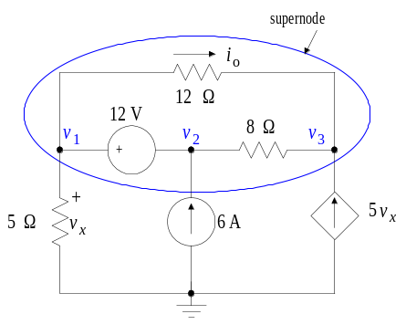
KCL for the supernode :
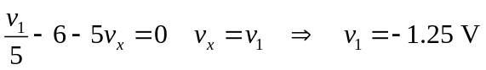
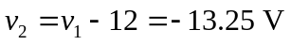
KCL for node 3 :
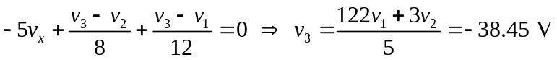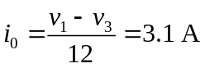

(b)
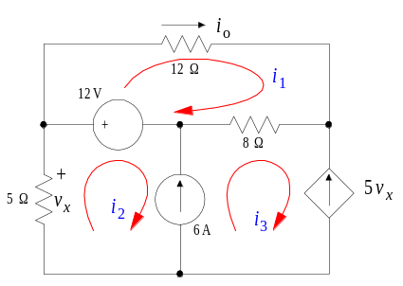
KVL eqn. can be written only for mesh 1:

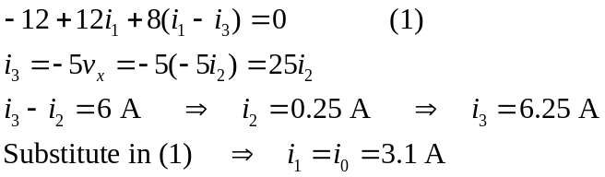

Q1. In the circuit of Figure 1, find the current i_{o} using mesh analysis
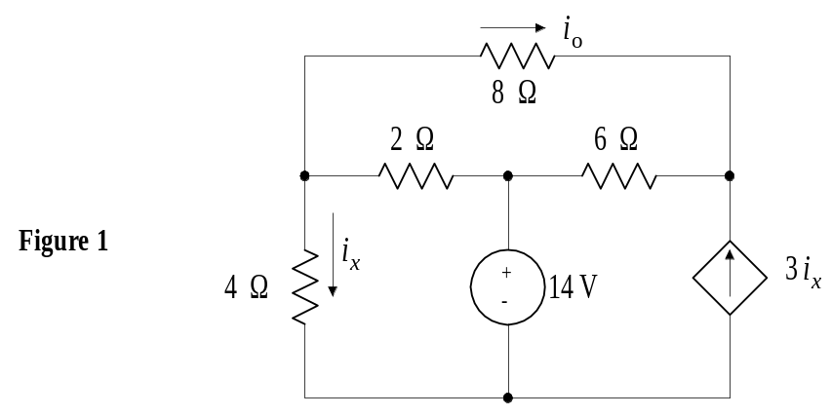

SOLUTION:

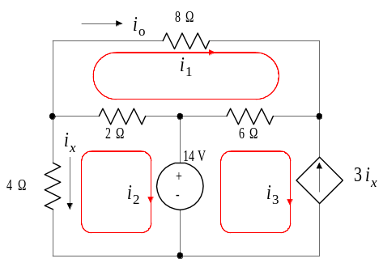

KVL eqn. for mesh 1:

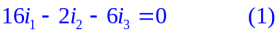

KVL eqn. for mesh 2:

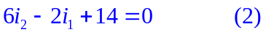

In meshes 2 and 3, 