NATIONAL UNIVERSITY OF LESOTHO
DEPARTMENT OF PHYSICS AND ELECTRONICS

EE3408 — ANALOGUE COMMUNICATIONS
ACM 3: FREQUENCY MODULATION
LABORATORY REPORT

Student and experiment details
Item | Details
Student name | Mope Maphutseng
Student ID | ________________________________
Date of experiment | ________________________________
Date of report | ________________________________

Academic Year 2026/2027

Abstract
Frequency modulation (FM) was investigated using simulation measurements and hardware observations. The instantaneous frequency limits were estimated from recorded periods, after which frequency deviation, modulation index and bandwidth were calculated. For the 10 kHz, 1 V simulation condition, the period readings gave a peak deviation of approximately 42.27 kHz, a modulation index of 4.23 and a Carson-rule bandwidth of 104.54 kHz. For the 20 kHz condition, the corresponding values were approximately 41.76 kHz, 2.09 and 123.52 kHz. A recorded spectrum was also examined and its outer frequency span compared with Carson’s estimate. Some handwritten readings were inconsistent, so uncertain values were identified rather than treated as verified measurements.

1. Introduction
Frequency modulation is an angle-modulation technique in which the instantaneous frequency of a carrier changes in response to the amplitude of a modulating signal. FM is used in radio broadcasting, telemetry and communication systems because information is represented by frequency variation rather than by intentional changes in carrier amplitude. The purpose of this experiment was to examine FM in the time and frequency domains and compare measured results with theoretical bandwidth estimates.
The EE3408 laboratory guide requires a report containing an abstract, introduction, theory, experimental results, discussion and interpretation, conclusion, and references. It also requires SI units, numbered equations, labelled figures and tables, and explanations of differences between predicted and measured results. This report follows that structure.

2. Theory
The instantaneous frequency can be estimated from the period of a waveform. The longer period corresponds to the lower frequency, and the shorter period corresponds to the higher frequency.
f = 1/T | (1)
where f is frequency in hertz (Hz) and T is period in seconds (s). The peak frequency deviation is half the difference between the highest and lowest instantaneous frequencies.
Δf = (f_high − f_low)/2 | (2)
For a single-tone modulating signal of frequency f_m, the FM modulation index is the ratio of peak deviation to modulating frequency.
β = Δf/f_m | (3)
Carson’s rule gives a practical estimate of the bandwidth containing most of the FM signal power.
B_C ≈ 2(Δf + f_m) = 2f_m(β + 1) | (4)
The spectrum consists of a carrier component and sidebands spaced at intervals of approximately f_m. Their relative amplitudes are described by Bessel coefficients J_n(β). Under the lab guide’s stated criterion, the Bessel bandwidth is estimated by retaining sidebands that are not below 1% of the unmodulated carrier amplitude.
B_Bessel ≈ 2Nf_m | (5)
Here N is the highest retained sideband order. The Bessel estimate cannot be confirmed unless the carrier reference level and sideband orders are identified reliably.

3. Experimental method

3.1 Simulation
- Set the modulating signal to 10 kHz and 1 V, and observe the FM output on the oscilloscope.
- Record the periods corresponding to the lowest and highest instantaneous frequencies.
- Display the spectrum analyser and record the frequency and amplitude of visible spectral lines.
- Repeat the measurements with the modulating frequency set to 20 kHz.
- Repeat with the modulating signal set to 10 kHz and 1.5 V.
- Configure the separate FM Generator to a 100 kHz carrier, modulation index 5 and 10 kHz message frequency.

3.2 Hardware
The laboratory manual lists a function generator, oscilloscope, spectrum analyser, two DC supplies, LM555 timer, 320 pF capacitor and 1 kΩ, 10 kΩ and 20 kΩ resistors. The supplied photographs were used as qualitative evidence of the hardware waveform. Precise cursor values could not be read reliably from the photographs, so no unsupported numerical hardware measurements are reported.

4. Experimental results and calculations

4.1 Simulation at f_m = 10 kHz and V_m = 1 V
The handwritten notes give T_low = 17.742 μs and T_high = 7.097 μs. The calculations below use these values as recorded.
Step 1: Convert the longer period to seconds.
T_low = 17.742 μs = 17.742 × 10⁻⁶ s | (6)
Step 2: Calculate the lowest instantaneous frequency.
f_low = 1/(17.742 × 10⁻⁶) = 56,363 Hz ≈ 56.36 kHz | (7)
Step 3: Convert the shorter period to seconds and calculate the highest instantaneous frequency.
T_high = 7.097 μs = 7.097 × 10⁻⁶ s | (8)
f_high = 1/(7.097 × 10⁻⁶) = 140,905 Hz ≈ 140.90 kHz | (9)
Step 4: Calculate peak frequency deviation.
Δf = (140.90 − 56.36) kHz / 2 | (10)
Δf = 84.54 kHz / 2 = 42.27 kHz | (11)
Step 5: Calculate the modulation index.
β = 42.27 kHz / 10 kHz = 4.227 ≈ 4.23 | (12)
Step 6: Calculate Carson’s-rule bandwidth.
B_C = 2(42.27 + 10) kHz = 104.54 kHz | (13)
Table 1. Calculated results for the 10 kHz, 1 V condition
Quantity | Result
Lowest instantaneous frequency, f_low | 56.36 kHz
Highest instantaneous frequency, f_high | 140.90 kHz
Peak frequency deviation, Δf | 42.27 kHz
Modulation index, β | 4.23
Carson-rule bandwidth, B_C | 104.54 kHz

4.2 Spectrum and outer frequency span
Table 2. Spectrum values transcribed from the supplied notes
Frequency (kHz) | Amplitude (mV)
39.791 | 101.768
49.821 | 211.802
59.731 | 288.638
69.761 | 249.144
80.030 | 30.183
90.060 | 148.799
100.209 | 223.087
110.119 | 280.124
120.030 | 43.287
130.060 | 346.460
140.090 | 352.222

The outer recorded frequencies were 39.791 kHz and 140.090 kHz. Their difference gives the recorded outer span:
B_span = 140.090 − 39.791 = 100.299 kHz | (14)
The absolute difference from Carson’s estimate is:
|104.540 − 100.299| = 4.241 kHz | (15)
The percentage difference, relative to Carson’s estimate, is:
(4.241/104.540) × 100% = 4.06% | (16)
The listed outer span is therefore 4.06% lower than the Carson-rule estimate. This comparison uses the outermost transcribed lines; it is not automatically equivalent to the bandwidth defined by the manual’s 1% amplitude threshold.
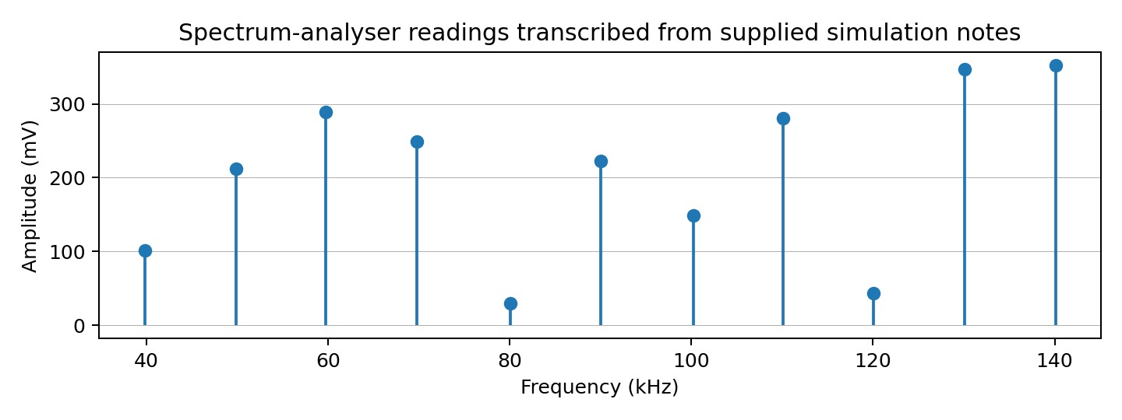
Figure 1. Spectrum-analyser values plotted from the handwritten simulation notes; this is a reconstructed plot, not a direct analyser screenshot.

4.3 Bessel-coefficient interpretation
Using β ≈ 4.23, the approximate Bessel-coefficient magnitudes are |J₀| ≈ 0.372, |J₁| ≈ 0.149, |J₂| ≈ 0.302, |J₃| ≈ 0.434, |J₄| ≈ 0.314, |J₅| ≈ 0.160, |J₆| ≈ 0.064, |J₇| ≈ 0.021 and |J₈| ≈ 0.006. These values are theoretical ratios and should not be confused with the measured amplitudes in millivolts.
A definitive Bessel bandwidth cannot be calculated from the transcribed table because the amplitudes are not symmetric around the apparent central line and the unmodulated carrier reference level is not documented. If N = 8 were independently confirmed using the laboratory’s 1% criterion, then B_Bessel ≈ 2 × 8 × 10 kHz = 160 kHz. This is conditional, not a verified experimental result.
B_Bessel = 2Nf_m = 2 × 8 × 10 kHz = 160 kHz (conditional) | (17)

4.4 Simulation at f_m = 20 kHz
The supplied notes give T_low = 11.532 μs and T_high = 5.874 μs.
f_low = 1/(11.532 × 10⁻⁶) = 86.72 kHz | (18)
f_high = 1/(5.874 × 10⁻⁶) = 170.24 kHz | (19)
Δf = (170.24 − 86.72)/2 = 41.76 kHz | (20)
β = 41.76 kHz / 20 kHz = 2.088 ≈ 2.09 | (21)
B_C = 2(41.76 + 20) kHz = 123.52 kHz | (22)
Table 3. Calculated results for the 20 kHz condition
Quantity | Result
Lowest instantaneous frequency, f_low | 86.72 kHz
Highest instantaneous frequency, f_high | 170.24 kHz
Peak frequency deviation, Δf | 41.76 kHz
Modulation index, β | 2.09
Carson-rule bandwidth, B_C | 123.52 kHz

The calculated deviation changes by 41.76 − 42.27 = −0.51 kHz, a decrease of about (0.51/42.27) × 100% = 1.21%. The modulation index changes from 4.23 to 2.09 because β = Δf/f_m and the modulating frequency doubles while the calculated deviation stays nearly constant. The Carson bandwidth increases by 123.52 − 104.54 = 18.98 kHz.
Percentage change in Δf = (0.51/42.27) × 100% ≈ 1.21% | (23)

4.5 Message amplitude increased to 1.5 V at 10 kHz
The handwritten period readings for this condition are not unambiguous enough to calculate a measured deviation without making an unsupported assumption. The correct calculation sequence is retained here for insertion of verified periods:
f_low = 1/T_low; f_high = 1/T_high | (24)
Δf = (f_high − f_low)/2; β = Δf/(10 kHz) | (25)
B_C = 2(Δf + 10 kHz) | (26)
If the VCO sensitivity were linear over the tested range, increasing the message amplitude from 1.0 V to 1.5 V would increase deviation by a factor of 1.5. This would predict Δf ≈ 1.5 × 42.27 = 63.405 kHz, β ≈ 6.34 and B_C ≈ 2(63.405 + 10) = 146.81 kHz. These are predictions only; they are not reported as measured values.
Δf_predicted = 1.5 × 42.27 = 63.41 kHz (linear-response assumption) | (27)

4.6 Separate FM Generator: f_c = 100 kHz, β = 5, f_m = 10 kHz
For the specified generator settings, the theoretical peak deviation follows directly from β = Δf/f_m.
Δf = βf_m = 5 × 10 kHz = 50 kHz | (28)
B_C = 2(50 + 10) kHz = 120 kHz | (29)
f_min = f_c − Δf = 100 − 50 = 50 kHz | (30)
f_max = f_c + Δf = 100 + 50 = 150 kHz | (31)
Table 4. Theoretical results for the separate FM Generator
Quantity | Theoretical value
Carrier frequency, f_c | 100 kHz
Message frequency, f_m | 10 kHz
Modulation index, β | 5
Peak deviation, Δf | 50 kHz
Frequency limits | 50–150 kHz
Carson-rule bandwidth | 120 kHz

4.7 Hardware observations
The supplied oscilloscope photographs show a sinusoidal signal and a pulse-like output from the LM555-based circuit. The changing pulse spacing is qualitatively consistent with a timing circuit whose oscillation frequency responds to the control signal. The photographs do not provide sufficiently readable cursor measurements or a clear spectrum-analyser trace to calculate hardware frequency deviation and bandwidth with defensible precision.
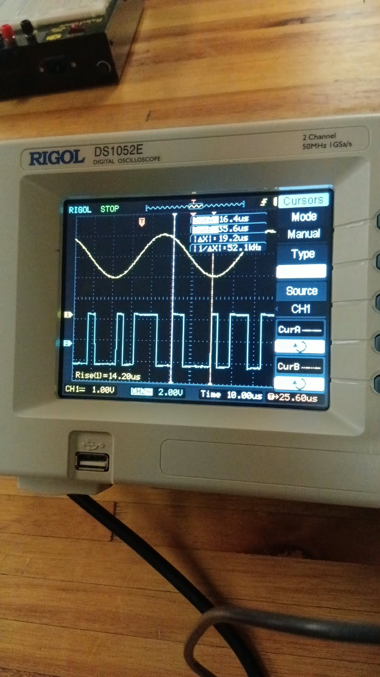
Figure 2. Supplied oscilloscope photograph showing the sinusoidal and pulse-like signals.
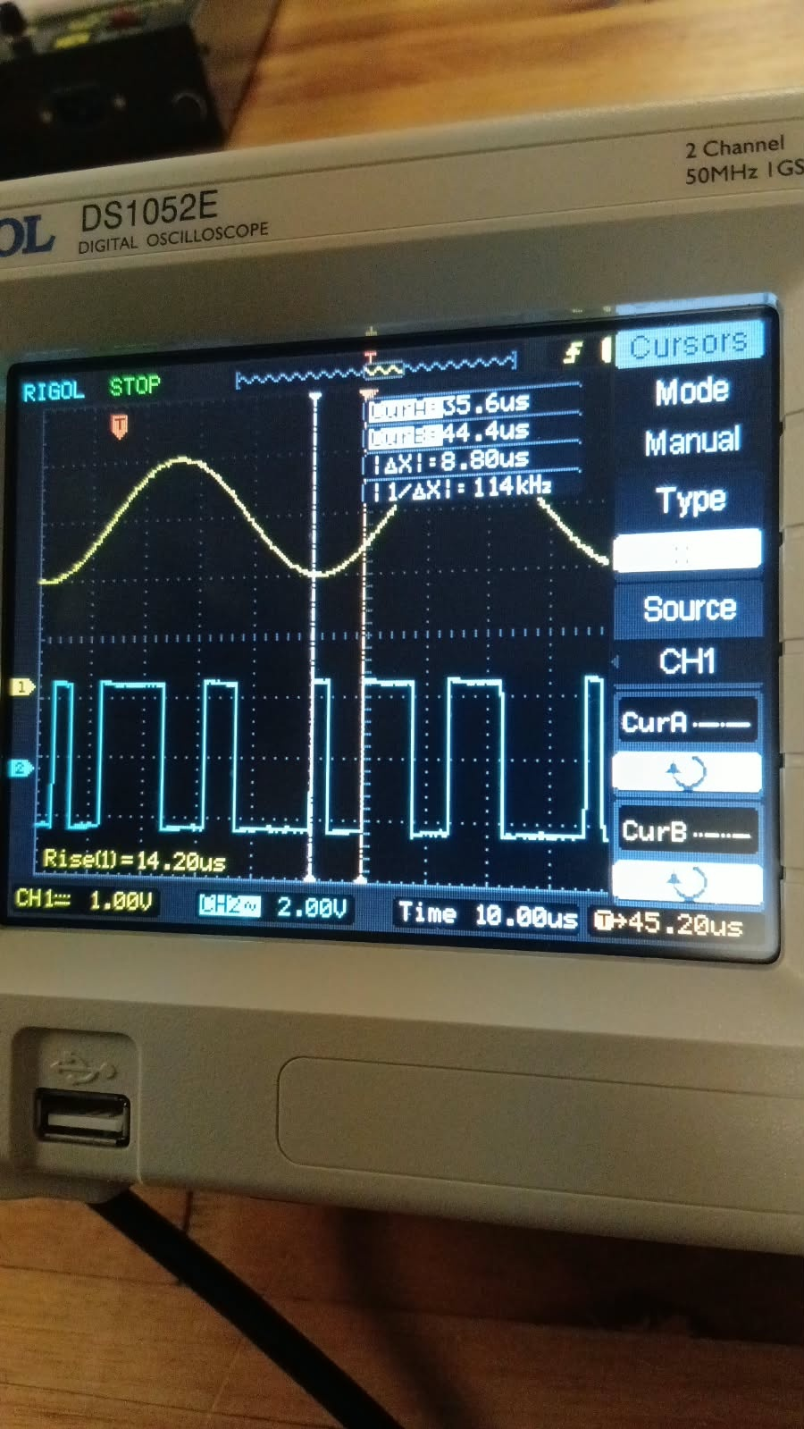
Figure 3. Additional oscilloscope photograph from the hardware results.
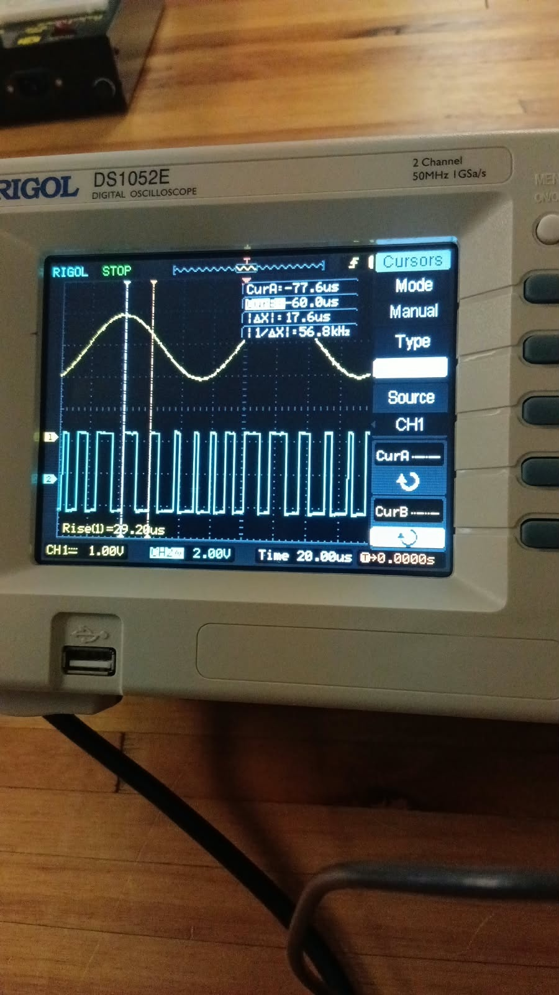
Figure 4. Additional hardware waveform observation.

5. Discussion and interpretation
At 10 kHz and 1 V, the period-based method produced f_low ≈ 56.36 kHz and f_high ≈ 140.90 kHz. The difference between these limits is 84.54 kHz, and the peak deviation is half this value, 42.27 kHz. The resulting modulation index is 4.23. Carson’s rule gives a bandwidth of 104.54 kHz, while the outer span of the recorded spectral lines is 100.299 kHz. The measured span is 4.06% below the Carson estimate.
The spectral-line spacing is approximately 10 kHz, broadly matching the message frequency. However, the recorded amplitudes are irregular and are not symmetric around the apparent central component. This may reflect transcription or reading errors, a misidentified carrier, instrument settings, or measurements taken under different settings. The spectrum should therefore be checked against the original analyser display before a firm Bessel-based bandwidth is stated.
At 20 kHz, the calculated deviation is 41.76 kHz, only 1.21% lower than the 10 kHz result. Since the deviation is nearly unchanged while f_m doubles, the modulation index falls from approximately 4.23 to 2.09. Carson’s bandwidth increases from 104.54 kHz to 123.52 kHz, as expected from B_C ≈ 2(Δf + f_m).
The 1.5 V case cannot be numerically confirmed from the unclear handwritten periods. A linear-response prediction has been provided separately and must not be presented as an observation. For the separate FM Generator, the specified settings imply Δf = 50 kHz, frequency limits of 50–150 kHz and a Carson bandwidth of 120 kHz. The handwritten spectrum notes do not consistently match these settings, so the theoretical calculation and the transcribed measurements have been kept separate.
Possible sources of uncertainty include reading the period from a waveform without clear cursor placement, rounding periods before inversion, selecting the wrong period extrema, misidentifying the carrier line, and using spectrum-line amplitudes without a documented unmodulated-carrier reference. These uncertainties affect the calculated deviation, modulation index and bandwidth. The original screenshots or simulation should be revisited to quantify these effects before final submission.

6. Conclusion
Frequency modulation was investigated using simulation notes and hardware waveform photographs. For the 10 kHz, 1 V condition, the measured periods yielded a peak deviation of approximately 42.27 kHz, modulation index 4.23 and Carson-rule bandwidth 104.54 kHz. The transcribed spectrum had an outer span of 100.299 kHz, which was 4.06% below the Carson estimate. For the 20 kHz condition, the calculated deviation was approximately 41.76 kHz, modulation index 2.09 and Carson bandwidth 123.52 kHz. These results illustrate that the modulation index decreases when the modulating frequency increases while deviation remains approximately constant. The 1.5 V measurement and definitive Bessel bandwidth remain unverified because the supplied handwritten data do not support a reliable numerical result.

References
- National University of Lesotho, Department of Physics and Electronics, EE3408 Labs: Laboratory Execution Guide, Academic Year 2026/2027.
- National University of Lesotho, EE3408, ACM 3 — Frequency Modulation laboratory manual supplied for this experiment.
- Student-supplied ACM3 simulation notes (ACM3 simulation.docx).
- Student-supplied ACM3 hardware results (ACM3 hardware results.docx).
- National University of Lesotho, EE3408, ACM 2 laboratory material, used only as a reference for the structure of laboratory work.

Appendix A. Checks required before final submission
The following items should be checked against the original simulator or laboratory logbook: (i) the period readings for the 10 kHz, 1.5 V condition; (ii) the carrier frequency and reference amplitude for the spectrum; (iii) the 20 kHz spectrum span, since a handwritten value of approximately 80.176 kHz conflicts with the period-based Carson estimate of 123.52 kHz; and (iv) the measured spectrum for the separate 100 kHz-carrier FM Generator. A measured result should only be reported after it has been confirmed from the original display or lab notebook.

