CSC3003S CS2ADMIN MLKKOK002 HPRMIC002 TFYILY001 Progress Report Stage 3

Date of Report: 18th August 2022

Time Period: 15th – 19th August 2022

Project Name: CS2ADMIN – Sonia Berman

Team Members: Moffat Moloko (MLKKOK002)

Michael Hooper (HPRMIC002)

Ilyaas Toefy (TFYILY001)

1.1) Task Activities during the Report Period

This week’s activity was to create the first prototype for the CSC2ADMIN project. The team decided on a vertical, evolutionary prototype as it was thought that the automation of convener tasks is the most important part of the project and so ensured it is implemented properly at the beginning of the project.

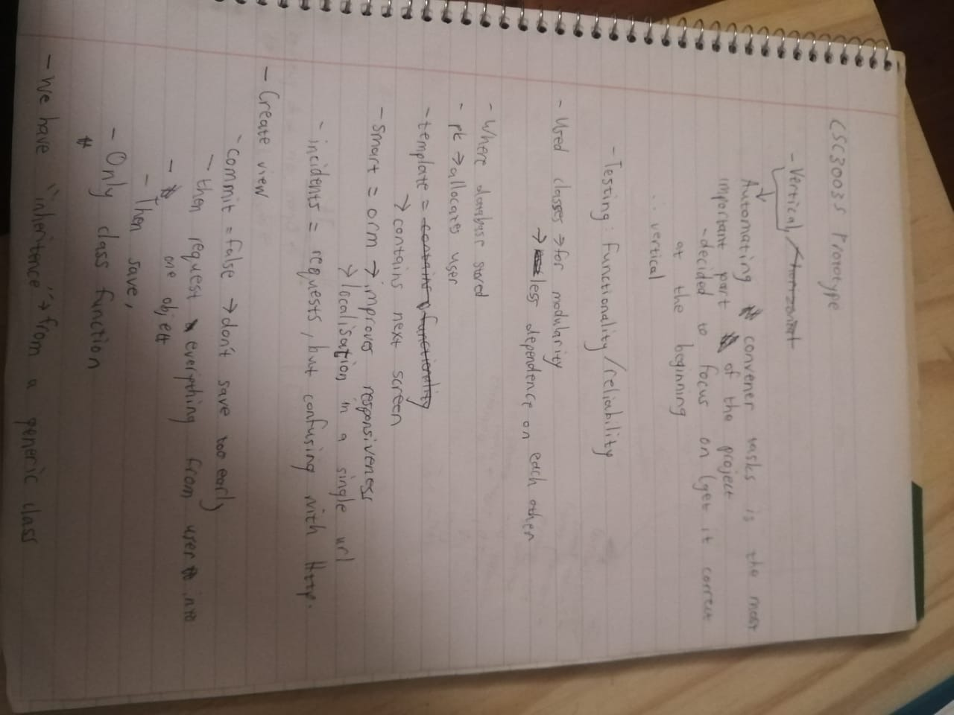

Above are the notes from the meeting this week where the project was designed. The coding was split up between the members in order to be successful in creating a baseline prototype where students can submit and view their queries and where course conveners can see queries and delete them.

We tested the prototype by making new student profiles, making sure that they could add and edit queries, as well as uploading files to the query, and also making sure that the convener could see the queries and delete them.

Furthermore, we have tested the functionality of our application to the expected functionality. The testing at this stage of the development was to test if the application is functional relating to the activity we decided to focus on, which is creation of user requests, the convener being able to view and edit requests, and for both the student and convener to delete a request made by the student.

1.2) Planned activities for the next Report Period

The next report period will take place from 22nd – 26th August. The planned activities are:

To continue designing the layout of the project so that it is easy to use and includes all the necessary use cases.

Add the ability for the convener to see which students are struggling with their marks and/or haven’t handed an assessment in in order to further fulfill the automation of convener tasks.

1.3) Problems

There were no problems as we were able to fulfill our planned activities from the last report period. We are on schedule for the next report period.

1.4) Revised Schedule and Goals

We are still on schedule for the project and do not need to revise our goals as no major problems were found.