Experiment 7
Problem 1: We begin with a simulated example in which there truly are two clusters in the data: the first 25 observations have a mean shift relative to the next 25 observations. The data set can be generated using the following code:
x <- matrix(rnorm(50 * 2), ncol = 2)
x[1:25, 1] <- x[1:25, 1] + 3
x[1:25, 2] <- x[1:25, 2] – 4
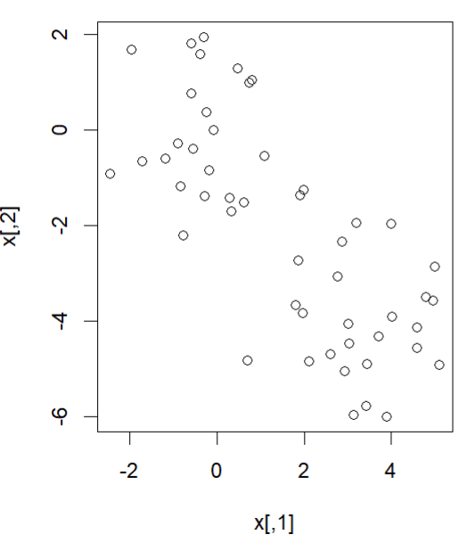
- Kmeans Method: Use help() to learn how to use kmeans function. Use Kmeans method split the data into 2 clusters, then plot the data, with each observation colored according to its cluster assignment. What about setting K=3? There is an input parameter nstart in kmeans(). If a value of nstart greater than one is used, then K-means clustering will be performed using multiple random assignments. When K=3, try to use nstart=1 and nstart=20 as the input parameter in kmeans(), then check the SSE for those two inputs.
- Hierarchical Clustering: Use help() to learn how to use hclust function. The input parameter ``method’’ controls the distance using in Hierarchical clustering. For example, ``complete’’ represents the Max distance, ``single’’ represents the Min distance, etc. We can plot the dendrograms obtained using the usual plot() function, e.g.
hc.complete =hclust(dist(x), method="complete ")
plot(hc.complete ,main="Complete Linkage ", xlab="", sub="", cex=.9)
Please draw the dendrograms with different distances: MAX, MIN, Average, and Centroid. To determine the cluster labels for each observation associated with a given cut of the dendrogram, we can use the cutree() function. Report the labels for the observations when using the MAX distance and K=2.
Problem 2: We consider the iris data set. It gives the measurements in centimeters of the variables sepal length and width and petal length and width, respectively, for 50 flowers from each of 3 species of iris. The species are Iris setosa, versicolor, and virginica. We treat the class label, namely, the species as unknown.
- Gaussian Mixture Model: Use the Mclust function in R package `` mclust’’. Cluster the data set into 2 and 3 clusters and draw the scatter plot with each observation colored according to its cluster assignment. Compare the results with Kmeans method.

