Northline Tire Distribution
Data Analytics — Internal Report
Prepared for: VP of Sales, Quebec Region
Prepared by: Data Analytics Team

Quebec Winter Tire Fulfillment Gap: Root-Cause Analysis

Executive Summary
Quebec sales reps reported losing garage customers ahead of the 2025 winter tire season, citing an inability to fulfill winter tire orders in time. This analysis confirms the complaint is accurate and quantifiable: Quebec's winter tire backorder rate is approximately 29%, four to seven times higher than every other region (4–8%). Unfulfilled winter tire demand in Quebec during the September–November peak represents approximately $124,169 in at-risk revenue across 738 short-shipped units and 87 affected orders — before accounting for any customers who left for a competitor rather than waiting on a backorder. The root cause is a severe seasonal inventory shortfall at the Montreal distribution centre, where winter tire stock on hand drops to roughly 1,200–1,300 units each August through November — the exact window when demand peaks ahead of Quebec's December 1 winter tire law — while every other region maintains stock in the 6,000–8,500 unit range through their equivalent season. This is a replenishment timing issue specific to Montreal, not a company-wide capacity constraint.

1. Background
Quebec's Highway Safety Code requires winter tires on passenger vehicles from December 1 to March 15. In practice, most customers buy well ahead of the deadline, so demand at Northline concentrates in September through November and typically peaks in October. Reps in the Quebec region flagged that garage customers were being told orders could not be fulfilled in time and were switching to competitors before the season started.

2. Is It Happening? Confirming the Complaint
Order-level data for 2024–2025 confirms a real and recurring pattern. Isolating winter tire orders specifically (rather than all orders, which would understate the effect) shows:
Province | Winter Backordered | Winter Orders (Total) | Backorder Rate
AB | 11 | 255 | 4.3%
BC | 22 | 272 | 8.1%
NB | 13 | 228 | 5.7%
ON | 16 | 258 | 6.2%
QC | 70 | 242 | 29.0%

Quebec's winter tire order volume is in line with other regions (~240–270 orders/year each), which rules out order volume as an explanation. The gap is specific to fulfillment, not demand.

3. How Bad, and Where
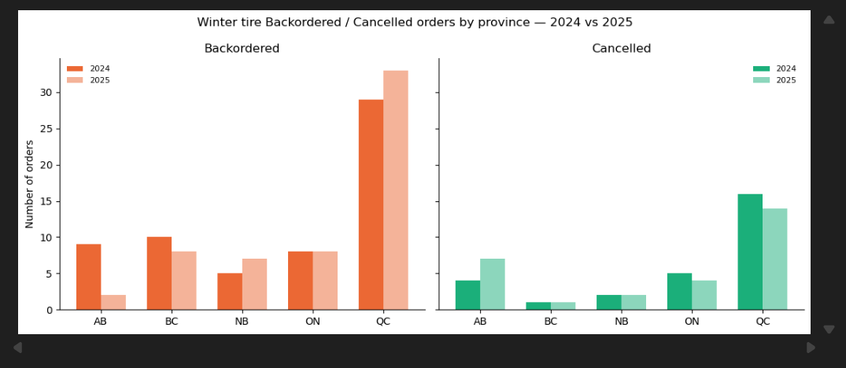
Figure 1. Winter tire backordered and cancelled orders by province, 2024 vs. 2025. Quebec is the clear outlier in both years.
The pattern is consistent across both 2024 and 2025, indicating a structural issue rather than a one-time disruption.

4. Quantified Impact
To move beyond order counts, unfulfilled quantity was priced out using each line item's unit price. Restricting to Quebec winter tire orders in the September–November window, the period both reps and the inventory data point to as the core problem:
At-Risk Revenue | Units Short | Affected Orders | Window
$124,168.80 | 738 | 87 | Sep–Nov, QC winter tires

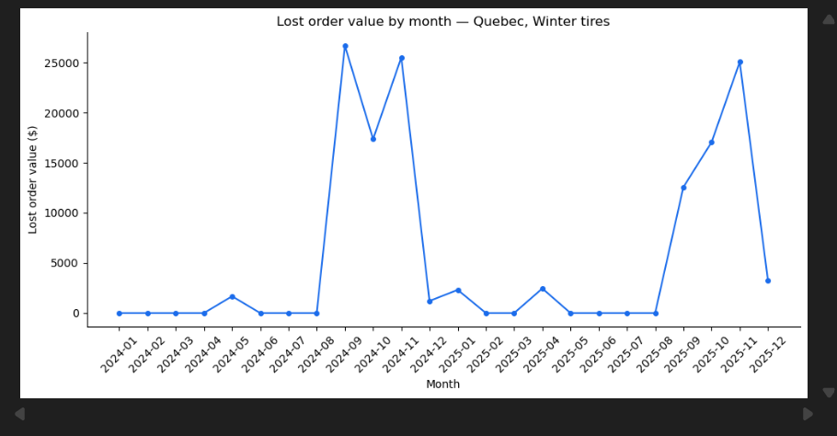
Figure 2. At-risk revenue by month, Quebec winter tires, Jan 2024–Dec 2025. The pattern repeats in both years and is concentrated almost entirely in September–November.
August and December together account for under 4% of the two-year total and were excluded from the headline figure to keep it scoped to the window both the complaint and the inventory data implicate. This $124,169 figure is a floor, not a ceiling: it only captures orders that were placed and partially unfulfilled. It does not capture demand that never became an order because a customer went straight to a competitor — the scenario reps originally described.

5. Root Cause: Inventory Timing at the Montreal DC
Comparing monthly winter tire inventory on hand across all five distribution centres isolates the mechanism:
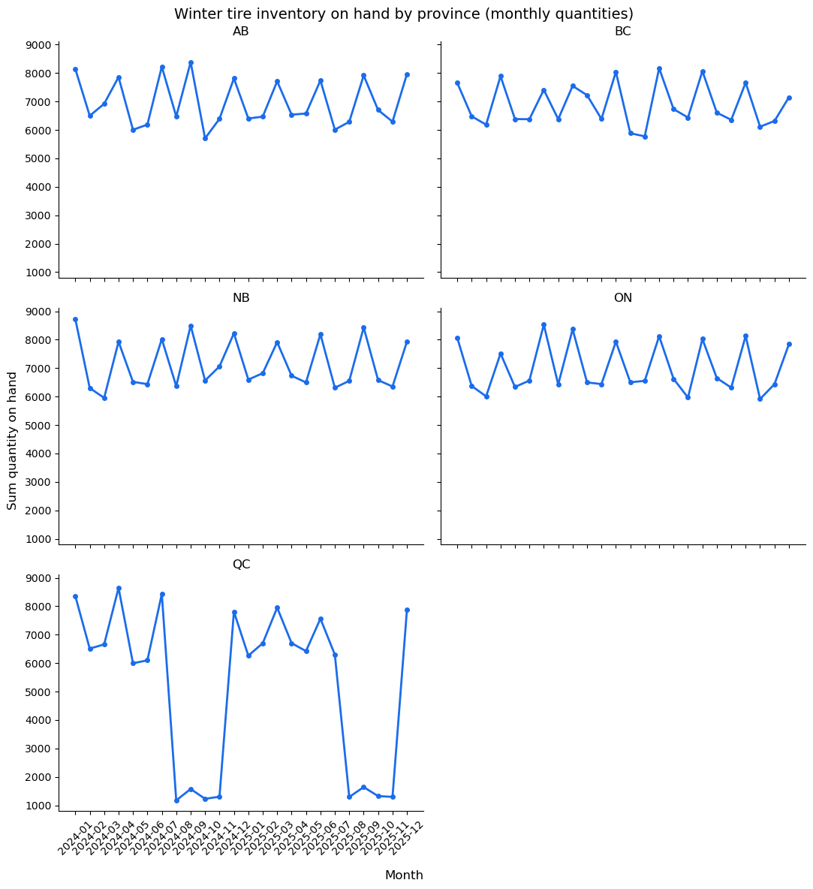
Figure 3. Winter tire inventory on hand by province, monthly. Alberta, BC, New Brunswick, and Ontario fluctuate mildly year-round. Quebec is the only region that collapses to roughly 1,200–1,300 units for four consecutive months, both years.
Montreal's winter tire stock falls sharply every August and does not recover until December — after the peak buying window has already passed. Every other distribution centre maintains substantially higher stock (6,000–8,500 units) through their own equivalent season. This timing mismatch between low inventory and peak demand is the direct driver of Quebec's elevated backorder rate.

6. Recommendations
- Shift Montreal's winter tire replenishment schedule earlier, targeting stock builds in June–July so inventory is at peak levels before the September demand ramp, matching the pattern already used successfully at the other four DCs.
- Set a Montreal-specific, season-aware reorder point for winter tire SKUs rather than a flat year-round threshold, given how sharply demand concentrates in Q3–Q4.
- Add a pre-season inventory check (e.g., August 1) as a standing checkpoint, flagging any winter tire SKU below target stock with enough lead time to reorder before the September–November rush.
- Track backorder rate and at-risk revenue by region and tire type as an ongoing metric, not just after complaints surface, so a recurrence would be caught before it affects customers.

7. Limitations & Alternative Explanations
Other explanations considered, and why they were ruled out:
- Could Quebec simply have more orders overall, making the backorder count look worse by volume alone? No — Quebec's total order count is roughly in line with every other province, so this is not a volume effect.
- Could this be normal seasonal inventory drawdown that happens everywhere, with Quebec just looking worse by coincidence? No — every region dips somewhat before its own busy season, but only Montreal's dip is severe enough to fall to critically low stock; the other four regions never approach that magnitude.
What this data can show, and what it can't:
- The data shows unfulfilled orders — customers who placed an order and did not receive it in full. It cannot show demand that never became an order because a customer went straight to a competitor, which was the original complaint. The $124,169 figure is therefore a floor, not the full picture.
- The data shows where and when the shortfall happens (Montreal, August–November). It does not show why Montreal's replenishment schedule is lagging — that would require supply chain or procurement data (supplier lead times, forecasting method, budget allocation) not present in this dataset.
Other boundaries on this analysis:
- Two years of data (2024–2025) is enough to see the pattern repeat, but not enough to say whether it is worsening, improving, or has existed longer than that.
- Inventory is recorded weekly, not daily — a stockout that both starts and resolves within the same week would not be visible at this resolution.
- No cost data was available to weigh the recommendations against. This report identifies what the status quo is costing in lost fulfillment, but not what earlier replenishment would cost operationally.

8. Data & Methodology
Analysis covers order and inventory data from January 2024 through December 2025. Backorder rate is calculated as backordered winter tire orders divided by total winter tire orders per province. At-risk revenue is calculated as (quantity ordered − quantity fulfilled) × unit price, summed across affected line items. Inventory figures are drawn from weekly warehouse snapshots, aggregated to monthly totals. Full queries and analysis notebook available in the accompanying repository.

