Underestimated benefits from refuge habitats on benthic macroinvertebrate communities

Moritz Link

Ralf Schaefer

Verena Schreiner

more to follow

June 05, 2021

Study on pesticides and other agricultural stressors in Central Romania affecting benthic macroinvertebrates. Sampling sites selected to represent catchments with a wide range of agricultural intensity and little urban and industrial activities. We find no correlation between maximum TU and SPEARpesticides, but can show that upstream refuge habitats positively affect SPEARpesticides-values and mask effects from pesticides. Something about aquatic leaf decomposition here and on parasite prevalence in *Gammarids* and *Baetis*.

# 1 Introduction

* Prevalence of small streams, importance for biodiversity and ecosystems, their spacial proximity to agricultural land use and the problem of pesticides entering non-areas.
* SPEARpesticides as empirically validated concept to detect pesticide contamination in streams.
* RDA to identify further environmental drivers affecting the benthic macroinvertebrate community.
* Ecosystem services like leaf litter decomposition are also important
* Ecology showed that parasite-host-interactions can be very susceptible to changes in environmental conditions. When the infected host cannot reproduce because the combined effect of parasite stress and environmental stress, parasite-infected hosts vanish from the population. We therefore analysed two taxa (*Gammarus balcanicus* and *Baetis sp.*) for parasites common in Arthropods (Microsporidia, Nematoda, Trematoda)

# 2 Materials and Methods

## 2.1 Study area, sampling site selection

The study area was located in Transylvania, north-west Romania around the city of Cluj-Napoca. The landscape in this rural study area is characterized by undulating terrain with hills reaching heights of several hundred meters (Fischer et al., 2012). At 19 small wadeable streams (3rd to 4th Strahler order, (Strahler, 1957)) a 100 m stream section was selected, respectively. The surrounding land use at all selected sampling sites was dominated by agriculture. No large urban settlements, industrial sites as well as municipal or industrial waste water treatment plants were located in the catchments upstream of the sampling sites to minimize effects of non-agricultural pesticide use and waste water.

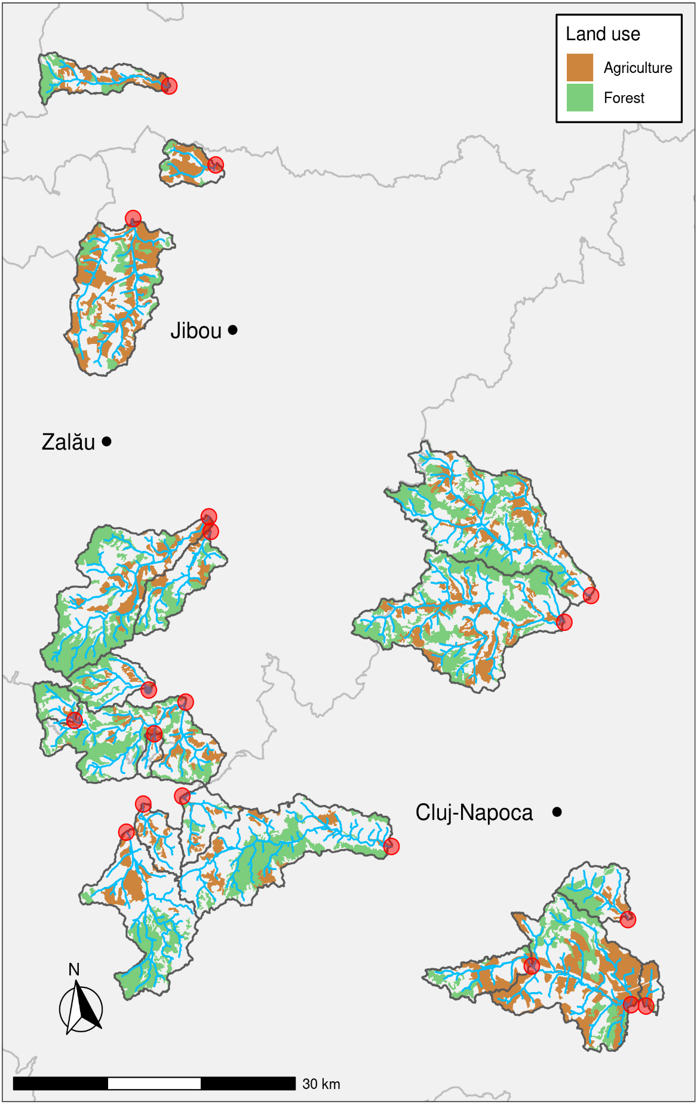

Figure 1: Upstream catchments, respective streams and land use of the sampling sites, indicated by red circles.

## 2.2 Spatial analysis of catchments and land use types

The upstream catchments for the respective sampling sites and a stream network were derived using the free open-source software R, version 4.0.5, (R Core Team, 2021) and the R-package openSTARS (Kattwinkel and Szöcs, 2020) from the European digital elevation model with a cell size of 1000 m (EEA, 2004), cropped to the study area of north-west Romania. By intersecting the derived catchments with the Corine Land Cover data (Programme, 2020) land use types and respective proportions could be identified for each catchment. We aggregated relevant land use types into three groups named agriculture (representing “non-irrigated arable land”), pastures (representing “pastures” and “land principally occupied by agriculture”), and forest (representing “broad-leafed forest,” “coniferous forest” and “mixed forest”) and added up the respective proportions. Finally, catchments were checked for the presence of forested stream sections upstream of the sampling sites acting as a refuge habitats for sensitive macroinvertebrates. In order to be classified as an upstream refuge habitat, the forested stream sections had to be at least 500 m long, with the forest patch reaching a minimum width of 100 m at both sides of the stream, with a distance less than 10 km upstream of the respective sampling site (Bailey, 1966; Elliott, 1971; Knillmann et al., 2018; Orlinskiy et al., 2015). The upstream catchments of selected sampling sites differ between sizes from 7.5 km2 to 176.8 km2 with a mean size of 73.9 km2. Agricultural land use covered between 6.8 % and 61.4 % of the catchment areas (mean = 25.2 %) and was mostly located in plain areas along the main streams and its larger tributaries. Pastures covered mainly areas with a steeper slope or greater elevation compared to the agricultural areas, with cover reaching from 3.9 % to 70.1 % (mean = 34.9 %). In most catchments, forests were located along their boarders, making up between 2.9 % and 50.7 % of the catchment area (mean = 25.2 %), surrounding the sources of the main stream and its tributaries, which also marked landscapes with the greatest slopes and elevation (Figure 2.1) (Fischer et al., 2012). Land use classification in the CLC-2018 data gives no indication on the degree of mechanization of agricultural practices (e.g. human/animal labour or technical equipment). Furthermore, a previous study found no correlation between agricultural intensity (degree of mechanization and size of average field size) and maximum sumTUinvertebrates (Schreiner et al., 2021). Consequently and for reasons of simplicity, we considered only land use variables based on categories provided by the CLC-2018 data for our analysis.

## 2.3 Macroinvertebrate sampling, identification, and community metrics

Benthic macroinvertebrates were sampled in late April and June, 2016. In the selected 100 m long stream sections four sub samples were taken, spanning a total distance of 75 m. Positions for the sub samples were selected in order to represent the proportional share of the occurring substrate types. A surber-sampler measuring 30 cm in width and height (0.5 mm mesh size) was used for collecting macroinvertebrates via standardized kick-sampling procedure. Macroinvertebrates were separated from sediment and debris in the field and directly stored in 95 % ethanol for later identification in the laboratory. Identification was done using respective identification keys to the highest possible taxonomic level. We derived biological indicator metrics from the macroinvertebrates communities, like proportion of Ephemeroptera, Plecoptera, and Trichoptera (% EPT, (Lenat, 1988)), and Shannon taxa diversity (SWD, (Shannon, 1948)), which respond unspecificallly to environmental stressors. Additionally, we calculated Saprobic index as a metric responding to oxygen deficiency [noauthor_din_nodate], and SPEARpesticides related to the toxic pressure of pesticides on the invertebrate community (Liess and Ohe, 2005). SPEARpesticides was specifically developed to detect pesticide driven changes in the macroinvertebrate community and showed a high and often exclusive relationship to pesticide toxicity in several studies (Knillmann et al., 2018; Liess et al., 2021; Liess and Ohe, 2005; Orlinskiy et al., 2015; Schäfer et al., 2007). We focused on the sampling data from June, since this coincides with the main pesticide applications period in Central Europe and therefore identification of effects on the macroinvertebrates is most likely here. In addition, we modeled the changes in SPEARpesticides as dependent variable and the environmental parameters as predictors from April to June. The change in pesticide pressure was calculated by subtracting the sumTUinvertebrates-values of the earliest event sampling from the maximum sumTUinvertebratesvalues. Again we used an elastic net approach, to identify relevant driver variables for the change in SPEARpesticide-values.

## 2.4 Shredder community and leaf litter breakdown

*Alnus glutinosa* (L.) Gaertn. (black alder) is common in the riparian zone of temperate Europe (Hewitt, 1999) as well as in the study area, and served as model species in many leaf decomposition studies (Englert et al., 2013; Fernández et al., 2016; Lima-Fernandes et al., 2019; Rossi et al., 2019). Leaves were collected directly from branches shortly before defoliation in October 2015 at a site close to Landau, Germany (49.201944 °N, 8.143611 °E). For logistic reasons concerning preparation and lack of an established site for collecting leaf material in the study area, we used used leaf material from Germany. After collection, leaves were stored at -20 °C until further use. In a first step during preparation for the decomposition study, leaves were dried at 60 °C and pre-weighed to 2 $±$ 0.02 g. Prior to placing the leaves in mesh bags (10 mm mesh size), leaves were re-soaked in tap water. At the end of May 2016 triplicates were placed at three different positions at each sampling site and remained in the streams for 27 to 29 days. Upon retrieval, the mesh bags were gentley rinsed to remove macroinvertebrates and sediment from the remaining leave litter, placed on ice and transported to the lab, where they were stored at -20 °C until further analysis. To determine leaf litter decomposition, remaining leaf litter was freeze-dried and weighed to the nearest of 0.01 mg. The leaf decomposition rate *ki* for each sampling site *i* was calculated as:

$$k_{i}=\frac{-ln(\frac{S_{i}(d)}{S_{i}(0)})}{d}$$

where *Si(d)* is the remaining leaf litter, *Si(0)* is the leaf mass at the start of the experiment, and *d* is the number of days the leaf bags were placed in the stream. Macroinvertebrates like *Gammarus spec.* and several taxa of the order Trichoptera are members of shre shredder guild, faciliating leaf litter degradation in streams (Graça, 2001). We identified shredder taxa by their feeding traits using the freshwaterecology.info-database (Schmidt-Kloiber and Hering, 2015), the shredder community at all sampling sites was dominated by *Gammarus balcanincus*, which was also the only gammarid species at all sites. We measured body weight of all (n < 100), or a subset of gammarid individuals (n > 100) and calculated the average body weight per sampling site. We modeled average body weight, log(x+1)-transformed gammarid abundances, and leaf litter decomposition *k* as dependent variables as generalized linear models with an elastic net approach to identify relevant environmental drivers.

## 2.5 Parasite prevalence

Individuals of *Gammarus balcanicus* and *Baetis sp.* sampled in June from 12 and 13 sampling sites were checked for parasite infestation with Microsporidia, Nematoda and Trematoda in the laboratory. For both invertebrate species checked, Microsporidia showed the highest prevalences, with Nematoda and Trematoda being less frequent. We calculated the average prevalence of parasites *ap_i* where *i* is either *Gammarus balcanicus* or *Baetis sp.*:

$$ap_{i}=\frac{\sum_{j=1}^{n}{p}revalence_{j}}{3}$$

where *j* represents the three parasite types.

## 2.6 Habitat sampling (environmental parameters, riparian vegetation)

We measured environmental parameters parallel to the macroinvertebrate sampling in April and June as well as at the installation and collection of the passive samplers. Abiotic parameters included water temperature, oxygen saturation, pH and electrical conductivity using a Multi 340i multi-parameter device from WTW Germany. Water concentrations of common nutrients like nitrate (NO3-), nitrite (NH2-), ammonium (NH4-), orto-phosphate (PO42-), as well as chloride (Cl-) were measured on site with a Nanocolor PF-12plus by Macherey-Nagel, Germany. Habitat characteristics like riparian vegetation type and height, width of buffer strips, shading provided by the riparian vegetation, average width, depth and flow velocity were recorded once in April and once in June.

## 2.7 Pesticide sampling and analysis

Pesticide sampling was done with two types of passive samplers, facilitating short term passive sampling, focused on peak concentrations of pesticides, as well as long term passive sampling. Pesticide concentrations peak during or shortly after precipitation events causing surface run-off from agricultural areas into streams, but drop off rather quickly again (Kreuger, 1998; Stehle et al., 2013). For these short term sampling periods Empore styrene divinylbenzene reverse phase sulfonate (SDB) disks from 3M Company were used, featuring high uptake rates and suitability for hydrophilic compounds (Vrana et al., 2006). Three precipitation events and one additional sampling period representing pesticide concentrations at base flow were captured (Schreiner et al., 2021). Shortly before a forecasted rain event with sufficient precipitation of at least 10mm day-1 (Refernce to Norwegian weather service) the SDB disks were mounted to stainless steel holders and deployed in the streams. Two replicates per sampling site were placed about 20 m apart, and retrieved after an exposure time of five to six days. The same criteria, except any precipitation, applied for the sampling at base flow conditions. After retrieval, SDB disks were stored at -20 °C in 6 mL of acetone (LC-grade) until further analysis. Long term passive sampling utilized polydimethylsiloxane sheets (PDMS, AlteSil, 0.5 mm thickness Altec) for sampling pesticides with high toxicity including pyrethroid and organophosphate insecticides. Higher toxicity results in lower amounts of active ingredient ha-1, consequently lower environmental concentrations require particularly low LOQs (Moschet et al., 2014a). The PDMS samplers (measuring 12.5 cm x 10 cm) were fixed to aluminum posts and deployed in the streams at two time points for four weeks each. At retrieval, the PDMS sampler were cleaned gently, rolled up and stored in glass vials at -20 °C until further analysis. For detailed information on preparation, conditioning, extraction, and analysis of the passive samplers, as well as calculation of water concentrations of pesticides see Schreiner et al. (2021).

## 2.8 Calculation of pesticide toxicity using toxic units

Toxicity and analyzed water concentrations can differ substantially for various pesticides, and the magnitude of effects on macroinvertebrates becomes difficult to distinguish. To assess potential, cumulative toxicity of the detected pesticides within one sample we used the logarithmic sum of toxic units (sumTU):

$$sumTU=log(∑\frac{c_{calc_{i}}}{EC_{{50}_{i}}})$$

where *ccalci~~* is the estimated concentration of pesticide *i* and *EC50i~~* is the concentration of pesticide *i* at which 50 % of test organisms are affected. Sensitivity of standard test organisms like *Daphnia magna* can differ from macroinvertebrates of other taxonomic classes (e.g. Plecoptera), with many of them showing greater susceptibility to pesticides (Wogram and Liess, 2001). We calculated sumTUs for most sensitive freshwater invertebrates (sumTU) to better capture pesticide pressure on the macroinvertebrate community. EC values for detected pesticides and freshwater invertebrates were compiled from Malaj et al. (2014), Lewis et al. (2016) and from US EPA Knowledgebase (EPA, n.d.) and checked for plausibility (water solubility, outliers). Only EC values for test duration of 48 h to 96 h were included, 53 pesticides were available for the analysis. Site specific sumTU were calculated by combining compounds from PDMS and SDB samplers deployed at the same time for each sampling side, respectively. We used the maximum sumTU of the four sampling events for each respective sampling site, assuming that environmental selection through the strongest stress event acts on the macroinvertebrate community (Fernández et al., 2015; Schäfer et al., 2011).

Table 2.1: Summary statistics for the environmental variables from April

|  |  |  |  |  |
| --- | --- | --- | --- | --- |
| Variable | Minimum | Maximum | Mean | SD |
| % agriculture | 0.068 | 0.614 | 0.262 | 0.179 |
| Cl mg/L | 1.000 | 44.997 | 14.421 | 11.457 |
| % fine sediment | 0.000 | 0.950 | 0.358 | 0.257 |
| flow velocity m/s | 0.037 | 0.903 | 0.388 | 0.184 |
| max sumTU inv. | -1.625 | -0.014 | -0.639 | 0.484 |
| % pastures | 0.039 | 0.708 | 0.350 | 0.154 |
| pH | 7.740 | 8.660 | 8.203 | 0.200 |
| ortho-phosphate mg/L | 0.200 | 0.800 | 0.305 | 0.154 |
| water tempereature °C | 7.900 | 17.300 | 12.889 | 2.974 |

Table 2.2: Summary statistics for the environmental variables from June

|  |  |  |  |  |
| --- | --- | --- | --- | --- |
| Variable | Minimum | Maximum | Mean | SD |
| % agriculture | 0.068 | 0.614 | 0.262 | 0.179 |
| Cl mg/L | 1.999 | 49.999 | 21.526 | 14.550 |
| % fine sediment | 0.000 | 0.900 | 0.316 | 0.259 |
| flow velocity m/s | 0.047 | 0.533 | 0.293 | 0.122 |
| max sumTUiv | -1.625 | -0.014 | -0.639 | 0.484 |
| % pastures | 0.039 | 0.708 | 0.350 | 0.154 |
| pH | 8.020 | 8.910 | 8.314 | 0.202 |
| ortho-phosphate mg/L | 0.200 | 1.000 | 0.553 | 0.227 |
| water tempereature °C | 17.330 | 27.900 | 21.981 | 2.776 |

## 2.9 Data analysis

All data preparation, calculation, and visualization was done with the statistical open-source software R, version 4.0.5, (R Core Team, 2021)) combined with packages including ggplot2 for graphical presentations (Wickham, 2016), and taxize (Chamberlain and Szöcs, 2013) for retrieval of taxonomic information. We provide all raw data and code under: Moritz’ Github for now.

### 2.9.1 Regression analysis

The derived macroinvertebrate metrics as well as Gammarid abundance, average body weight of *Gammarus balcanicus*, and leaf litter decomposition rate *k* where used as dependent variables in separate generalized linear models. The number of recorded environmental variables exceeded the sample size of observed streams. To avoid over-fitting of models, we selected a subset of variables, which have been correlated to pesticide contamination (Lemm and Feld, 2017; Szöcs et al., 2017) and changes in macroinvertebrate communities in previous studies (Rasmussen et al., 2012; Rasmussen et al., 2011). Leptokurtic vsriables (kurtosis > 9), where transformation did not improve the distribution (e.g. water concentrations of Nitrite-N and Ammonia-N), and variables that showed high multicollinearity based on correlation coefficients (*r* > 0.7), and variance inflation factors above 10 (Lin, 2008) were excluded from the analysis. The remaining variables are listed in Table 2.2, and represent stressors on the catchment scale (e.g. % agriculture, % pastures), as well as on the local scale, restricted to the proximity of the sampling sites (e.g. % fine sediment, flow velocity). Furthermore, the selected variables can be classified into two groups. The first group includes variables, which are assumed to be constant over the study period (e.g. % agriculture, and presence of refuge habitats), while variables from the second group vary with the time of their recording (e.g. water temperature, or flow velocity, pH). All selected predictor variables showed no relevant inter-correlation (pairwise r $≤$ 0.65 and variance inflation factors < 7). With regard to the low ratio of observations to predictor variables, we chose an elastic net regression approach with assumed Gaussian distribution (Zou and Hastie, 2005) from the glmnet package (Friedman et al., 2010) and the caret package (Kuhn, 2020) to implement the analysis in R. The caret package provides a wrapper function, which we used for parameter estimation of $α$ and $λ$ with “Leave-One-Out-Cross-Validation” (LOOCV). The number of observations for parasite prevalence in *Gammarus balcanicus* and *Baetis sp* were too low for a regression analysis and we calculated single Pearson’s correlations instead to investigate the the effects of our environmental predictors.

### 2.9.2 Redundancy analysis

We analyzed changes in the species composition of macroinvertebrate communities caused by environmental factors using Redundancy Analysis (RDA) (Oksanen et al., 2020) with species data. At first, we a RDA was performed for the data from the June-sampling. In addition, we pooled the species data and the environmental data from April and June and performed a partial RDA to partial out the effect of sampling time on the species composition. In both cases we aggregated the species data on family level do avoid effects of pseudo-species (or pseudo-diversity like *Caenis sp.* and *Caenis luctuosa*) and to reduce dimensionality, while still including higher order taxa like Oligochaeta. This resulted in 34 taxa the June-data and 49 taxa in the partial RDA over both timepoints. Model building was based on step wise selection in both directions, including environmental predictors with p-values < 0.1. The final model and its terms were tested for significance using ANOVA.

# 3 Results

## 3.1 Identified macroinvertebrates and measured toxicity

We identified 100 and 64 taxa in April and June, respectively. Along with fewer macroinvertebrate taxa, the total number of individuals decreased from 64,414 in April to 28,351 in June. Taxa like *Chironomidae Gen. sp.* and Oligochaeta were highly abundant at most sampling sites, whereas many other taxa occurred only at few sampling sites and in much smaller numbers. Maximum sumTUinvertebrates ranged from -1.625 at site R up to -0.014 at site T, comparable to areas with high intensity agriculture in central Europe (Moschet et al., 2014b; Pe’er et al., 2014; Rasmussen et al., 2013), showing high correlation with the decadic logarithm of agricultural area in km^2 (*r* = 0.73).

## 3.2 Macroinvertebrate metrics

The macroinvertebrate metric best explained by the set of environmental variables was the Saprobix index (Table 3.1), where pH and flow velocity were identified as the main drivers negatively affecting the metric (R2 = 0.106, regression coefficients = -0.022 and -0.001, respectively). In previous studies SPEARpesticides often showed exclusive negative correlation to pesticide pressure on macroinvertebrates (Knillmann et al., 2018; Liess and Ohe, 2005; Schäfer et al., 2007, liess_pesticides_2021). However, in our study the elastic net regression solely selected the presence of refuge habitats (variable “refugium”) as a relevant driver, reducing regression coefficients of all other variables to zero (R2 = 0.104, regression coeffiecient = 0.019). For both models a of 1 was selected, resulting in a LASSO-regression. The proportion of EPT as a measure for genera degradation (Lenat, 1988) was best explained by a model with an of 0.118, resulting in a fewer variables with regression coefficients shrunk to zero. Percent fine sediment, % agriculture, where the main drivers for this metric, with % fine sediment and % agriculture exhibinting a negative effect on the proportion of EPT. The elastic net model with Shannon diversity (SWD) as dependent variable showed the lowest R2 of all models (0.002), relevant predictor variables were % fine sediment and % pastures. See Table 3.1 and Table 3.2 for details.

Table 3.1: Model parameters of the fitted models

|  |  |  |  |  |  |
| --- | --- | --- | --- | --- | --- |
| Metric | alpha | lambda | RMSE | Rsquared | MAE |
| SWD | 0.284 | 0.428 | 0.523 | 0.002 | 0.446 |
| % EPT | 0.118 | 0.193 | 0.230 | 0.083 | 0.199 |
| Saprobic index | 1.000 | 0.093 | 0.232 | 0.106 | 0.152 |
| SPEAR | 1.000 | 0.024 | 0.062 | 0.104 | 0.051 |

Table 3.2: Regression coefficients of the environmental variables

|  |  |  |  |  |
| --- | --- | --- | --- | --- |
| Variable | SWD | Perecnt_EPT | Saprobic_index | SPEAR |
| (Intercept) | 0.000 | 0.000 | 0.000 | 0.000 |
| ph | 0.000 | 0.000 | -0.022 | 0.000 |
| po4 | 0.000 | 0.000 | 0.000 | 0.000 |
| water_temp | 0.000 | 0.033 | 0.000 | 0.000 |
| flow | 0.000 | 0.000 | -0.001 | 0.000 |
| max_sumtu_iv | 0.000 | 0.000 | 0.000 | 0.000 |
| fine_sed | -0.077 | -0.039 | 0.000 | 0.000 |
| pastures | 0.043 | 0.021 | 0.000 | 0.000 |
| agriculture | 0.000 | -0.027 | 0.000 | 0.000 |
| refugium | 0.000 | 0.021 | 0.000 | 0.019 |
| sqrt_cl | 0.000 | 0.000 | 0.000 | 0.000 |

For the change model pH was identified as the only relevant variable, affecting changes in SPEARpesticides (= 0.78, = 0.026, R2 = 0.013 and regression coefficient = 0.012).

## 3.3 Redundancy analysis of macroinvertebrate communities

To assess the relevance of pesticide pressure compared to other environmental variables for changes in the macroinvertebrate communities, we used redundancy analysis. The step wise model building for June-data included two constrained axes, explaining 18.7 % of variation. % agriculture and % pastures in the catchment were identified as the most important drivers. The overall model was significant (p = 0.007) and variables % agriculture and % pastures were significant with permutation test derived pseudo p values of 0.013 and 0.038, respectively. Asellidae along with Gastropoda were positively correlated with % agriculture, while families like Elmidae and Hydropsychidae showed correlation with % pastures (Figure @ref(fig:rda_fig)).

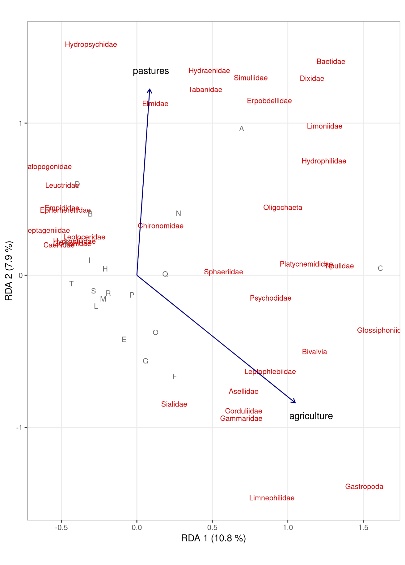

The time point of sampling explained 2.3 % of variation in the partial RDA. Water temperature, ortho-P concentration, flow velocity, and pH were identified by the step wise model selection as important drivers for the pooled data from April and June, explaining a total of 17.8 % of constrained variation (Figure 3.2). The first two RDA-axes explained 6.1 % and 4.8 % of variation respectively. The overall model was significant (p = 0.001) and variables water temperature, ortho-P concentration, and ph were significant with permutiation test derived pseudo p values of 0.001, 0.015, and 0.42, respectively. Flow velocity had a pseudo p-value of 0.052.

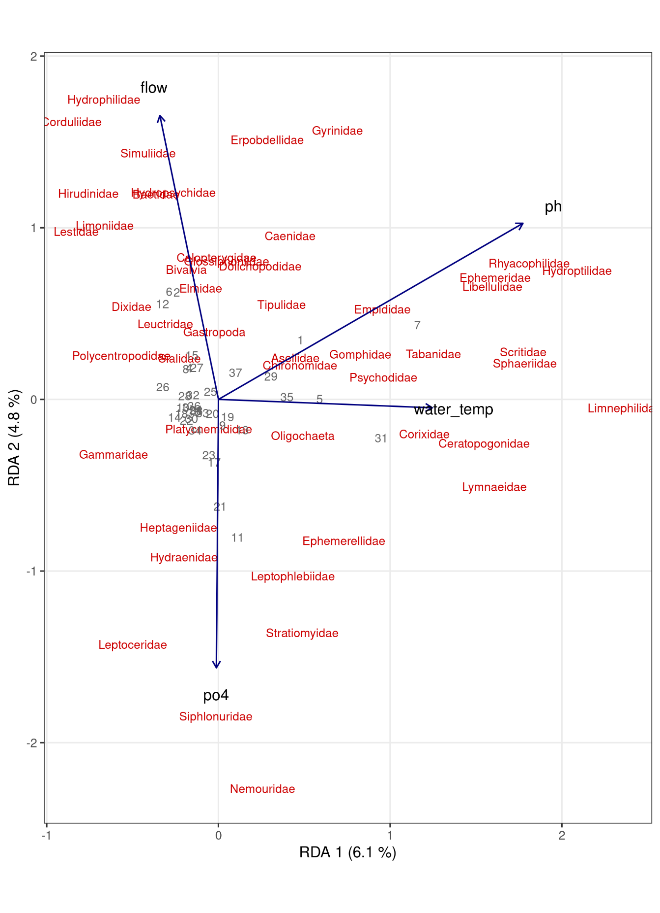

## 3.4 Shredder community and leaf litter degradation

Leaf litter decomposition rate *k* was manly driven by gammarid abundance (regression coefficiens = 0.097), followed by % pastures (regression coefficient = -0.065) and % agriculture (regression coefficient = -0.041), according to an elastic net model (= 1, lambda = 0.002, RMSE = 0.06, R2 = 0.566). Furthermore, maximum sumTUinvertebrates exhibited a negagive effect on k (regression coefficient = -0.023). All further regression coefficients were almost one order of magnitude smaller (See Table SI *non-existend ye*). No environmental drivers were selected by the elastic net models for average body weight of *Gammarus balcanicus* and gammarid abundance as dependent variables.

## 3.5 Parasite infestation in and

Microsporidia infested gammarids were found at all sites, with constantly high prevalance from 80 % up to 100 % in individuals. Nematoda and Trematoda were found at eight out of twelve sites, also with lower prevalence, not more than 50 % of sampled specimens infested (mean prevalence: 15 % and 16.7 %). Overall, parasite prevalence for all three parasite groups was lower in *Baetis sp.* compared to *Gammarus balcanicus*. At two sampling sites, *Baetis .sp* specimens were not infested with microsporidia and at maximum 80 % of sampled individuals carried the parasite (mean prevalence = 33.1 %). Trematod- and nematod-parasites were far less frequent in *Baetis sp.*. only 10 % of individuals at two sampling sites in total carried nematods, whereas trematods where found in *Baetis sp.* of four sampling sites (maximum prevalence = 60 %, mean prevalence = 8.5 %). The average prevalence over all three parasites in *Gammarus balcanicus* showed moderate positive correlateion to % pastures (*r* = 0.497, p = 0.1) and to the presence of refuge habitats (*r* = 0.413, p = 0.182), whereas % agriculture exhibited a moderate negative correlation (*r* = -0.472, p = 0.121). All other variables showed only minor correlation to average parasite prevalence in *Gammarus balcanicus* (all |*r*| < 0.34). In *Baetis sp.* the average parasite prevalece showed positive correlation to square root transformed chloride concentraiton (*r* = 0.524, p = 0.054) and negative correlation towards flow velocity (*r* = -0.505, p = 0.065). All other variables were only minor correlated (|*r*| < 0.4).

# 4 Discussion *Outline, not updated*

## 4.1 Macroinvertebrates, SPEARpesticides

* No clear effect of maximum sumTUinvertebrates on macroinvertebrates, SPEARpesticides showed no clear response to pesticide pressure.
* however very clear relation between agricultural area (km2) in catchment and maximum sumTUinvertebrates, irrespective of farming practices
* strong effect of presence of refugia on SPEARpesticides, effect was shown by Knillmann et al. (2018) before, but very pronounced in this study
* landscape of the study area might play an important role: see (Fischer et al., 2012) and fig 1 about landscape structure: Agriculture in the plain areas along the streams, pastures on the slope of the hills and large continuous forests around the springs of the streams. Likely very high recolonization potential and source effects outweigh sink effects. also reference to Lucas Streibs paper about costs of crossing different land use types. In this study area costs are probably low.
* RDA analysis also identify % pastures and % agriculture as relevant variables for the macroinvertebrate communities, supporting the importance of the landscape for mediating pesticide effects
* any indication on how frequent pesticide peaks occur in this region compared to other regions?

## 4.2 Shredder taxa and leaf litter degradation

* Gammarus as a rather robust macroinvertebrate becomes more frequent in numbers when % agriculture increases, and also gains in average body weight, likely because of less competition? Also catchments with refugia have lower numbers of gammarids on average, here competition with other macroinvertebrates might be higher. However, Gammarus is already the dominating shredder in this study, so what competition does he actually have?
  + Microbial leaf litter decomposition was positively correlated to phosphate concentrations, which was also shown by (Fernández et al., 2015). Also % pastures showed positive correlation to microbial leaf litter decomposition, indirectly showing effects of intensive agriculture.
* Why no relationships with invertebrate leaf litter degradation? Quality of the data (research project report from students indicate that coarse mesh bags were empty for at some sites)?

## 4.3 Parasites in Gammarids and Baetis

* We found Microsporidia infested Gammaridae at all sampling sites with high prevalence. Whereas *Baetis sp.* showed lower prevalence and two sampling sites without infested individuals. Might be explained by the difference in sensitivity of the two taxa, Gammarus being more robust. Still has energy resources to live with one and up to three types of parasites, where more sensitive taxa like *Baetis sp.* can not compensate pesticide stress and parasite stress, so one finds less individuals infested with parasites. This is supported by the moderare correlation of Microsporidia prevalance in *Baetis sp.* and phosphate concentrations, since studies have shown, that slight eutrophication increases productivity in stream ecosystems. Hosts have higher energy reserves and can survive and reproduce with the parasites.

# References

Bailey, R.G., 1966. Observations on the nature and importance of organic drift in a Devon River. Hydrobiologia 27, 353–367. <https://doi.org/10.1007/BF00042698>

Chamberlain, S.A., Szöcs, E., 2013. Taxize: Taxonomic search and retrieval in R. F1000Research 2, 191. <https://doi.org/10.12688/f1000research.2-191.v2>

EEA, 2004. Elevation map of Europe — European Environment Agency.

Elliott, J.M., 1971. The distances travelled by drifting invertebrates in a Lake District stream. Oecologia 6, 350–379. <https://doi.org/10.1007/BF00389109>

Englert, D., Zubrod, J.P., Schulz, R., Bundschuh, M., 2013. Effects of municipal wastewater on aquatic ecosystem structure and function in the receiving stream. Science of The Total Environment 454-455, 401–410. <https://doi.org/10.1016/j.scitotenv.2013.03.025>

EPA, U., n.d. ECOTOX Home. ECOTOX Knowledgebase.

Fernández, D., Tummala, M., Schreiner, V.C., Duarte, S., Pascoal, C., Winkelmann, C., Mewes, D., Muñoz, K., Schäfer, R.B., 2016. Does nutrient enrichment compensate fungicide effects on litter decomposition and decomposer communities in streams? Aquatic Toxicology 174, 169–178. <https://doi.org/10.1016/j.aquatox.2016.02.019>

Fernández, D., Voss, K., Bundschuh, M., Zubrod, J.P., Schäfer, R.B., 2015. Effects of fungicides on decomposer communities and litter decomposition in vineyard streams. Science of The Total Environment 533, 40–48. <https://doi.org/10.1016/j.scitotenv.2015.06.090>

Fischer, J., Hartel, T., Kuemmerle, T., 2012. Conservation policy in traditional farming landscapes: Conserving traditional farming landscapes. Conservation Letters 5, 167–175. <https://doi.org/10.1111/j.1755-263X.2012.00227.x>

Friedman, J., Hastie, T., Tibshirani, R., 2010. Regularization Paths for Generalized Linear Models via Coordinate Descent. Journal of Statistical Software 33. <https://doi.org/10.18637/jss.v033.i01>

Graça, M.A.S., 2001. The Role of Invertebrates on Leaf Litter Decomposition in Streams – a Review. International Review of Hydrobiology 86, 383–393. https://doi.org/[https://doi.org/10.1002/1522-2632(200107)86:4/5<383::AID-IROH383>3.0.CO;2-D](https://doi.org/10.1002/1522-2632(200107)86:4/5%3c383::AID-IROH383%3e3.0.CO;2-D)

Hewitt, G.M., 1999. Post-glacial re-colonization of European biota. Biological Journal of the Linnean Society 68, 87–112. <https://doi.org/10.1111/j.1095-8312.1999.tb01160.x>

Kattwinkel, M., Szöcs, E., 2020. openSTARS: An Open Source Implementation of the ’ArcGIS’ Toolbox ’STARS’.

Knillmann, S., Orlinskiy, P., Kaske, O., Foit, K., Liess, M., 2018. Indication of pesticide effects and recolonization in streams. Science of The Total Environment 630, 1619–1627. <https://doi.org/10.1016/j.scitotenv.2018.02.056>

Kreuger, J., 1998. Pesticides in stream water within an agricultural catchment in southern Sweden, 1990–1996. Science of The Total Environment 216, 227–251. <https://doi.org/10.1016/S0048-9697(98)00155-7>

Kuhn, M., 2020. Caret: Classification and Regression Training.

Lemm, J.U., Feld, C.K., 2017. Identification and interaction of multiple stressors in central European lowland rivers. Science of The Total Environment 603-604, 148–154. <https://doi.org/10.1016/j.scitotenv.2017.06.092>

Lenat, D.R., 1988. Water Quality Assessment of Streams Using a Qualitative Collection Method for Benthic Macroinvertebrates. Journal of the North American Benthological Society 7, 222–233. <https://doi.org/10.2307/1467422>

Lewis, K.A., Tzilivakis, J., Warner, D.J., Green, A., 2016. An international database for pesticide risk assessments and management. Human and Ecological Risk Assessment: An International Journal 22, 1050–1064. <https://doi.org/10.1080/10807039.2015.1133242>

Liess, M., Liebmann, L., Vormeier, P., Weisner, O., Altenburger, R., Borchardt, D., Brack, W., Chatzinotas, A., Escher, B., Foit, K., Gunold, R., Henz, S., Hitzfeld, K.L., Schmitt-Jansen, M., Kamjunke, N., Kaske, O., Knillmann, S., Krauss, M., Küster, E., Link, M., Lück, M., Möder, M., Müller, A., Paschke, A., Schäfer, R.B., Schneeweiss, A., Schreiner, V.C., Schulze, T., Schüürmann, G., Tümpling, W. von, Weitere, M., Wogram, J., Reemtsma, T., 2021. Pesticides are the dominant stressors for vulnerable insects in lowland streams. Water Research 117262. <https://doi.org/10.1016/j.watres.2021.117262>

Liess, M., Ohe, P.C.V.D., 2005. Analyzing effects of pesticides on invertebrate communities in streams. Environmental Toxicology and Chemistry 24, 954–965. <https://doi.org/10.1897/03-652.1>

Lima-Fernandes, E., Bundschuh, M., Bakanov, N., Englert, D., Schulz, R., Schäfer, R.B., 2019. Effects of a Systemic Pesticide Along an Aquatic Tri-Trophic Food Chain. Bulletin of Environmental Contamination and Toxicology 103, 507–514. <https://doi.org/10.1007/s00128-019-02696-w>

Lin, F.-J., 2008. Solving Multicollinearity in the Process of Fitting Regression Model Using the Nested Estimate Procedure. Quality & Quantity 42, 417–426. <https://doi.org/10.1007/s11135-006-9055-1>

Malaj, E., Ohe, P.C. von der, Grote, M., Kühne, R., Mondy, C.P., Usseglio-Polatera, P., Brack, W., Schäfer, R.B., 2014. Organic chemicals jeopardize the health of freshwater ecosystems on the continental scale. Proceedings of the National Academy of Sciences 111, 9549–9554. <https://doi.org/10.1073/pnas.1321082111>

Moschet, C., Vermeirssen, E.L.M., Seiz, R., Pfefferli, H., Hollender, J., 2014a. Picogram per liter detections of pyrethroids and organophosphates in surface waters using passive sampling. Water Research 66, 411–422. <https://doi.org/10.1016/j.watres.2014.08.032>

Moschet, C., Wittmer, I., Simovic, J., Junghans, M., Piazzoli, A., Singer, H., Stamm, C., Leu, C., Hollender, J., 2014b. How a Complete Pesticide Screening Changes the Assessment of Surface Water Quality. Environmental Science & Technology 48, 5423–5432. <https://doi.org/10.1021/es500371t>

Oksanen, J., Blanchet, F.G., Friendly, M., Kindt, R., Legendre, P., McGlinn, D., Minchin, P.R., O’Hara, R.B., Simpson, G.L., Solymos, P., Stevens, M.H.H., Szoecs, E., Wagner, H., 2020. Vegan: Community Ecology Package.

Orlinskiy, P., Münze, R., Beketov, M., Gunold, R., Paschke, A., Knillmann, S., Liess, M., 2015. Forested headwaters mitigate pesticide effects on macroinvertebrate communities in streams: Mechanisms and quantification. Science of The Total Environment 524-525, 115–123. <https://doi.org/10.1016/j.scitotenv.2015.03.143>

Pe’er, G., Dicks, L.V., Visconti, P., Arlettaz, R., Baldi, A., Benton, T.G., Collins, S., Dieterich, M., Gregory, R.D., Hartig, F., Henle, K., Hobson, P.R., Kleijn, D., Neumann, R.K., Robijns, T., Schmidt, J., Shwartz, A., Sutherland, W.J., Turbe, A., Wulf, F., Scott, A.V., 2014. EU agricultural reform fails on biodiversity. Science 344, 1090–1092. <https://doi.org/10.1126/science.1253425>

Programme, C., 2020. CLC 2018 — Copernicus Land Monitoring Service.

R Core Team, 2021. R: A Language and Environment for Statistical Computing. R Foundation for Statistical Computing, Vienna, Austria.

Rasmussen, J.J., Baattrup-Pedersen, A., Larsen, S.E., Kronvang, B., 2011. Local physical habitat quality cloud the effect of predicted pesticide runoff from agricultural land in Danish streams. Journal of Environmental Monitoring 13, 943. <https://doi.org/10.1039/c0em00745e>

Rasmussen, J.J., McKnight, U.S., Loinaz, M.C., Thomsen, N.I., Olsson, M.E., Bjerg, P.L., Binning, P.J., Kronvang, B., 2013. A catchment scale evaluation of multiple stressor effects in headwater streams. Science of The Total Environment 442, 420–431. <https://doi.org/10.1016/j.scitotenv.2012.10.076>

Rasmussen, J.J., Wiberg-Larsen, P., Baattrup-Pedersen, A., Monberg, R.J., Kronvang, B., 2012. Impacts of pesticides and natural stressors on leaf litter decomposition in agricultural streams. Science of The Total Environment 416, 148–155. <https://doi.org/10.1016/j.scitotenv.2011.11.057>

Rossi, F., Mallet, C., Portelli, C., Donnadieu, F., Bonnemoy, F., Artigas, J., 2019. Stimulation or inhibition: Leaf microbial decomposition in streams subjected to complex chemical contamination. Science of The Total Environment 648, 1371–1383. <https://doi.org/10.1016/j.scitotenv.2018.08.197>

Schäfer, R.B., Caquet, T., Siimes, K., Mueller, R., Lagadic, L., Liess, M., 2007. Effects of pesticides on community structure and ecosystem functions in agricultural streams of three biogeographical regions in Europe. Science of The Total Environment 382, 272–285. <https://doi.org/10.1016/j.scitotenv.2007.04.040>

Schäfer, R.B., Ohe, P.C. von der, Kühne, R., Schüürmann, G., Liess, M., 2011. Occurrence and Toxicity of 331 Organic Pollutants in Large Rivers of North Germany over a Decade (1994 to 2004). Environmental Science & Technology 45, 6167–6174. <https://doi.org/10.1021/es2013006>

Schmidt-Kloiber, A., Hering, D., 2015. Www.freshwaterecology.info – An online tool that unifies, standardises and codifies more than 20,000 European freshwater organisms and their ecological preferences. Ecological Indicators 53, 271–282. <https://doi.org/10.1016/j.ecolind.2015.02.007>

Schreiner, V.C., Link, M., Kunz, S., Szöcs, E., Scharmüller, A., Vogler, B., Beck, B., Battes, K.P., Cimpean, M., Singer, H.P., Hollender, J., Schäfer, R.B., 2021. Paradise lost? Pesticide pollution in a European region with considerable amount of traditional agriculture. Water Research 188, 116528. <https://doi.org/10.1016/j.watres.2020.116528>

Shannon, C.E., 1948. A Mathematical Theory of Communication. Bell System Technical Journal 27, 379–423. <https://doi.org/10.1002/j.1538-7305.1948.tb01338.x>

Stehle, S., Knäbel, A., Schulz, R., 2013. Probabilistic risk assessment of insecticide concentrations in agricultural surface waters: A critical appraisal. Environmental Monitoring and Assessment 185, 6295–6310. <https://doi.org/10.1007/s10661-012-3026-x>

Strahler, A.N., 1957. Quantitative analysis of watershed geomorphology. Eos, Transactions American Geophysical Union 38, 913–920.

Szöcs, E., Brinke, M., Karaoglan, B., Schäfer, R.B., 2017. Large Scale Risks from Agricultural Pesticides in Small Streams. Environmental Science & Technology 51, 7378–7385. <https://doi.org/10.1021/acs.est.7b00933>

Vrana, B., Mills, G.A., Dominiak, E., Greenwood, R., 2006. Calibration of the Chemcatcher passive sampler for the monitoring of priority organic pollutants in water. Environmental Pollution 142, 333–343. <https://doi.org/10.1016/j.envpol.2005.10.033>

Wickham, H., 2016. ggplot2: Elegant Graphics for Data Analysis. Springer-Verlag New York.

Wogram, J., Liess, M., 2001. Rank Ordering of Macroinvertebrate Species Sensitivityto Toxic Compounds by Comparison with That of Daphnia magna. Bulletin of Environmental Contamination and Toxicology 67, 360–367. <https://doi.org/10.1007/s001280133>

Zou, H., Hastie, T., 2005. Regularization and variable selection via the elastic net. Journal of the Royal Statistical Society: Series B (Statistical Methodology) 67, 301–320. <https://doi.org/10.1111/j.1467-9868.2005.00503.x>