

**Project and laboratories on communication systems**

**Final Project Report**

Master degree in Electronics Engineering

Master degree in Computer Engineering

Referents: Prof. Guido Albertengo

Authors:

* Mora Andrea
* Nunnari Antonio
* Zaccaria Salvatore

July 12, 2018

**1 Introduction**

The problem with this project was to go to make measurements with various sensors.

Imagining that our FEZ was used in agriculture. So using the temperature, light and humidity sensors (air and ground) we designed an FEZ that takes and sends the various data.

Can these data be analyzed? Of course, yes. Because our data are sent to the AMAZON cloud and, through a site made by us, viewable.

The site has a map where there are various FEZ and selecting one of these on the side there are the various sensors used by the specific FEZ and clicking on the desired sensor is made a chart with the measures taken.

**2 Fez Spider II**

2.1 Summary

Fez Spider II supports the .NET Micro Framework, so the code is developed in C# through the IDE Visual Studio 2013.  
A web interface is available to view the measurements.

2.2 DHT 11  
DHT 11 is a temperature and humidity sensor. This sensor gave us initial problems in fact he did not read any measures.   
The main problem was that it had a communication protocol too fast for the schedule times then he communicated onewire on one thread has in and out, so we had to put two pins on the breakout in tristate. After that we had to do an ad hoc class for manage protocol.

2.3 WI FI   
The wifi module is used to connect the FEZ to the internet. The broker that receives from the FEZ all JSONs containing the measurements is also connected to the same network. Then these json will go to the cloud.

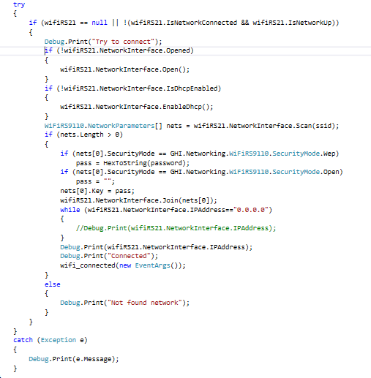

Every two minutes, when we send the data, we check the connection. If the FEZ is not connected, try to reconnect.  
FEZ sends data if the events of the connection to the wifi and the connection to the broker have been triggered

2.4 OTHER SENSORS  
In addition to the above mentioned there are other sensors:

* ground moisture
* brightness.

**3 Storage FEZ**   
The measurements are put into the SD card that contains the database. Every 7 minutes you have a database backup in order not to lose data in case there is a malfunction of the main database.

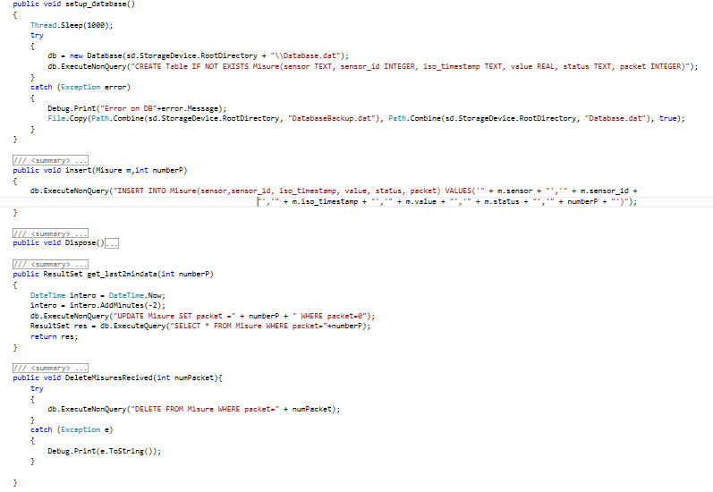

When we receive the ack from the broker coming from amazon, we delete the database entries related to that package.

**4 Broker**

You connect to the internet and every 3 seconds it broadcasts its ip and also connects to amazon. When the FEZ receives the IP and connects to the broker, the broker waits for the data arriving with the MQTT protocol.

When it receives the data it forwards them to amazon with MQTT TLS 1.2 protocol.

When amazon has received the data it sends the ack to the broker that forwards it to the FEZ.

If the broker does not receive an ACK from amazon he does not tell the FEZ to delete the data.

**5 Web site**  
When opened the map appears with the FEZ available on AWS (bucket). Selecting an FEZ to the left of the screen will make those that are not present in the FEZ opaque. For each sensor we select, the measurement graph is shown