**Project Title:**

***Bitcoin Price Movement Analysis (2024–2025)***

**1. Objective:**

The goal of this project is to perform a detailed analysis of the daily price fluctuations and trading behavior of Bitcoin during the years 2024 and 2025. Using Microsoft Excel, the raw data was cleaned, processed, and enhanced by calculating important financial metrics such as daily return percentage and volatility percentage. The cleaned dataset was then imported into Power BI to build an interactive dashboard that allows users to explore market trends, observe bullish and bearish movements, identify spikes in trading volume, and uncover hidden correlations through visual analytics.

**2. Dataset Preparation in Excel:**

The original dataset, named bitcoin_2024_2025.csv, contains historical Bitcoin trading data including:

* Date
* Open Price
* Close Price
* High Price
* Low Price
* Volume

**Data Cleaning and Enrichment:**

The data was processed in Excel with the following steps:

* **Calculated Columns Added:**
  + Daily Return %: This shows the percentage change in price from the open to the close.
    - Formula: =(Close - Open) / Open * 100
  + Volatility %: This measures the intraday price movement.
    - Formula: =(High - Low) / Open * 100
  + Trend: Categorized as "Bullish" if return > 0, "Bearish" otherwise.
  + Volume Spike Flag: Marked as "Spike" if the volume was unusually high compared to nearby days; otherwise "Normal".

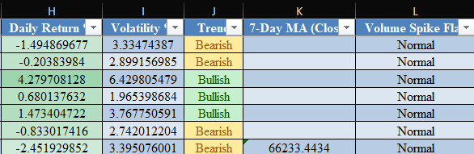

* **Formatting:**
  + Currency columns were formatted with comma separators.
  + Dates were converted to standard date format and duplicated to extract Year, Quarter, and Month.

**3. Pivot Table Summary:**

A Pivot Table was created in Excel to perform quick insights before moving to Power BI. This helped in validating the calculations and served as a reference point.

**Key Aggregations:**

* Average and Sum of Daily Return %
* Average and Sum of Volatility %
* Count of Bullish and Bearish trends
* Aggregated view by Year and Month

This summary helped in understanding seasonal patterns and yearly differences in trading behavior.

**4. Importing to Power BI:**

The enhanced Excel sheet was imported into Power BI Desktop for visual exploration and dashboard creation.

**Transformations & Preparations:**

* Date column was split into hierarchy: Year, Quarter, Month, Day.
* Numeric data types were ensured for financial calculations.
* DAX Measures and Calculated Columns were created where necessary to enhance interactivity and perform conditional aggregations.

**5. Dashboard Visualizations:**

The dashboard consists of the following major components that offer both summary and detailed views:

**Key Metric Cards:**

* **Highest Close Price**
* **Minimum Close Price**
* **Sum of Daily Return %**
* **Sum of Volatility %**
* **Total Spike Days**

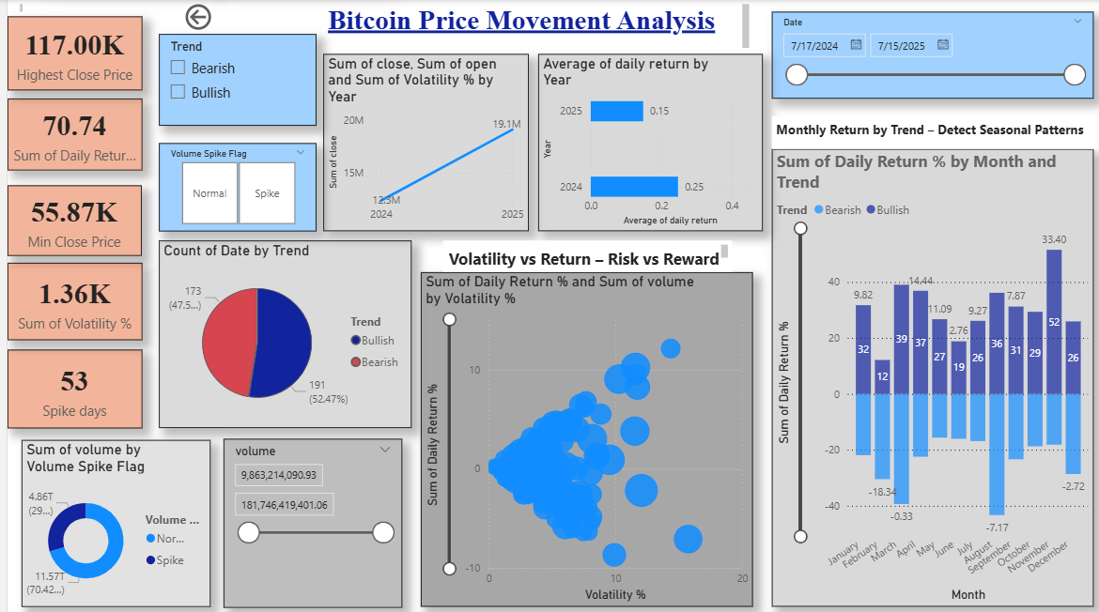

**Visuals:**

1. **Pie Chart**: Displays the count of Bullish vs Bearish days.
2. **2.Donut Chart**: Represents the sum of volume grouped by the Volume Spike Flag (Spike or Normal).
3. **Line Chart**: Shows the trend in closing prices over years to visualize long-term performance.
4. **Bar Chart**: Illustrates the average of daily return percentage across 2024 and 2025.
5. **Clustered Column Chart**: Depicts monthly return performance segmented by Trend (Bullish/Bearish).
6. **Scatter Chart**: Plots Daily Return % against Volatility % to find correlation and cluster behaviour.
7. **Slicers**: Date Range Slicer to filter by timeframe trend Slicer (Bullish/Bearish) Volume Spike Flag Slicer (Spike/Normal)

**6. Interactivity & Drill-through Pages:**

An interactive drill-through page was created to show detailed statistics for a selected point in the main report.

**Features:**

* Clicking a data point (e.g., specific date or month) opens a detailed view.
* The detailed page includes:
  + Date, Day, Month, Quarter, Year
  + Open, Close, Volume, Daily Return %, Volatility %, and Trend

Filters are applied at visual and report level for dynamic data exploration.

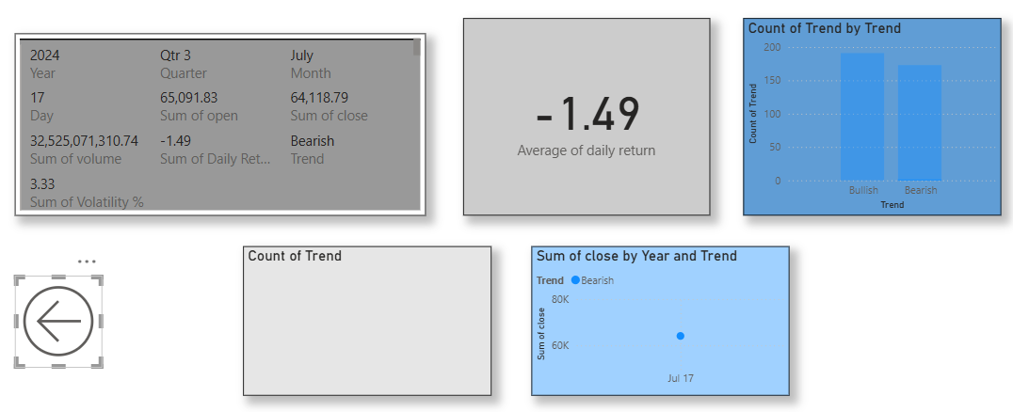

**7. Insights & Findings:**

* **Trend Distribution**: Bullish days slightly outnumber Bearish ones.
* **Return Patterns**: October and November show higher-than-average returns.
* **Volume Anomalies**: Many spike days coincide with increased volatility.
* **Volatility vs Return**: Scatter chart shows mild positive correlation, confirming higher volatility often brings stronger return fluctuations.

These insights allow traders and analysts to focus on periods of strategic opportunity and risk.

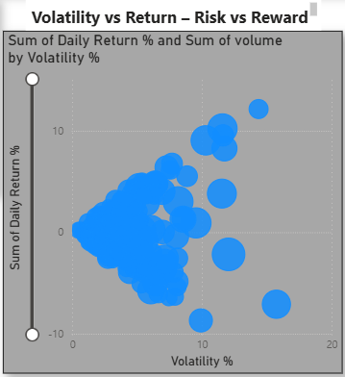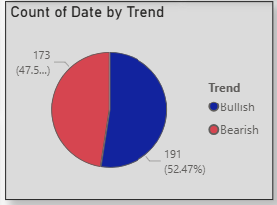

**8. Conclusion:**

This Bitcoin Price Movement Analysis dashboard offers a holistic view of price dynamics over two years. It combines statistical rigor with visual clarity. Through Excel preprocessing and Power BI visual analytics, meaningful trends were extracted. The project provides an excellent foundation for further financial forecasting, risk assessment, or strategy building.

The interactivity of the dashboard, alongside clearly defined KPIs and data breakdowns, makes it a strong tool for both analysts and non-technical audiences alike.