Report 01
  - Sensors, Embedded Systems and Algorithms for Service Robotics
1st Leonardo Carreras, S360909 and 2nd Morad Boumasdour, S364165

Abstract – Write a self-contained summary of 150–250 words (a single paragraph) that captures the entire project. Map your abstract directly to the four report sections by answering these core questions in sequence. What specific problem or robotics challenge does this work address? What key algorithmic approach and ROS 2 setup (nodes/interfaces) did you implement to solve it? How was the system tested (e.g., Gazebo simulation or physical robot), and what was the main quantitative or operational outcome? What is the primary takeaway or notable limitation of your solution?
As a rule of thumb, write the abstract last after completing the four main sections. Do not include code snippets, figures, citations, or undefined acronyms.

Objectives
The main objective of this laboratory is to design a Bump&Go controller to guide a TurtleBot3 through a path delimited by walls to reach a green target cube. To achieve this, the work is divided into two phases. In the first (Lab 02), the controller is developed and tested in a simulated environment using Gazebo, utilizing RViz 2 for sensor visualization.
In the second phase (Lab 03), the validated control logic code is adapted and transferred to a physical TurtleBot3. This requires handling the robot's bring up process and modifying the logic to deal with real-world hardware conditions, such as variable LiDAR scan sizes, to verify that the robot works properly outside the simulation.
Throughout both tasks, the exercises a aim is to consolidate practical experience with ROS2 concepts, such as nodes, topics, parameters, Quality of Services (QoS) and launch files.

Methods and Design
II.1 Controller Architecture
The Bump&Go controller designed to autonomously navigate a TurtleBot3 consists of a Python ROS2 node that handles the logic, a YAML file for tunable parameters, and a launch file to easily start the controller and environment.

II.2 Bump&Go logic
The robot's navigation relies on a finite state logic loop based on a Bump&Go strategy, (as illustrated in the flowchart Figure 1) consisting of two primary states: FORWARD and TURNING. The robot starts in a FORWARD motion state and maintains this behaviour until a wall is detected in front of it. For each LiDAR scan, the controller verifies if the path ahead is clear and publishes the corresponding forward motion commands.
Once an obstacle is detected within a predefined threshold, the robot stops and transitions into a TURNING state. It then evaluates the sensor data to determine the optimal turning direction, choosing the side (left or right) with the maximum available clearance. The controller commands a 90-degree rotation, counterclockwise for left rotation and clockwise for right rotation, and, upon completion, the robot automatically resumes its forward motion state. By continuously iterating this loop, the Bump&Go controller successfully navigates the robot through the wall-delimited path to reach the final destination.
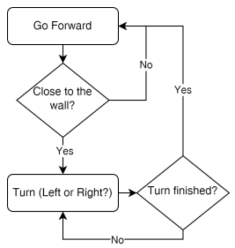
Figure 1: control logic loop

II.3 Python control node
The controller is implemented as a ROS 2 node that initializes communication across four primary topics:
- /scan (subscription): receives LiDAR measurements at a frequency of 5Hz.
- /odom (subscription): tracks the robot's pose and orientation using wheel odometry data.
- /ground_truth (subscription): retrieves the exact pose and orientation from Gazebo to evaluate the odometry error.
- /cmd_vel (publisher): publishes linear and angular velocity commands to control robot's movement.
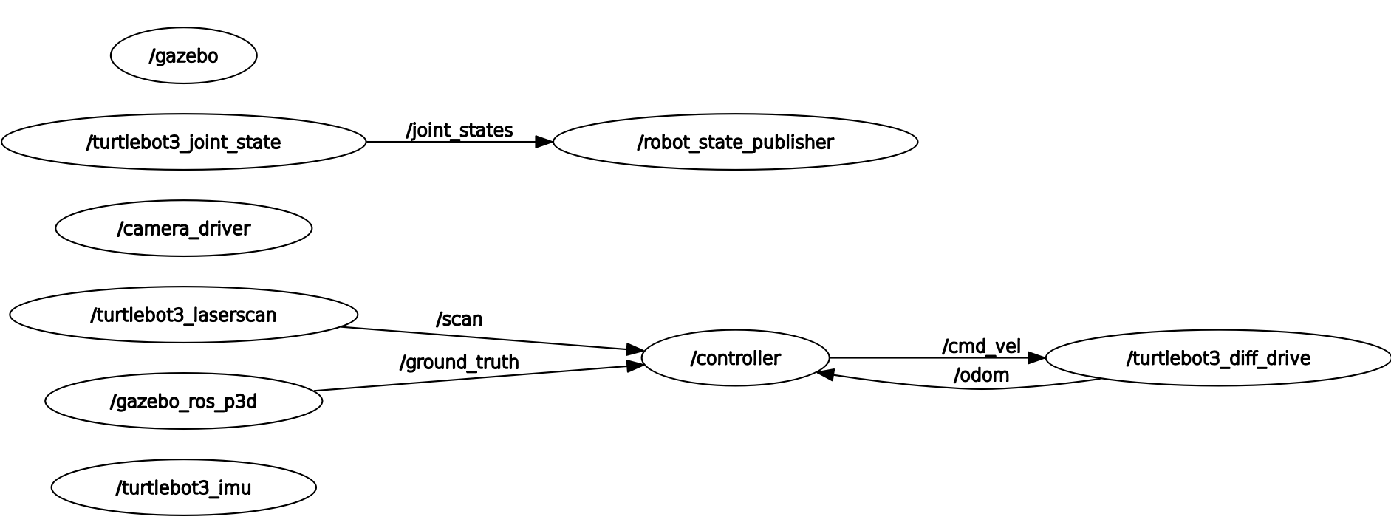
. Figure 2 Rqt graph of communications
II.4 YAML configuration file
A YAML configuration file is used to set several key parameters. This allows the values to be easily adjusted without modifying the Python code, ensuring the controller to work both in simulation and real-world environment, since different movement dynamics are often required. The configurable parameters include the robot's maximum linear velocity (velMax variable), angular rate (velAngMax), and the bump threshold value (bumperThreshold).

II.5 Launch file
The Launch file was implemented by extending the TurtleBot3 launch file. The original script handles Gazebo setup, starting the simulation with Turtlebot3 mode and spawning the robot into custom simulation world.
Building on top of this, the custom controller node and the YAML parameters file were integrated. The resulting launch file executes two main tasks simultaneously:
1. simulation: Call to the gazebo launch file provided in turtlebot3_gazebo package.
2. controller startup: runs the custom Python controller node and loads its tunable parameters.

Using this launch file is highly convenient because it allows starting the complete simulation and the control system together in a single step, avoiding the need to run multiple console commands across different terminals.

Task 1
Task 1 involved designing the controller and testing it within the Gazebo simulation environment. The control logic is executed through a continuous loop based on a Bump&Go strategy.
The loop is triggered whenever a new sensor_msgs/msg/LaserScan message is received on the /scan topic. This message contains various data: angle_min, angle_max and angle_increment represent the starting angle, ending angle, and the angular step between each LiDAR ray, respectively. Additionally, range_min and range_max define the valid physical distance limits of the sensor. The actual distance measurements are stored in ranges vector as float values. Because this vector can have a variable length in real-world hardware conditions, angle_min, angle_max and angle_increment must be used to dynamically calculate the correct array indices to process the data safely.
For each Lidar scan a dedicated callback method LidarCallback(), processes the raw sensor data. To handle out of bounds rreadings and invalid data (such as inf or nan values), the distance array are pre-processed by capping the values to the sensor's reliable minimum and maximum limits (range_min and range_max values). The conditioned data is then passed to moving() method, which dictates the robot's kinematic behaviour.
In the forward motion state, the controller extracts a 10-degree field of view (calculated through angle_increment value given in scan message) directly in front of the robot. A median filter is applied to this subset to reject Gaussian noise and prevent false obstacle detection. If the evaluated frontal distance falls below the established safety threshold, the robot halts and triggers the turning sequence, otherwise, it maintains its forward trajectory.
When the robot detects an obstacle within the threshold distance, the rotation phase begins. First, the controller must determine the optimal turning direction. To handle the variable length of the LiDAR scan array properly, the exact indices for the +90 degree (left) and -90 degree (right) directions are dynamically calculated using the angle_min and angle_increment A 10-degree field of view is then extracted around these dynamically calculated indices. A median filter is applied to both subsets to remove Gaussian noise, and the robot selects the turning direction that offers the maximum free space.
Through the /odom topic subscription the controller receives messages of type nav_msgs/msg /Odometry, it contains estimated pose and twists data. The odomCallback() callback method extracts the quaternion of robot’s current orientation from pose, with a pre-built function it is possible to convert in Euler angles and extract the yaw angle (current_yaw).
The target yaw is calculated by adding the required rotation angle (+90 or -90 degrees) to the current_yaw, The resulting target yaw is then normalized to stay within the [-180 °,180°] range, preventing mathematical errors or jump behaviors during the rotation phase
The actual rotation is executed using a proportional controller based on angular error, which is calculated by as the difference between the target yaw and the current yaw. A proportional gain is applied to ensure a smooth rotation, and the angular velocity is dynamically adjusted based on the remaining error. Once the absolute angular error falls below a strict tolerance of 0.03 rad, the rotation is considered complete. The robot then returns to the FORWARD motion state and starts moving in the new direction.
The physical movement commands are sent through the /cmd_vel topic using geometry_msgs/msg/Twist messages. This message type consists of two 3D vectors containing the linear and angular velocities for the x, y, and z axes. Since the velocities are relative to the robot's local frame, the control logic is applied as follows:
- forward motion: The linear velocity along the x-axis is set to the velMax variable (loaded from the YAML configuration file), and all other linear and angular rates are set to zero.
- Turning motion: The linear velocities are set to zero. The angular rate around the z-axis is set by the proportional controller and capped at the velAngMax variable (also loaded from the YAML file) to ensure the robot respects its physical speed limits.
During the simulation phase, an additional subscription to /ground_truth topic is used to receive nav_msgs/msg /Odometry messages. The topic provides the exact pose of the robot within the Gazebo environment. The position retrieved from ground_truth topic is processed in groundTruthCallback() method to compare estimated position with actual position in the simulation. This comparison is needed to check the positioning error accumulated by the differential drive odometry system, which could influence the performance of the control algorithm.
Because this exact positioning data is only available in simulation, this subscription must be removed or disabled when deploying the controller on the physical robot in the real world.

Task 2
In task 2 the previous programmed controller was adjusted to work on a physical robot; the following adjustment were done:
1. groud_truth removal:
ground_truth topic subscription was removed since in real world environment only odometry estimation of position is possible.
2. QoS profile:
The /scan subscription was updated introducing qos_profile_sensor_data quality of service to set the following behaviors:
- History: KEEP_LAST (only drops older messages when the queue is full)
- Depth: 5 (stores a small queue of up to 5 messages to minimize latency)
- Reliability: BEST_EFFORT (prioritizes speed and low latency over delivery guarantees; dropped packets are not retransmitted)
- Durability: VOLATILE (late-joining subscribers will not receive past data)
3. Parameters:
The YAML configuration parameters (such as maximum velocities and thresholds) were retuned to accommodate the physical dynamics of the real robot and ensure its safe operation.
4. Launch file:
The launch file was modified to remove the Gazebo simulation call, as the simulated environment is no longer needed.

These adjustment preserve the controller architecture while adapting sensing, communication and motion parameters to the behaviour of the real Turtlebot3.

Experiment and Results

Simulation
To run the simulations, we had to launch the following commands:
1. source ./install/setup.bash (to source the local workspace),
2. export TURTLEBOT3_MODEL=burger (to set the Turtlebot3 model),
3. ros2 launch turtlebot3_gazebo lab02.launch.py (to run the simulation)

As described in the architecture section, the simulation experiments aimed to validate the finite state logic (FORWARD and TURNING) within the Gazebo environment, utilizing RViz 2 for visualization.
In this ideal phase, the pre-processing of LiDAR data via clipping to physical limits (range_min and range_max) and the application of a median filter on the 10-degree frontal field of view ensured the total rejection of Gaussian noise, preventing the detection of phantom obstacles.
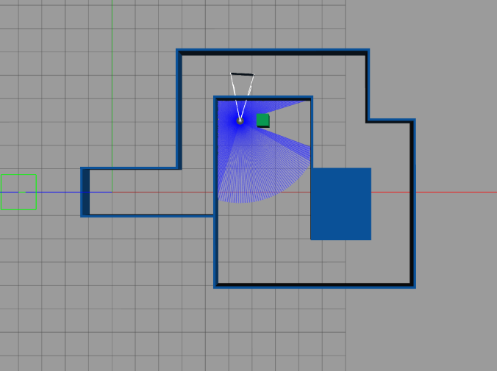

Real Robot:

The test on the physical robot confirmed the validity of the adaptations described in Task 2. The transition from static array indexing to a dynamic calculation based on the angle_min, angle_max, and angle_increment metadata proved crucial for handling the variability of the physical scanner's ranges vector length.

During the simulation phase, we tuned the parameters — the minimum distance from the wall and the linear velocity. As in the simulation, we also carried out several tests to ensure consistent and homogeneous behavior.
in the end we had decided:
Linear velocity [m/s] 0.15
Minimum distance [m] 0.4

Extracting the free space by dynamically evaluating the regions at 25% and 75% of the array allowed the robot to correctly decide the direction of rotation. From a communication standpoint, the adoption of the sensor_data QoS profile (with BEST_EFFORT reliability and VOLATILE durability on a queue limited to 5 messages) prevented latency accumulation in the /scan topic reception, ensuring that evasive maneuvers were processed instantaneously.

Results
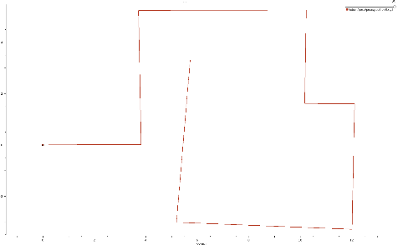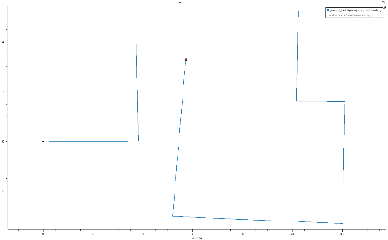

The collected results demonstrate the expected functioning of the system. The pose graph extracted from /odom faithfully highlights the zig-zag trajectory performed by the TurtleBot3. By superimposing this data onto the /ground_truth provided by the simulator, a perfect overlap is observed, proving that in the synthetic environment, the differential odometric error is negligible in the simulation.

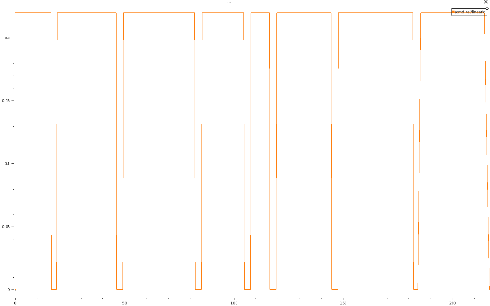
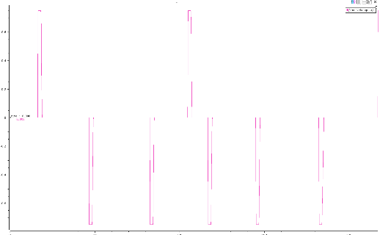

The analysis of the commands on the /cmd_vel multiplexer faithfully reflects the flowchart of the Bump&Go controller: the linear velocity on the x-axis assumes a square wave profile, dropping instantaneously from the maximum value to zero as soon as the bumperThreshold is exceeded. At exactly those moments, the angular commands on the z-axis calculated by the proportional controller are triggered to actuate the TURNING state to the right or left. Finally, the directional vectors on RViz confirm that the completed rotations are orthogonal, stable, and free from spatial drifts.

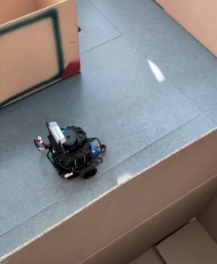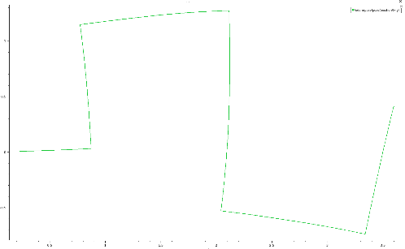
This plot shows the robot trajectory during the real test. We can see that the robot follows the track well, is able
to avoid obstacles and behaves almost the same as in the virtual simulation.

Conclusions

Conclusions
All architectural and functional objectives set forth by the laboratory activity were successfully achieved. The implemented Python ROS 2 node autonomously governed the TurtleBot3’s kinematics through a purely reactive Bump&Go navigation paradigm, successfully guiding the robot along the wall-delimited path to the final destination in both the Gazebo simulation and the physical hardware deployment.

The most critical engineering challenges faced during development revolved around the abstraction and pre-processing of the raw LiDAR sensory payload. On the physical robot, the LDS-01/LDS-02 scanner produces a variable-length ranges array, which necessitated abandoning the static indexing used in simulation in favor of a dynamic sector-partitioning algorithm based on the angle_min, angle_max, and angle_increment metadata.
Under non-ideal conditions, such as the presence of stochastic measurement noise and infinite (range_max) out-of-bounds readings, the system remained robust. This stability was achieved by clipping the raw data to the sensor's reliable limits and applying a median filter to the 10-degree field of view, effectively rejecting Gaussian noise and preventing false obstacle detections. Additionally, to handle non-ideal network latency over Wi-Fi, the /scan subscriber was strictly configured with a sensor_data Quality of Service (QoS) profile.

The transition from the simulated environment to the real hardware prominently highlighted the intrinsic "reality gap" of mobile robotics. In the Gazebo simulation, the odometric estimation (/odom) perfectly matched the absolute /ground_truth, demonstrating zero cumulative error. Conversely, physical hardware execution introduced significant dead-reckoning drift. The real TurtleBot3's trajectory was affected by wheel slip-ratio, asymmetrical floor friction, and encoder inaccuracies, which progressively degraded the purely odometric localization over time.

