Report 01
  - Sensors, Embedded Systems and Algorithms for Service Robotics
1st Leonardo Carreras, S360909 and 2nd Morad Boumasdour, S364165

Abstract – Write a self-contained summary of 150–250 words (a single paragraph) that captures the entire project. Map your abstract directly to the four report sections by answering these core questions in sequence. What specific problem or robotics challenge does this work address? What key algorithmic approach and ROS 2 setup (nodes/interfaces) did you implement to solve it? How was the system tested (e.g., Gazebo simulation or physical robot), and what was the main quantitative or operational outcome? What is the primary takeaway or notable limitation of your solution?
As a rule of thumb, write the abstract last after completing the four main sections. Do not include code snippets, figures, citations, or undefined acronyms.

Objectives
The main objective of this laboratory is to design a Bump&Go controller to guide a TurtleBot3 through a path delimited by walls to reach a green target cube. To achieve this, the work is divided into two phases. In the first (Lab 02), the controller is developed and tested in a simulated environment using Gazebo, utilizing RViz 2 for sensor visualization.
In the second phase (Lab 03), the validated control logic code is adapted and transferred to a physical TurtleBot3. This requires handling the robot's bring up process and modifying the logic to deal with real-world hardware conditions, such as variable LiDAR scan sizes, to verify that the robot works properly outside the simulation.
Throughout both tasks, the exercises a aim is to consolidate practical experience with ROS2 concepts, such as nodes, topics, parameters, Quality of Services (QoS) and launch files.

Methods and Design
II.1 Controller Architecture
The Bump&Go controller designed to autonomously navigate a TurtleBot3 consists of a Python ROS2 node that handles the logic, a YAML file for tunable parameters, and a launch file to easily start the controller and environment.

II.2 Bump&Go logic
The robot's navigation relies on a finite state logic loop based on a Bump&Go strategy, (as illustrated in the flowchart Figure 1) consisting of two primary states: FORWARD and TURNING. The robot starts in a FORWARD motion state and maintains this behaviour until a wall is detected in front of it. For each LiDAR scan, the controller verifies if the path ahead is clear and publishes the corresponding forward motion commands.
Once an obstacle is detected within a predefined threshold, the robot stops and transitions into a TURNING state. It then evaluates the sensor data to determine the optimal turning direction, choosing the side (left or right) with the maximum available clearance. The controller commands a 90-degree rotation, counterclockwise for left rotation and clockwise for right rotation, and, upon completion, the robot automatically resumes its forward motion state. By continuously iterating this loop, the Bump&Go controller successfully navigates the robot through the wall-delimited path to reach the final destination.
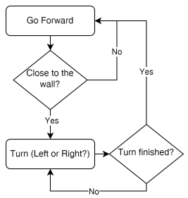
Figure 1: control logic loop

II.3 Python control node
The controller is implemented as a ROS 2 node that initializes communication across four primary topics:
- /scan (subscription): receives LiDAR measurements at a frequency of 5Hz.
- /odom (subscription): tracks the robot's pose and orientation using wheel odometry data.
- /ground_truth (subscription): retrieves the exact pose and orientation from Gazebo to evaluate the odometry error.
- /cmd_vel (publisher): publishes linear and angular velocity commands to control robot's movement.
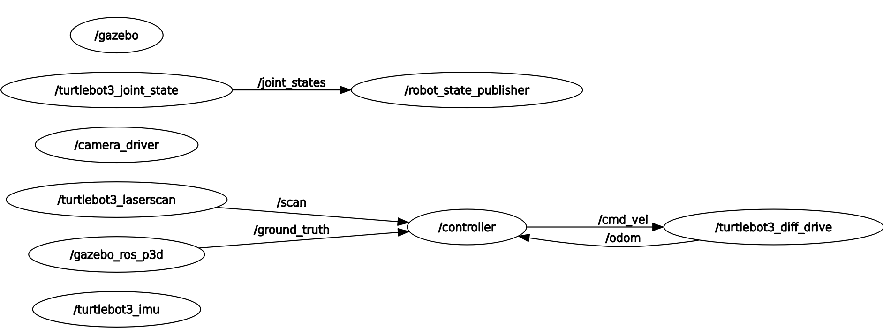
. Figure 2 Rqt graph of communications
II.4 YAML configuration file
A YAML configuration file is used to set several key parameters. This allows the values to be easily adjusted without modifying the Python code, ensuring the controller to work both in simulation and real-world environment, since different movement dynamics are often required. The configurable parameters include the robot's maximum linear velocity (velMax variable), angular rate (velAngMax), and the bump threshold value (bumperThreshold).

II.5 Launch file
The Launch file was implemented by extending the TurtleBot3 launch file. The original script handles Gazebo setup, starting the simulation with Turtlebot3 mode and spawning the robot into custom simulation world.
Building on top of this, the custom controller node and the YAML parameters file were integrated. The resulting launch file executes two main tasks simultaneously:
1. simulation: Call to the gazebo launch file provided in turtlebot3_gazebo package.
2. controller startup: runs the custom Python controller node and loads its tunable parameters.

Using this launch file is highly convenient because it allows starting the complete simulation and the control system together in a single step, avoiding the need to run multiple console commands across different terminals.

Task 1
Task 1 involved designing the controller and testing it within the Gazebo simulation environment. The control logic is executed through a continuous loop based on a Bump&Go strategy.
The loop is triggered whenever a new sensor_msgs/msg/LaserScan message is received on the /scan topic. This message contains various data: angle_min, angle_max and angle_increment represent the starting angle, ending angle, and the angular step between each LiDAR ray, respectively. Additionally, range_min and range_max define the valid physical distance limits of the sensor. The actual distance measurements are stored in ranges vector as float values. Because this vector can have a variable length in real-world hardware conditions, angle_min, angle_max and angle_increment must be used to dynamically calculate the correct array indices to process the data safely.
For each Lidar scan a dedicated callback method LidarCallback(), processes the raw sensor data. To handle out of bounds rreadings and invalid data (such as inf or nan values), the distance array are pre-processed by capping the values to the sensor's reliable minimum and maximum limits (range_min and range_max values). The conditioned data is then passed to moving() method, which dictates the robot's kinematic behaviour.
In the forward motion state, the controller extracts a 10-degree field of view (calculated through angle_increment value given in scan message) directly in front of the robot. A median filter is applied to this subset to reject Gaussian noise and prevent false obstacle detection. If the evaluated frontal distance falls below the established safety threshold, the robot halts and triggers the turning sequence, otherwise, it maintains its forward trajectory.
When the robot detects an obstacle within the threshold distance, the rotation phase begins. First, the controller must determine the optimal turning direction. To handle the variable length of the LiDAR scan array properly, the exact indices for the +90 degree (left) and -90 degree (right) directions are dynamically calculated using the angle_min and angle_increment A 10-degree field of view is then extracted around these dynamically calculated indices. A median filter is applied to both subsets to remove Gaussian noise, and the robot selects the turning direction that offers the maximum free space.
Through the /odom topic subscription the controller receives messages of type nav_msgs/msg /Odometry, it contains estimated pose and twists data. The odomCallback() callback method extracts the quaternion of robot’s current orientation from pose, with a pre-built function it is possible to convert in Euler angles and extract the yaw angle (current_yaw).
The target yaw is calculated by adding the required rotation angle (+90 or -90 degrees) to the current_yaw, The resulting target yaw is then normalized to stay within the [-180 °,180°] range, preventing mathematical errors or jump behaviors during the rotation phase
The actual rotation is executed using a proportional controller based on angular error, which is calculated by as the difference between the target yaw and the current yaw. A proportional gain is applied to ensure a smooth rotation, and the angular velocity is dynamically adjusted based on the remaining error. Once the absolute angular error falls below a strict tolerance of 0.03 rad, the rotation is considered complete. The robot then returns to the FORWARD motion state and starts moving in the new direction.
The physical movement commands are sent through the /cmd_vel topic using geometry_msgs/msg/Twist messages. This message type consists of two 3D vectors containing the linear and angular velocities for the x, y, and z axes. Since the velocities are relative to the robot's local frame, the control logic is applied as follows:
- forward motion: The linear velocity along the x-axis is set to the velMax variable (loaded from the YAML configuration file), and all other linear and angular rates are set to zero.
- Turning motion: The linear velocities are set to zero. The angular rate around the z-axis is set by the proportional controller and capped at the velAngMax variable (also loaded from the YAML file) to ensure the robot respects its physical speed limits.
During the simulation phase, an additional subscription to /ground_truth topic is used to receive nav_msgs/msg /Odometry messages. The topic provides the exact pose of the robot within the Gazebo environment. The position retrieved from ground_truth topic is processed in groundTruthCallback() method to compare estimated position with actual position in the simulation. This comparison is needed to check the positioning error accumulated by the differential drive odometry system, which could influence the performance of the control algorithm.
Because this exact positioning data is only available in simulation, this subscription must be removed or disabled when deploying the controller on the physical robot in the real world.

Task 2
In task 2 the previous programmed controller was adjusted to work on a physical robot; the following adjustment were done:
1. groud_truth removal:
ground_truth topic subscription was removed since in real world environment only odometry estimation of position is possible.
2. QoS profile:
The /scan subscription was updated introducing qos_profile_sensor_data quality of service to set the following behaviors:
- History: KEEP_LAST (only drops older messages when the queue is full)
- Depth: 5 (stores a small queue of up to 5 messages to minimize latency)
- Reliability: BEST_EFFORT (prioritizes speed and low latency over delivery guarantees; dropped packets are not retransmitted)
- Durability: VOLATILE (late-joining subscribers will not receive past data)
3. Parameters:
The YAML configuration parameters (such as maximum velocities and thresholds) were retuned to accommodate the physical dynamics of the real robot and ensure its safe operation.
4. Launch file:
The launch file was modified to remove the Gazebo simulation call, as the simulated environment is no longer needed.

These adjustment preserve the controller architecture while adapting sensing, communication and motion parameters to the behaviour of the real Turtlebot3.

Experiment and Results

Simulation
To run the simulations, we had to launch the following commands:
1. source ./install/setup.bash (to source the local workspace),
2. export TURTLEBOT3_MODEL=burger (to set the Turtlebot3 model),
3. ros2 launch turtlebot3_gazebo lab02.launch.py (to run the simulation)

The initial phase of the experimental campaign was conducted within the Gazebo simulation environment, a physics engine employed in the ROS 2 stack for emulating kinematics and generating synthetic sensory data (Software-In-The-Loop). Concurrently, the RViz 2 tool was utilized for real-time telemetry monitoring, allowing the visualization of the odometric track and the layers generated by the simulated LiDAR sensor. The fundamental objective of this phase was to validate the logical architecture of the Finite State Machine (FSM) governing the reactive Bump&Go navigation paradigm, isolating the algorithm from stochastic hardware noise.

The testing process in simulation proved crucial for refining the parsing of spatial data. In the early iterations of development, the algorithm incorrectly assumed that the distance vector (ranges) published on the /scan topic consisted of a static array of exactly 360 elements (assuming a rigid angular resolution of $1^{∘}$ per index). This hardcoded assumption generated severe indexing errors: the calculation of the frontal and lateral sectors failed, leading the robot to misinterpret the free space and collide with the walls.

To permanently resolve this critical issue and render the algorithm agnostic to the sensor's resolution, the code was deeply refactored by implementing a dynamic index partitioning. By leveraging the native metadata of the LiDAR message, the algorithm now calculates the index offset based exclusively on the angle_increment parameter. Specifically, to isolate a ${10}^{∘}$ Field of View (rangeTotal = 0.174533 rad), the code dynamically computes the half-interval of the arrays using the formula math.ceil(rangeTotal/(2* angle_increment)).
This approach is surgically extended to the lateral sectors for turning decisions: the indices corresponding to ${90}^{∘}$ and ${270}^{∘}$ are dynamically extracted by calculating math.ceil((math.pi / 2.0 - angle_min) / angle_increment) and math.ceil((3.0 * math.pi / 2.0 - angle_min) / angle_increment), respectively.

To further fortify the payload processing, a validation layer was introduced: before processing any distance, the node verifies the completeness of the scan, ensuring that angle_min is less than $≈5^{∘}$ (0.0872665 rad) and angle_max is greater than $≈{355}^{∘}$. Furthermore, to manage out-of-bounds ray-tracing values (Inf or NaN), the algorithm implements a clipping routine that forces these values to the sensor's physical limits (range_min and range_max). Finally, to determine the actual presence of an obstacle, the concatenated frontal vector is not evaluated on its absolute minimum, but is processed through a statistical filter (np.median), guaranteeing deterministic state transitions and the total rejection of Gaussian noise.
The virtual environment ultimately allowed for the precise fine-tuning of the kinematic parameters exposed via YAML: the linear velocity (velMax) was optimized to 0.22 m/s, the maximum angular velocity (velAngMax) was limited to 1.5 rad/s, and the stopping distance (bumperThreshold) was set to 0.7 meters to ensure safe braking. In the TURNING logical block, a Proportional (P) controller computes the normalized yaw error between $-π$ and $π$, dynamically scaling the angular velocity sent to the robot until the target yaw is reached with a stringent tolerance of 0.03 radians

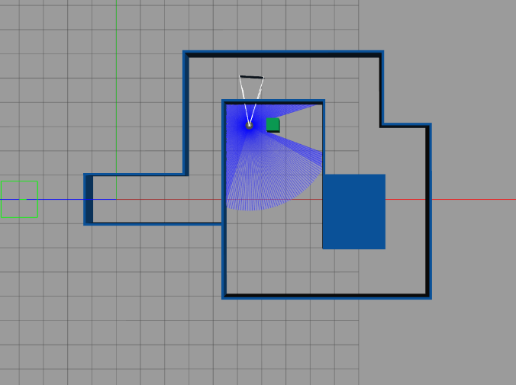

Results
The effectiveness of the Bump&Go control architecture was validated through a quantitative analysis of telemetric and kinematic data, recorded via system logs (ROS bags) during executions in both the virtual environment and on the hardware target. This section presents a detailed examination of the navigation node's performance, evaluating three fundamental metrics: the accuracy of the generated spatial trajectory compared to the odometric estimation, the dynamic response of the actuation commands injected into the velocity multiplexer, and finally, the geometric coherence of the rotations visualized through RViz telemetry.

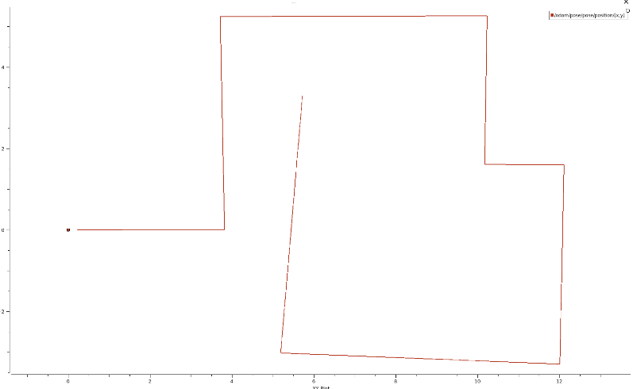
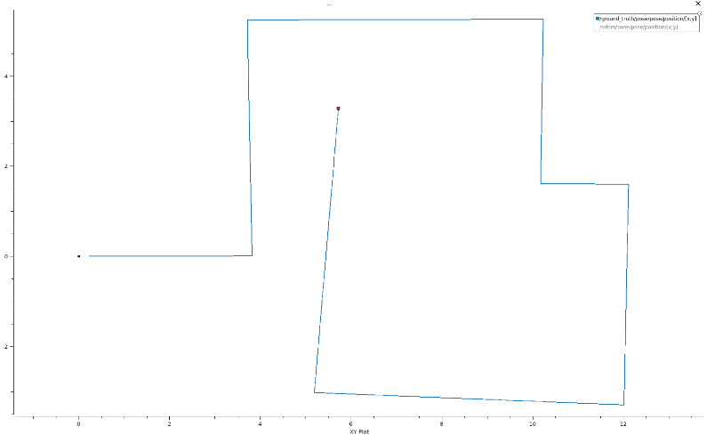

The first dataset analyzed concerns the two-dimensional track (XY graph) of the trajectory traveled by the robot. As is clearly evident from the plot extracted from the nav_msgs/msg/Odometry (/odom) topic, the macroscopic behavior of the vehicle strictly adheres to the designed finite-state paradigm: the path assumes a distinct piecewise linear conformation, characterized by long straight segments of pure forward motion interspersed with sharp in-place pivoting rotations

In the ideal domain of the Gazebo simulation, odometric validation yielded a mathematically flawless result. By mapping the trajectory estimated locally via the kinematic integration of the encoders and superimposing it onto the absolute track published by the simulator on the /ground_truth topic, a total and indistinguishable overlap of the two geometric profiles is observed. This perfect correlation demonstrates that, in a synthetic environment characterized by a zero slip-ratio of the driving wheels and the absence of quantization noise on the transducers, the cumulative error deriving from the differential odometric calculation (Dead-Reckoning) is completely non-existent.

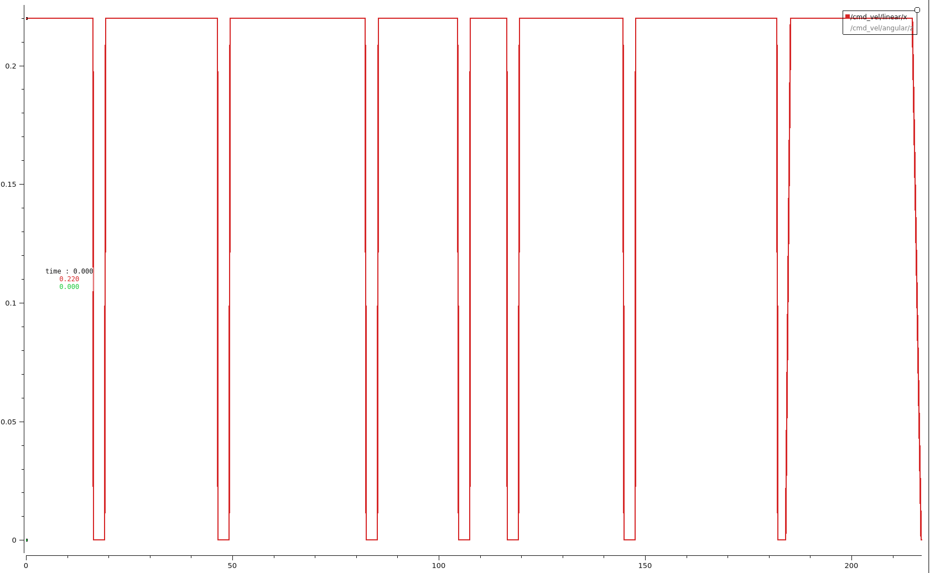
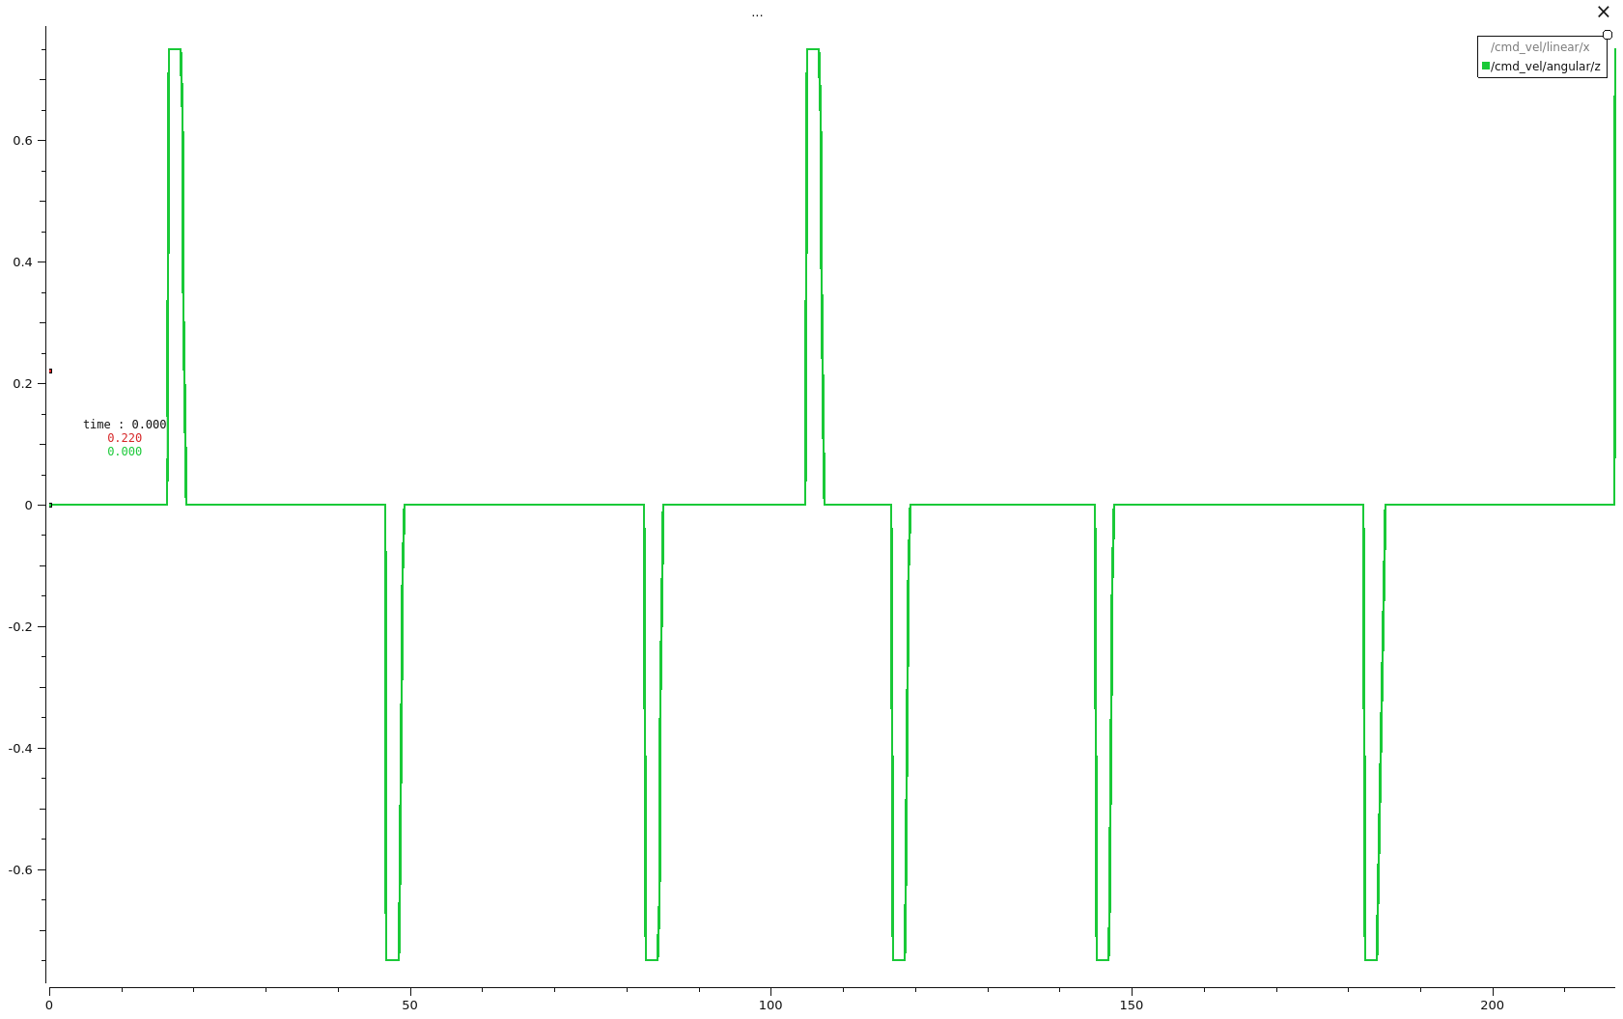

The dynamics of the actuation transients were validated by profiling the geometry_msgs/msg/Twist commands published in a streaming fashion on the /cmd_vel topic. The velocity graphs reflect the rigid transitions of the finite state machine with absolute fidelity. The plot of the longitudinal velocity on the x-axis ($v_{x}$) exhibits a strict square wave morphology. During the FORWARD state, the signal remains constant at the parameterized setpoint (velMax); as soon as the median filter applied to the LiDAR's frontal scan detects a distance below the bumperThreshold, the velocity undergoes an immediate step response, collapsing to $0.0$ m/s without perceptible delays.

In perfect phase synchronization with the falling edge of $v_{x}$, the graph relating to the yaw velocity around the z-axis ($ω_{z}$) registers sharp, impulsive operational peaks, which certify the triggering of the TURNING state. The most important characteristic of these peaks is their asymmetrical bipolarity (positive values for counterclockwise rotation, negative for clockwise). This alternation unequivocally demonstrates that the automaton does not execute pre-programmed directional sequences, but decides the evasive kinematics in real-time by calculating and comparing the median of the free space at the precise indices corresponding to ${90}^{∘}$ and ${270}^{∘}$, always rotating towards the vector that guarantees the maximum spatial clearance.

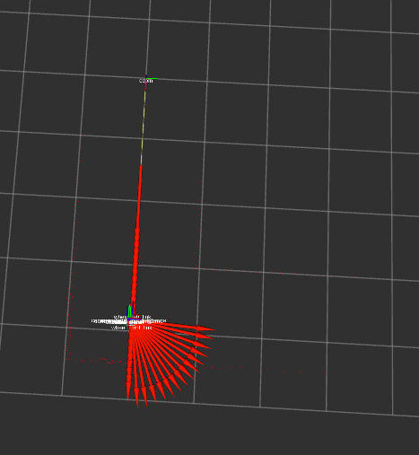
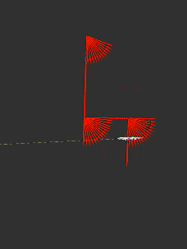

The accuracy of the angular positioning is visually supported by the telemetric reconstruction in RViz. By analyzing the array of odometric directional vectors (represented by the red arrows), it is evident that the robot does not describe circular arcs or parasitic trajectories during direction reversals. The vectors trace surgical right angles, settling exactly at ${90}^{∘}$ and ${270}^{∘}$ orthogonal to the initial approach vector.

This stability is the direct result of the proportional controller implemented at the software level: thanks to the extraction of the real yaw via the mathematical conversion of quaternions into Euler angles, and the normalization of the angular error within the $\left[-π,π\right]$ range, the feedback control loop smoothly reduces the rotational speed as it approaches the target yaw, stopping the motors only when the absolute error falls below the strict tolerance threshold of 0.03 radians.

REAL ROBOT

The transition of the control node from the synthetic environment of Gazebo to the physical hardware target (TurtleBot3) required a rigorous initialization procedure and highlighted the systemic criticalities typical of transitioning to the real world. The deployment phase first involved a remote connection via SSH protocol to the Single Board Computer (SBC) onboard the vehicle, followed by the essential execution of the native bring-up package (turtlebot3_bringup). This step proved mandatory to power on the OpenCR microcontroller drivers, establish serial communication with the motors' differential encoders, and initiate the continuous data streaming from the LDS-01/LDS-02 optical sensor. Concurrently, at the ROS 2 architecture level, the launch file was refactored by excluding all simulator-related processes, delegating the entirety of the decision-making computation to the local Python node.

During the very first physical tests post-bringup, the system exhibited severe behavioral anomalies: the robot was paralyzed, unresponsive to actuation commands, and merely scanned the environment while remaining completely immobile, despite the LiDAR regularly perceiving the surrounding space. This immobility was not caused by logical errors within the finite state machine, but rather by a combination of communication bottlenecks and kinematic parameters unsuited for the physical environment. The parameters inherited from the simulation (high velocities and wide stopping thresholds) were excessively aggressive: the real chassis's mechanical inertia, combined with the heterogeneous sliding friction of the flooring and, above all, an unacceptable latency in receiving heavy messages on the /scan topic over the Wi-Fi network, caused the "starvation" of the control loop. Commands were not generated and processed in time before triggering safety violations.

To restore the system's reactivity and enable navigation, it was necessary to apply fine-tuning and two fundamental corrective actions. Firstly, to resolve the network latency, the subscriber associated with the LiDAR was forced to utilize a sensor_data Quality of Service (QoS) profile. By imposing a BEST_EFFORT reliability policy and VOLATILE durability with a queue depth of 5, the accumulation of obsolete messages in the TCP/UDP buffer was prevented, ensuring that the node instantaneously processed only the most recent scan. Secondly, via the YAML file, the kinematics were heavily dampened: the maximum linear velocity (velMax) was conservatively lowered to 0.15 m/s to mitigate inertial forces, and the minimum stopping distance (bumperThreshold) was reduced to 0.4 m. These adjustments—combined with the dynamic calculation of the LiDAR arrays implemented in the code to cope with the variability of physical samples—unblocked the vehicle, allowing it to move and react in real-time.
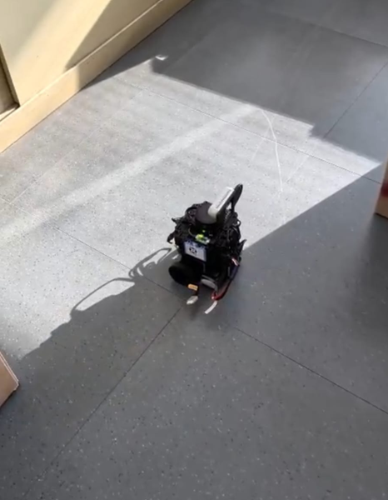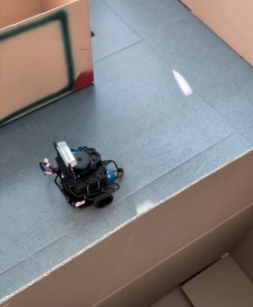

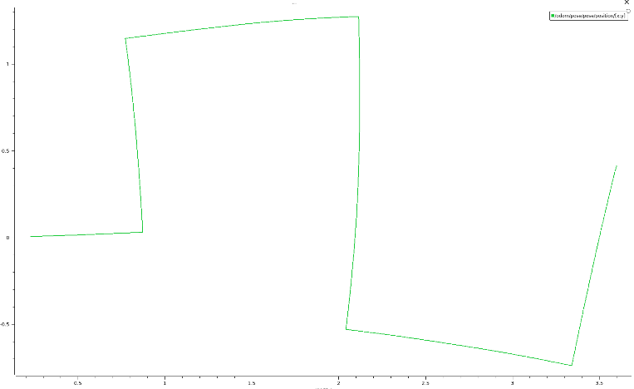

The effectiveness of the solutions implemented during the challenging bring-up phase was validated by analyzing the recorded telemetric data (rosbags) a posteriori during the autonomous execution in the cardboard maze. Unlike the odometric track previously extrapolated in simulation—which exhibited perfectly straight vectors and absolutely overlapped with Gazebo's Ground Truth—the two-dimensional track generated by the real robot unequivocally reveals the phenomenon of the Reality Gap.
Observing the green dashed line extracted from the nav_msgs/msg/Odometry (/odom) topic, evident angular drifts and physiological spatial inaccuracies emerge. These deviations do not reflect errors in the algorithm, but are the mathematical translation of physical imperfections: the asymmetrical slip-ratio of the driving wheels, slight skidding during abrupt decelerations, and the constant quantization error accumulated by the differential encoders during the ${90}^{∘}$ pivoting.
Nevertheless, the most important experimental finding is that the TurtleBot3 completed the entire path safely and without perimeter collisions. The Python algorithm does not suffer from odometry degradation (Dead-Reckoning) because it does not rely on pre-computed global maps; instead, it makes dynamic decisions moment by moment by processing only the local depth gradients measured polarly by the LiDAR. Thanks to the extraction of a filtered median on the ${10}^{∘}$ frontal FOV and the mathematical comparison of the lateral sectors to search for the optimal opening, the system implicitly compensated for the chassis drifts, guiding the machine safely despite the corrupted odometry.

Conclusions
The laboratory activity successfully met all the established architectural and operational objectives. The custom Python ROS 2 node, implementing a reactive Bump&Go strategy, autonomously and reliably navigated the TurtleBot3 through a wall-delimited path in both the Gazebo simulation and the physical real-world environment. The project served to consolidate practical experience with core ROS 2 concepts, including node management, topic communication, dynamic parameter configuration via YAML, and the use of launch files.

A primary technical challenge addressed during development was the robust processing of raw LiDAR data. Moving from the simulation to the physical LDS-01/LDS-02 sensor revealed that static array indexing was insufficient due to the variable sizes of real-world LiDAR scans. To resolve this, the control logic was dynamically adapted to calculate optimal turning indices based on the metadata angle_min, angle_max, and angle_increment. To manage non-ideal hardware conditions, a rigorous data filtering pipeline was implemented. This included verifying scan completeness, clipping out-of-bounds Inf and NaN values to the sensor's physical limits, and applying a median filter to specific Fields of View (like the 10-degree frontal slice) to reject Gaussian noise and prevent false obstacle detection.

The deployment phase on the physical robot highlighted significant communication bottlenecks over the Wi-Fi network. The initial physical tests resulted in the robot remaining unresponsive despite active LiDAR perception. This issue, caused by unacceptable latency in receiving the heavy /scan messages, was resolved by enforcing a sensor_data Quality of Service (QoS) profile. Utilizing a BEST_EFFORT reliability policy and a VOLATILE durability with a limited queue depth of 5 prevented the accumulation of obsolete data, restoring the system's real-time reactivity.

The comparison between simulated and real-world results clearly demonstrated the "Reality Gap". In Gazebo, the odometric estimation perfectly matched the absolute Ground Truth, indicating zero cumulative error. However, the physical execution introduced observable dead-reckoning drift due to asymmetrical wheel slip-ratio and encoder inaccuracies. Despite this degradation in proprioceptive localization, the reactive logic successfully guided the robot through the maze without collisions.
The Bump&Go algorithm's reliance on instantaneous, local depth gradients rather than a global map allowed it to implicitly compensate for spatial drift.
For future development, the current discrete stop-and-rotate logic could be optimized. Integrating a continuous closed-loop controller, such as a Proportional-Integral-Derivative (PID) algorithm for wall-following, would allow the robot to maintain a safe distance from boundaries dynamically without halting forward motion.

