

*Geophysical Research Letters*

Supporting Information for

**Repeat Subglacial Lake Drainage and Filling beneath Thwaites Glacier**

G. Malczyk1, N. Gourmelen1, D. Goldberg1, J. Wuite2, and T. Nagler2

1School of Geosciences, University of Edinburgh, Edinburgh, UK.

2ENVEO IT GmbH, Innsbruck, Austria.

**Contents of this file**

Text S1 to S4

Figures S1 to S4

**Introduction**

This document contains a detailed description of the time series approach used to obtain time dependent elevations (Text S1), a synopsis of altimetry techniques (Text S2), the formula used to calculate hydraulic potential (Text S3) and details regarding the model used to estimate channel size extent (Text S4). Figures displaying a divergence map of the Thwaites lake region (Figure S1), primary wind direction over Thwaites (Figure S2) and corresponding rates of surface elevation change profiles (Figure S3), and potential gradients between the subglacial lakes (Figure S4).

**Text S1. Detailed description of adapted timeseries approach**

We calculate the temporal height change for specific areas using an adapted version of the point-to-point method outlined in Gray *et al.,* (2015) and Gray *et al.,* (2019). An area is selected over which we want to determine the behaviour of surface elevation through time, and the corresponding data is segmented into separate time periods at 45-day intervals. In each time period we incorporate a 45-day search radius to ensure redundancy and stable results. Because of this, there is some overlap in the data between sequential time periods, but this will not skew results as the average of the epochs within each search radius centralizes around the time intervals. We index our data at a 500-meter gridding; which has a computational speed advantage over the method stated in Gray et al., (2019) as it eliminates the need to compare the distance of all possible arrangements of data points. Within each grid cell we estimate the temporal height change by comparing every height point in one time period against every other point in the later time periods. With this the mean of height changes for each cell and time difference are available. For each possible arrangement of time periods we remove outliers iteratively through omitting cells with an average height change greater than three standard deviations away from the average of all the cells until no further outliers are detected. Our final elevation difference between two pairwise unique time periods (e.g period 1 and period 5) is calculated by taking the mean of elevation differences in each cell. We also collect the standard deviations for future statistical analysis. Additional time series are created using the multi-period approach outlined in Gray *et al.,* (2019). When comparing the average height change from one time period (A) to any two other periods (B and C) different points will be used in the creation of the A – B and A – C height change. For example, the height difference A – B can be calculated as the height difference from A – C minus the height difference from B – C, assuming B and C are consecutive. This is repeated for all possible arrangements of time periods. If there are N 45-day time periods, then there are N-1 estimates of height change from the first period to any other subsequent period. One of these estimates is the direct calculation between the two periods, the other N-2 are calculated indirectly using the other time periods. This approach allows us to check for statistical error and consistency. When calculating the final time series, we take the weighted average of all possible time series. The direct estimate is given a weight of 1, whilst indirect estimates are given a weight of $1/{\sqrt{2}}$. The statistical error for any time-dependent elevation in our final timeseries is determined by taking the mean of the standard deviations and dividing by the square root of the number of samples. We convert our elevation change time series to volume change time series by integrating our temporal change against the total area of our lake masks. The statistical error from our timeseries is carried over into the volume change estimates, giving us a statistical bound on volume change based upon the elevation change observed at each lake.

Text S2. Synopsis of altimetry techniques

Our timeseries approach is broadly different to the method used in Smith et al., (2017), yet captures similar volume changes for 2013 activity. However, our drainage timings seem inconsistent with Smith, particularly at Thw124 which was thought to have deflated in January 2013. Smith determines elevation change by fitting a Digital Elevation Model (DEM) to swath processed elevations at three monthly intervals, although the smoothing-constraints of this approach tends to blur the timings of very large elevation changes. Therefore, the DEM approach would struggle to resolve the exact timings of Thw124 activity due to the extreme elevation changes of 2013. Hence, we attribute our timing disagreement to this phenomenon. At the other lakes, the timings stated by Smith fall within the 90-day search interval of our temporal sampling approach, which signifies a consistent order of drainage. Therefore, we can reimagine 2013 activity as a cascading drainage system where Thw170 activated first and triggers the downstream lake, therefore harmonizing the system with observations from other subglacial systems (Fricker et al., 2007, Fricker et al., 2014, Flament et al., 2014). The recursive approach, used in this study, seems more appropriate than the DEM approach due to the lack of temporal smoothing-constraints, the greater temporal resolution and the ability to produce multiple timeseries to determine the statistical error on elevation change. However, since this approach compares changes in all possible arrangements of time periods, it fails when the temporal resolution of data is inconsistent.

**Text S3. Calculation of hydraulic potential**

We assume that basal water pressure is equal to the ice overburden pressure and calculate the glaciological hydraulic pressure as:

$φ= \frac{ρ_{i}}{ρ_{w}}z_{s}+ \frac{(ρ_{w}- ρ_{i})}{ρ_{w}}z_{b}$**. (1)**

Here $φ$ is the hydraulic potential in units of height (m), $ρ_{i}$ is the density of ice, $ρ_{w}$ is the density of water, $z_{s}$ (m) is the surface height of the glacier and $z_{b}$ is the elevation of the glacier bed. Hydraulic potential is forced over the Thwaites lake region using BedMachine ice thickness and bed elevation data (Morlighem, 2019).

Text S4. Methods of estimating channel extent and melting rates (Schoof, 2010)

We assume that water discharged from subglacial lakes is transported primarily through Röthlisberger channels along drainage routes. The R-channel model was chosen for simplicity but we note there are other potential models of subglacial channelized flow; still, we expect the R-channel model to give an order-of-magnitude estimate for channel size and melt production during drainage events. This model allows us to estimate the size of the subglacial channels ($S)$, assuming semi-circular cross-section, during lake activity with:

$S= {\left[\frac{Q\sqrt{Ψ}}{c\left|Ψ\right|}\right]}^{\frac{4}{5}}$. (2)

Here steady state is assumed; and ***Ψ*** is hydraulic gradient and ***c*** is a constant related by friction factor ($f$) defined by $2^{\frac{1}{4}}\sqrt{π+2}/\left(π^{\frac{1}{4}}\sqrt{ρ_{w}f}\right)$, with $f$ being 0.1 (Schoof, 2010), $ρ_{w}$ the density of water and $Q$ the water discharge. When using formula (2) we assume that cross-sectional area (***S***), discharge (***Q***) and hydraulic gradient (***Ψ***) are uniform along the channel. We determine ***Q*** by taking the average discharge of upstream lakes from Figure 1c. Hydraulic gradient ***Ψ*** is approximated as the change in hydraulic potential ($φ$) divided by the distance along the likely flow paths highlighted in Figure 2. The velocity of water flowing through the channels ($U$) can be deduced by dividing water flux ($Q$) by the channel cross sectional area ($S$). This allows us to determine a rough estimate of the melting rate ($M$) within the channel with:

$M= \frac{QΨ}{ρ_{i}L}$ (3)

where $ρ_{i}$ represents the density of ice and $L$ is the latent heat fusion per unit mass of ice. This value is extrapolated over the drainage period to determine the total amount of melt within the subglacial channel system.

Additional Figures

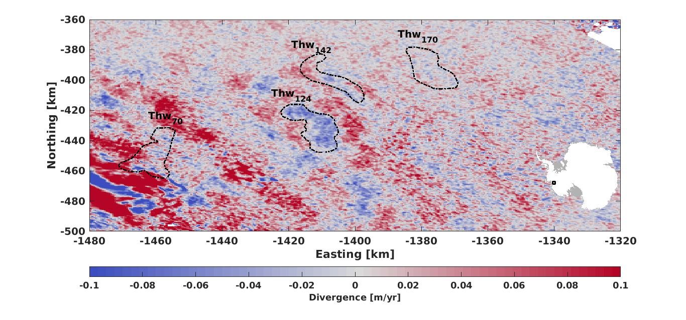

Figure S1: Divergence over the Thwaites lake system during the inter-drainage period (2014 – 2017). Dashed outlines show lake boundaries

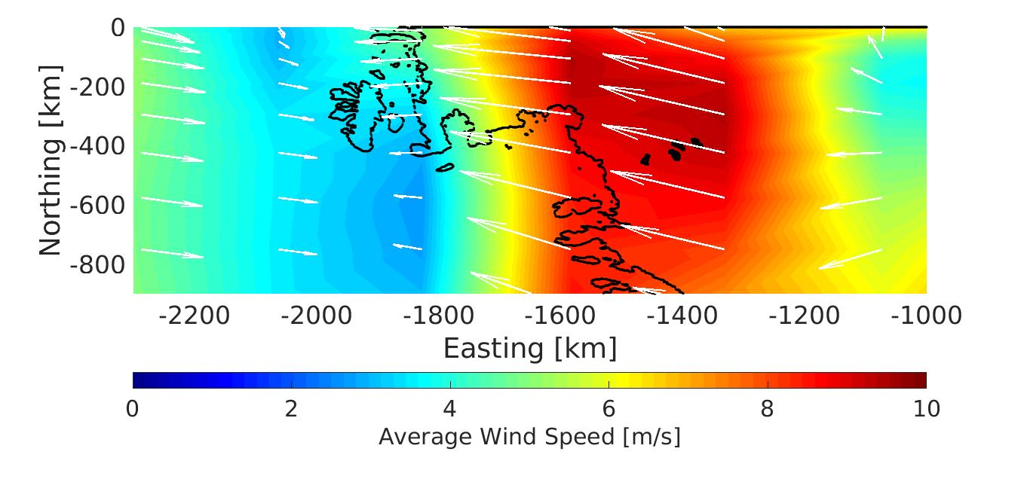

Figure S2: Average wind speed and direction (Kalney *et al.,* 1996) over the Amundsen Sea Sector from January 2014 to December 2017. Black outline represents grounding lines (Fretwell *et al.,* 2012), whilst the black features represent the Thwaites subglacial lakes.

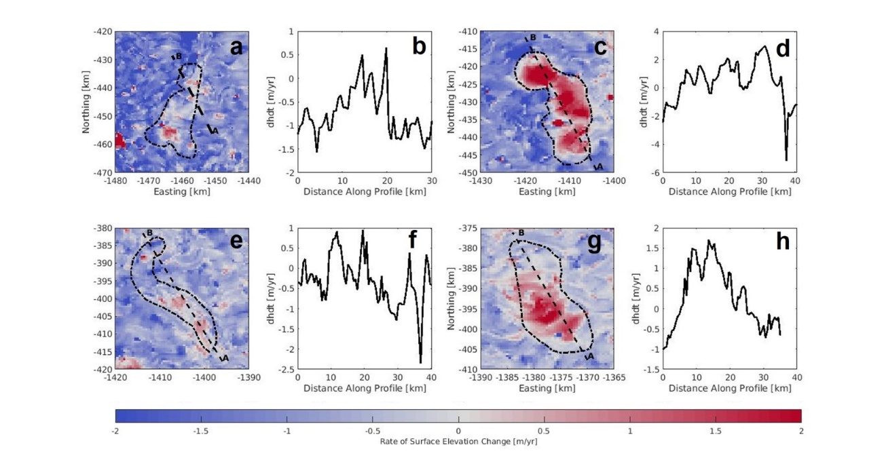

Figure S3: Profile of average rates of surface elevation change over lake outlines during the inter-drainage period (2014 – 2017). Maps show surface elevation change over features with background thinning removed. Lake outlines are drawn with dashed lines. (a), (c), (e) and (g): Rates of surface elevation change for Thw70, Thw124, Thw142 and Thw170 respectively during the inter-drainage period with profiles in prevailing wind direction. (b), (d), (f) and (h): Profiles of surface elevation change in prevailing wind direction for Thw70, Thw124, Thw142 and Thw170 respectively.

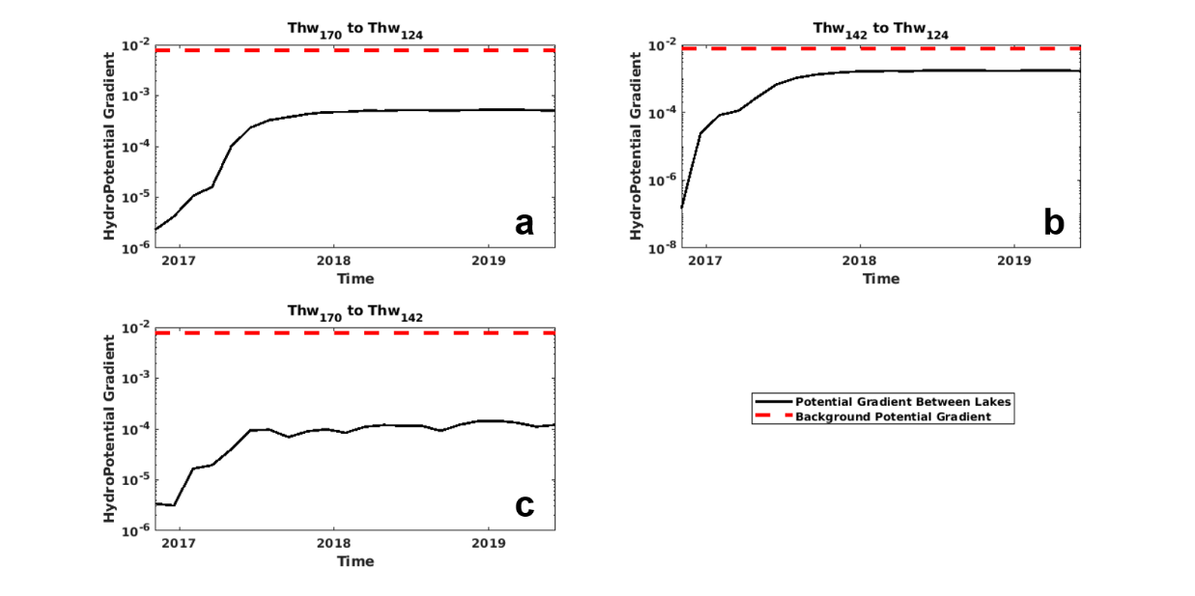

Figure S4: Hydropotential gradient between lakes compared against background hydropotential gradient. Potential gradient between lakes is calculated by dividing the difference in height anomaly between lakes during 2017 activity by distance along drainage pathways. Background potential gradient found by averaging hydropotential within each basin and dividing by distance. (a) hydropotential gradient comparison between Thw170 and Thw124. (b) hydropotential gradient comparison between Thw142 and Thw124. (c) hydropotential gradient comparison between Thw170 and Thw142.