- General Information

Student Name: Yolmorakatpanhcharong (Morakat) Lim
Student ID number: 01844931
Lab #4
Date of completion: 04/19/2026
GitHub:

- Lab Focuses and Outcomes:

  - Main Topics covered in this Lab

  - Software Design

  - Results

Part 1 Results: Below shows the images generated from the original prompts, modified prompts (1), and modified prompts (2). Overall great results but some as seen below do not really follow the prompts well but still provided an image similar to that of the reference image.

Description – Original (OpenPose)

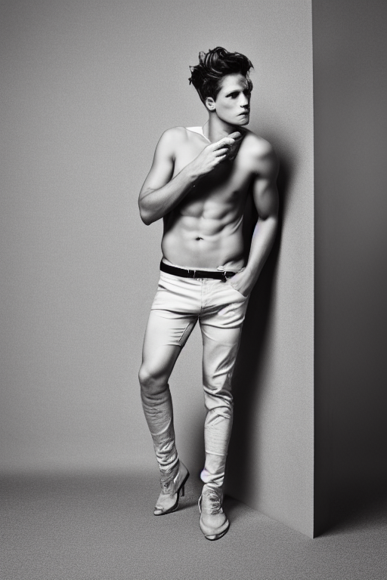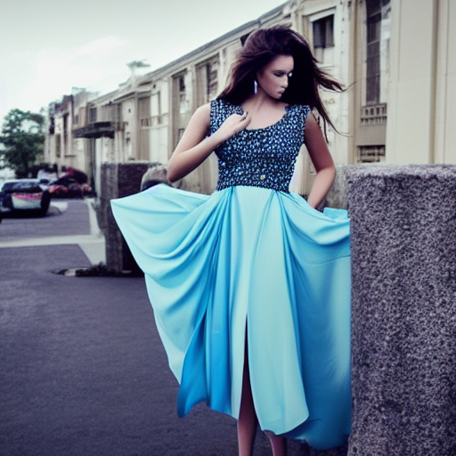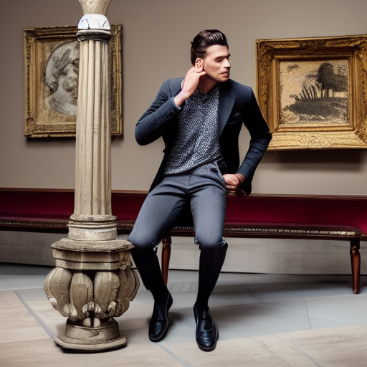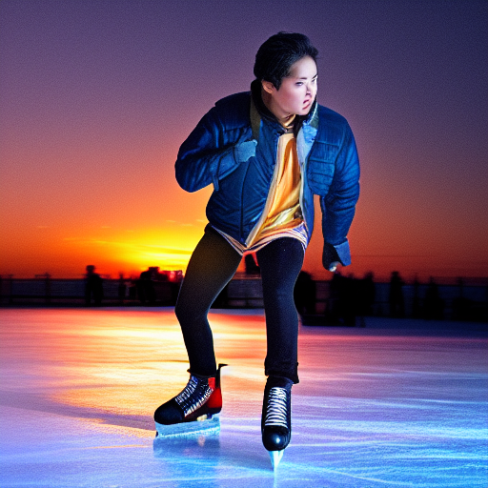

Description – Original (Canny)

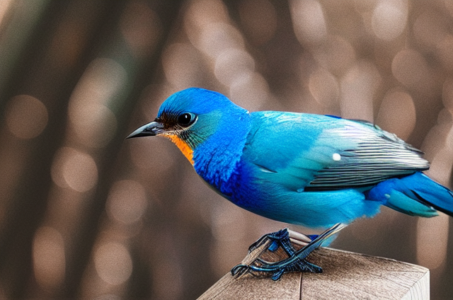

Description – Original (Depth)

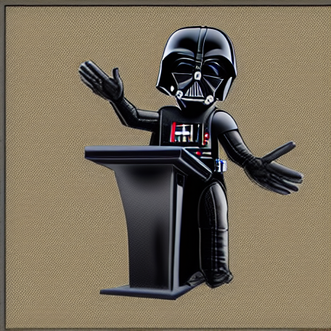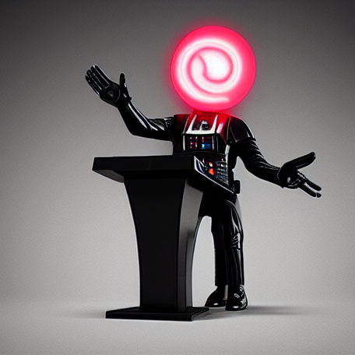

Description – Original (Normal)

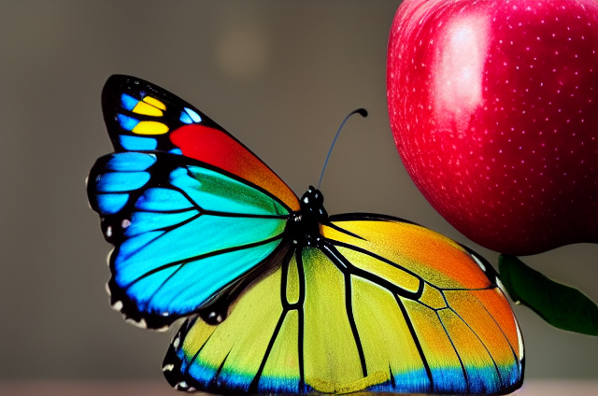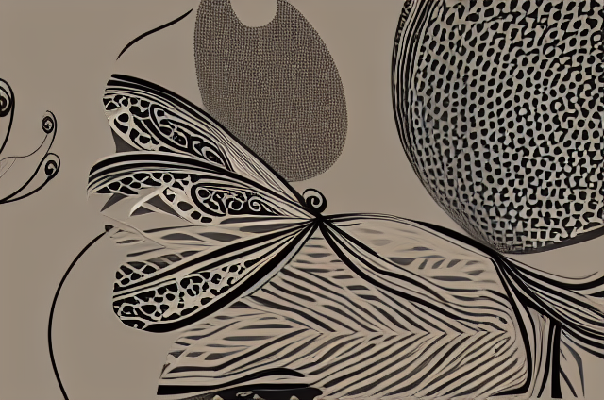

Description – Original (Segmentation)

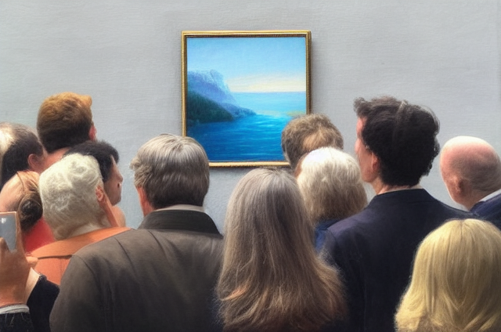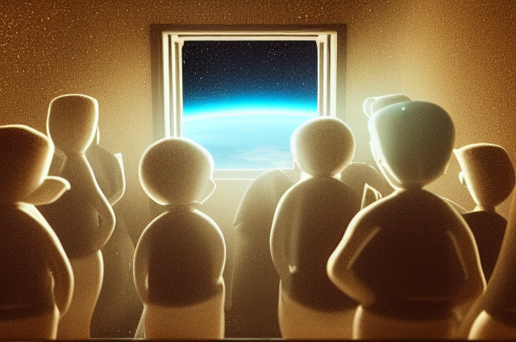

Description – Prompt1 (OpenPose)

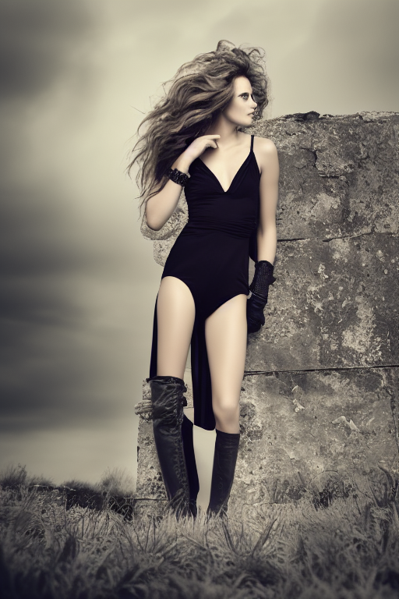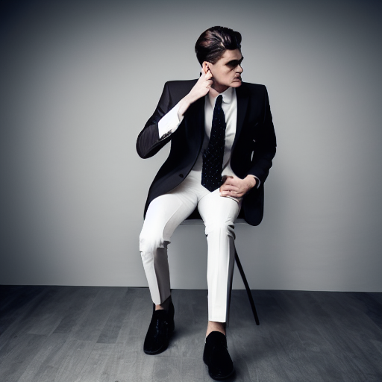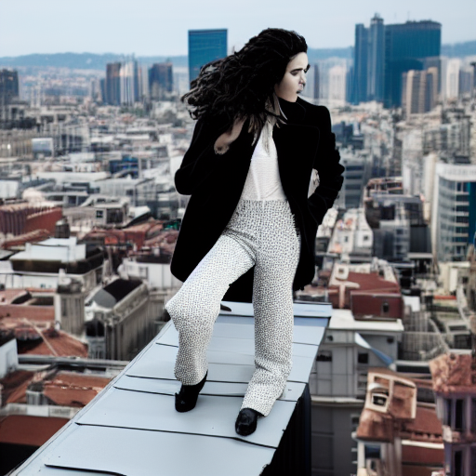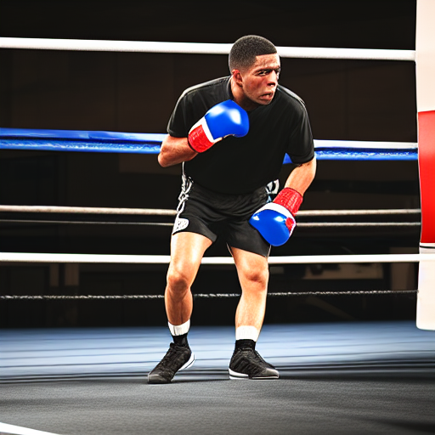

Description – Prompt1 (Canny)

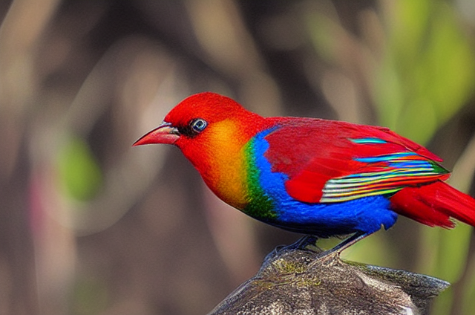

Description – Prompt1 (Depth)

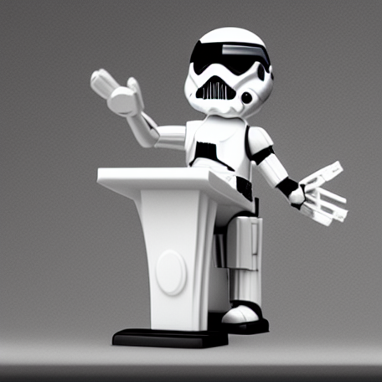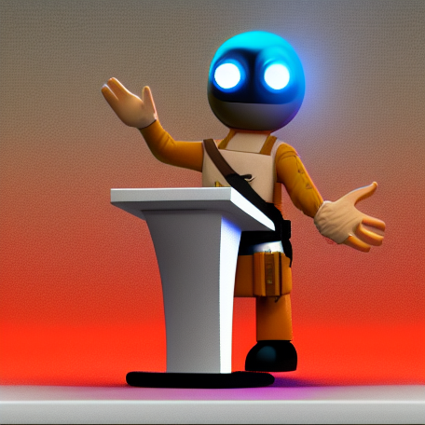

Description – Prompt1 (Normal)

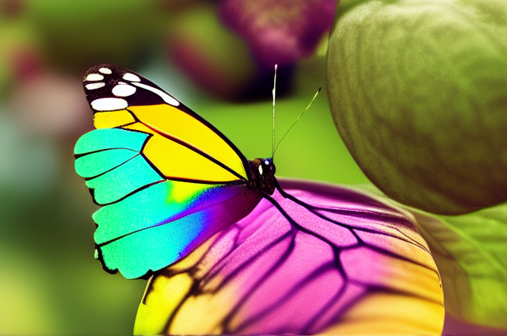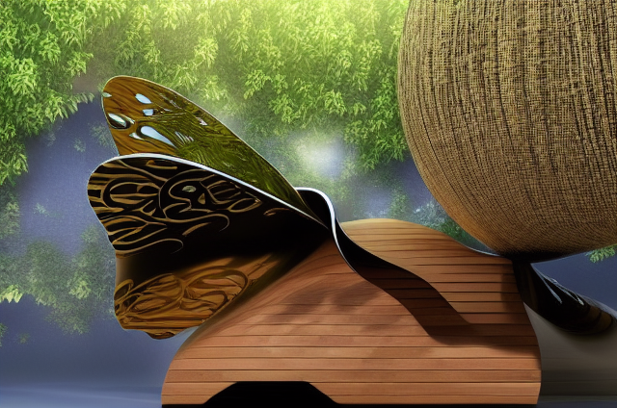

Description – Prompt1 (Segmentation)

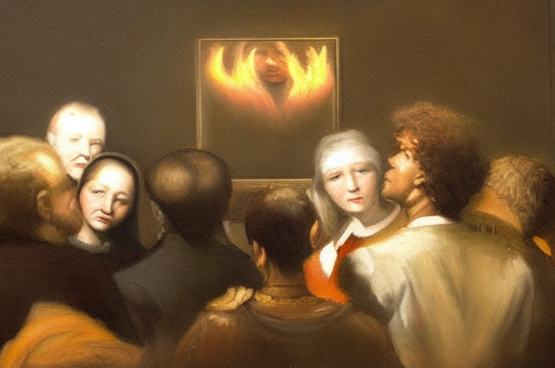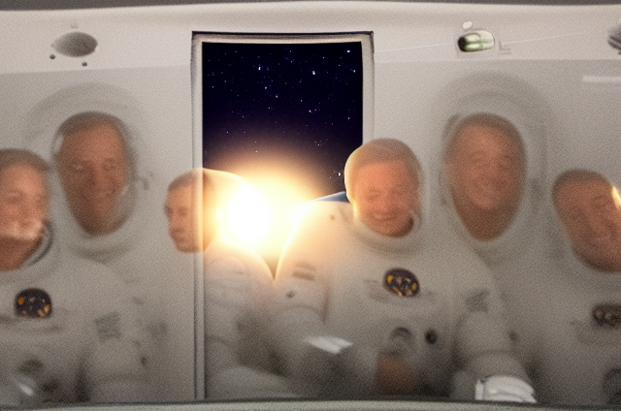

Description – Prompt2 (OpenPose)

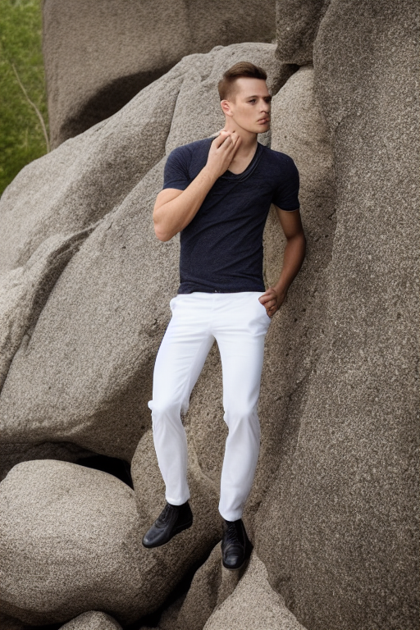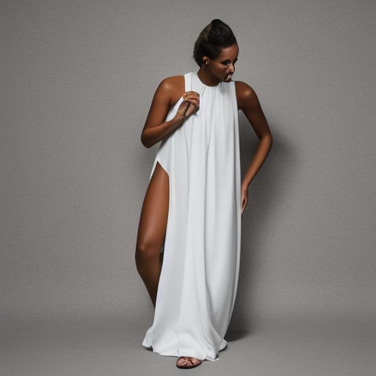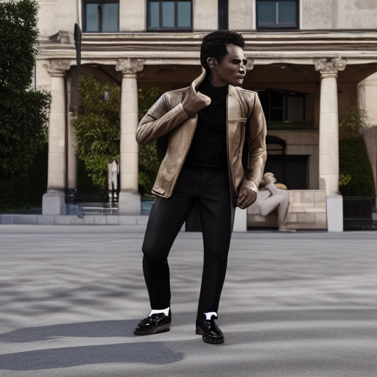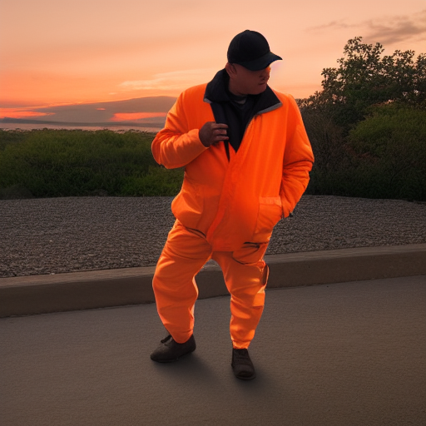

Description – Prompt2 (Canny)

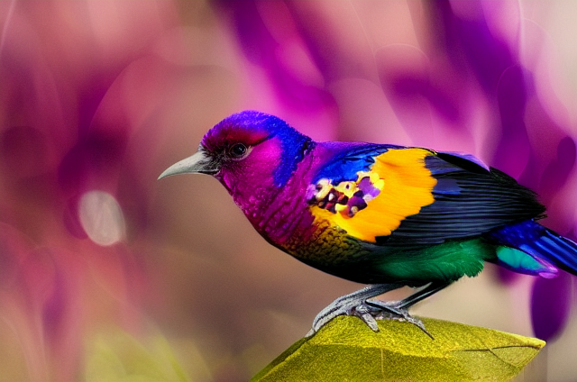

Description – Prompt2 (Depth)

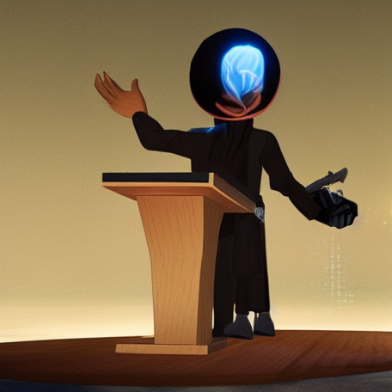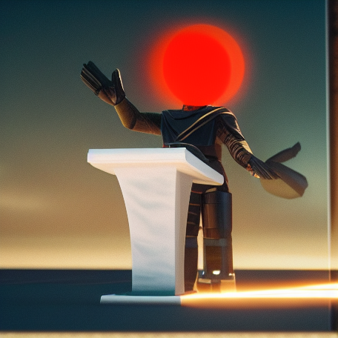

Description – Prompt2 (Normal)

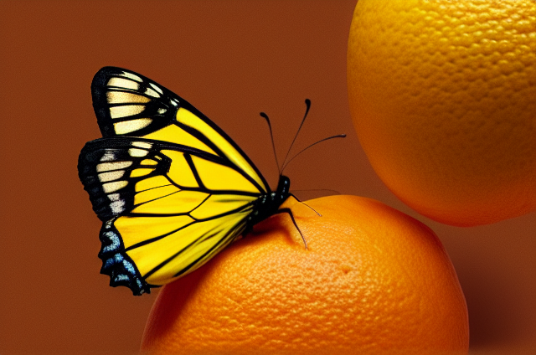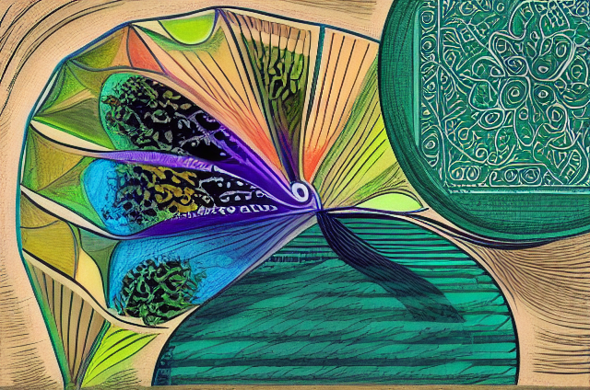

Description – Prompt2 (Segmentation)

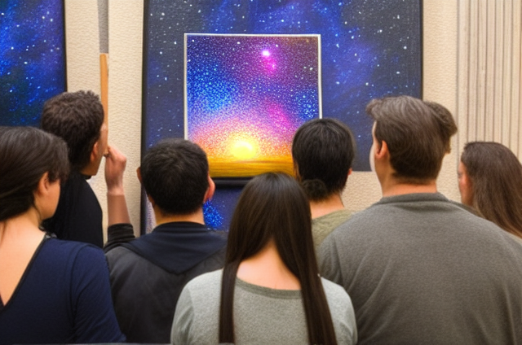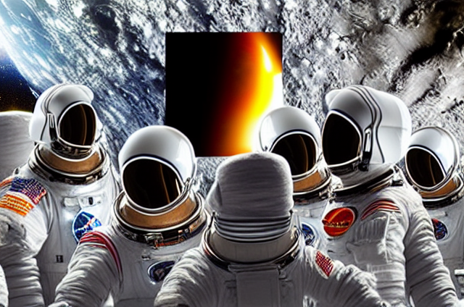

Part 2 Results:

Description –

Description –

Description –

- Problems Encountered and Solved:

One problem arose when performing part 1 of this lab. That is, the system did not recognize a model being used. It provided the error saying “No model was supplied, defaulted to Intel/dpt-large and…”. The fix I added to the code was to import os and add a line of code saying “os.environ[‘HF_HOME’] = ‘/tmp/huggingface’” to specify redirect the cache to a temporary, writable location.

- Answers to Lab Questions:

Part 1 Answers:

- OpenposeDetector strips away background, clothes, lighting, and other factors that may confuse the model so that it would only focus on the target’s pose. It turns the image into a simple stick figure that just contains the pose of the target. This is because ControlNet was trained to read that exact stick figure format to understand human anatomy.

- Since regular stable diffusion relies on text, it will hallucinate where things should be placed on the image. So, ControlNet changes this by using an image map to force the model to draw things in specific locations. As for “torch_dtype=torch.float16”, this cuts the model’s memory by 50% so it will fit on our GPUs. Targeting the “xpu” device is for running the code on the GPU instead of the CPU which is much faster in terms of generation time.

- The prompt tells the model what to generate, and the image tells the model where to draw it. ControlNet layers constantly input the physical layout rules into the image as they get generated so that both instructions are matched.

Part 2 Answers:

- Lessons Learnt:

