- General Information

Student Name: Yolmorakatpanhcharong (Morakat) Lim
Student ID number: 01844931
Lab #2
Date of completion: 03/22/2026
GitHub: https://github.com/MorakatLim/intro_genai/tree/master

- Lab Focuses and Outcomes:

  - Main Topics covered in this Lab

The objective of this lab was to explore advanced model training and evaluation methods in two phases. Part 1 focuses on LoRA to fine-tune a pretrained model, followed by a quantitative analysis of its performance. Part 2 focuses on experimenting with Reinforcement Learning from Human Feedback (RLHF) utilizing the Proximal Policy Optimization (PPO) algorithm.

  - Software Design

For this lab, code changes were applied to sections with #TODO commented. All .ipynb files for this lab were downloaded and uploaded to GitHub in the link above. Part 1 and Part 2 modified codes are in their respective .ipynb files on Github. Aside from adding code to fix issues errors, most of the codes stayed the same with little to no changes in sections that do not contain #TODO. Lines that were added under #TODO were referenced from exercises.

  - Results

Part 1 Results: Successfully implemented a SFT pipeline given the base code and code that I implemented for the #TODO sections. I had issues with out of memory when running the entire program, so I did some research and looked back at notes and found that using a 4-bit quantization (QLoRA) with the bitsandbytes library fixes this issue. It compresses the model’s memory footprint and loads its weight in a lower precision format. Afterwards, I added the code to compute the aggregated ROUGE metrics against the references. See the GitHub for the code and full results

Description – Result from evaluating base model summaries using ROUGE Metric
Screenshot – Good scores for the baseline. We are not looking at any gibberish which I would assume is 0%.

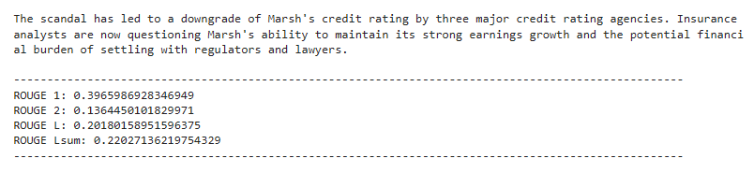

Description – Result from evaluating summaries using ROUGE on inference Fine-tuned Model

Screenshot – Model reads great. LoRA implementation was successful and taught the model how to summarize well. Scores increased from their initial baseline scores.
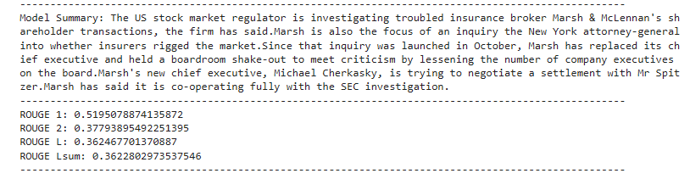

Part 2 Results: Successfully implemented RLHF using PPO to align the fine-tuned model against generating toxic content. TODO blocks were implemented with a slight tweak where I mapped the toxicity reward model to the GPU since I was getting a warning that it was using CPU only on the pipeline for some reason. The final quantitative results yielded a negative percentage improvement in toxicity reduction; it proved that the RLHF pipeline was functional. The negative metrics in my opinion was expected since I restricted the step count to 250 for faster training.

Description – Model Fine-Tuning

Screenshot – 250 max_steps for a faster training model (downside is the training will yield a suboptimal result)

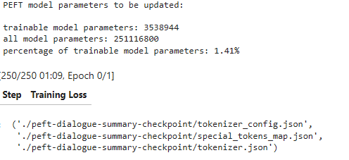

Description – Setup Reward Model

Screenshot – Shows that the TODO sections were implemented correctly

Description – Non-Toxic Text results

Screenshot – We can see that the model identified the text as non-toxic with 99.98% probability

Description – Toxic Text results

Screenshot – We can see that the model identified the text as toxic with a 97.45% probability

Description – Toxicity mean/std before detox

Screenshot – Mean and Std shows it’s naturally polite and consistent

Description – Toxicity mean/std after detox

Screenshot – Still fairly the same as previous

Description – Evaluation of Model Quantitatively

Screenshot – High negative mean and std due to low step count

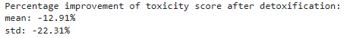

- Problems Encountered and Solved:

In Part 1, the primary challenges were from the kernel memory issues specifically the mismatched versions between the trl library and transformers packages which gave RuntimeErrors. I solved it by modifying the pip install line at the beginning and added “transformers==4.44.2” and restarting the kernel after. During the RLHF phase, I faced issues with the reward model using CPU to evaluate the pipeline. I overwrote it by moving the PPO model’s value heads using “ppo_model.v_head.to(device)” and “ref_model.v_head.to(device)”.

- Answers to Lab Questions:

Part 1 Answers:

- The key components and hyperparameters defined in the LoraConfig are:
  - r (rank) – This determines the size of the matrices. It controls how much new information LoRA can learn.
  - lora_alpha – This determines how aggressive the new LoRA weights influence the original base model. Higher values make the LoRA updates more influential.
  - target_modules – This tells which layers too attach the LoRA matrices to.
  - lora_dropout – This applies dropouts to the layers during training to prevent overfitting.
  - bias – This specifies if the bias weights should be trained or not
  - task_type – This just defined the architecture’s goal or kind of task.

- ROUGE evaluates the summarization quality by measuring them comparing them with reference summary. Based on the results above, we can see that the baseline achieved a rouge1 and rouge2 ~39.7% and ~13.6% respectively. But, after fine-tuning, rouge1 jumped to ~52.0% and rouge2 jumped to ~37.8%, similarly for rougeL and rougeLsum.

  - rouge1 – measures the overlap of unigrams
  - rouge2 – measures the overlap of bigrams
  - rougeL – measures the longest common subsequence
  - rougeLsum – similar to rougeL but calculates the entire summary
Part 2 Answers:

- Datasets are filtered by character or token length. It will drop dialogues shorter than 200 characters or longer than 1000 characters. Quality-wise, filtering out any long dialogues prevents the input from exceeding the max context window. Suitability-wise, filtering out short dialogues ensures the model isn’t trained on short words like “a, the, hi, or hello”.

- The logit “not hate” is used as a reward signal by feeding it directly to the PPO algorithm. Some advantages are that it is efficient because it optimizes for a continuous reward signal, meaning that higher “not hate” score equals better rewards and teaches the model to avoid toxicity. Some disadvantages are that it captures only one aspect of response quality. It does not check if the text is a good summary, has good grammar, or if it is a logical input at all.

- Every time the model creates a summary, the ref_model also creates a summary for the same prompt. The system calculates the difference between the two outputs and if the active output is too different from the reference model, it will apply a penalty. Essentially, it forces the active model to chase the non-toxic reward. Without the reference model, the active model would basically forget how to summarize dialogues and give weird outputs.

- Lessons Learnt:

This lab demonstrated that SFT using techniques like LoRA can rapidly improve a base model’s summarization skills as shown by the results above. Using RLHF for behavioral alignment showed that the PPO pipeline requires us to specify between CPU and GPU usage (although this might be something I have done on my end – unsure). Another lesson learned is regarding the reference model, it is critical to keep the active model anchored to prevent forgetting during reward optimization. My counterintuitive toxicity results proved that the model works as expected and this lab is perfect for testing these techniques but a better model would require more datasets and even more steps (instead of my 250 max steps) to yield a better result.

