- General Information

Student Name: Yolmorakatpanhcharong (Morakat) Lim
Student ID number: 01844931
Lab #1
Date of completion: 02/22/2026
Github: https://github.com/MorakatLim/intro_genai/tree/master

- Lab Focuses and Outcomes:

  - Main Topics covered in this Lab

This lab is to practice the usage of LLMs and use the concepts of prompt engineering based on what was discussed in class to experiment with initial LLMs and finetuned ones. Initial testing of simple LLM testing provides the basic understanding of differences in LLMs’ settings such as temperature, top p, top k, and so on. Additionally, prompt engineering through the use of gemma will teach how to use prompt engineering effectively. Lastly, fine-tuning shows an LLM’s ability to understand better of specific terminology and concepts.

  - Software Design

For this lab, the only code changes made were in part 3 where the dataset names as well as various variable inputs like “instruction”, “response”, and inputs. were changed to match that of the dataset. All .ipynb files for this lab were downloaded and uploaded to GitHub in the link above. Part 1 does not have an .ipynb file included in GitHub as the results are shown below. Parts 2 and 3 does have an .ipynb file uploaded to showcase the output of each .ipynb files. Please refer to the GitHub location as well as the results sections below to see screenshots and explanations.

Part 3 Changes to the code:

I modified some of the code when using the lavita/ChatDoctor-HealthCareMagic-100k dataset to make the fine-tuning a little bit faster on my end since originally it was going to take 12 hours to fine-tune 5608 steps. I modified and added some code to the fine-tuning process to limit the steps to 500. Although, this is not ideal, due to the huge amount of time needed to fine tune this dataset, I believe the fine-tuning process is still nominal. Please refer to the .ipynb file for part 3 on the GitHub to see code changes.

  - Results

Part 1 Results:

Description – Changing the temperature of the model changes the randomness of the AI. From the results, we can see that if we reduce the temperature close to 0 or below 0.25, the model becomes fairly deterministic as it provides us with similar if not the same responses. Vice versa for higher temperature values, it provided us with more randomness and interesting responses. Their quality of completion is good based on the inputs, since most of the questions are about space, it answers correctly and accurately.
Screenshot – Difference in outputs given the same input

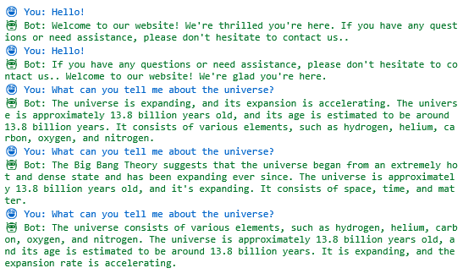

Screenshot – Temperature Variability, Results from variable Temperature values 1.00, 0.25, 0.50 respectively:

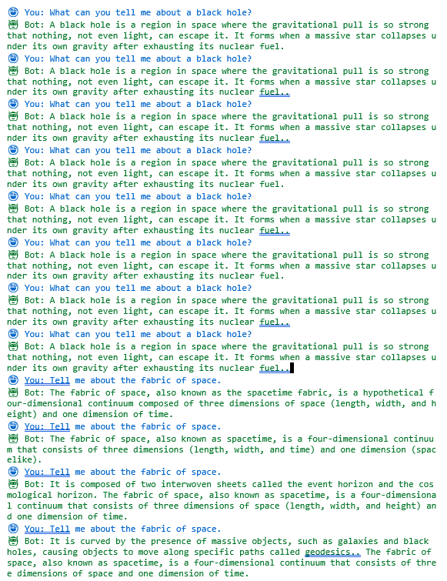

Part 2 Results:

Description – The output includes a list of winners and years in json format. The json format also include the year of 2024. The output also discusses why the year 2026 is still empty.

Screenshot – The screenshot shows a list of winners and years with explanation at the bottom of the json format.



Part 3 Results:

Description – Results are as follows: First we provide the same three prompts before fine tuning and after fine tuning to compare the differences.

Screenshot – This screenshot shows three inputs from the lavita/ChatDoctor-HealthCareMagic-100k dataset before fine-tuning the gemma model.
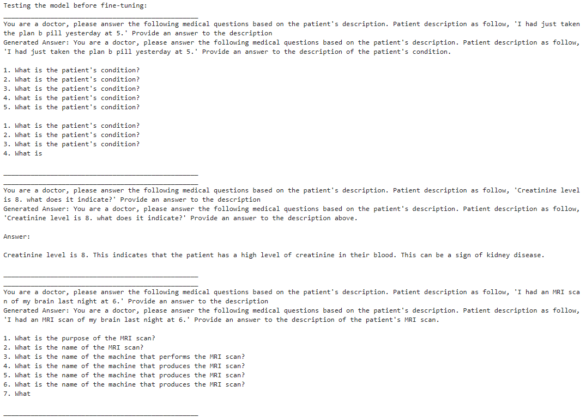

Screenshot – This screenshot shows three inputs from the lavita/ChatDoctor-HealthCareMagic-100k dataset after fine-tuning the gemma model. In comparison to the model without fine tuning, we can see each response is complete and does not repeat multiple times like the original. This model is now also saved as gemma-2-2b-it-finetuned (see the GitHub file gemma_finetuning.ipynb).

- Problems Encountered and Solved:

A few problems occurred throughout this lab, one being the root disk is always getting full while using HuggingFace. But the solution was very simple as it was only needed to do rm -rf ~/.cache/huggingface while in root directory to clear the caches from HuggingFace. Some lines of code were needed to change in part 3 for the new dataset but not much else besides the name and variable names to match that of the dataset. Another issue found in part 3 was that the fine-tuning process for lavita/ChatDoctor-HealthCareMagic-100k data originally took 12 hours. I had modified the code as a workaround solution for now to limit the fine-tuning max to 500 so that it only took 30 minutes instead of 12 hours. This sped up the fine-tuning process a lot, but it has some drawbacks as it did not train through its actual number of steps.

- Answers to Lab Questions:

Part 1 Answers:
- The parameters that can be configured for an LLM in this notebook are Temperature, Top P, Top K, Num Beams, and Rep Penalty.
- When picking the parameter Temperature, changing the variability of it from 0.25 to 1.00, it can be seen that the model’s completions are more deterministic when lower temperatures as opposed to higher temperatures.

Part 2 Answers:
- The years 2010 to 2025 are already known by the model without any context learning and just zero-shot instruction.
- It downloads the files to define the model’s architecture and trained weights.
Part 3 Answers:
- Datasets are divided into training and validation samples with a specified test size. Preprocessing is performed by a function that computes the instruction and output into a string which then gets tokenized using the model’s tokenizer.
- While the full dataset would have taken 12 hours, my modified code is capped at 500 steps. This allows the fine-tuning process to run in 30 minutes (although not ideal, it is worth it for my case). Time is heavily influenced by batch_size and gradient_accumulation_size. These parameters determine how many samples are processed before weights are applied. Reducing the max steps is a trade off since the model’s performance is now also reduced and is no longer as “well-trained”.

- Lessons Learnt:

This lab highlighted several key takeaways regarding LLM performance and optimization. Part 1 demonstrated the impact of model parameters, showing how adjusting variables directly controls the variability and consistency of the output. Part 2 focused on prompt engineering, proving that clear and specific instructions are necessary to get predictable, high-quality results. Finally, Part 3 showed that fine-tuning with targeted datasets is the most effective way to improve factual accuracy and refine the model’s responses. This lab emphasized that high-performance outputs require a combination of precise settings, effective prompting, and quality data.

