OooSVN user guide

Introduction

Placing a document under Change Control
To enable version, a document must first be placed under change control. This can be accomplished in two ways. The default way is by calling SVN > Place document under version control from within OOo. This will extract the document, place it in the repository, then check out and rebuild a working copy which will be reloaded. This whole process happens in the background and should only take a fraction of a second.
The second way to place a documents under version control is to enable automatic importing when ever a 'Save As' is done. This option is not enabled by default as it is not suitable for many users. To enable this option, go to Tools > Customise, Events tab, make sure the action is set to 'OpenOffice.org', select the OnSavedAs event and assign a macro to it. Assign the OooSVN > Module1 > OnSavedASSVN macro to it.
To be able to be imported into change control the document must be of a compatible type (OASIS OpenDocument Format or StarOffice XML) and the working directory and repository must be present. If not, the system will present you with an error and it will exit safely.

Committing changes in a document

Viewing Document Info
SVN > Active version info allows you to view information stored in the repository about the active version of the current document. It is presented in the form of a dialogue box:
A few quick definitions:
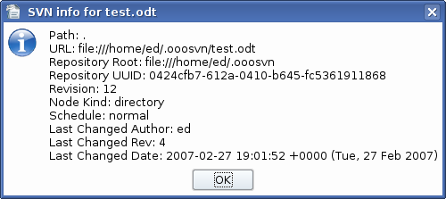Figure 1: Document information dialogue
URL: The directory within the repository where the document is stored. With this URL you could access the contents of the document.
Repository Root: A URL for the repository where the document is stored.
Repository UUID: A unique identifier for the repository. This is the method by which repositories may be tracked and it is recorded in the metadata of the document upon importing to change control. This can be viewed in File > Properties, User defined tab.
Revision: The revision number of the active version. This number is not sequential for an individual document but is incremented for each document in the repository.
Node Kind:
Schedule:
Last Changed Author: The user ID (in the SVN repository) of the person who last committed a change in the document.
Last Changed Rev: The repository revision in which the document last changed. This is frequently not the same as the 'Revision' field.
Last Changed Date: A useful time tag for the last modification.

Viewing Document Revision Log
SVN > Document log allows you to view a log of all of the changes that have taken place in the document.
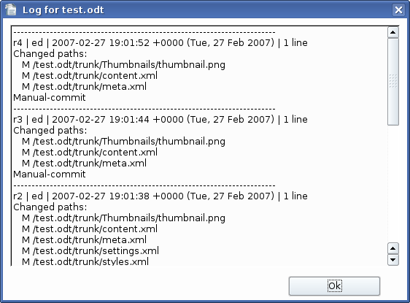Figure 2: Document log dialogue

