**Lab 1.2 - .NET command line compiler tools and IL exercise**

3.d.a Explain what each of IL line of code does :

.method private hidebysig static int32 Add(int32 a, int32 b) cil managed

{

// Code size 9 (0x9)

.maxstack 2

.locals init (int32 V_0)

IL_0000: nop Performs an operation without behavior

IL_0001: ldarg.0 Load the first argument onto stack

IL_0002: ldarg.1 Load the second argument onto stack

IL_0003: add Add the 2 previous values and return the value

IL_0004: stloc.0 Pops a value from the stack and stores it in **local** variable

IL_0005: br.s IL_0007 transfers control to line IL_0007 (next line)

IL_0007: ldloc.0 Load the local variable at index 0 onto stack

IL_0008: ret return

} // end of method Calc::Add

3.iii. Compile the code using csc program.cs /out:calc.exe

1. Can you explain the error?

**Answer:** class Calc is not define in program.cs

3.iv. Try to compile the code again using: csc program.cs /addmodule:calc.netmodule /out:calc.exe

1. Can you explain the errors?

**Answer:** the methods Add and Subtract is private.

3. x. Open Calc.exe using ildasm:

1. Ildasm calc.exe

2. Press Ctrl-M

3. Can you explain what you see?

**Answer:** The assembly metadata contains a collection of data that describes how the elements in the assembly

relate to each other. An assembly manifest contains all the metadata needed to specify the assembly's version

requirements and security identity, and all metadata needed to define the scope of the assembly and resolve

references to resources and classes. ([msdn.microsoft.com](https://msdn.microsoft.com/en-us/library/1w45z383(v=vs.110).aspx))

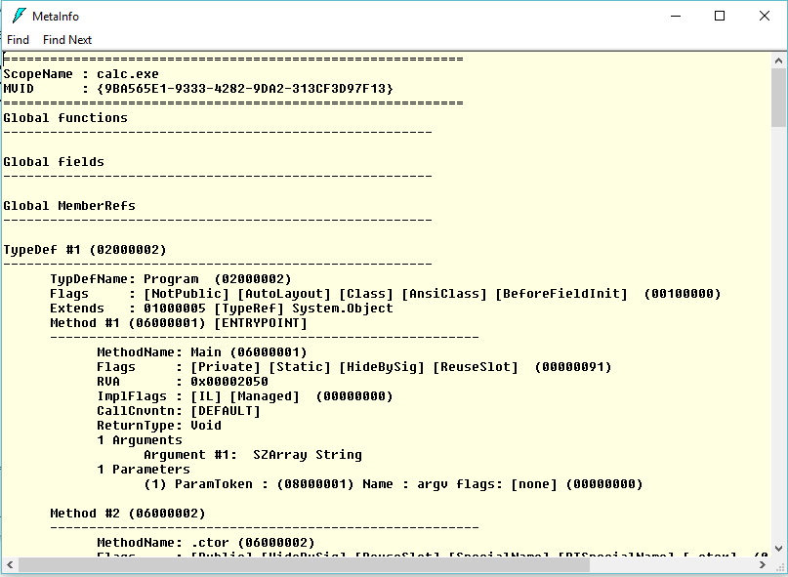

MetaInfo מכיל את כל המידע על הקובץ calc.exe: שדות, פונקציות, היררכיות