Tehnical Report
Object Tracking
Muresan Mihai-Daniel and Morar Horea-Razvan
Supervisor: Camelia Costina Florea
Date: 16.04.2026

Abstract
In this project,an application for object tracking in real-time from a video sequence was developed, using the CSRT (Channel and Spatial Reliability Tracking) algorithm. The main objective of the system is to allow the user to select an object of interest in an initial frame and to continuously track its position across subsequent frames, while also evaluating the tracking performance through multiple quantitative metrics.
The application follows a structured processing pipeline. In the first stage, the user manually selects a region of interest corresponding to the target object. This region is then used to initialize the tracking model. In the second stage, each incoming video frame is processed using the CSRT tracker, which estimates the new position of the object by applying correlation filters enhanced with spatial reliability mechanisms. The tracked object is visualized in real time through a dynamically updated bounding box.
In addition to tracking, the system performs continuous performance analysis. Several metrics are computed, including frame processing time, frames per seconds, tracking success rate, time intervals in which the object is successfully tracked versus lost, and variations in the bounding box area. These indicators provide insight into both the robustness and stability of the tracking process under different conditions.
The implementation was carried out in Python, using libraries such as OpenCV, NumPy, and Matplotlib. Experimental results demonstrate that the CSRT-based approach provides reliable tracking for objects with moderate motion and limited occlusion. However, performance degrades in challenging scenarios involving fast motion, significant scale changes, or temporary object disappearance.
- Key words: video processing,CSRT,OpenCV,Numpy,Matplotlib.
- Input data:self-made video.
- Output data:Object tracked by CSRT algorithm.

Introduction
Object tracking is a fundamental task in computer vision, with important applications in video surveillance and autonomous systems. The ability to continuously estimate the position of an object across video frames enables higher-level processes such as motion analysis and scene understanding. While modern approaches often rely on deep learning, classical tracking algorithms remain relevant due to their efficiency and low computational requirements.
The core idea is to initialize a region of interest (ROI) corresponding to the target object and to update its position in each frame based on visual features. In this project, the CSRT (Channel and Spatial Reliability Tracking) algorithm is used, as it improves robustness by combining correlation filters with spatial reliability mechanisms, allowing better handling of appearance changes and partial occlusions.
The objective of this work is to demonstrate that classical tracking methods can provide reliable real-time results, while also enabling performance evaluation through metrics such as FPS, tracking success rate, and bounding box variation.
The implementation was carried out in Python using OpenCV, NumPy, and Matplotlib.

Theoretical Background
The proposed object tracking method is based on fundamental concepts from classical computer vision and signal processing. It relies on the use of correlation filters, spatial reliability modeling, and region-based representation to continuously estimate the position of a target object in a video sequence.
Object Tracking
Object tracking refers to the process of locating a target object across consecutive video frames after an initial position is defined. Unlike object detection, which identifies objects independently in each frame, tracking assumes temporal continuity and updates the object’s position based on its previous state. This allows for more efficient processing and real-time performance.
CSRT Algorithm
A key component of the system is the CSRT (Channel and Spatial Reliability Tracking) algorithm. This method is based on discriminative correlation filters, which learn the appearance of the target object and match it in subsequent frames. The “channel reliability” aspect refers to the use of multiple feature channels (such as color and gradients), while “spatial reliability” assigns different weights to regions of the object, improving robustness in the presence of background noise, deformation, or partial occlusion.
Region of Interest (ROI)
The tracking process begins with the manual selection of a region of interest (ROI), corresponding to the object to be tracked. This region defines the initial bounding box and serves as the reference for the tracker. The ROI is essential, as it provides the initial appearance model that will be updated throughout the tracking process.
Bounding Box Representation
The position of the tracked object is represented using a bounding box defined by its coordinates and dimensions. This rectangular region is updated in each frame based on the tracker’s prediction. The bounding box allows for a simple yet effective representation of the object’s location and size, and it also enables the computation of additional metrics such as area variation.
Performance Metrics
To evaluate the effectiveness of the tracking process, several performance metrics are used. Frames per second (FPS) measure the processing speed, while the tracking success rate indicates the proportion of frames in which the object is correctly tracked. Additionally, tracking time versus lost time provides insight into the stability of the algorithm, and variations in bounding box area reflect changes in scale or tracking accuracy.

Implementation
The main library used is OpenCV, which provides the implementation of the CSRT tracking algorithm and functions for video processing and visualization. NumPy is used for numerical computations and statistical analysis, while Matplotlib is employed for plotting performance metrics and generating visual reports.
1. Dependency Installation
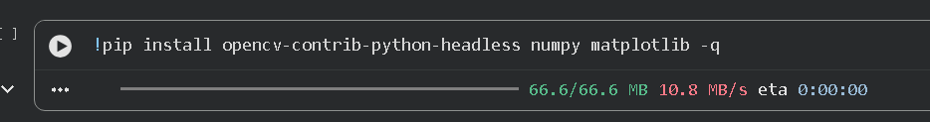
The first section installs the required libraries:
- OpenCV for CSRT object tracking
- NumPy for numerical computations
- Matplotlib for visualization
The headless version of OpenCV is used because the implementation runs in Google Colab, where graphical display windows are not supported.

2. Library Imports and Initialization
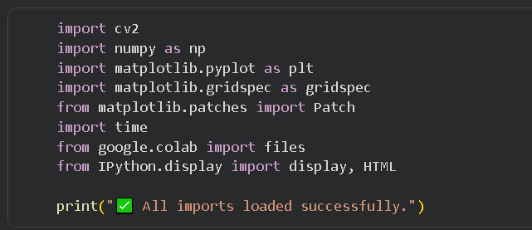
- Cv2 for video processing and tracking
- Numpy for statistical calculations
- Matplotlib for plotting
- Time for performance measurement

3. Video Loading and Validation
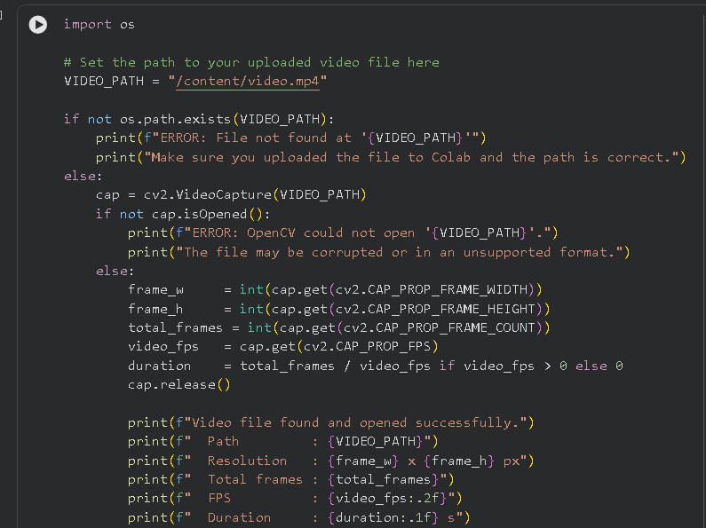
The video file path is defined and verified. The system checks:
- whether the file exists
- whether it can be opened using OpenCV
If the file is valid, key properties are extracted:
- resolution (width and height)
- total number of frames
- frames per second (FPS)
- video duration
This step ensures that the input data is valid before processing begins.

4. First Frame Visualization with Grid
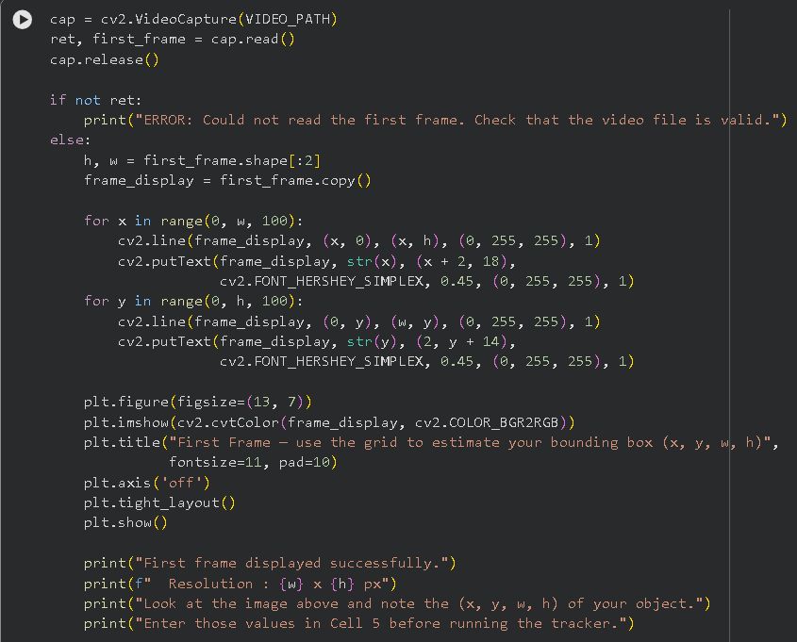
The first frame of the video is extracted and displayed along with a coordinate grid.
The purpose of this step is to assist the user in manually estimating the bounding box coordinates (x, y, w, h) for the object of interest.

5. Bounding Box Definition
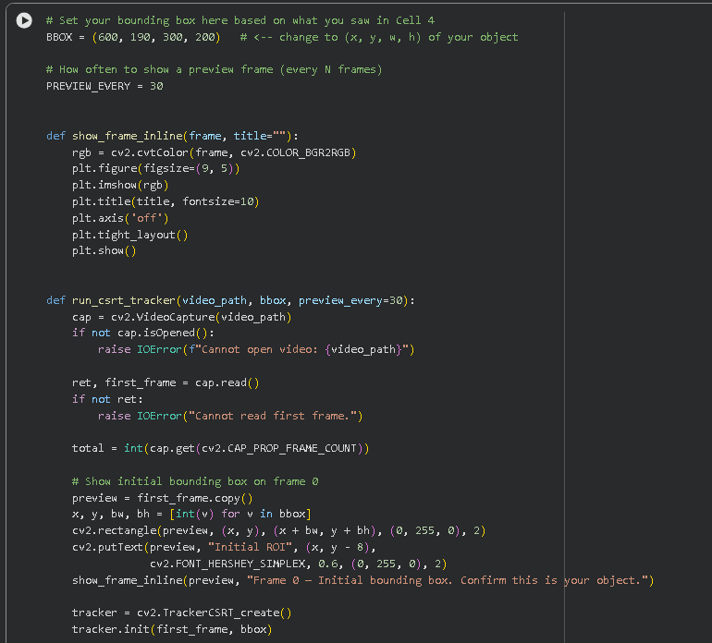
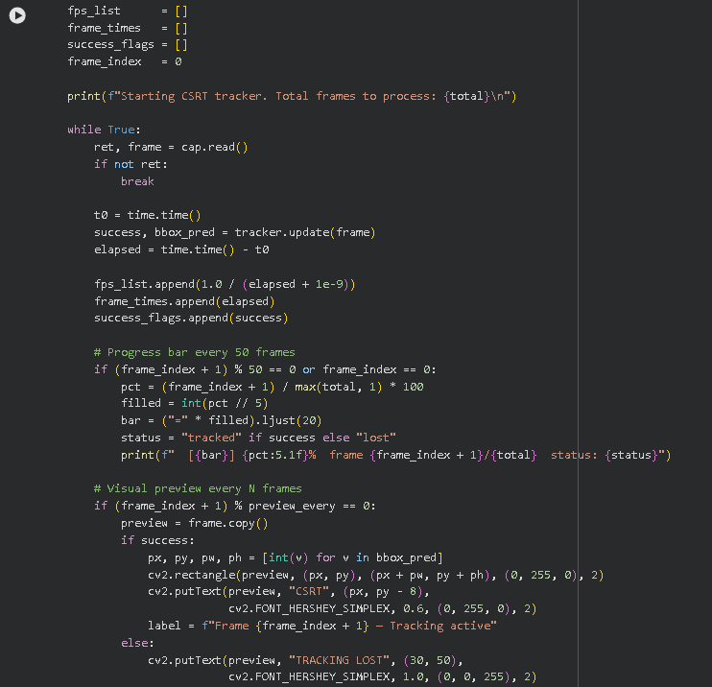
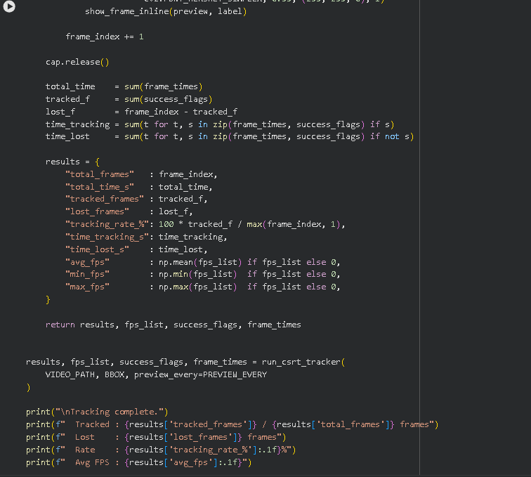
The tracking process begins by manually defining a bounding box that specifies the initial position of the object of interest. A helper function is used to display frames within the notebook environment, enabling visualization of both the initial setup and intermediate results. The core functionality is implemented in a dedicated function that loads the video, initializes the CSRT tracker using the first frame and the selected region, and processes each frame sequentially. During execution, the tracker updates the object’s position, while basic performance data such as processing time, FPS, and tracking success are recorded. Periodic visual previews and progress updates are provided to monitor the tracking process. After all frames are processed, key performance metrics are computed and displayed, offering a concise overview of the tracker’s effectiveness.

6. Frame Display Function
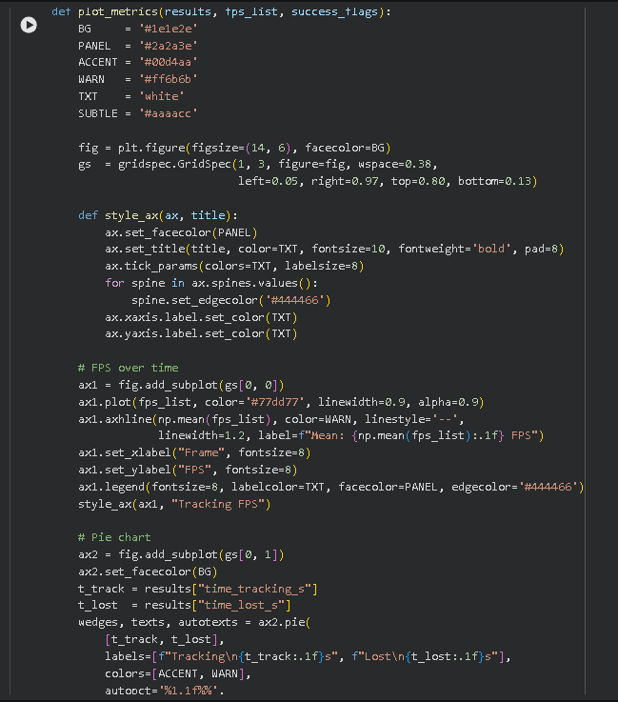
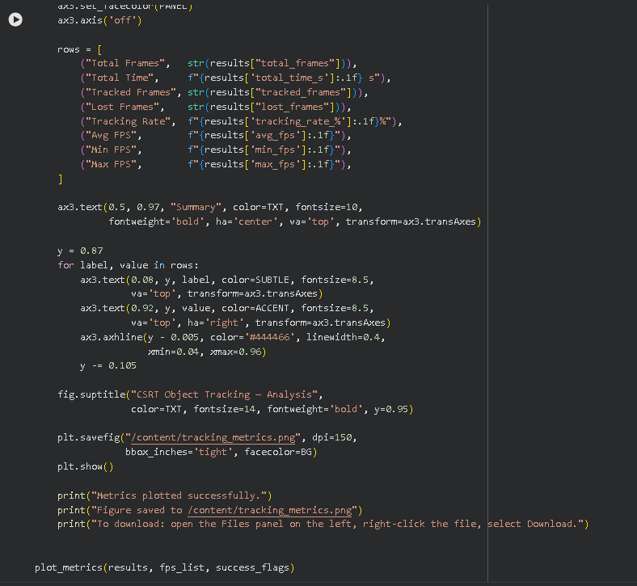
A helper function is implemented to display frames inline using Matplotlib.

Experimental Results and Analysis
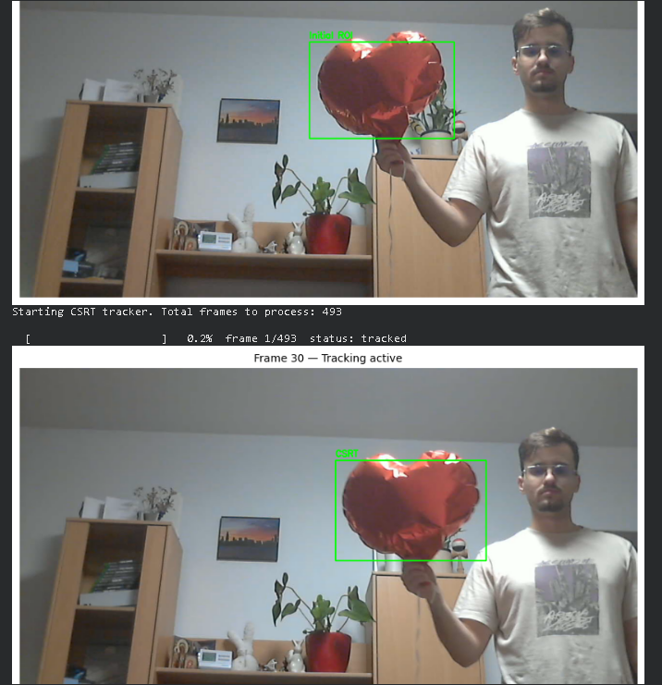
In the example shown above, the tracker is initialized by selecting the object (a heart-shaped balloon) in the first frame. The bounding box correctly encloses the object, confirming a proper initialization. In subsequent frames (e.g., Frame 30), the tracker successfully follows the object, maintaining a stable bounding box despite small movements and slight changes in position. The “Tracking active” status indicates that the algorithm is functioning correctly.

Overall, the results demonstrate that the CSRT tracker performs reliably in controlled conditions, maintaining accurate tracking when the object undergoes moderate motion and remains visible. However, in more challenging scenarios such as fast movement or temporary occlusion, the tracker may lose the object, which is reflected in the “Tracking Lost” state.
In conclusion, the experimental results confirm that the implemented method is effective for real-time object tracking, while also highlighting its limitations in more complex situations.

Conclusion
This project demonstrated the implementation of a real-time object tracking system using the CSRT algorithm. The results show that the method provides reliable tracking performance in scenarios with moderate motion and limited occlusion, while maintaining good processing speed. However, its performance decreases in more challenging conditions such as fast motion or object disappearance. Overall, the project confirms that classical tracking algorithms remain effective and suitable for real-time applications.

Bibliography
[1] OpenCV Documentation – Object Tracking Module
https://docs.opencv.org/
[2] Lukezic, A., Vojir, T., Čehovin Zajc, L., Matas, J., Kristan, M.
“Discriminative Correlation Filter with Channel and Spatial Reliability”
IEEE Conference on Computer Vision and Pattern Recognition (CVPR), 2017
[3] Bradski, G., Kaehler, A.
Learning OpenCV: Computer Vision with the OpenCV Library, O'Reilly Media, 2008
[4] Szeliski, R.
Computer Vision: Algorithms and Applications, Springer, 2010
[5] NumPy Documentation
https://numpy.org/doc/
[6] Matplotlib Documentation
https://matplotlib.org/stable/index.html

