Student: Oscar Armando González Patiño

Clave: 256007

Teacher: M.C. Claudia Alicia Méndez Hernández

Course: Data Base A

Data base manager system

Data Base A project – User’s manual

# Installation

To install the project, unzip in the desired location. This will create the DBMS executable.

# Executing the program

To launch the program, double click on exe. The following screen will show up:

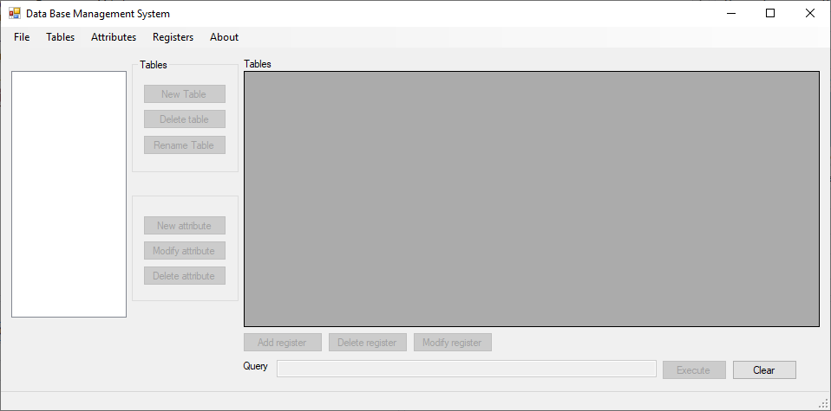

In the left control, the current database tables can be located. Controls to the tables and attributes are next to this control. The tables are shown in the right control. Register operations buttons are in the bottom. Query sentences can be executed at the bottom textbox.

The menu bar is located at the top, it contains all the basic commands, and every button action in the program. You can resize and minimize the window. This program automatically saves the database after every action (insert register, delete register, modify register, etc.).

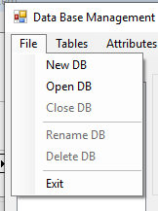In the “File” menu you can find these commands:

**New DB:** create a DB folder in the preferred location with name.

**Open DB**: open a DB folder: this must be exclusively a folder created with this project. If any other folder is opened, it will cause error.

**Close DB:** closes currently opened database.

**Rename DB:** rename the current database

**Delete DB:** deletes currently opened database from Windows explorer

**Exit:** closes the program

# Managing databases

## Create, delete and rename tables

Different actions can be done in databases that are opened or created. The first thing to do is to create Tables. Select “New table button” to create tables. You can also rename a table or delete it by just click on the name in the left control, and then click on “Delete table” button, or “Rename table” button.

A table can only be deleted or renamed only if it it’s primary key is not used as foreign key in another table.

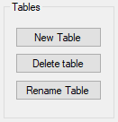

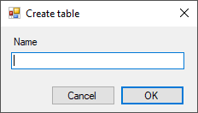Clicking on **New table** or **Rename table** will show dialog like this.

Enter or modfy a table name, then click ok to add it

## Add, modify or delete attributes

A table must be selected to make attributes operations. After selecting a table in the left control, you can add, remove or modify an attribute.

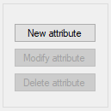Clicking on “**New attribute”** button opens a dialog. You must enter all attribute metadata to add an attribute to the table.

The modify and delete buttons are only activated if the current table has no registers. If a table has registers, you can delete all registers and the buttons will be activated.

To delete and modify and attribute, first you must select its column name from the data grid. Then the buttons will be activated.

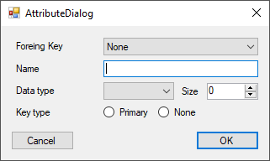

This is what the attribute dialog looks like. If you want to insert a foreign key, select it from the top combo box. After selecting, only the field you can modify is the **Name**: the type and size of the attribute will lock.

If you select *None*, all controls are activated. Enter the attribute name, type and length *Note: length is only available to String type*. Select *primary* or *none* key. A table can only have one primary key. You can modify this later before inserting any register.

# Registers

After creating some tables and some attributes, you can start inserting registers. Make all desired changes before inserting registers, as you won’t be able to modify any table attributes or names. To make register operations, click on the bottom buttons.



**Add register:** click on a table with attributes. Click the button. A dialog with all attributes will show up for you to fill. After the values are inserted, click on OK to confirm. The register will appear in the above table.

To delete or modify a register, please select the corresponding row in the above table. Then the delete and modify register buttons will be activated.

**Delete register:** by clicking on this, a confirmation dialog will appear, to delete the register just press Ok.

**Modify register:** to modify a register, click on the modify button. A dialog filled with all register values will appear. You can modify whatever values you want. When all values are correct, click on OK button to save changes.

*Note: a table with a foreign key will only accept those values who are found in the corresponding primary key table. If you insert a value that doesn’t exists, an error dialog will show, and you must correct this. For instance, a table with primary key being used in another must be filled before the table with the foreign key.*

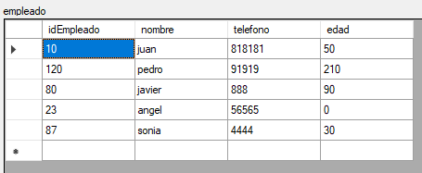

After inserting registers, the table up above will look like this. These are some registers of a table called “empleado”.

# Queries

This data base managing system supports a very basic query language. You can enter your query in the bottom field.



The supported queries are the following. You can write the keywords “CAPITALIZED”, “lowercase”, or as “Sentence”, o a mix of lower and upper case.

The *SELECT* can be written in the following rules:

**SELECT * FROM *table***

**SELECT *attr1, attr2, attr3* FROM table**

**Or**

**SELECT *table*.*attr1, table.attr2, table.attr3* FROM table**

You can add a WHERE clause only to the simple select. Here, the attribute to compare must be alone, without writing *table.attribute.*

**SELECT * FROM *table* WHERE *attribute = value***

**SELECT *attr1, attr2* FROM table WHERE attribute = value**

**Or**

**SELECT *table.attr1, table.attr2* FROM table WHERE attribute = value**

You can only compare numeric values, and with these comparators:

* =
* <=
* >=
* !=

A basic inner join is working, but only with the SELECT. For example:

*Note: the INNER JOIN won’t work with the WHERE clause. Also, in this sentence, you must select the attributes of the tables to be joint: so, the SELECT * FROM will not work. Only numeric values can be compared. And only works between a primary key in a table and its foreign key in the other table.*

**SELECT table1.attribute, table2.attribute FROM table1 INNER JOIN table2 ON table1.value = table2.value**

To execute your query, click on the execute button. If everything is OK and there are no errors in the grammar, then a table will show in a window. If the condition of the query satisfices values in the table, these will show in a dialog.

