SRT411 Assignment 1
All documentation and files of work can be found in the GitHub account of: https://github.com/MoreExcuses/SRT411-Assign1

Part 1: Studying the Verizon Data Breach and Investigations Report and VERIS

Verizon DBIR 2015 provides an in-sight look at the last year’s reported attacks and different angles that were used. They also provide details on areas of major concern and also bring up many wide topics that deal with security. It is very interesting to see that mobile attacks do not even add up to 1% of attacks with most of these being negligible. Also even though there were quite a few more interesting things to note. It is stated that many of the systems that were attacked, had vulnerabilities that had CVE posted information about that existed over a year ago. This was the cause of 99.9% of successful attacks. Systems that became compromised often were also found out too late. For malware problems, it was detailed that 5 malware events occur every second and the average time for a company to find it was under 35 days. Also there has been an increase of successful phishing attacks which went up by roughly ~3%.
VERIS is a system to provide a common scheme or way to communicate how problems are reported. This is similar to RFC used by the IEEE. VERIS’s schema files can be found on Github. For Incident Tracking, an incident id/case id is made as well as information regarding the source, a summary and confirmation is made. Also there is an area for related cases and there is even a field to facilitate for room for error or wrong hypothesis about the situation. There also have a ton of enumeration tools used to help keep information structured. Verizon DBIR uses the VERIS framework for data collection and analysis.
Using the most recent data from verisr. Since I downloaded the file and put it in my working directory I had to set : jsondir <- 'data/json/' to gain access to the files. In the more recent file we see a huge spike in the number of incidents when we do a summary of vcdb from 1643 in the textbook to 5711. This is over 3 times the number of incidents in the year that from 2013->2014. In the old heatmap, the old cross products that showed the most or significant amount of activity were related to server-hacking, userdev-physical and media-error. In the most recent set of data the heatmap shown below indicates that significant reduction in userdev-physical.
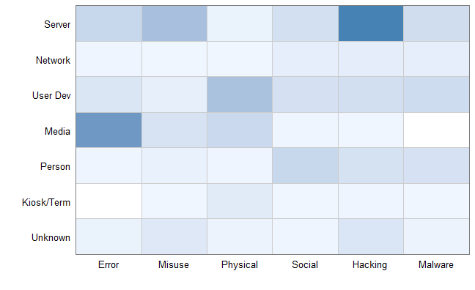
Code had to be altered and below are the corrected changes in order for it to work with new data set.
a2 <- a2[which(a2$enum!="Environmental" & a2$enum!="Unknown"), ]
for the above line, Environmental was not being filtered initially due to that it only filters by exact words, and the lower case in the original code did not work.
gg <- ggplot(a2, aes(x=enum, y=enum1, fill=freq))
Another thing I noticed that, in the book it is stated that you need to assign freq to a2, but it seems that even without specifications when we use the getenum() function, frequency is already taken into account. Also setting the y here to the assigned “primary” which was asset.assets was not very liked. Instead when you print or pull up the a2 enumeration you will see that the 2nd column has the name enum1. Using enum1 for the y variable worked much better.
This heatmap provides a very interesting cross-reference to show what indicative issues are at hand.
Replicating tables as shown in the textbook as shown below with the new dataset
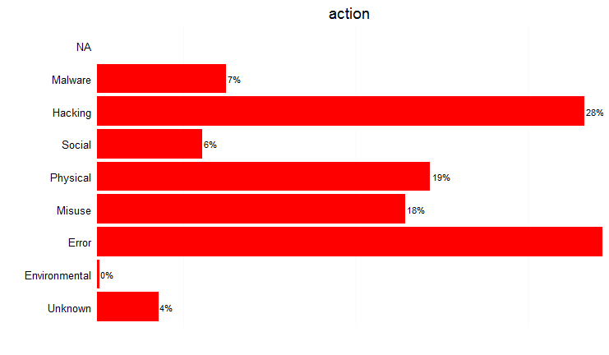
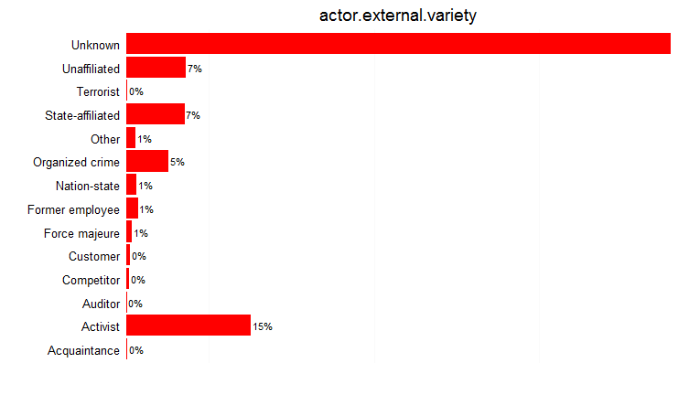
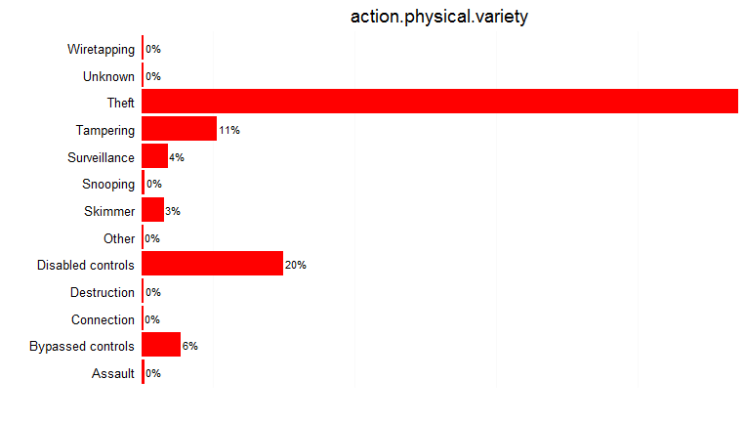
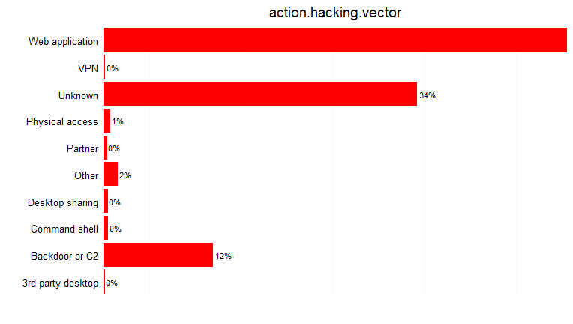
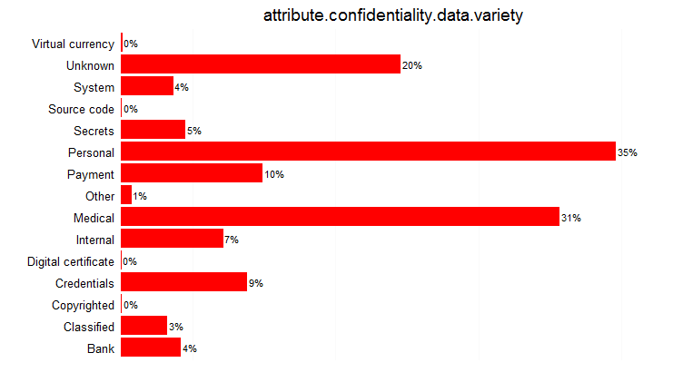
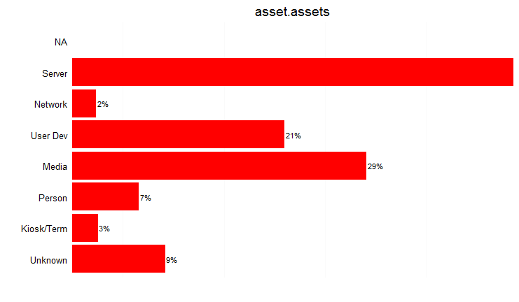

I had to use a larger vector because I couldn’t figure out how to order or sort the data while plotting.

Questions:
- There has been a huge increase in error prone issues in the “action” table, is there a possibility of new software or hardware implementation that is the cause of this?
- There has a doubled amount of malware “actions” found, what methods of attack are most likely the cause for this?
- Apart from theft and tampering as key physical issues, disabling controls has been a huge increase, what are different methods that can be discussed to combat this problem?
- There has been an increased rate of backdoor or C2 usage as a hacking vector, is there the possibility of unknown backdoors within any proprietary used software?
- It seems that targets are now attacking personal information over medical, what are ways we can reduce the likelihood of being a victim of such information lost?
- Servers are still the primary target for hackers, what are ways that can mitigate or methods that will deter these issues?
The R script used for this section is located on Github under the name of Chpt7work.R

Part 2: Studying Large Datasets
Traffic Data from Kyoto University’s Honeypots
Using Data with Sanitized IP addresses
Data from June 01 2009
This data is a capture of IPv6 packets saved within a text file, and since it was properly spaced within the file, it was easily exported to Excel to be verified for the correct format. After pasting this information in, I had to go back and ensure that all fields lined up properly. There were some extra spaces which left columns blank which had to be fixed. Such examples were found in line 560 and 579 which can be seen in the below screen shot. In total there are 125702 rows
We have to left shift row 579 to ensure it matches the other row’s fields. Apart from that, in order to sucessfuly transfer this information with read.csv in R. I must assign proper names for each column and put these in very first row. In the document it shows that there are 14 conventional methods of capturing data for honeypots and there are another additional 10 which were rather interesting. These consist of source ips with source port number as well as destination ip and destination number. Within these last columns there were also extra fields to detect Intrusion, Malware and Ashula (shellcodes) during the connection as well as a label to see if there were any attacks.
Using R, I was able to pinpoint the amount of errors were contained within the newly converted .csv file.
honey2 <- honeypot[which(honeypot$IDS_detect!=""), ]
This will filter out any rows where the IDS is not set, and in the given documentation it is either 0 a number extracted from Symantec. This reduced our dataset from 125702 rows into 118814.

The most interesting part is the Label column. The label can hold 1 of 3 values, 1 for a normal session, -1 means a known attack was observed and -2 means and unknown attack was observed in the session.
Below, by using the verisr library we can see an overall look at the results.
library(verisr)
h2 <- getenum(honey2, "Label")
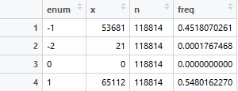

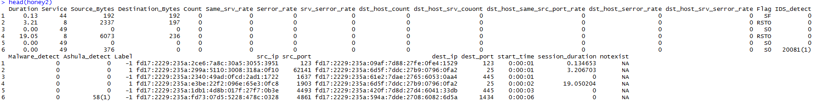

With 24 fields, it is still too hard to work with so I felt it was better to look at the more interesting last 10 columns. Using the dplyr library we can use the select function to choose the last few interesting columns from IDS_detect to destination port.

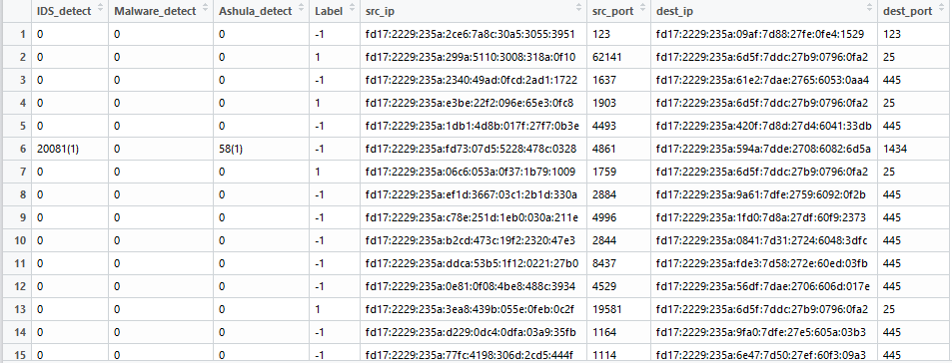

Now we just want to find where an attack occurred, so we look through the Label value for a -1 value.
h4 <- filter(honey4, Label == "-1" )
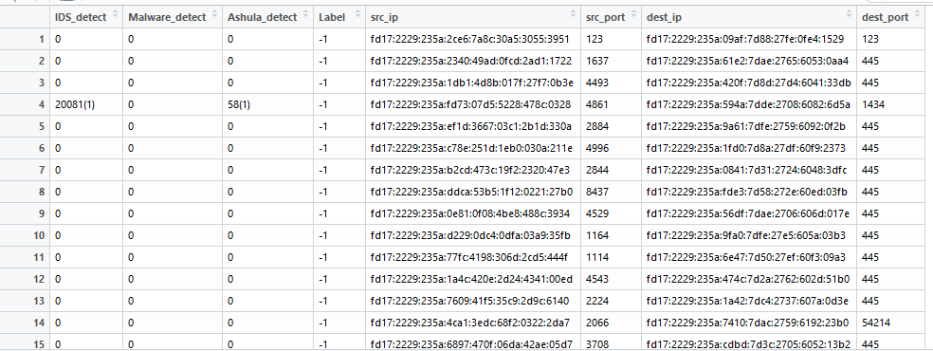
Finally we want to get rid of any possible false positives within Label. Entries without a valid IDS_detect, Malware_detect or Ashula_detect value (if all 3 are 0, meaning nothing was detected) we want to omit it from the database.
honey5<- h4[which(h4$IDS_detect!="0" | h4$Malware_detect!="0" | h4$Ashula_detect!="0" ), ]
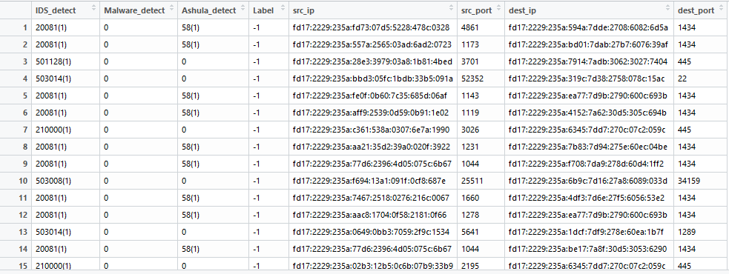
After running a getenum on Malware_detect, I found that all values were 0.
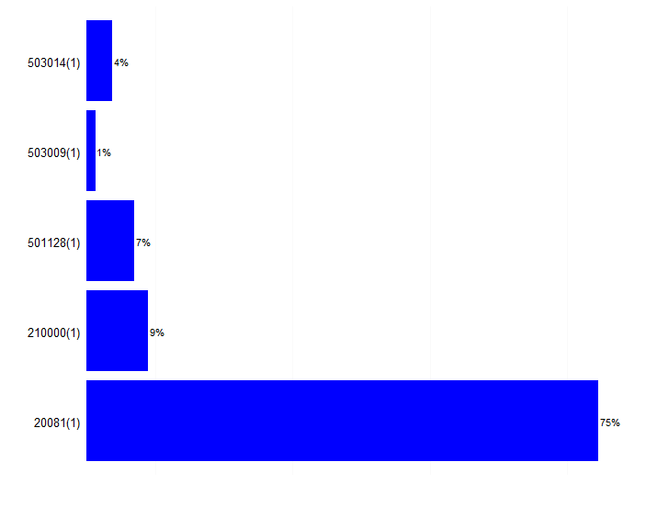
This first table shows the different types of intrusions detected on the system that were flagged. For the IDS_detection we find that the major distribution of detected intrusions were detected as 20081 in the Symantec IDS
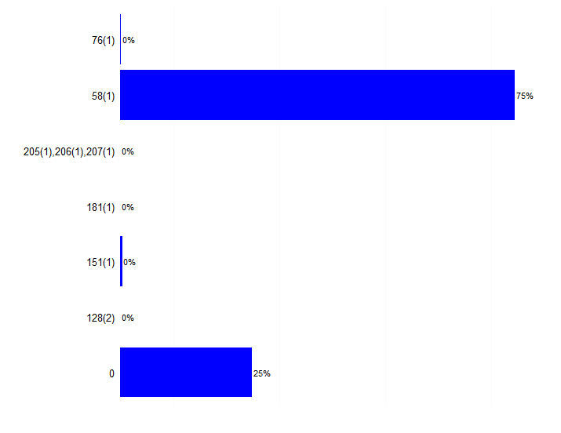
For Ashula_detect on the other hand, although event 151 and 76 state 0%, since the bar is still there, out of the total events it was relatively small (1-3 events). Even though we extracted this data from the same as the IDS, 0s appear even though there were none that were in the IDS_detect. It looks like the OR statements did run into a case, but Ashula_detect did not see anything, meaning no shellscripts were used. Event 58 was a staggering 75% of these cases. The graphs I used were the same as Chapter 7 as I wanted to see the frequency of the cases.
The R documentation for this section of the assignment is located on Github with the name Part2.R

Part 3: Chart Labeling
Additional Documentation is available on GitHub
Phase 1
For phase 1 I was looking for the Destination IPs that played a role by providing a response to the attacker by using:
phase1s<-phase1[which(grepl("reply in", phase1$Info)!= "FALSE"),]
where phase1 is the original csv file.
Then I plotted it with a simple point graph.
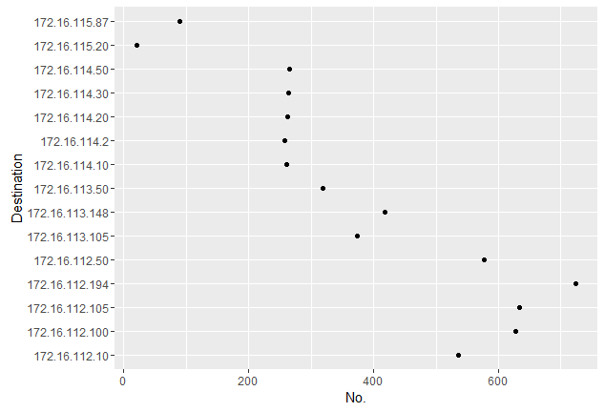
The dots correlate to the specific IP that gave a reply as well as its placement on the x-axis during the capture of the pcap. Roughly after 200 packets, the attacker were able to find quite a large amount of possible targets.

Phase 2
For Phase 2, I first wanted to look at data whereby sadmind makes contact and gets a reply with a port number.
phase2s<-phase2[which(grepl("Port:", phase2$Info)!= FALSE),]
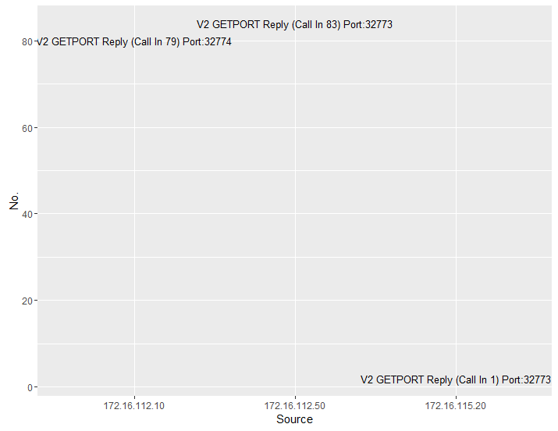
I had issues just trying to extract the port numbers in the text.

Phase 3
For Phase 3, I examined the characteristics of SADMIND and looked at how it how the conversations looked like.
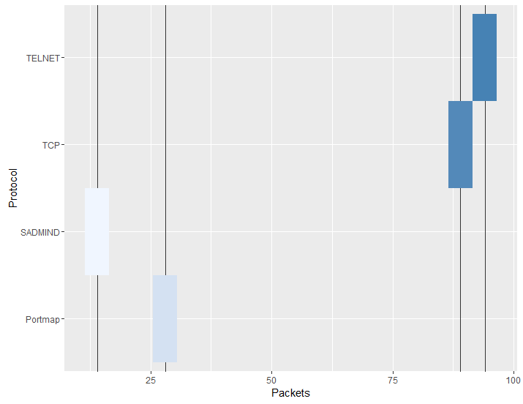
Misusing a boxplot, to illustrate density compared to total packets and using the line to show much packets were actually sent to show how SADMIND and its communication behaved.

Phase 4
In phase 4, I was very interested in the TELNET data. Unlike the last couple of graphs, there was just enough data after isolating the TELNET packets that I could look at the information from source and destination without the graph looking too busy.

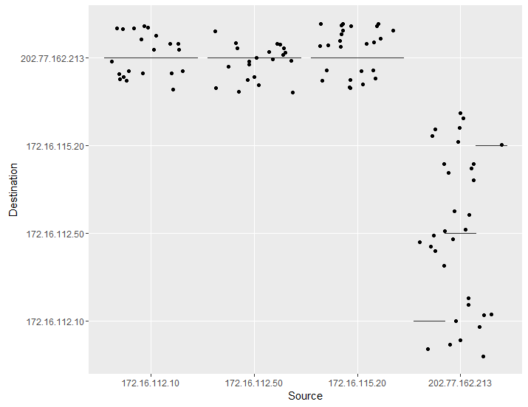

Phase 5
This phase was supposed to be an attempt at using the audit bsm file in conjuction of plotting a parallel coordinate graph. In order for us to plot a parallel coordinate graph, we must install a library such as MASS for R. Also the data will also need to be in a dataframe or matrix form. I ran into issues using the bsm files as the contents are binary. Also when trying to use the csv files as a matrix, the strings would often be an issue when using parallel coordinate plot.
The function parcoord was very easy to use when trying to look at what it is trying to achieve.
In the sample example given:
ir <- rbind(iris3[,,1], iris3[,,2], iris3[,,3])
parcoord(log(ir)[, c(3, 4, 2, 1)], col = 1 + (0:149)%/%50)

By combining the dataframes with rbind, and passing this to passcoord along side some colour adjustments for the graph it quite easily produced a nice plot with the vectors given to it. I could use more work on this once I find a notable dataset with mainly interesting numbers to work with.

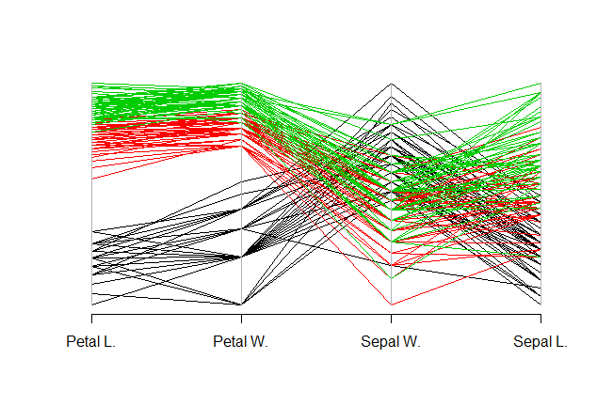

Although I was able to get some data, it was not as unique as I would have liked. I examined the TELNET activity caused by the SADMIND. Although the last pcap is huge compared to the other 4, it was possible to filter out for the actual malicious TCP traffic.
In summation, the process of cleaning data and tidying was a very interesting field as it allows for the designer to craft the field of view of what the data is about and what are the key important aspects. I felt I still lack in making graphs as I am still too accustomed to using functions to visualize information and the best I could achieve without the use of time is a cross-reference of two fields of data.
The R documentation for this section of the assignment is located on Github with the name Part3.R

Part 4: Interacting with APIs
Cymon has a multitude of useful APIs that we can use to check whether a website or domain is back or whether a hash is potentially harmful or not. The backbone of the Cymon api relies on GET requests that the user can utilize to use these available tools on Cymon. Ways we can use this within code is by using the jsonlite library in R or we can use the traditional httr library meant for doing HTTP related tasks such as GET and POST for R. Cymon however will limit the bandwidth if too many requests are made, and a special authorization token will be necessary. Using Cymon we can check the current blacklist of ips and domains and search them out using a tag. Also we can check whether a domain name is “human” or machine made. This was the focus of my simple R script which will be shown later. Also Cymon allows us to look at IPs and the history of them. This is helpful to see if these sites were previously an issue or not.
The use of APIs greatly improves on our ability to grab and use information and tools already made for us. Especially in R, a key usage when plotting that was very handy is to use a Get request to get an updated list to help match IPs with geolocation. This is very handy in mapping out attacks and see how they work on a global scale visually. This also can be used to map out latitude and longitude positions on the map.
Sample API work:
#checking with cymon to see if website is human-made or robot generated.
library("httr")
checkip <- function()
{
n <- readline(prompt="Enter a domain address to check (eg. xyzhfazc.us) : ")
"Using Cymon to check whether this domain is not randomly generated"
url = paste("https://cymon.io:443/api/nexus/v1/dga/",n,"/",sep="")
url
info <- GET(url)
content(info)
curlGetHeaders(url)
}
print(checkip())

Sample Output:

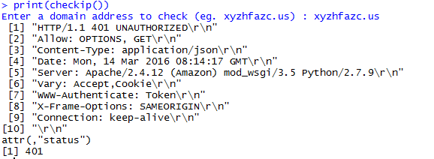

By calling the checkup function we can check whether or not a site domain was generated by an algorithm. As this is not one of the more prominent APIs available there are still some kinks to work out. Some big websites get flagged also for being machine generated. Cymon works better using the jsonlite library when I tried it out, but I chose to stuck to httr for criteria of work.

The code for this section will be in API work.R on Github.

If there any missing files, or corrupted please let me know so I can update the master.

