Write a program that takes a number and prints whether it is "Positive", "Negative", or "Zero"
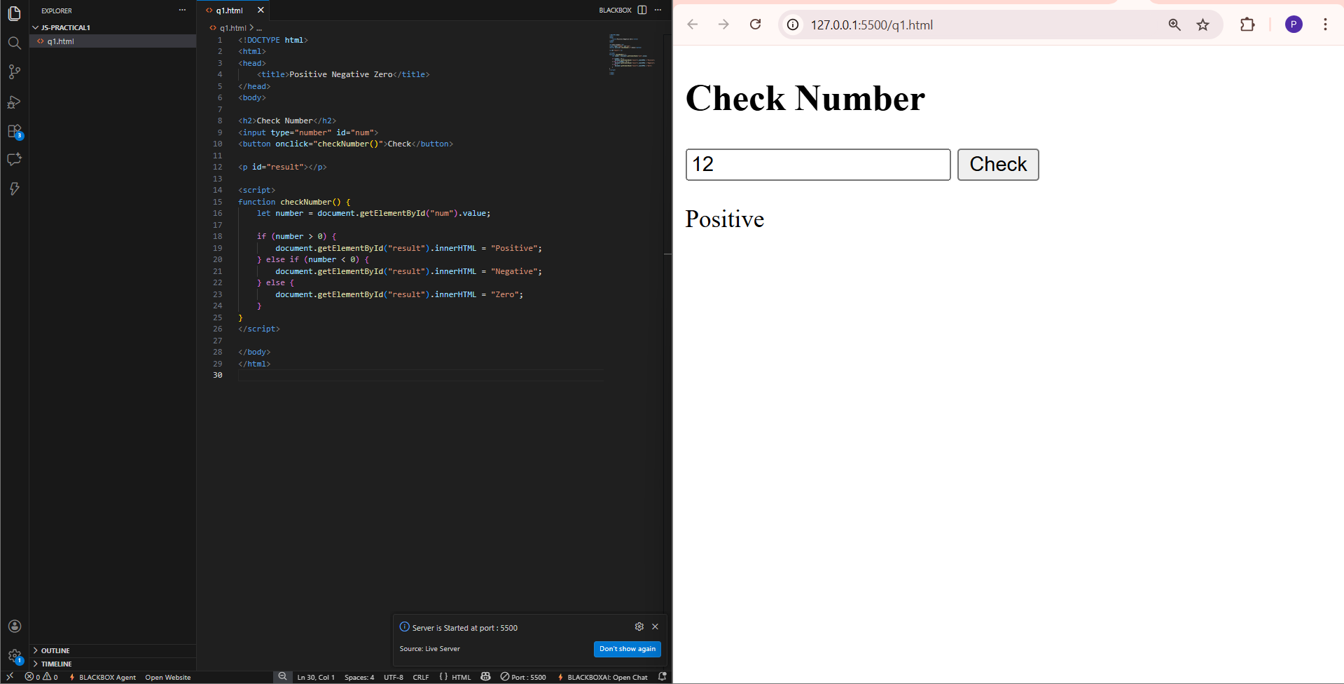
Create a function that accepts an integer and returns true if it's even and false if it's odd
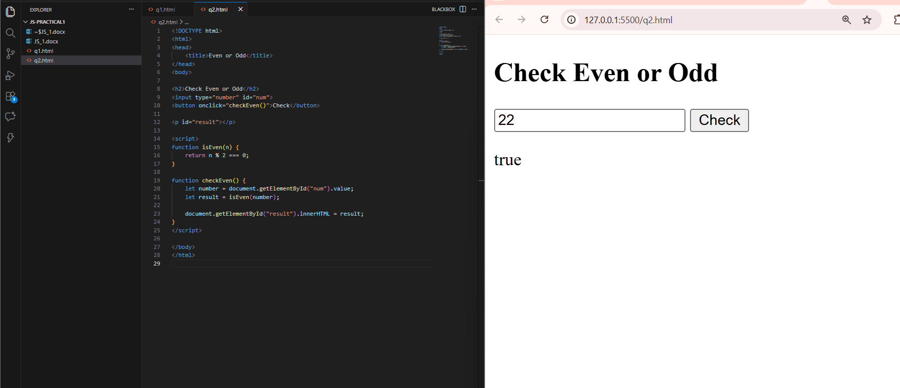
Write a script that checks if a person's age is 18 or older to determine if they are "Eligible to Vote"
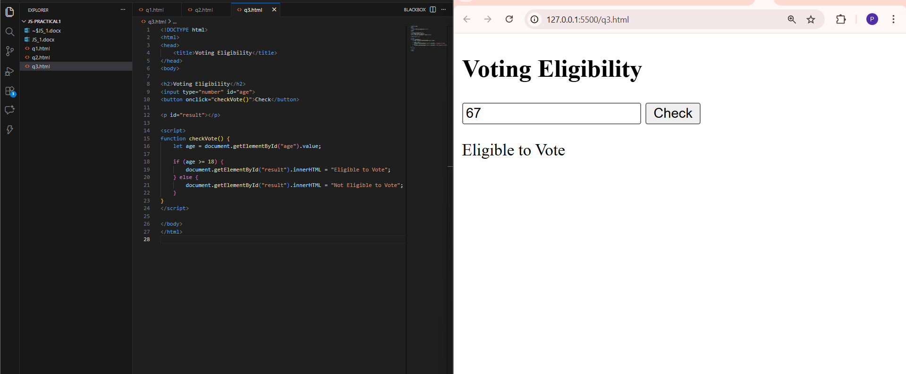
Write a program that compares two integers and displays the larger one
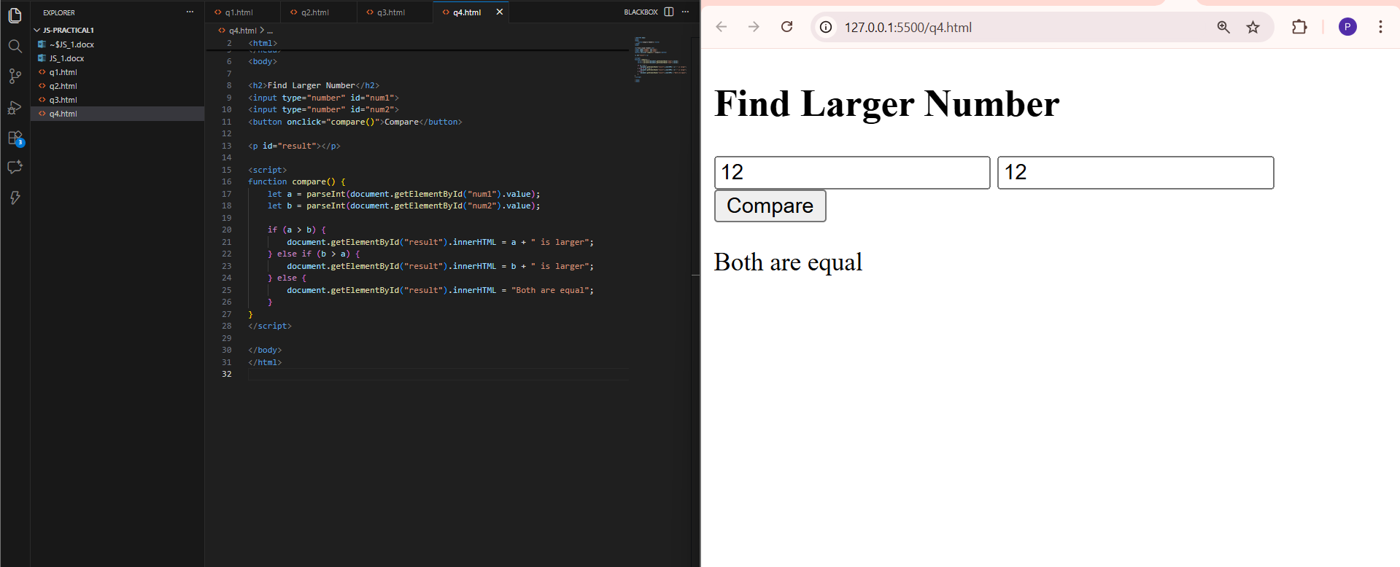
Given a numerical score (e.g., 85), use else if to print a letter grade: A (>=90), B (>=80), C (>=70), or F (below 70).
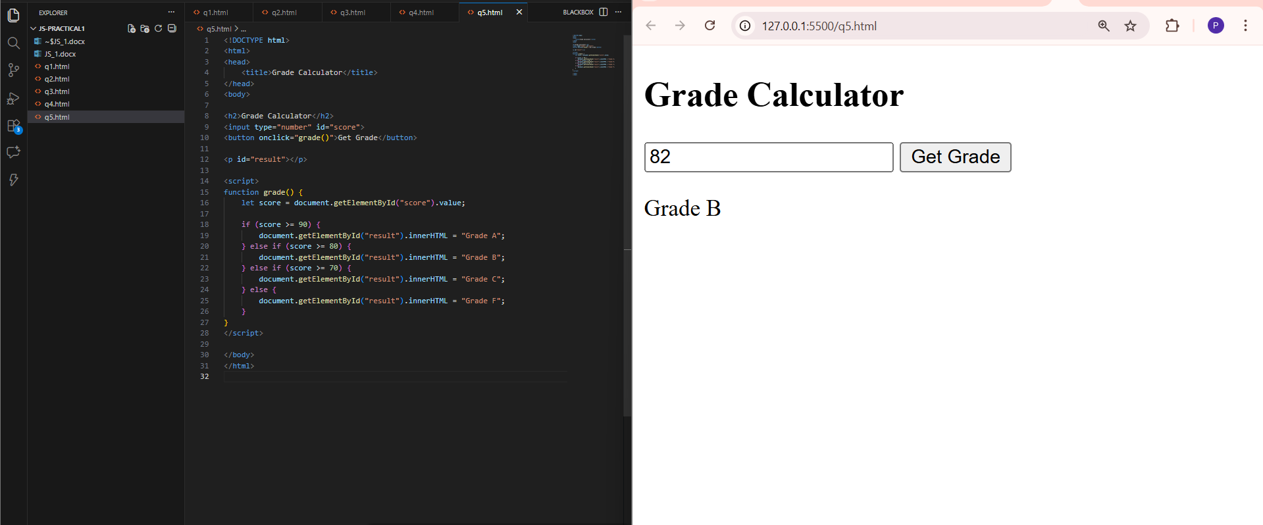
Write a program to determine if a given year is a leap year.
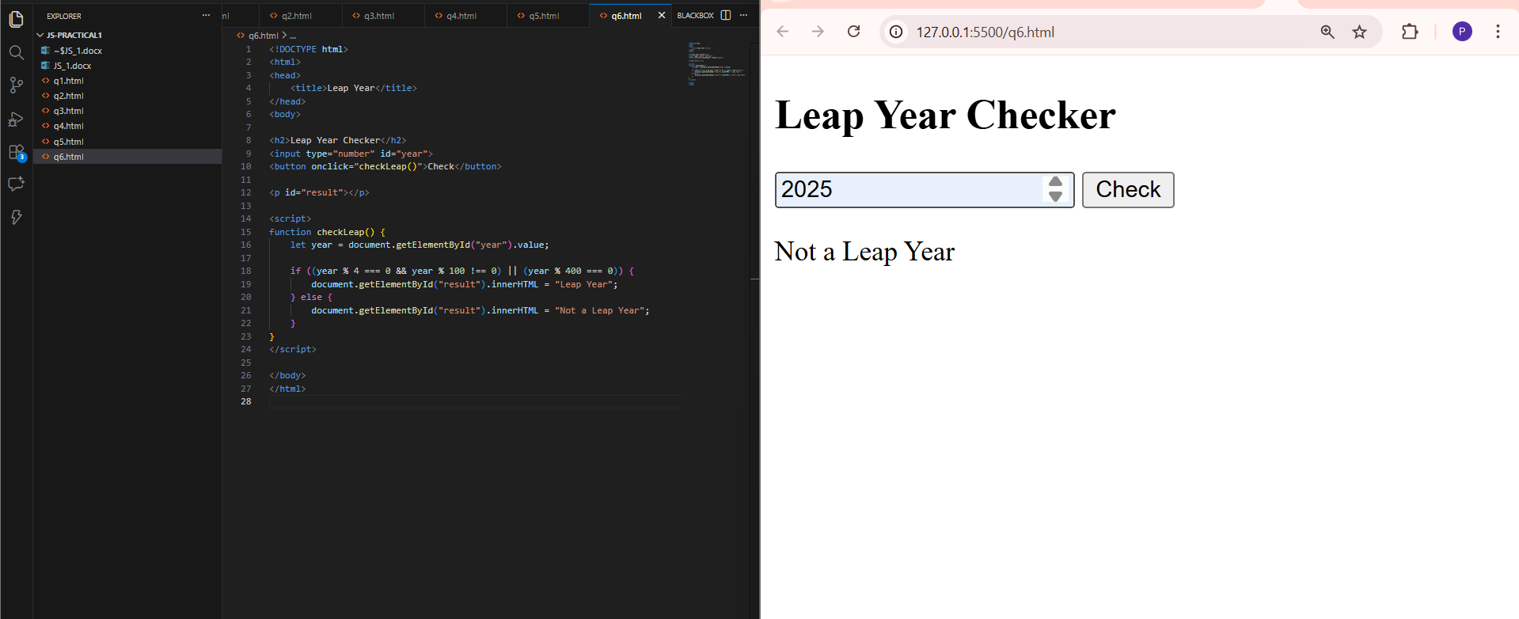

Use a switch statement to perform addition, subtraction, multiplication, or division based on a given operator string (like + or -).
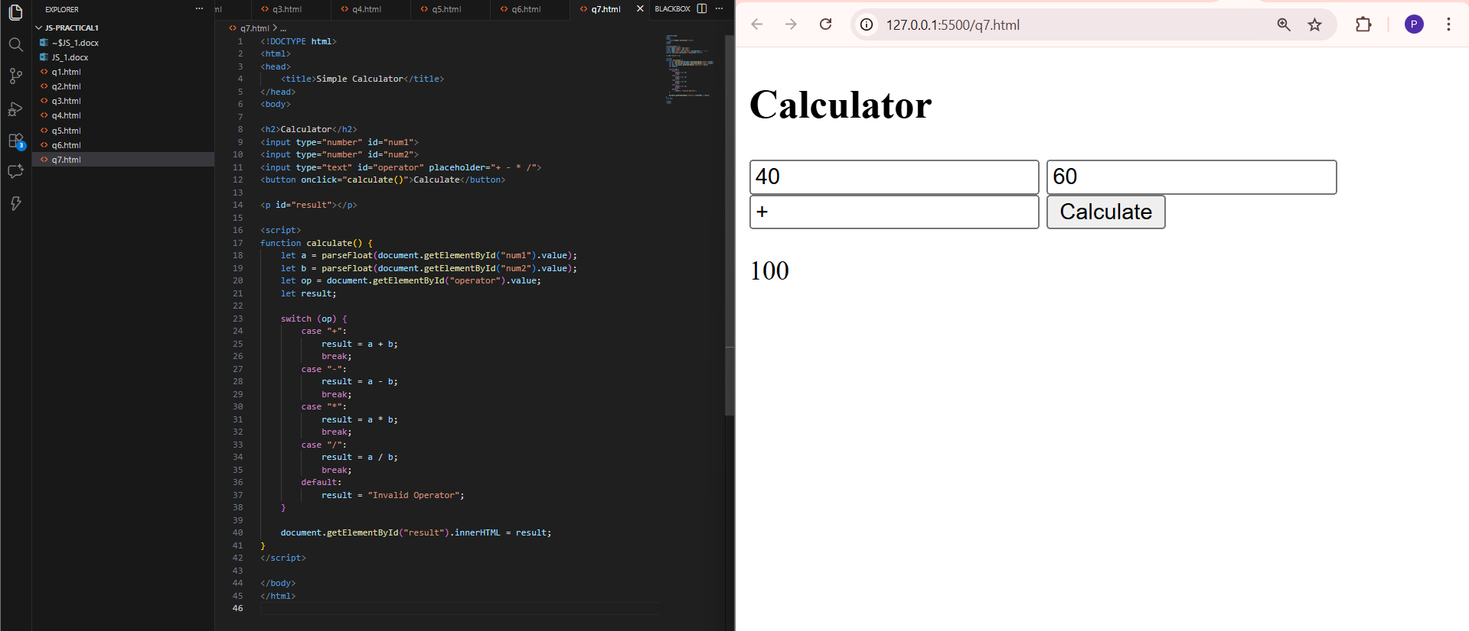
Write a script that prints "Fizz" if a number is a multiple of 3, "Buzz" if it's a multiple of 5, and "FizzBuzz" if it's a multiple of both.
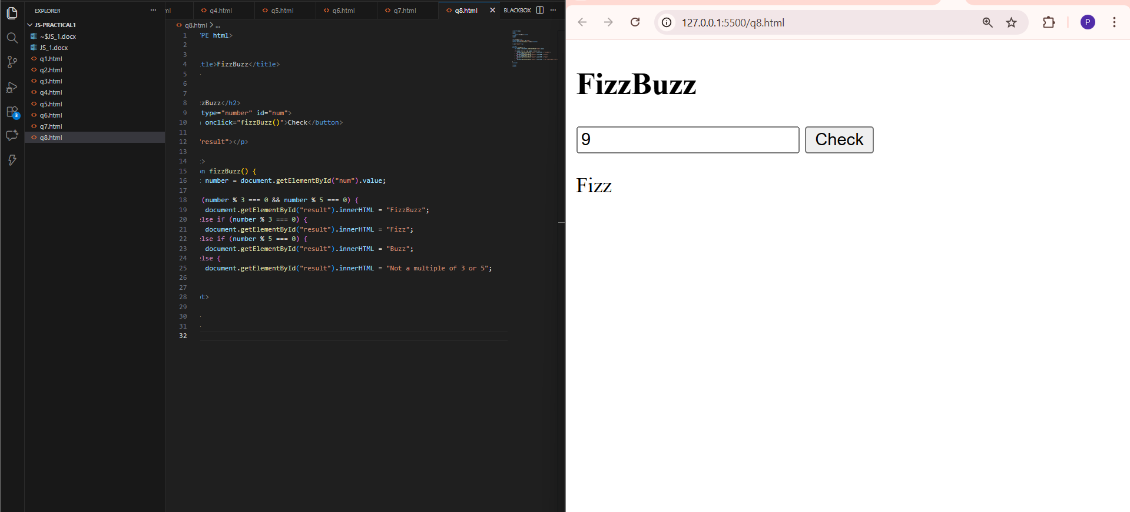

Calculate a ticket price based on age: under 12 pays $5, 12-17 pays $10, 18-59 pays $20, and 60+ pays $15.
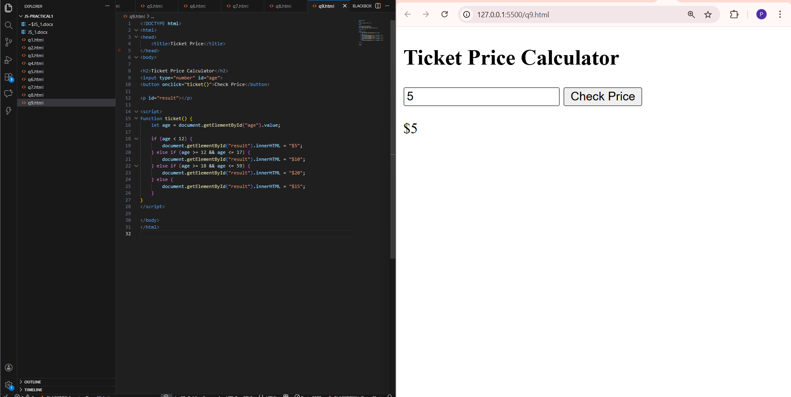
. Write a program that first checks the weather ("Sunny" or "Rainy"). If "Sunny", check the temperature; if above 30, print "Wear sunscreen", otherwise print "Enjoy the day".
