for Loop Tasks
1. Print numbers from 1 to 10.
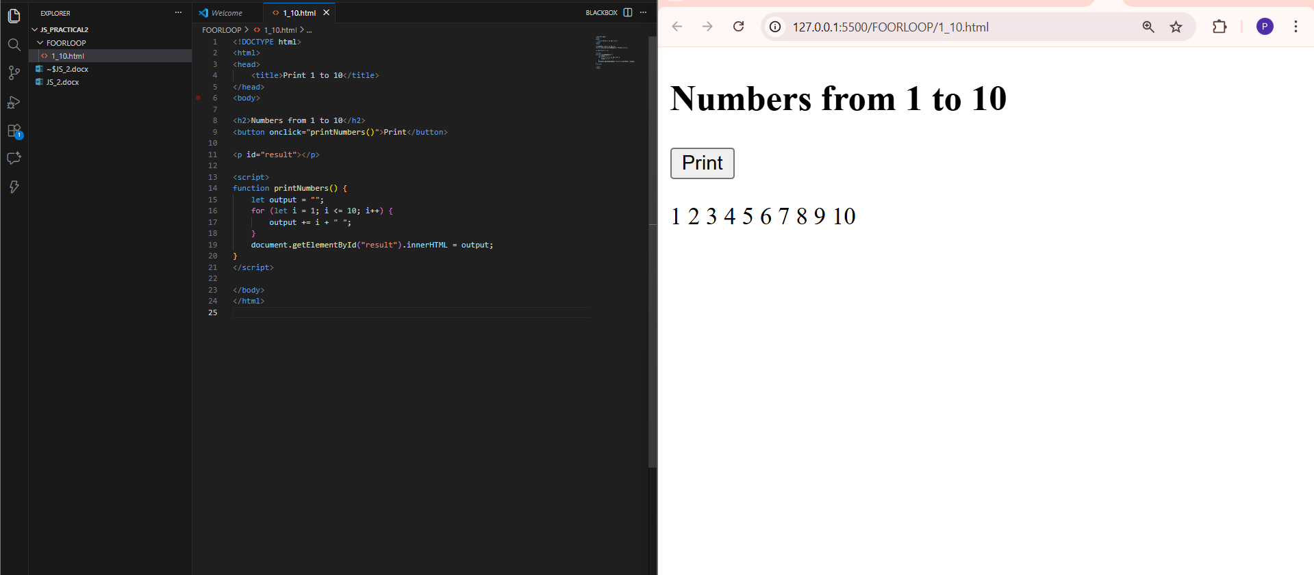
2. Print all even numbers between 1 and 20.
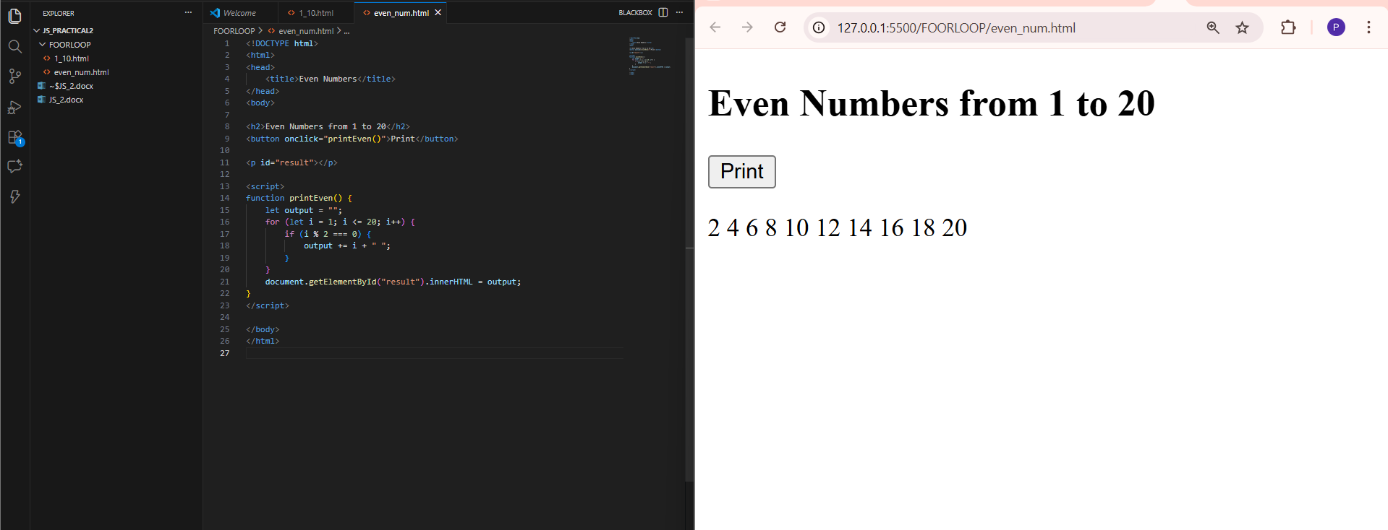
3. Take a number (e.g., 5) and print its multiplication table up to 10 (5 x 1 = 5... 5 x 10 = 50).
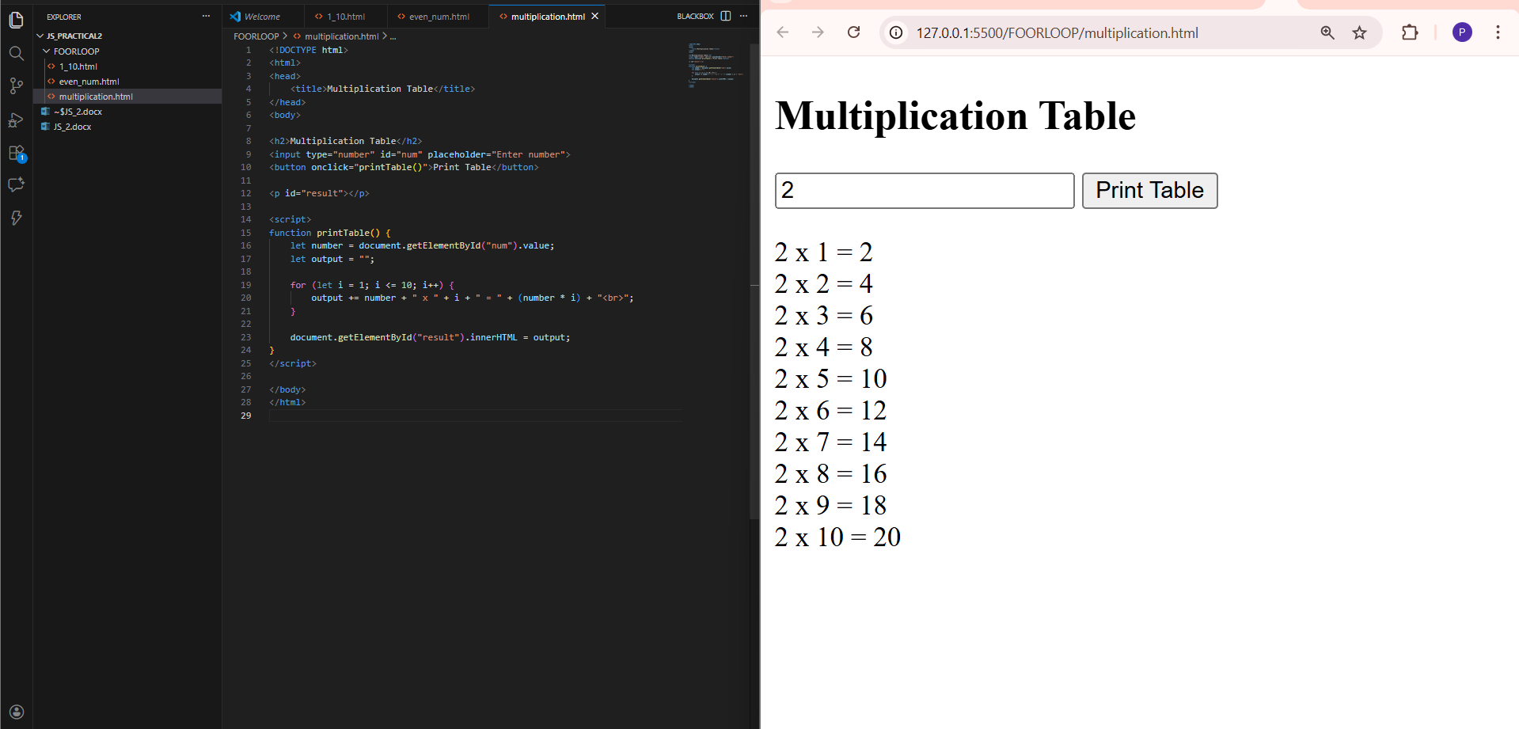
4. Start from 10 and count down to 1, then print "Blast off!"
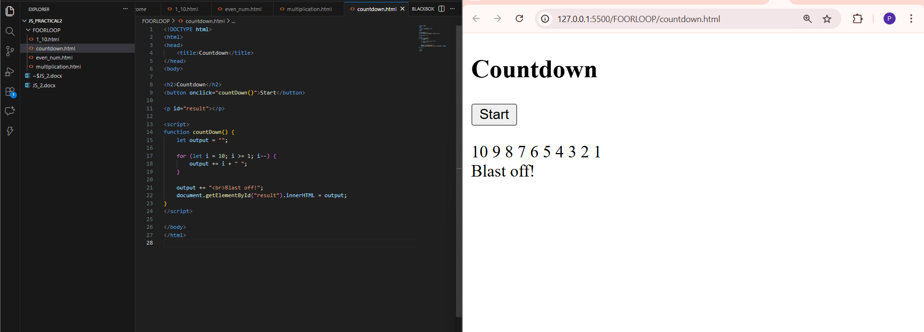
while Loop Tasks
1. Find the sum of the first 10 natural numbers (1+2+3...+10). 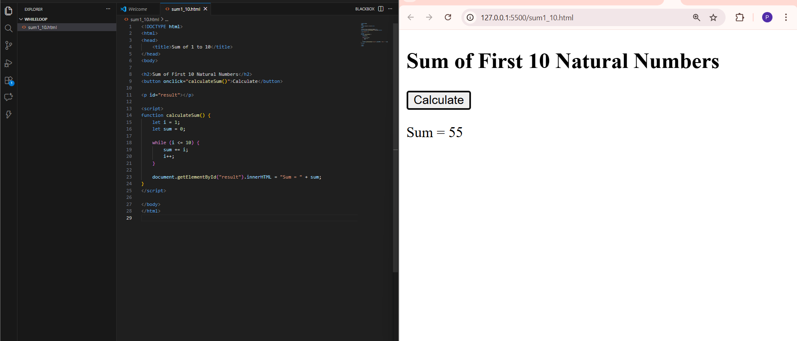
2. Print the powers of 2 (2, 4, 8, 16...) that are less than 100. 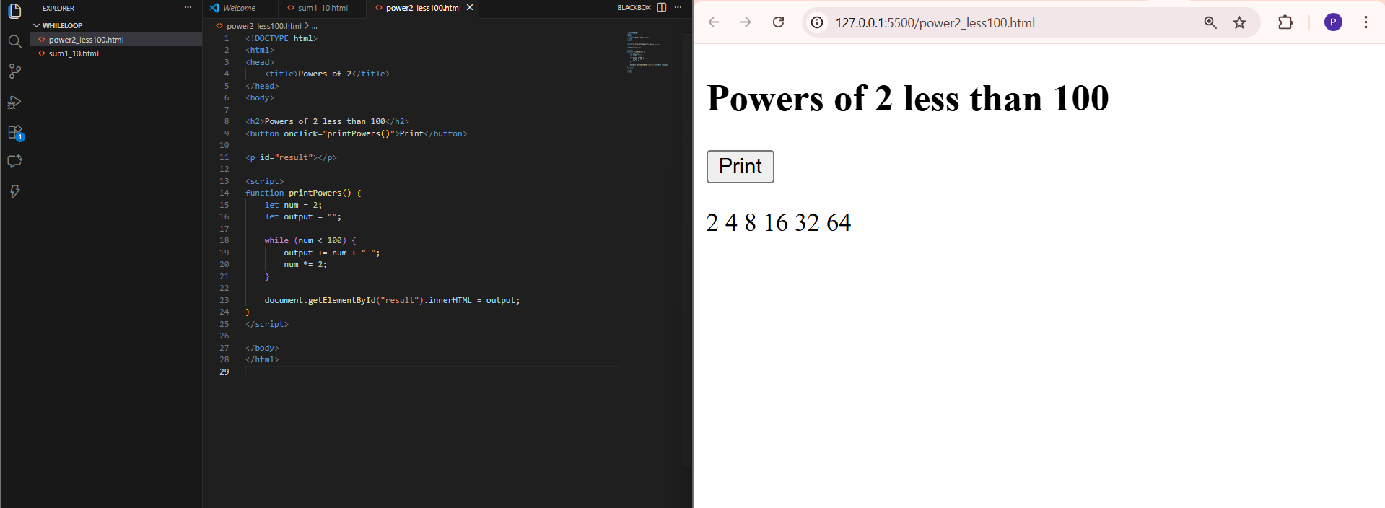
3. Use a while loop to find the first number after 500 that is divisible by 7. 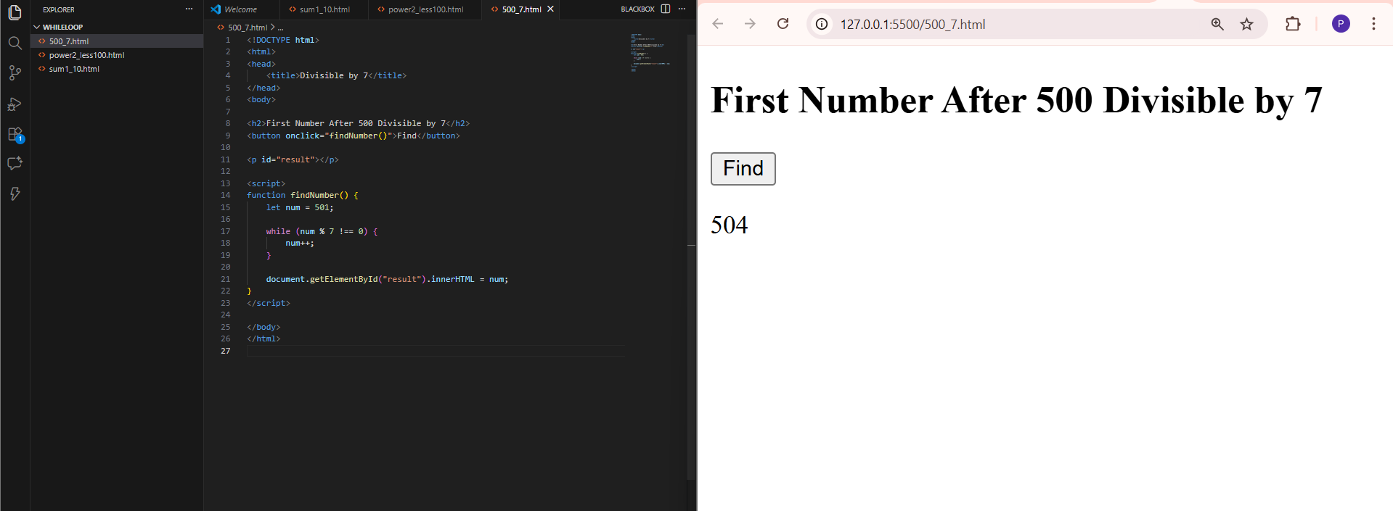
do...while Loop Tasks
1. Create a loop that "asks" for a password and keeps running until the password equals "1234"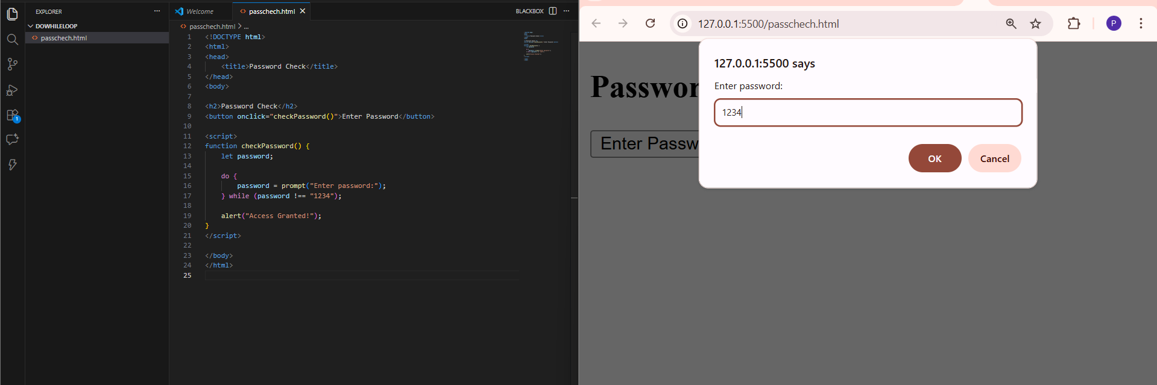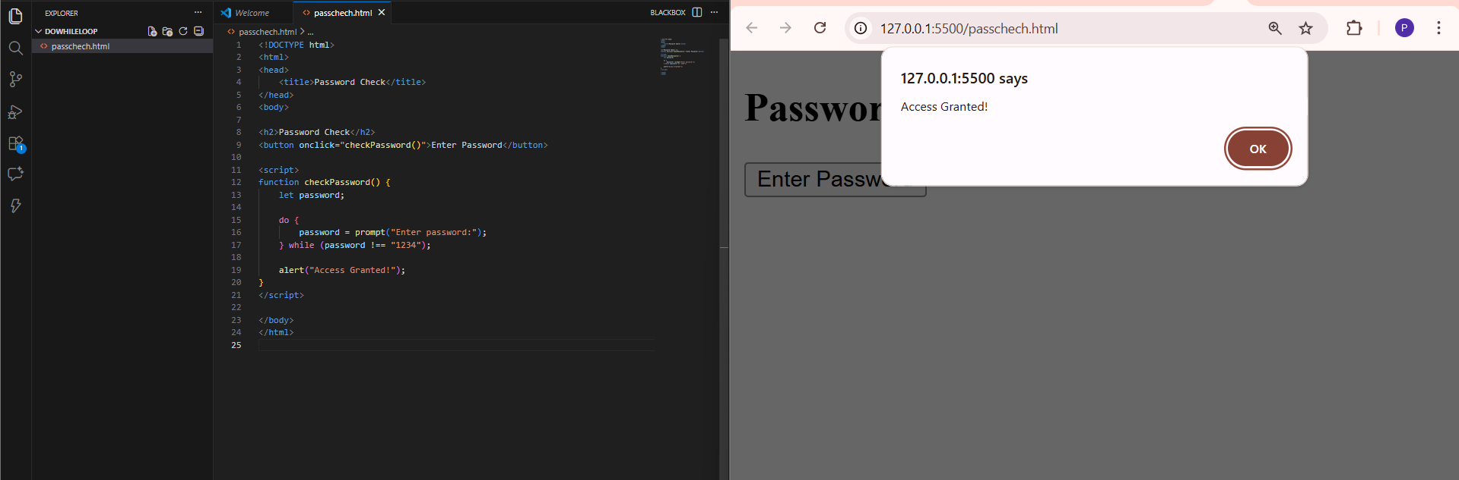
2. Simulate rolling a 6-sided die. Keep rolling and printing the result until you hit a 6. 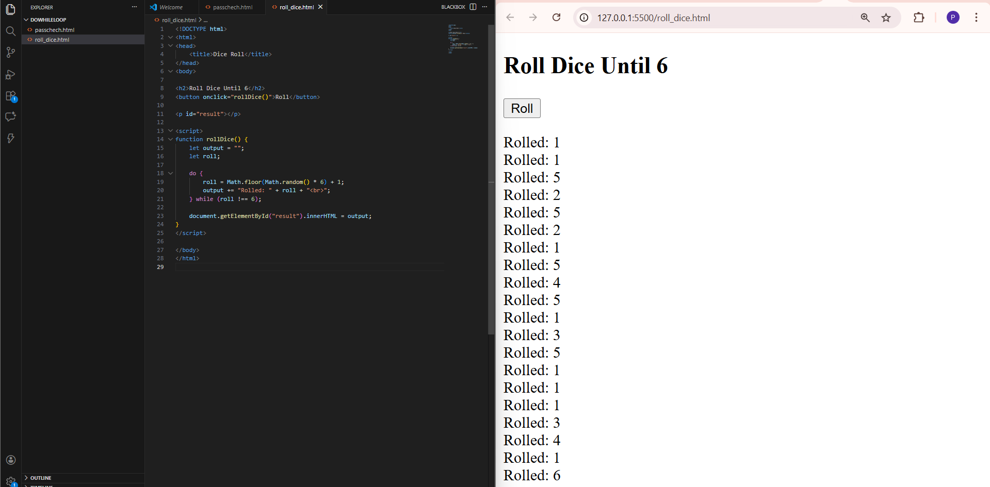
3. Calculate the factorial of a number using a do...while loop.
