INSTITUTE FOR ADVANCED COMPUTING AND SOFTWARE DEVELOPMENT AKURDI, PUNE

Documentation On

**“Slot Booking for Charging an EV at Charging Station”**

**PG-DAC SEPT 2021**

*Submitted By:*

**GROUP NO 54**

More Sangram Rajkumar - 210941220108

Joshi Sushant Prakashrao - 210941220080

**Mrs. Shilpa Pawale Mr. Kashinath Patil** Project Guide Project Guide

**Index**

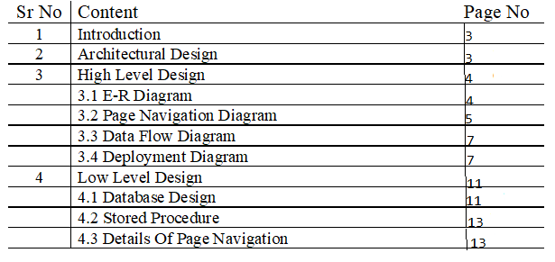

**Introduction**

This document is meant for the description of the structure and the database which we are using in this project. This document gives brief description about Architecture of the system, E-R diagram of the system and the table descriptions, the page navigation diagrams and the detail description for the page navigation.

Electric vehicles are more efficient, and that combined with the electricity cost means that charging an electric vehicle is cheaper than filling petrol or diesel for your travel requirements. Using renewable energy sources can make the use of electric vehicles more eco-friendly.

**Architecture Design**

**Following diagram shows the details of the e-faming system architecture**

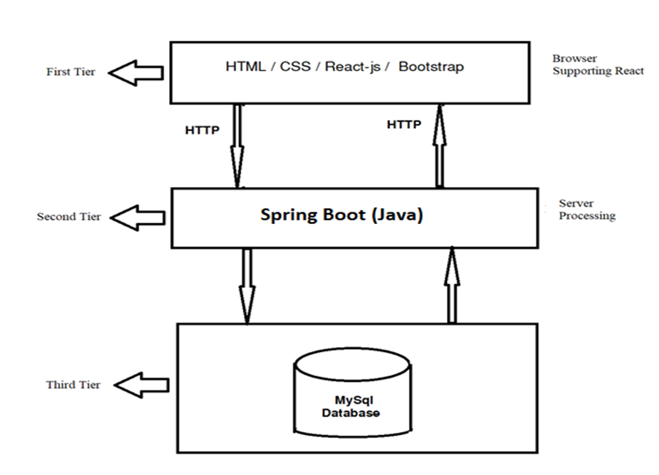

**This System consist of three tiers as listed below:-**

**First Tier:**

This tier is used for user interface and it is called as client tier. In this tier we are using React-JS because of it provides better interactivity, easier navigation, compact and also helps us to create single page application . The use of JSX script facilities us for the client side validation. That’s why in first tier we are using the JSX script. We are using HTML, CSS , BOOTSTRAP for the presentation purpose.

**Second Tier:**

**Server Process:**

This application requires database access to fetch various information. It will also need to update the database. To sync my application front-end, We are using Spring boot as a middle tier. The choice of Spring boot was made because we want it to scale properly and it is the fastest way we can achieve our desired result . This middle tier will serve the front-end with all the required data that it needs. It will also receive data from the front-end and update the back-end database.

**Third Tier:**

**MySQL Database :**

We are using MySQL as our database management system . The reason we choose this as our data base because it is a relational data base system . It is the open source easy to use we can build and interact with MySQL by using only a few simple SQL statements. MySQL follows the working of a client/server architecture. There is a database server (MySQL) and arbitrarily many clients (application programs), which communicate with the server; that is, they can query data, save changes, etc. MySQL supports multi-threading that makes it easily scalable. It can handle almost any amount of data, up to as much as 50 million rows or more. The default file size limit is about 4 GB. However, we can increase this number to a theoretical limit of 8 TB of data MySQL uses Triggers, Stored procedures, and views that allow the developer to give higher productivity.

**High Level Design: E-R Diagram:**

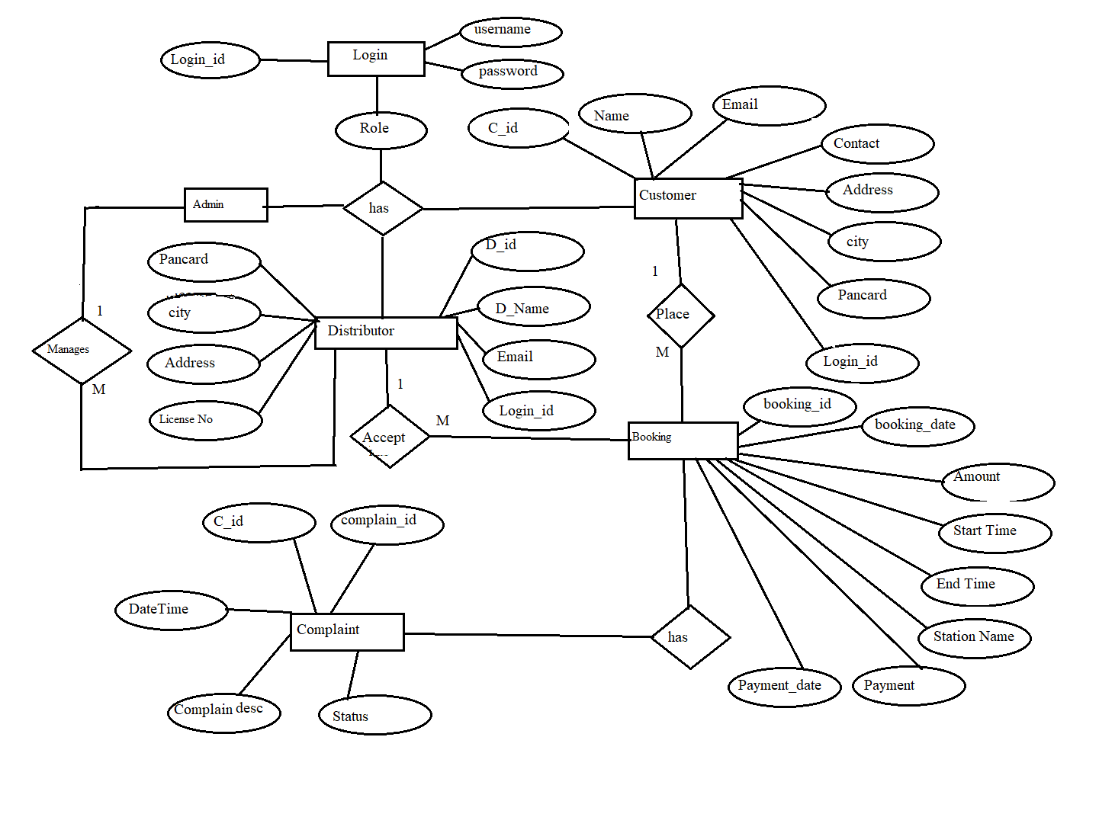

Above E-R Diagram shows that database of Slot booking for an Ev at Charging station consist of following entities:

• **Customer :**

This entity contains the Customer id , Name , Email-id , Password Contact Number ,Consumer Number , Address , Pan Card .

• **Distributer :**

This entity contains the Email id , Distributer name ,Distributer id ,

License -number , Location .

• **Message**

This entity contains the Message Id, Date-Time, Receiver-Status, Sender-Status, Receiver Id, Sender Id, Message, Subject attributes.

* **Admin**

This entity contains the Admin id, Password .

• **Payment**

This entity contains the Transection id, Withdraw, Fid, Sender Account Number , Receiver Account Number , Amount, Date Time, Seller Status, Buyer Status attributes.

**Page Navigation Diagram:**

* **Customer :**Following diagram explains the page navigation for the Customer module:

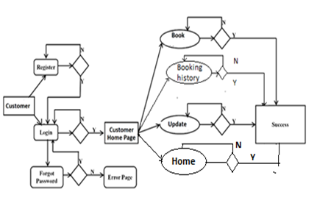

• **Distributer**

Following diagram explains the page navigation for the farmer module:

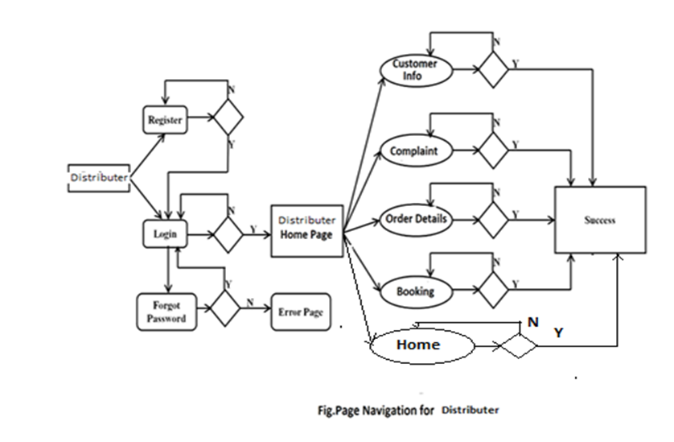

* **Admin**

Following diagram explains the page navigation for the Admin module:

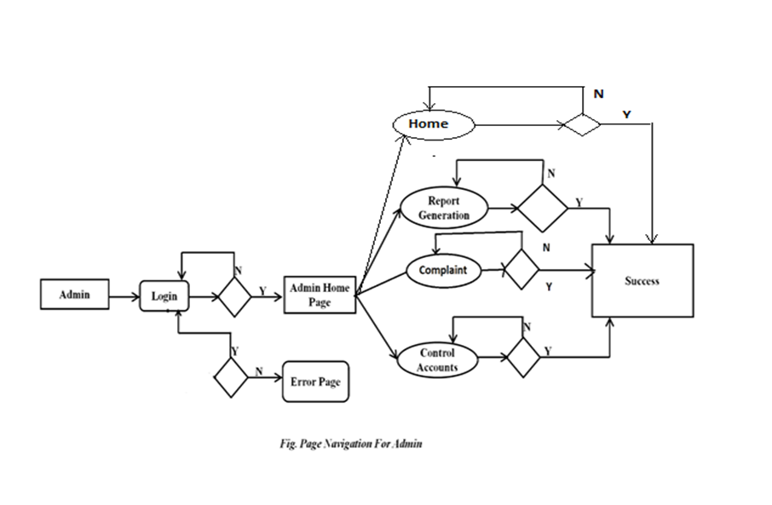

**Data Flow Diagram:**

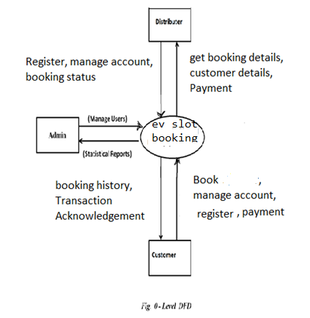

**•In 0-Level DFD, there are three Entities:**

•Customer

•Distributer

•Admin

* **1-Level DFD:**

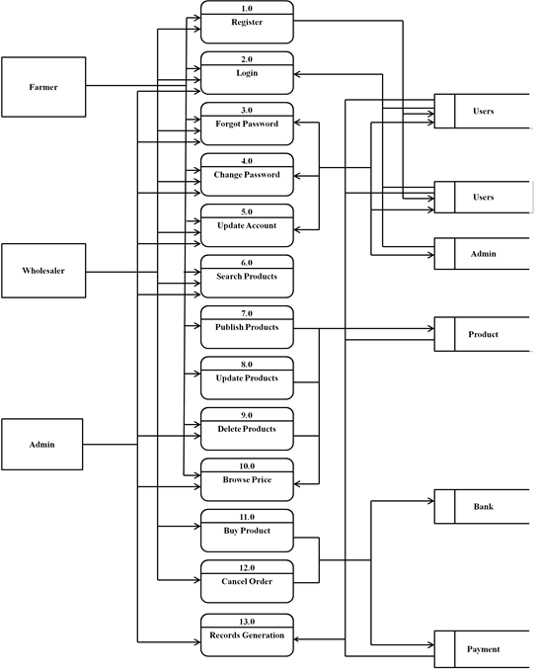

**In 1-Level DFD,**

**Costumer Entity having following processes:**

• Registration/new connection

• Select distributor

• Sign in

• Profile management

• Update profile

• Booking management

• View all booking

• Add a booking

• Cancel booking

• Logout

**Distributer Entity having following processes:**

• Registration

• Sign in

• Distributor Profile Management

• update profile

• Consumer Management

• approve consumer (with sending e-mail notification)

• view all the consumers

• Logout

**Admin Entity having following processes:**

• Sign In

• Profile Management

• Update profile

• Distributor Management

• Approve distributor (with sending e-mail notification)

• View distributor list

• Suspend/block distributor

• Unblock distributor

• Consumer Management

• View all consumers

• Suspend consumers

• Orders Management

• View all orders of distributor

• View pending orders of distributor

• Feedback Management

• feedbacks from consumers

• Orders Management

• Payment management

• Payment status of consumers

• Logout

**• Low Level Design:**

**• Database Design:**

**1] Login Table**



**2] Table _Customer_ detail**



**3] Table _Distributer_ detail**



**4] Tbl_booking_table**

|  |  |  |  |  |  |
| --- | --- | --- | --- | --- | --- |
| **Field** | **Type** | **Null** | **Key** | **Default** | **Description** |
| booking_id | Integer | No | Primary key | - | Booking_ ID |
| booking_date | Date | No |  | - | Booking_Date |
| amount | Double | No |  | - | Amount To Be Transfer |
| Start time | Time | No |  | - | Charging start time |
| End time | Time | No |  | Null | Charging end time |
| Vehicle no | Varchar(15) | No |  | - | Vehicle No |
| Charging station  Name | Varchar  (15) | No | Foreign key |  | Distributer Name |
| payment_mode | Varchar(15) | No |  |  | COD/UPI/NetBanking |
| transection_id | Integer | No | - | - | Transection_id |
| payment_date | Date | No | - | - | Payment date |
| status | Varchar(15) | No | - | - | Completed/Cancel/pending |



**• Stored Procedure:**

**• CreateCustomer:**

This stored procedure is used for creating new user

Input parameters:

Cid, Name, Email, Password, Contact, Address, , Consumer No , Pan card .

**• SendMessage:**

This stored procedure is used for inserting message details

Input parameters:

ReceiverId, SenderId, Message, Subject

**• Details Page Navigation:**

**• Home Page:**

**• Following snapshot shows the home page of the Slot Booking for an EV**

**at charging station.**

**Home page:**

**Login Page:**

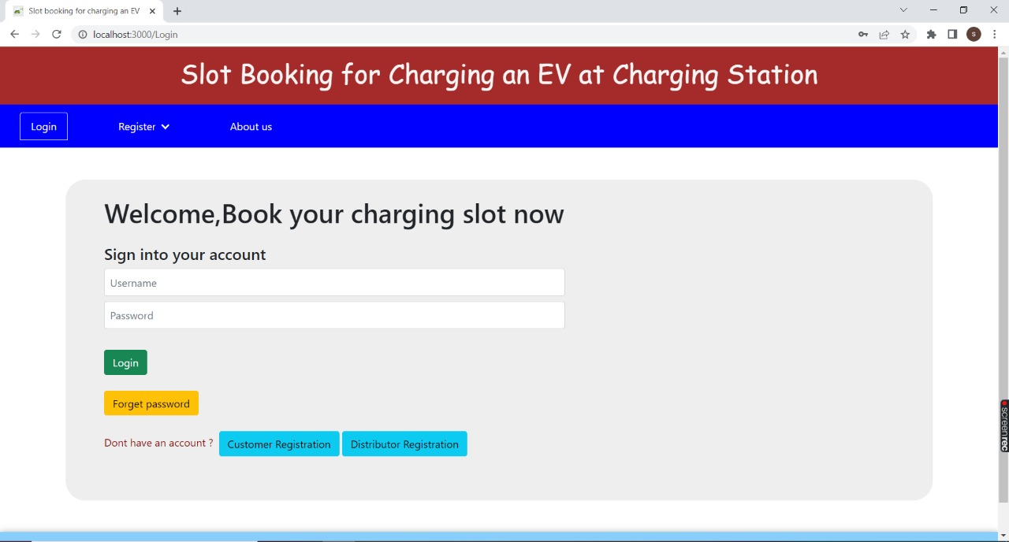

**Admin page/Admin Dashboard**

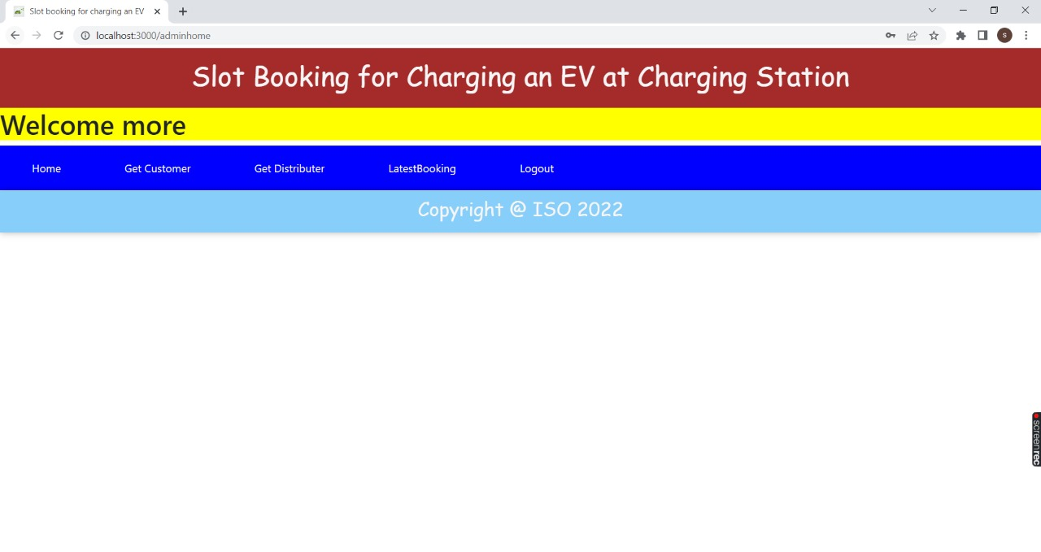

**Admin -> get customer page:**

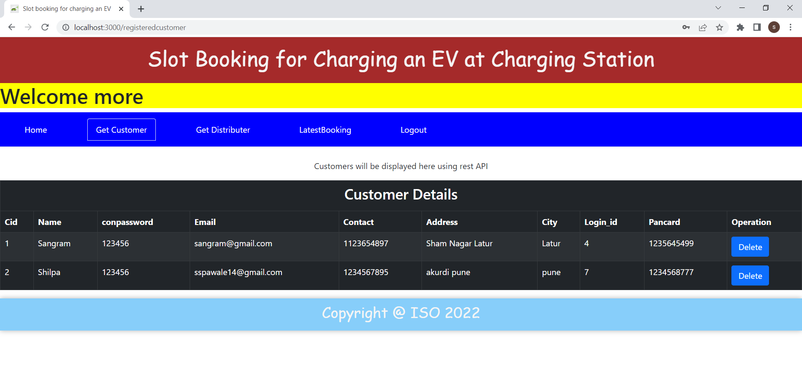

**Admin -> get distributer page**

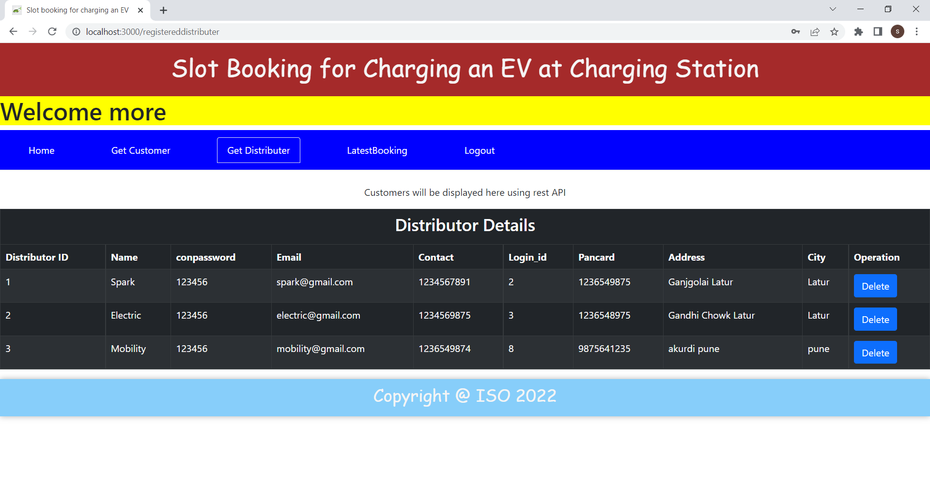

**Admin -> latest booking page**

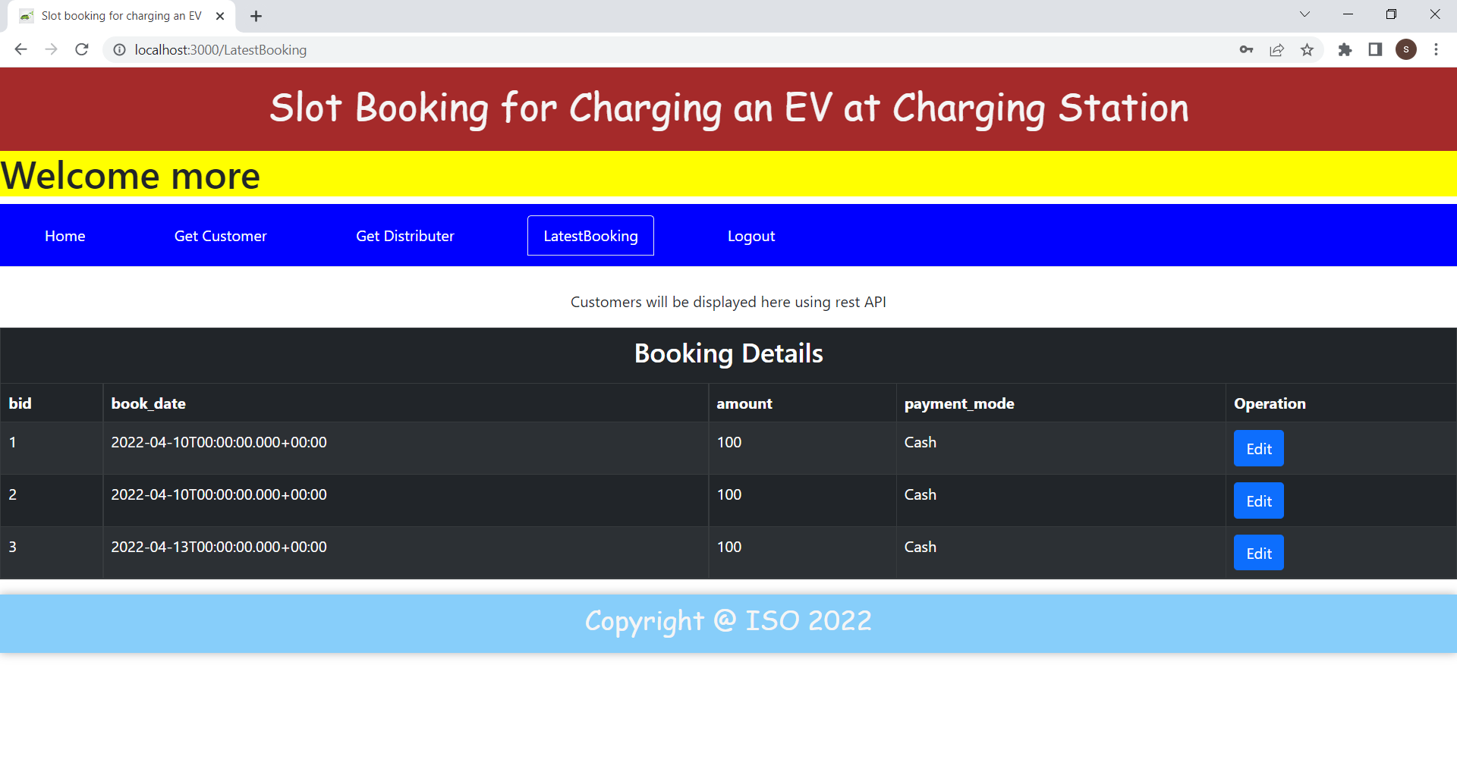

**New Customer registeration form:**

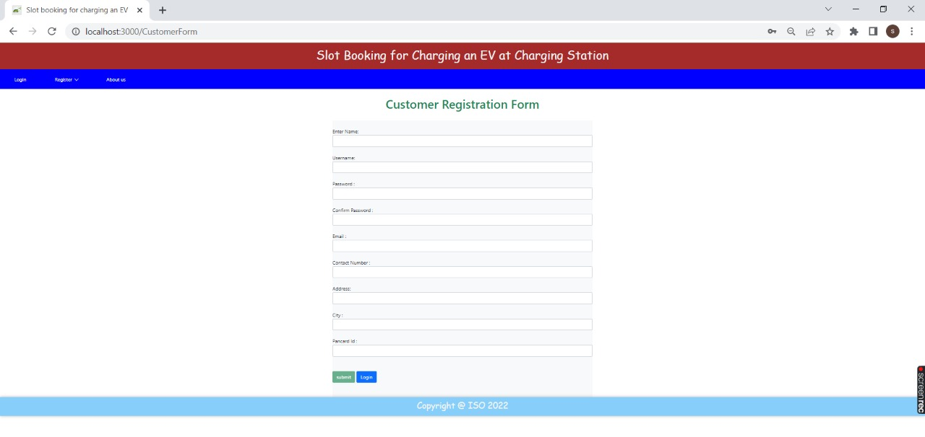

**New Distributer registeration form**

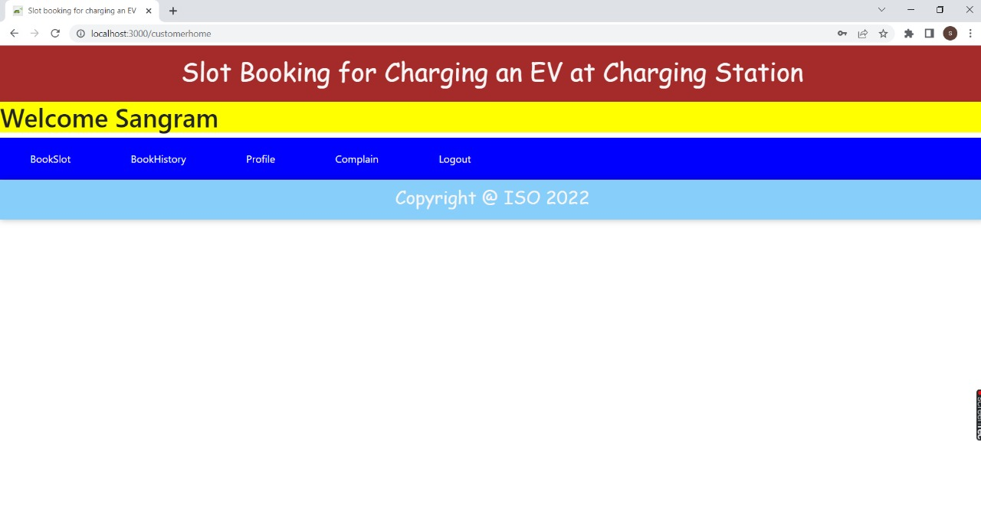

**Customer -> book slot page**

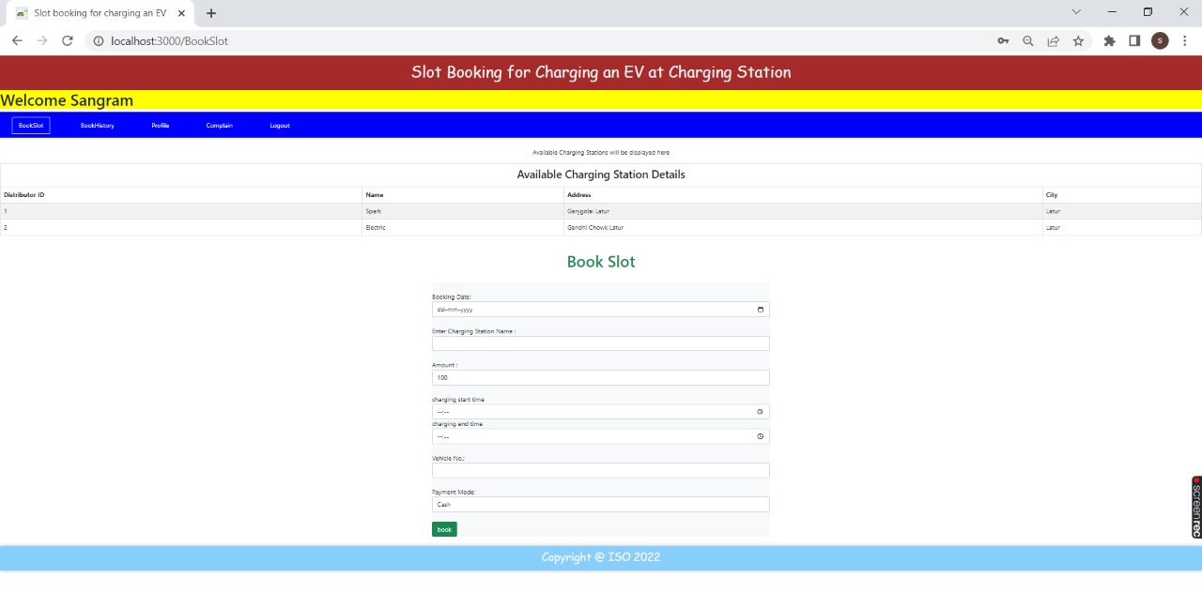

**Customer -> book history page**

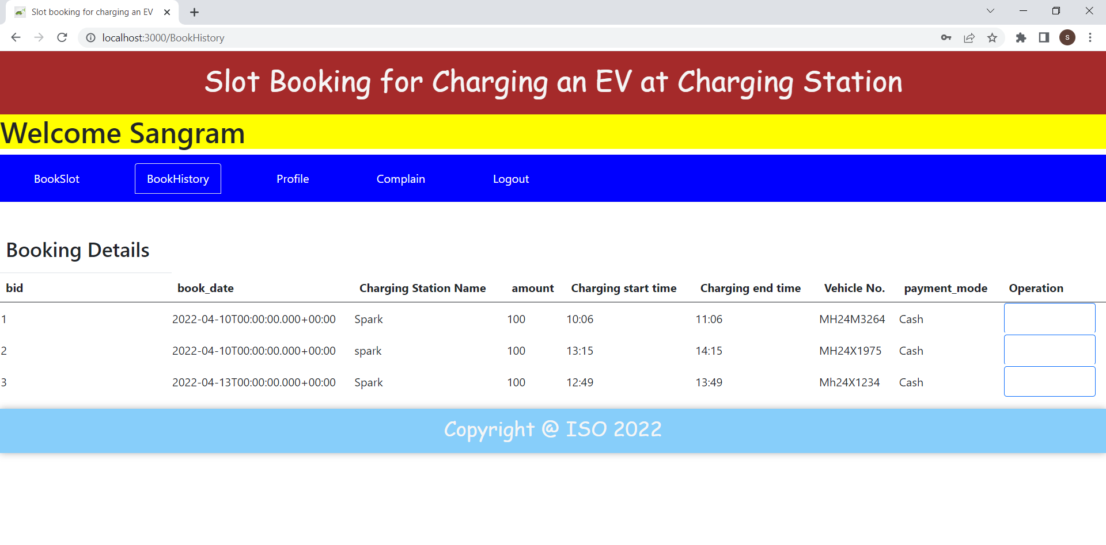

**Customer -> profile page**

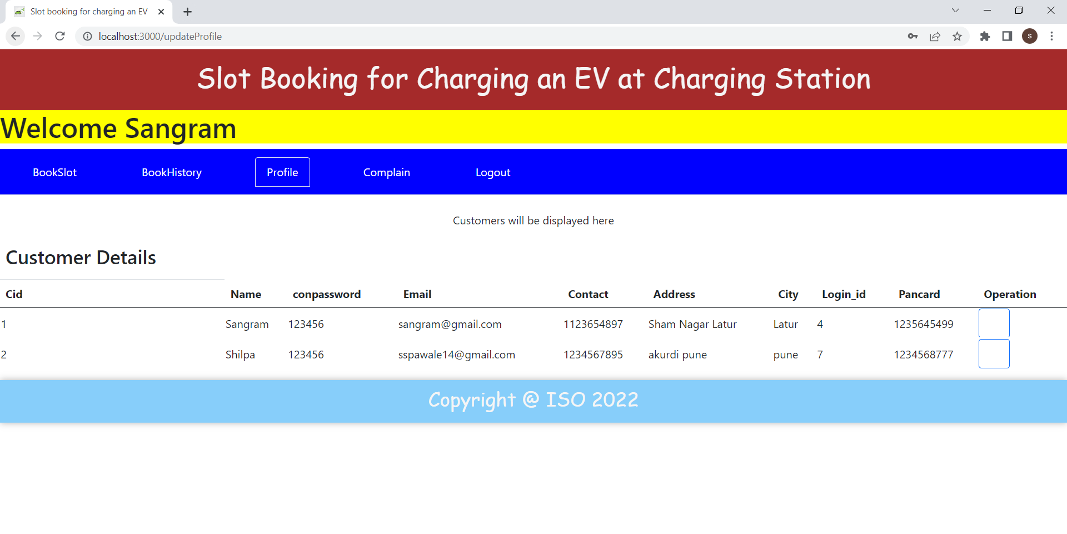

**Customer -> complaint page**

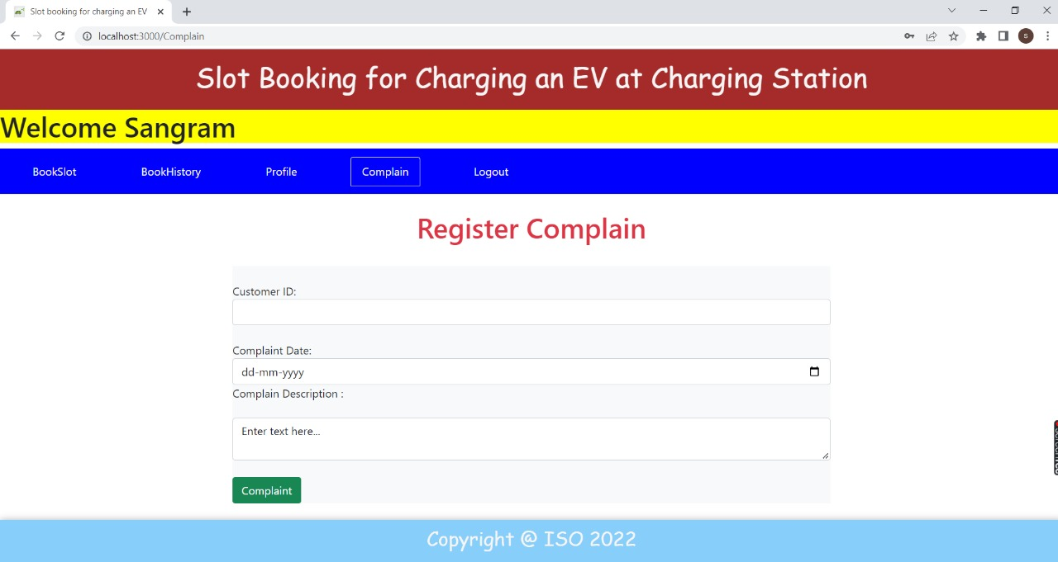

**Distributer -> home/dashboard page**

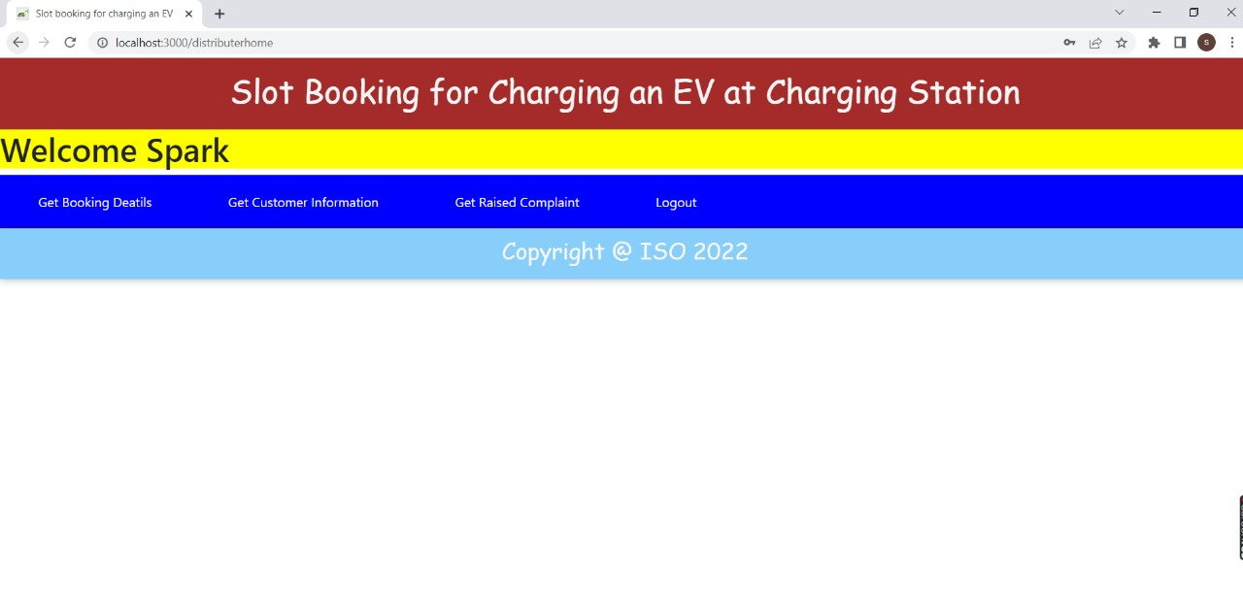

**Distributer -> get booking details**

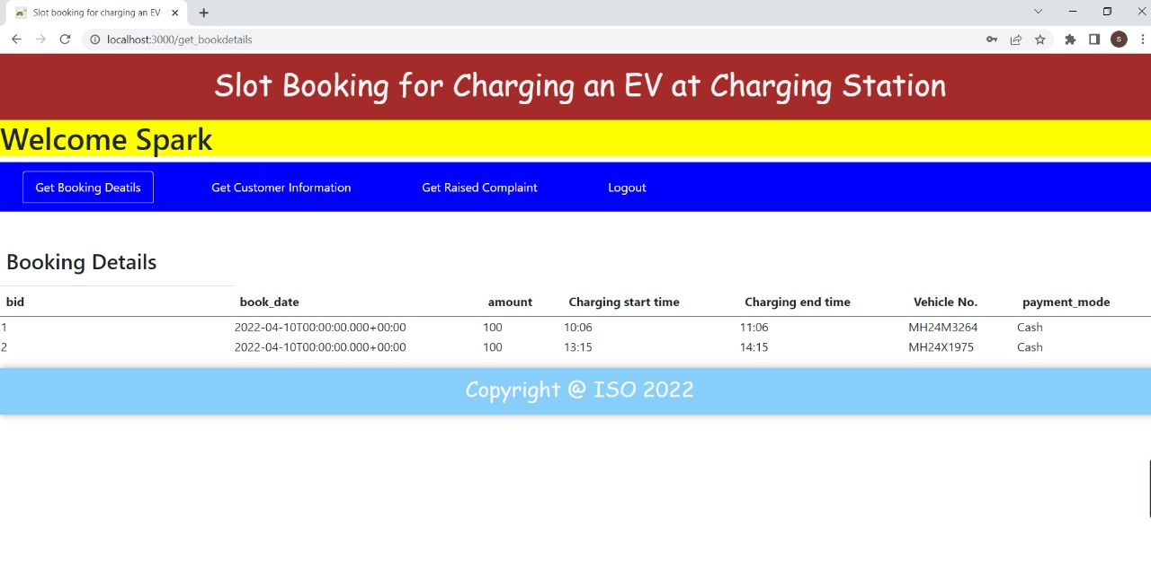

**Distributer -> get customer information page**

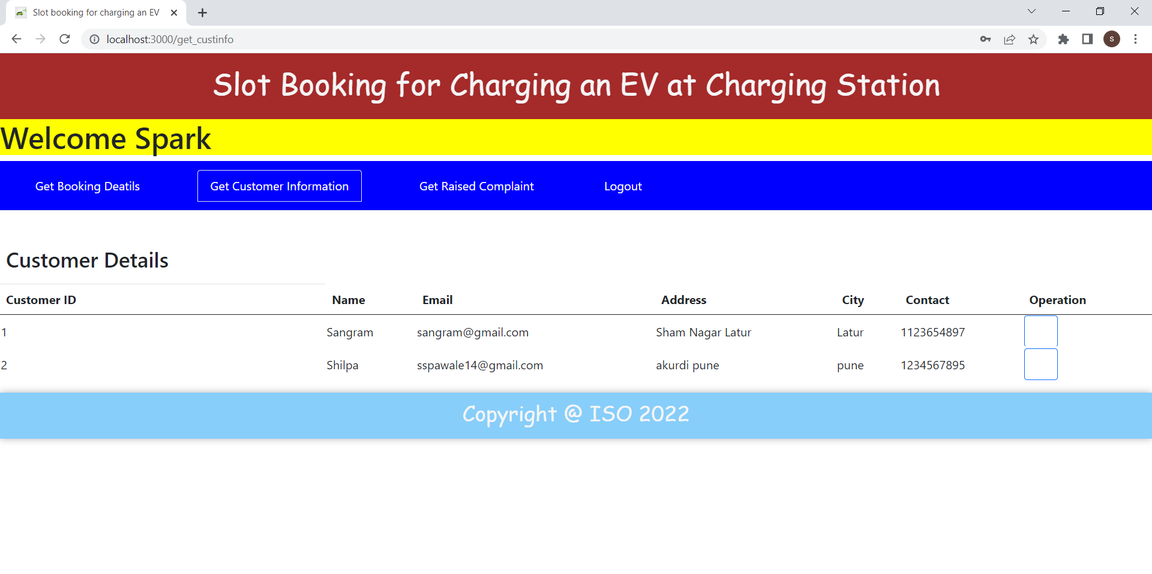

**Distributer -> get raised complaint page**

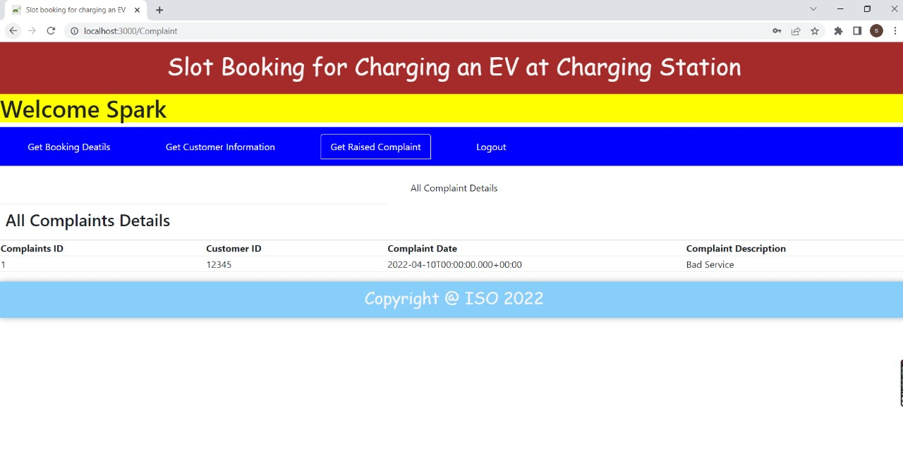

**REFERENCES**

<http://www.google.com>

<http://www.webdevelopersjournal.com/>

<http://www.w3.org>

<http://www.wikipedia.org>

<http://reactjs.org>

<http://getbootstrap.com>