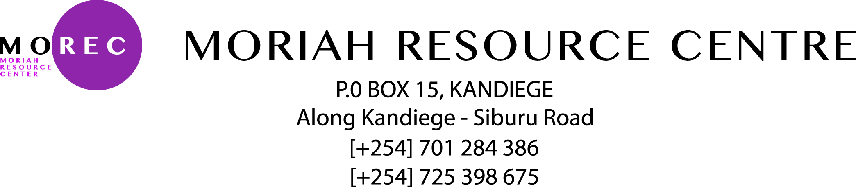

MOREC COURSES AND SERVICES

*MOREC offers the following services*

Computer packages Training and certifications:

|  |  |  |
| --- | --- | --- |
| Course | Duration | Cost (Ksh.) |
| Microsoft office word | 1 week | 300 |
| Microsoft Excel | 1 week | 300 |
| Microsoft Access | 2 weeks | 400 |
| Microsoft Power Point | 1 week | 300 |
| Corel Draw & Designs | 2 weeks | 400 |
| Microsoft publisher | 1 week | 300 |
| Internet and Browsing | 1 week | 300 |
| Microsoft Outlook | 1 week | 300 |
| Microsoft Windows | 1 week | 300 |
|  |  |  |



Certificate courses offered at Moriah Resource Centre 2018

|  |  |  |
| --- | --- | --- |
| Course | Duration | Amount Ksh. |
| Certificate in Customer service course | **1 month / 4 weeks** | **1,000** |
| Certificate in Project Management course | **1 month/4 weeks** | **1,000** |
| Certificate in Internet Marketing course | **1 month/4 weeks** | **1,000** |
| Certificate in business Management course | **1 month/4 weeks** | **1,000** |
| Certificate in Supply chain management course | **1 month/ 4 weeks** | **1,000** |
| Certificate in starting and running Business Online | **1 month/ 4 weeks** | **1,000** |
| Certificate in Management course | **1 month/ 4 weeks** | **1,000** |

**Admission is in progress…..**

We are located in Homa bay County, Karachuonyo Constituency Kisumu- Homa bay route, alight at Kadel, come to Kandiege: Along Kandiege- Siburi Road.

|  |  |
| --- | --- |
| COURSES | DESCRIPTION |
| Basics in hardware Maintenance | Hardware maintenance and troubleshooting of computer hardware,printers,scanners,laptops and desktops. |
| Basics in Website Designs and Template Creations | Creation of content management systems such as individual portfolios, schools and organizations |
| IT Training services outsourcing. | MOREC provides a conducive environment for the ICT related programs training ie Google youth empowerment program, NGO’ trainings |
| Data Entry Services | MOREC provides data entry programs to NGO,CBO,CHVs both locally and Nationally |
| Examinations Printing | Most schools in the county prefer MOREC for the Exam printing programs especially the surrounding schools |
| Concepts of Software Program | Installations of software  Basics in computer programming |