

Space Ship

SpaceShip version 1.0 29/11/2012

You have the secret dream to join the border of our solar system to save the Earth?

Well you are born to play to SpaceShip,

In this shooting game, take control of the Condor and repulse the conquistadores aliens!

General usage notes

-SpaceShip has been developed in Python 3.8 .

-This program has been possible thanks to pygame library.

-To make it run, installing pygame is a requirement;

Entering pip install pygame command in the terminal

of your IDE should provide it.

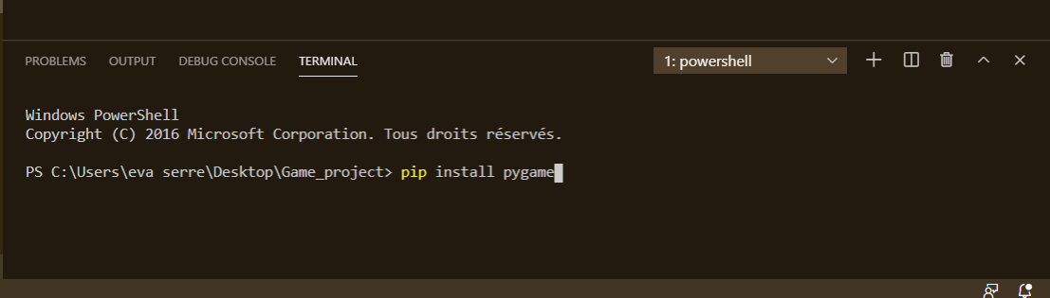

Commands

-Once you will have made run the program, you should see a frame printing a space ship and a play button.

Click on it to start the game.

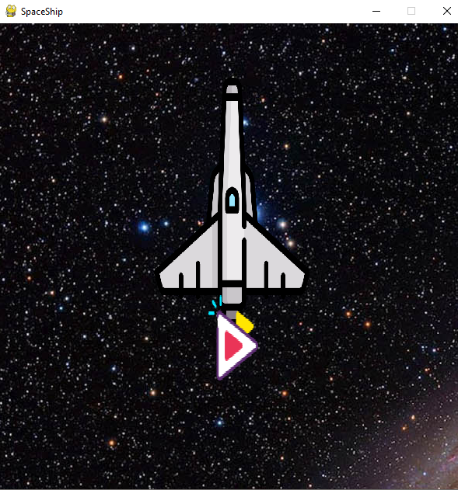

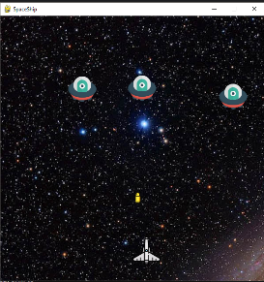_Tab = Shoting

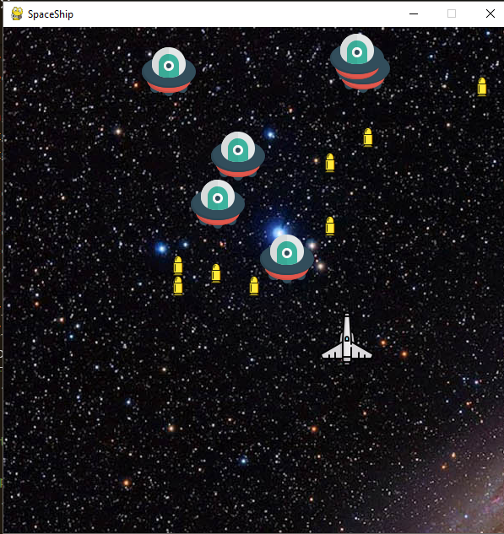

-Arrow keys = deplacement

SpaceShip is an open source program.