**IST 263 Project Milestone 6 – First Draft Using CSS**

**Name**: Marlon Orellana

**Description:**  
Please paste your project description from Project Milestone 1 here.

Since I could remember, video games have always been something that I enjoyed back then, now, and probably forever. In 2017, I decided that PC gaming would be something that I wanted to dive into and thus I decided to build my own computer. Now, I have been building computers for others and upgrading my own as technology continues to evolve. For this project, creating a website that explains what is inside a computer would be knowledgeable for someone to know if they ever have any issue with any component. Showing a computer built entirely might be too

**What is the URL of the page you choose to work on for this part?**

<https://morell01.github.io/ist263/project5/components.html>

**Paste a screen shot of the wireframe you created for this page below.**

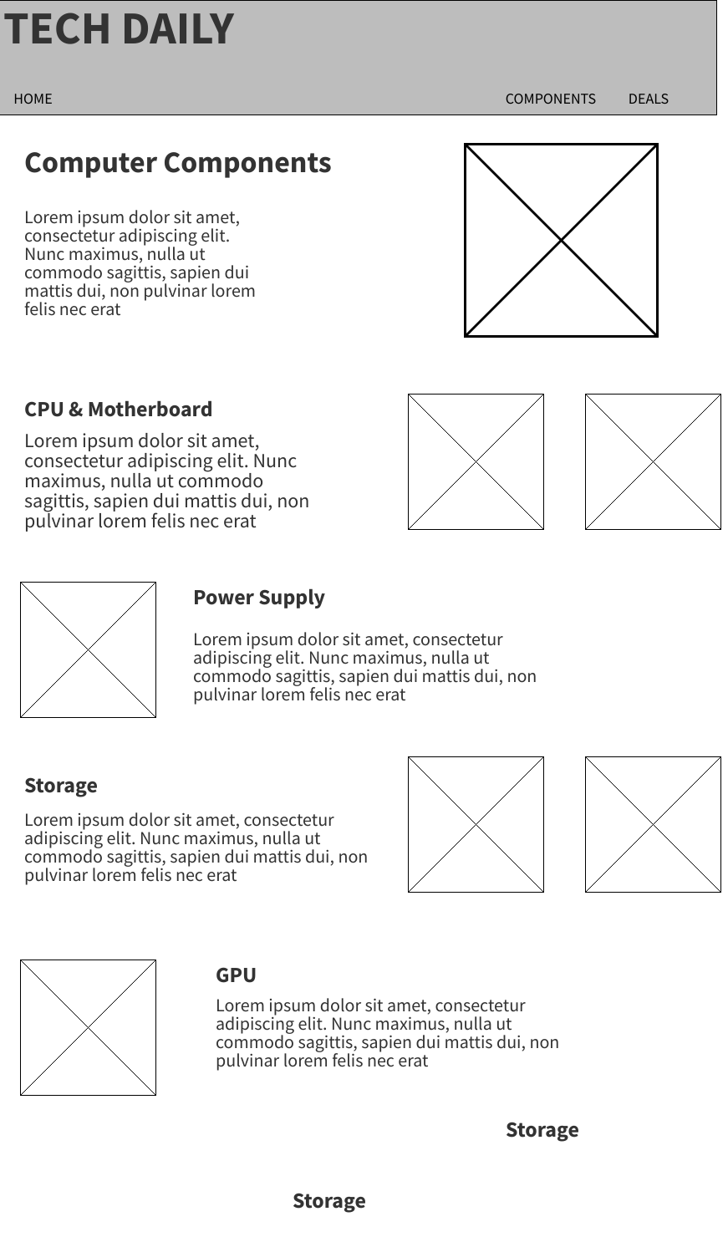

**Provide the URL of the HTML validator for you page below.**

[**https://html5.validator.nu/?doc=https%3A%2F%2Fmorell01.github.io%2Fist263%2Fproject6%2Fcomponents.html**](https://html5.validator.nu/?doc=https%3A%2F%2Fmorell01.github.io%2Fist263%2Fproject6%2Fcomponents.html)

**If something went wrong in this part, describe what happened and how you can fix it moving forward.   
Examples of problems could be, page isn’t responsive, page doesn’t look like wireframe, etc.**