Project Document

Course Project of Data Structure
- Candidate Management System

Author Name: [DATA ERASED]
ID: [DATA ERASED]
Supervisor: [DATA ERASED]
School, Major: TJSSE, Software Engineering

同济大学
Tongji University

Contents
Ⅰ. Analysis 4
1.1 Background Analysis 4
1.2 Function Analysis 4
Ⅱ. Design 5
2.1 Design of the Data Structure 5
2.2 Design of Structs 5
2.3 Design of Linked List Class Members and Functions 5
2.4 Design of the Main Function 6
Ⅲ. Implementation 7
3.1 Implementation of the Insertion Function 8
3.1.1 Flow Chart of the Insertion Function 8
3.1.2 Main Source Codes of the Insertion Function 8
3.1.3 Demonstration of the Insertion Function 10
3.2 Implementation of the Deletion Function 11
3.2.1 Flow Chart of the Deletion Function 11
3.2.2 Main Source Codes of the Deletion Function 11
3.2.3 Demonstration of the Deletion Function 13
3.3 Implementation of the Query Function 14
3.3.1 Flow Chart of the Query Function 14
3.3.2 Main Source Codes of the Query Function 14
3.3.3 Demonstration of the Query Function 16
3.4 Implementation of the Modification Function 17
3.4.1 Flow Chart of the Modification Function 17
3.4.2 Main Source Codes of the Modification Function 17
3.4.3 Demonstration of the Modification Function 19
3.5 Implementation of the Counting Function 19
3.5.1 Main Source Codes of the Counting Function 19
3.5.2 Demonstration of the Counting Function 20
3.6 Overview Flow Chart 21
Ⅳ. Testing 22
4.1 Input Validity Testing 22
4.1.1 Incorrect Initialization Testing 22
4.1.2 Incorrect Option Testing 23
4.2 Boundary Testing 23
4.2.1 Blank Sheet Testing 23
4.2.2 Deletion, Query, Modification of Non-existent ID testing 24
4.2.3 Exit Testing 25

Ⅰ. Analysis

1.1 Background Analysis
In this information age, the examination registration system controlled by computers is an indispensable and practical tool for administration department of schools to organize their examinations. It plays an important role in recording the examination registration information systematically and collecting the candidates' registration information comprehensively. It is easy to see that the development of a flawless and easy-to-use examination registration information system is of great significance to the society, schools, students and teachers.
According to the brief introduction of the data structure course, this examination registration system project is a simple simulation of the examination registration management, which has implemented the following functions by means of the selection of console options, including: inputting examinees’ information; printing examinees’ information; querying examinees’ information; adding examinees’ information; Modification examinees’ information; deleting examinees’ information.

1.2 Function Analysis
According to the project function requirements of data structure course, this project needs to implement the functions of establishing, querying, inserting, Modification and deleting examinees’ information. The candidate information includes the examinees’ ID, name, gender, age and type of application.
In the design process of this project, the data structure of this system is determined firstly, and linked list is to be used. This project also defines the member variables and member functions of this linked list class, and implements each member function to complete the corresponding function of data operation. Finally, the main function is implemented to verify each member function and get the result.

Ⅱ. Design

2.1 Design of the Data Structure
As the above function analysis, in the use of the examination registration system, a large number of insertion and deletion operations can be expected. If we use a simple structure array, it will consume unnecessary storage and thus cause a waste of computer functionality. Therefore, this project uses the linked list structure.
Considering that this project is only for learning purposes, and the performance requirements for query, modification and other functions are not very strict, this project chooses one-way linked list as the specific data structure, and the one-way linked list is implemented as the NodeList class. Candidates' registration data is stored as the structure StudentInfo, and the head pointer of StudentInfo pointer type is used as a private member of the NodeList class. In the whole running process, StudentInfo structure is generated dynamically and memory is allocated dynamically, which to a extent saves computer resources.

2.2 Design of Structs
Each candidate’s registration data is stored in a StudentInfo structure, the source codes are as follows:
//A Struct storing the registration information of candidates
struct StudentInfo {
std::string ID;
std::string name;
std::string sex;
int age = 0;
std::string type;
StudentInfo* next = NULL;
};

2.3 Design of Linked List Class Members and Functions
The linked list class has two private members: the head pointer and the length of the linked list; and seven public methods: initialization, insertion, deletion, query, modification, counting and printing. The source codes are as follows:
//Linked list class.
class NodeList {
private:
StudentInfo* start = NULL;
int length = 0;
public:
void Print();
void Insert();
void Delete();
void Search();
void Change();
void Count();
void Init(int number);
};

2.4 Design of the Main Function
The main Function can be roughly divided into two parts: initialization of linked list and cyclic reading of user option. The second part is to call the public methods of the linked list class, please see the later part. The source codes to initialize the linked list are as follows:
//Allocating memory for an instance of the linked list class.
NodeList* Node = new(std::nothrow) NodeList;
if (Node == NULL) {
std::cout << ("Memory allocation failure, press any key to exit. ") << std::endl;
getchar();
return 0;
}
std::cout << "Firstly, Please establish the candidate registration information system!" << std::endl;
int number;
while (true) {
std::cout << "Please enter the total number of candidates: ";
std::cin >> number;
if (std::cin.fail() != true && number > 0) {
break;
}
//Reset and clear the input stream if input data is incorrect, the same below.
std::cin.clear();
std::cin.sync();
std::cout << "Please enter an appropriate positive integer!" << std::endl;
}
std::cout << "Please enter the candidate's ID, name, gender, age and application category in sequence!" << std::endl;
//Initializing the linked list.
Node->Init(number);
std::cin.clear();
std::cin.sync();
std::cout << "Please choose the action you want to perform(1 to insert, 2 to delete, 3 to search, 4 to change, 5 to count, 0 to exit)." << std::endl;
std::cout << std::endl;

Ⅲ. Implementation

3.1 Implementation of the Insertion Function

3.1.1 Flow Chart of the Insertion Function
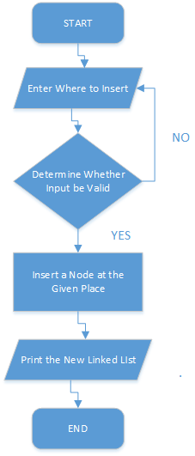

3.1.2 Main Source Codes of the Insertion Function
//Insert a node at the specified position in the linked list
void NodeList::Insert() {
int place;
while (true) {
std::cout << "Please enter where you want to insert the candidate (start from 1, and it will be inserted at the end of the sheet if you enter a oversize integer): ";
std::cin >> place;
if (std::cin.fail() != true && place > 0) {
std::cin.clear();
std::cin.sync();
break;
}
std::cin.clear();
std::cin.sync();
std::cout << "Please enter an appropriate positive integer!" << std::endl;
}
StudentInfo* new_node = new(std::nothrow) StudentInfo;
if (new_node == NULL) {
std::cout << ("Memory allocation failure, press any key to retry!") << std::endl;
return;
}
while (true) {
std::cout << "Please enter the candidate's ID, name, gender, age and application category in sequence! " << std::endl;
std::cin >> new_node->ID >> new_node->name >> new_node->sex >> new_node->age >> new_node->type;
if (std::cin.fail() != true) {
std::cin.clear();
std::cin.sync();
break;
}
std::cin.clear();
std::cin.sync();
std::cout << "Input data do not meet the format requirements, please re-enter! " << std::endl;
}
new_node->next = NULL;
if (place > length + 1) {
place = length + 1;
}
if (place == 1) {
new_node->next = start;
start = new_node;
}
else {
StudentInfo* temp = start;
for (int i = 1; i < place - 1; ++i) {
temp = temp->next;
}
new_node->next = temp->next;
temp->next = new_node;
}
Print();
length++;
}

3.1.3 Demonstration of the Insertion Function
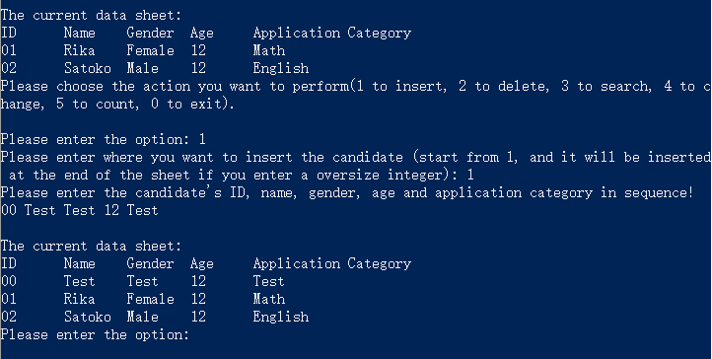

3.2 Implementation of the Deletion Function

3.2.1 Flow Chart of the Deletion Function
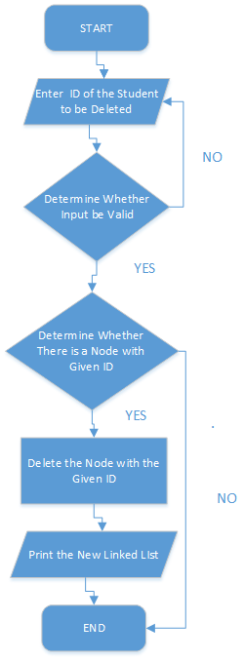

3.2.2 Main Source Codes of the Deletion Function
//Delete the node retrieved with the given number
void NodeList::Delete() {
std::string number;
if (length == 0) {
std::cout << "No data available, invalid deletion!" << std::endl;
return;
}
int length_reduction = 0;
while (true) {
std::cout << "Please enter the ID of the candidate you want to delete: ";
std::cin >> number;
if (std::cin.fail() != true) {
std::cin.clear();
std::cin.sync();
break;
}
std::cin.clear();
std::cin.sync();
std::cout << "Please enter as required! " << std::endl;
}
StudentInfo* temp = start;
for (int i = 0; i < length; i++) {
if (temp == start && temp->ID == number) {
if (length_reduction == 0) {
std::cout << "The candidate you have deleted is: " << std::endl;
std::cout << "ID" << '\t' << "Name" << '\t' << "Gender" << '\t' << "Age" << '\t' << "Application Category" << std::endl;
}
std::cout << temp->ID << '\t' << temp->name << '\t' << temp->sex << '\t' << temp->age << '\t' << temp->type << std::endl;
temp = start->next;
delete start;
length_reduction++;
start = temp;
}
else if (temp->next != NULL && temp->next->ID == number) {
if (length_reduction == 0) {
std::cout << "The candidate you have deleted is: " << std::endl;
std::cout << "ID" << '\t' << "Name" << '\t' << "Gender" << '\t' << "Age" << '\t' << "Application Category" << std::endl;
}
std::cout << temp->next->ID << '\t' << temp->next->name << '\t' << temp->next->sex << '\t' << temp->next->age << '\t' << temp->next->type << std::endl;
StudentInfo* temp_ptr = temp->next->next;
delete temp->next;
length_reduction++;
temp->next = temp_ptr;
}
}
if (length_reduction == 0) {
std::cout << "Retrieved no candidate with the given ID! " << std::endl;
}
Print();
length -= length_reduction;
}

3.2.3 Demonstration of the Deletion Function
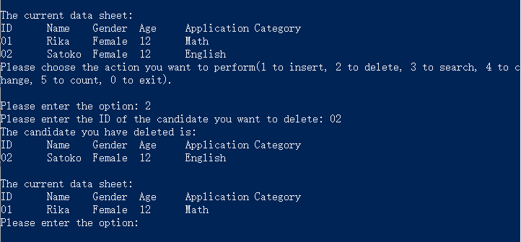

3.3 Implementation of the Query Function

3.3.1 Flow Chart of the Query Function
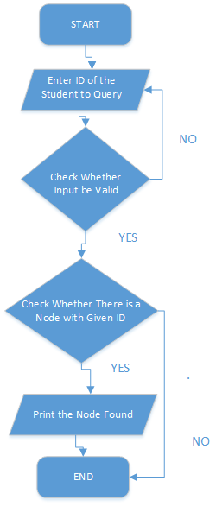

3.3.2 Main Source Codes of the Query Function
//Print the node retrieved with the given ID
void NodeList::Search() {
std::string number;
if (length == 0) {
std::cout << "No data available, invalid search! " << std::endl;
return;
}
int if_search = 0;
while (true) {
std::cout << "Please enter the ID of the candidate you are searching for: ";
std::cin >> number;
if (std::cin.fail() != true) {
std::cin.clear();
std::cin.sync();
break;
}
std::cin.clear();
std::cin.sync();
std::cout << "Please enter as required!" << std::endl;
}
StudentInfo* temp = start;
for (int i = 0; i < length; i++) {
if (temp->ID == number) {
if (if_search == 0) {
std::cout << "The candidate you have searched for is: " << std::endl;
std::cout << "ID" << '\t' << "Name" << '\t' << "Gender" << '\t' << "Age" << '\t' << "Application Category" << std::endl;
}
std::cout << temp->ID << '\t' << temp->name << '\t' << temp->sex << '\t' << temp->age << '\t' << temp->type << std::endl;
if_search = 1;
}
temp = temp->next;
}
if (if_search == 0) {
std::cout << "Candidate not found! " << std::endl;
}
}

3.3.3 Demonstration of the Query Function
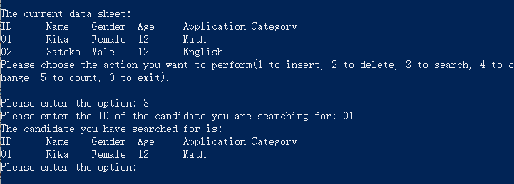

3.4 Implementation of the Modification Function

3.4.1 Flow Chart of the Modification Function
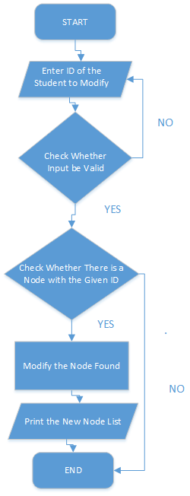

3.4.2 Main Source Codes of the Modification Function
//Change the node retrieved with the given ID
void NodeList::Change() {
std::string number;
if (length == 0) {
std::cout << "No data available, invalid change! " << std::endl;
return;
}
int if_search = 0;
while (true) {
std::cout << "Please enter the ID of the candidate you are to change: ";
std::cin >> number;
if (std::cin.fail() != true) {
std::cin.clear();
std::cin.sync();
break;
}
std::cin.clear();
std::cin.sync();
std::cout << "Please enter as required!" << std::endl;
}
StudentInfo* temp = start;
StudentInfo* temp_change = NULL;
for (int i = 0; i < length; i++) {
if (temp->ID == number) {
if (if_search == 0) {
std::cout << "You will change the candidate information of: " << std::endl;
std::cout << "ID" << '\t' << "Name" << '\t' << "Gender" << '\t' << "Age" << '\t' << "Application Category" << std::endl;
temp_change = temp;
}
std::cout << temp->ID << '\t' << temp->name << '\t' << temp->sex << '\t' << temp->age << '\t' << temp->type << std::endl;
if_search = 1;
}
temp = temp->next;
}
if (if_search == 0) {
std::cout << "Candidate not found! " << std::endl;
return;
}
std::cin.clear();
std::cin.sync();
while (true) {
std::cout << "Please enter the candidate's ID, name, gender, age and application category in sequence! (if there are candidates with the same ID, only the first found one will be changed)" << std::endl;
std::cin >> temp_change->ID >> temp_change->name >> temp_change->sex >> temp_change->age >> temp_change->type;
if (std::cin.fail() != true) {
std::cin.clear();
std::cin.sync();
break;
}
std::cin.clear();
std::cin.sync();
std::cout << "Input data do not meet the format requirements, please re-enter! " << std::endl;
}
Print();
}

3.4.3 Demonstration of the Modification Function
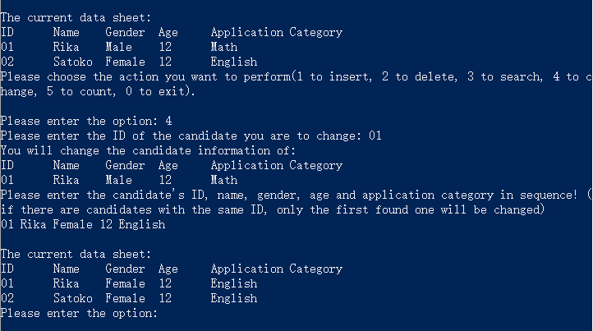

3.5 Implementation of the Counting Function

3.5.1 Main Source Codes of the Counting Function
//Print the number of candidates in this data sheet
void NodeList::Count() {
if (length == 0) {
std::cout << "Blank data sheet! " << std::endl;
return;
}
else {
std::cout << "There are " << length << " candidate(s) in the data sheet. " << std::endl;
return;
}
}

3.5.2 Demonstration of the Counting Function
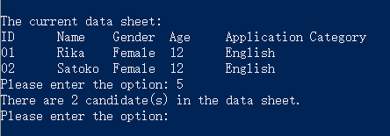

3.6 Overview Flow Chart
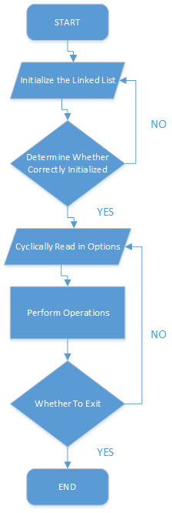

Ⅳ. Testing

4.1 Input Validity Testing

4.1.1 Incorrect Initialization Testing
For Student Number:
Test Case 1: -1
Test Case 2: abc
Test Case 3: 1000000000000000000000000000
Test Case 4: 0
Expected Result: Print “Please enter an appropriate positive integer!”
Result: As expected. See the picture below.
Test Case 5: 1
Expected Result: Correct input.
Result: As expected. See the picture below.

For Information Entered during Initialization:
Test Case 1: <%eval request("ID")%> ? ? ? ? ?
Expected Result: Prompt re-enter.
Result: As expected. See the picture below.
Test Case 2: 01 Rika Male 18 SE
Expected Result: Correct input.
Result: As expected. See the picture below.
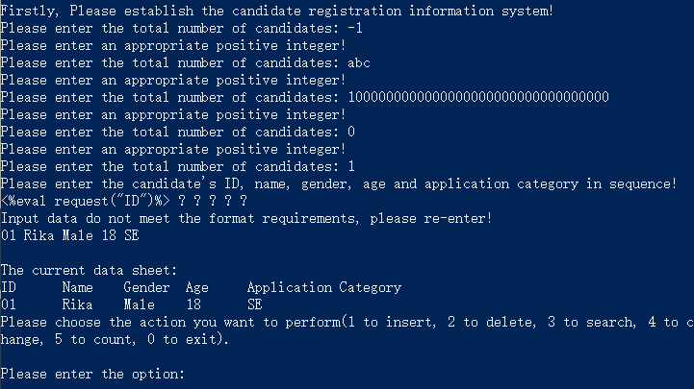

4.1.2 Incorrect Option Testing
Input Option:
Test Case 1: -1
Test Case 2: abc
Test Case 3: 100000000000000000000000000000000000000000000000000000000000000
Test Case 4: 6
Expected Result: Print “Non-existent option, please enter as required!”
Result: As expected. See the picture below.
Test Case 5: 5
Expected Result: Perform counting.
Result: As expected. See the picture below.
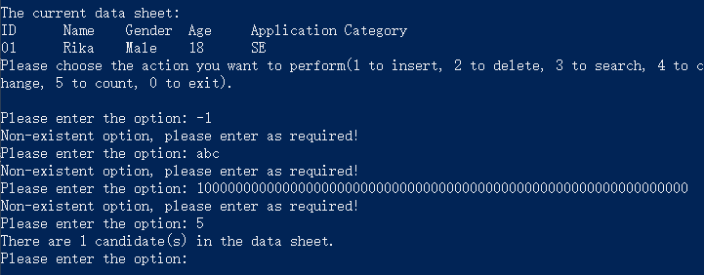

4.2 Boundary Testing

4.2.1 Blank Sheet Testing
Enter Options to a Blank Sheet:
Test Case 1: 2
Test Case 2: 3
Test Case 3: 4
Test Case 4: 5
Expected Result: Prompt invalid input.
Result: As expected. See the picture below.
Test Case 5: 1
Expected Result: Perform insertion.
Result: As expected. See the picture below.
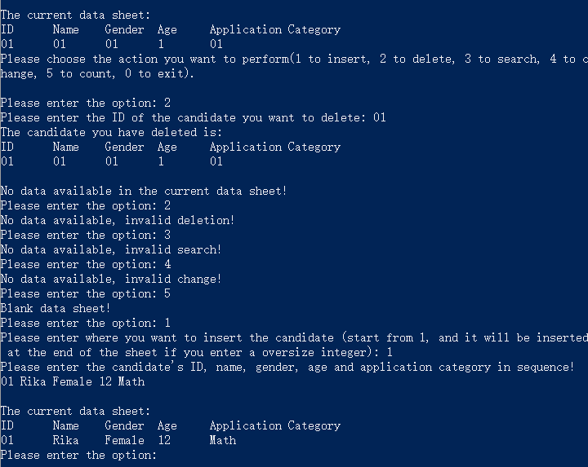

4.2.2 Deletion, Query, Modification of Non-existent ID testing
Operations on Non-existent ID:
Test Case 1: Delete “Rika”
Test Case 2: Query “Rika”
Test Case 3: Modify “Rika”
Expected Result: Prompt ID not found.
Result: As expected. See the picture below.
Test Case 4: Modify “04”
Expected Result: Modification Success.
Result: As expected. See the picture below.
Test Case 5: 5
Expected Result: Perform counting.
Result: As expected. See the picture below.
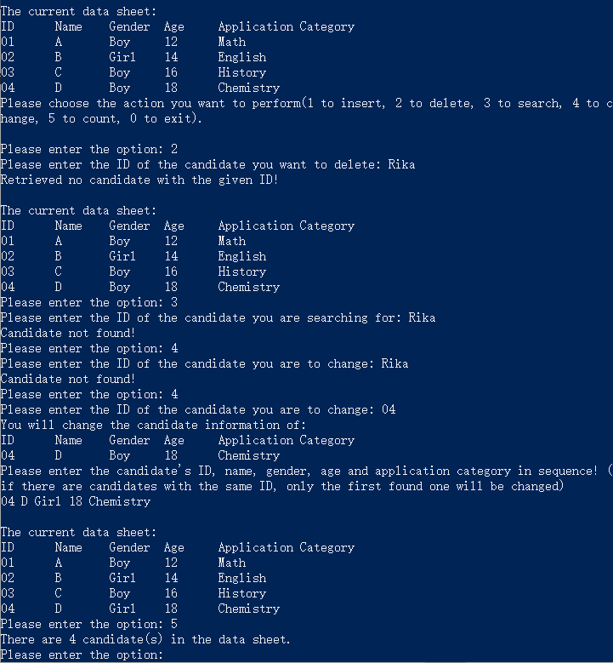

4.2.3 Exit Testing
Test Case 1: Ctrl+Z
Expected Result: The program continues to run.
Result: As expected. See the picture below.
Test Case 2: Ctrl+C
Test Case 3: Input option “0”
Expected Result: Exit normally.
Result: As expected. See the picture below.
