Project Document

Course Project of Data Structure
- Intersection of Two Linked Lists

Author Name: [DATA ERASED]
ID: [DATA ERASED]
Supervisor: [DATA ERASED]
School, Major: TJSSE, Software Engineering

同济大学
Tongji University

Contents
Ⅰ. Analysis 3
1.1 Background Analysis 3
1.2 Function Analysis 3
Ⅱ. Design 4
2.1 Design of the Data Structure 4
2.2 Design of Structs 4
2.3 Design of Linked List Class Members and Functions 5
2.4 Design of the Main Function 5
Ⅲ. Implementation 7
3.1 Implementation of the Intersection Function 7
3.1.1 Main Source Codes of the Intersection Function 7
3.1.2 Demonstration of the Intersection Function 9
3.2 Implementation of Printing the Linked List 10
3.2.1 Main Source Codes of Printing the Linked List 10
3.3 Overview Flow Chart 11
Ⅳ. Testing 12
4.1 Input Validity Testing 12
4.1.1 Incorrect Input Testing 12
4.2 Boundary Testing 12
4.2.1 Exit Testing 12

Ⅰ. Analysis

1.1 Background Analysis
Linked list is an incontinuous and nonsequential storage structure on physical storage unit. The logical order of data elements is implemented by the pointer linking order in the linked list. The linked list is composed of multiple nodes. Each node must have at least one pointer to the next node, and there should be some data in non-empty nodes. In addition, other pointers or data may be stored in the node according to the functions the linked list is to implement.
It is one of the basic operations of the linked list to find the intersected linked list of two linked lists and print it. It is widely used in computer programming, and it helps to improve the coding ability of students, let them accumulate coding experience, and lay a good programming foundation for more complex projects in the future.

1.2 Function Analysis
According to the function requirements of the project, the input of this project is divided into two lines. Each line is a non-descending sequence composed of several positive integers. Use -1 to indicate the end of the sequence (-1 does not belong to this sequence), and use space to separate the numbers.
The required output is the intersection sequence of two input sequences in a line, the numbers are separated by spaces, and there can be no extra spaces at the end; if the new list is empty, the output shall be null.
The testing cases given are as follows:
No. | Input | Output | Description
1 | 1 2 5 -1  2 4 5 8 10 -1 | 2 5 | A General Case
2 | 1 3 5 -1  2 4 6 8 10 -1 | NULL | A Case where the intersection is null
3 | 1 2 3 4 5 -1  1 2 3 4 5 -1 | 1 2 3 4 5 | A Case where the two input linked lists are the same
4 | 3 5 7 -1  2 3 4 5 6 7 8 -1 | 3 5 7 | A case where one input line in contained in the other
5 | -1  10 100 1000 -1 | NULL | A case where one input line is null

Ⅱ. Design

2.1 Design of the Data Structure
As the above functional analysis, the requirements of this project is to use the linked list, which is to exercise the ability of students to use the linked list, and improve the skill of students to use the linked list. Therefore, this project uses the linked list structure.
Considering that the requirements of this project are relatively simple, after the intersection of the linked lists only the print operation needs to be performed, and the time complexity and space complexity is not high, so this project chooses the one-way linked list as the specific data structure, and this one-way linked list is implemented as the NodeList class. Each input number is stored as the structure Number, and the head pointer of the Number pointer type is used as a private member of the NodeList class. In the whole running process, the Number structure is generated dynamically and the memory is allocated dynamically, which to a extent saves the computer resources.

2.2 Design of Structs
Each input number is stored in a Number structure, the source codes are as follows:
//A Struct storing the numbers
struct Number {
int number = 0;
Number* next = NULL;
};

2.3 Design of Linked List Class Members and Functions
The linked list class has two private members: the head pointer and the length of the linked list, and three public methods: initialization, print and intersection. The source codes are as follows:
//Linked list class.
class NodeList {
private:
Number* start = NULL;
public:
void Print();
void Init();
void Merge(NodeList* Node1, NodeList* Node2);
};

2.4 Design of the Main Function
The main function can be roughly divided into three parts: initialization, intersection and print. The second and third part calls the public methods of the linked list class, please see the later part. The source codes to initialize the linked list are as follows:
//Initialize the linked list
void NodeList::Init() {
while (true) {
Number* temp_node_ptr = NULL;
int key = 0;
int test_number = -1;
bool is_failed = false;
while (true) {
Number* new_node = new(std::nothrow) Number;
if (new_node == NULL) {
std::cout << "Memory allocation failure, press any key to retry! " << std::endl;
getchar();
continue;
}
int temp_number;
std::cin >> temp_number;
//Break if input data is incorrect
if (std::cin.fail() == true) {
break;
}
if (temp_number == -1) {
break;
}
if (temp_number < test_number) {
std::cout << "The input linked list must be positive integers divided by a space, end with -1 and non-descending! " << std::endl;
is_failed = true;
break;
}
if (temp_number <= 0) {
std::cout << "The input linked list must be positive integers divided by a space, end with -1 and non-descending! " << std::endl;
is_failed = true;
break;
}
test_number = temp_number;
if (key == 0) {
start = new_node;
key = 1;
}
else {
temp_node_ptr->next = new_node;
}
temp_node_ptr = new_node;
new_node->number = temp_number;
new_node->next = NULL;
}
//Reset and clear the input stream if input data is incorrect.
if (std::cin.fail() != true && is_failed == false) {
break;
}
std::cin.clear();
std::cin.sync();
std::cout << "Input data do not meet the format requirements, please re-enter! " << std::endl;
}
}

Ⅲ. Implementation

3.1 Implementation of the Intersection Function

3.1.1 Main Source Codes of the Intersection Function
//Perform intersection
void NodeList::Merge(NodeList* Node1, NodeList* Node2) {
if (Node1->start != NULL && Node2->start != NULL) {
Number* temp1 = Node1->start;
Number* temp2 = Node2->start;
Number* temp = NULL;
while (temp1 != NULL && temp2 != NULL) {
//As the input linked lists are non-descending, when one number is smaller than the other, just shift afterwards the iterator of that linked list by one.
if (temp1->number > temp2->number) {
temp2 = temp2->next;
continue;
}
if (temp1->number < temp2->number) {
temp1 = temp1->next;
continue;
}
if (temp1->number == temp2->number) {
Number* new_node = new(std::nothrow) Number;
if (new_node == NULL) {
std::cout << "Memory allocation failure, press any key to retry! " << std::endl;
getchar();
continue;
}
//Insert a node into the result linked list
new_node->number = temp1->number;
new_node->next = NULL;
if (start == NULL) {
start = new_node;
temp = new_node;
}
else {
temp->next = new_node;
temp = temp->next;
}
temp1 = temp1->next;
temp2 = temp2->next;
}
}
}
//Either input linked list is NULL, the result linked list is NULL
else {
start = NULL;
return;
}
}

3.1.2 Demonstration of the Intersection Function
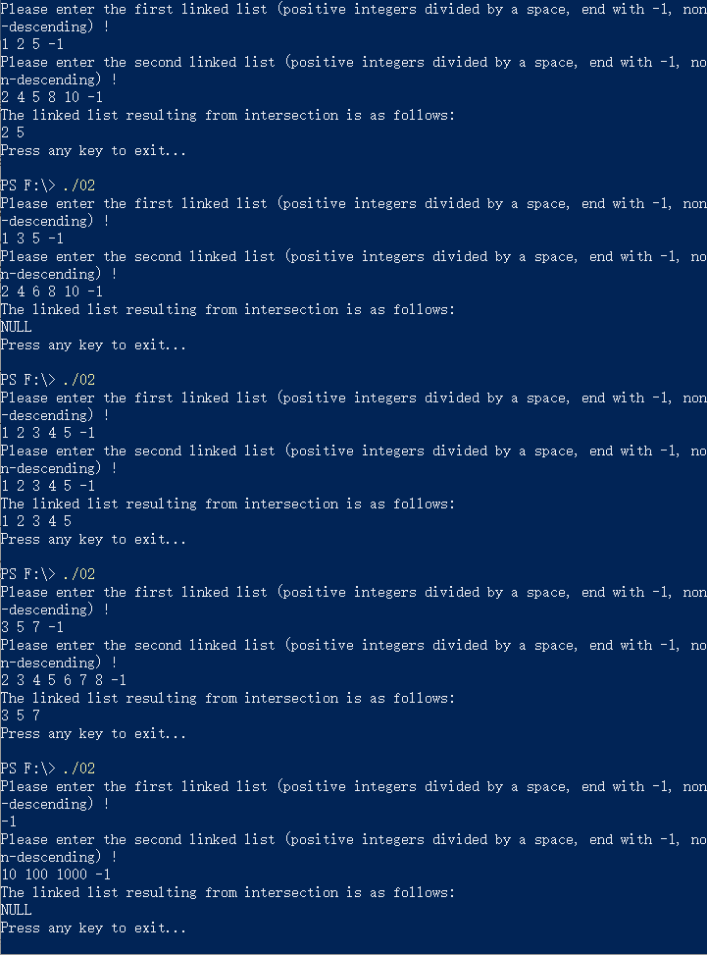

3.2 Implementation of Printing the Linked List

3.2.1 Main Source Codes of Printing the Linked List
//Print the current linked list.
void NodeList::Print() {
if (start == NULL) {
std::cout << "NULL";
}
else {
Number* temp = start;
while (temp != NULL && temp->next != NULL) {
std::cout << temp->number << " ";
temp = temp->next;
}
if(temp != NULL){
std::cout << temp->number;
}
}
std::cout << std::endl;
}

3.3 Overview Flow Chart
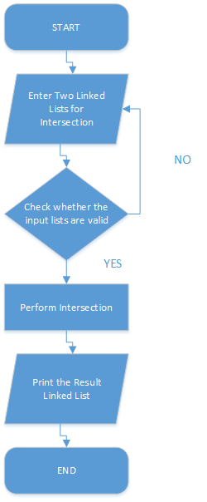

Ⅳ. Testing

4.1 Input Validity Testing

4.1.1 Incorrect Input Testing
Test Case 1: 10000000000000000000000000000000 1 -1
Test Case 2: 100000000000000000000000000000000000000000000000000000000000000
Test Case 3: 1,7,9,-1
Test Case 4: !@#$%^&*()
Test Case 5: NULL
Expected Result: Print “Input data do not meet the format requirements, please re-enter!”
Result: As expected. See the picture below.
Test Case 6: 9 8 7 -1
Expected Result: Print “The input linked list must be positive integers divided by a space, end with -1 and non-descending!”
Result: As expected. See the picture below.
Test Case 7: 1 3 5 -1
Expected Result: Correct input.
Result: As expected. See the picture below.
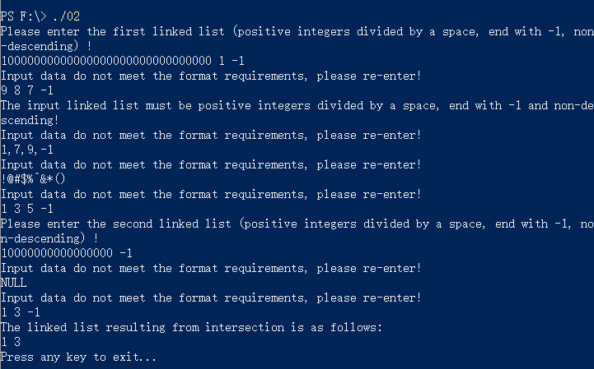

4.2 Boundary Testing

4.2.1 Exit Testing
Test Case 1: Ctrl+Z
Expected Result: The program continues to run.
Result: As expected. See the picture below.
Test Case 2: Ctrl+C
Expected Result: Exit normally.
Result: As expected. See the picture below.
