Project Document

Course Project of Data Structure
- Maze Raider

Author Name: [DATA ERASED]
ID: [DATA ERASED]
Supervisor: [DATA ERASED]
School, Major: TJSSE, Software Engineering

同济大学
Tongji University

Contents
Ⅰ. Analysis 3
1.1 Background Analysis 3
1.2 Function Analysis 3
Ⅱ. Design 4
2.1 Design of the Data Structure 4
2.2 Design of Maze Class Members and Functions 4
2.3 Design of Some Simple Functions in Maze Class 5
2.4 Design of the Main Function 6
Ⅲ. Implementation 7
3.1 Implementation of the Maze-Generating Function 7
3.1.1 Flow Chart of the Maze-Generating Function 7
3.1.2 Main Source Codes of the Maze-Generating Function 7
3.1.3 Demonstration of the Maze-Generating Function 11
3.2 Implementation of the Maze-solving Function 12
3.2.1 Flow Chart of the Maze-solving Function 12
3.2.2 Main Source Codes of the Maze-solving Function 13
3.2.3 Demonstration of the Maze-solving Function 14
3.3 Overview Flow Chart 15
Ⅳ. Testing 16
4.1 Input Validity Testing 16
4.1.1 Incorrect Option Testing 16
4.2 Boundary Testing 17
4.2.1 Exit Testing 17

Ⅰ. Analysis

1.1 Background Analysis
There are only two doors in the maze, one is called the entrance and the other is called the exit. A knight rides into the maze from the entrance. The maze is set with many obstacles. The knight needs to find a way in the maze to reach the exit.

1.2 Function Analysis
The maze problem can be solved by using a backtracking method, that is, searching under certain constraint conditions to search forward, and if the process is blocked, then go back to correct the error and choose another path to continue searching. Start from the entrance and explore forward in a certain direction. If it can get through, that is, reach a certain point (reach a new point), otherwise we explore the next direction; if there is no access in all directions, return to the previous point along the original road. Change direction and continue testing until all possible paths are explored, or one path is found, or there is no way to go and return to the entrance.
In the finding solution process, in order to ensure that when we cannot continue to walk forward after reaching a certain point, we can correctly return to the previous one so as to test forward from the next direction, we need to save the index of each point that can be reached during the test and the direction of the point. The searching process ends when the exit is found.

Ⅱ. Design

2.1 Design of the Data Structure
As described in the function analysis above, the backtracking method is used to find the way to go. To make the sources codes more concise and easier to implement, a recursive algorithm is used. At the same time, an array is used to save the coordinates of the point of each recursive temptation. After finding the exit, the coordinates are popped out of the array and printed according to the format to obtain the required path.
According to the requirements of this project, we use Depth-first Search (DFS) for this project. Depth-first search (DFS) is an algorithm for traversing or searching tree or graph data structures. The algorithm starts at the root node (selecting some arbitrary node as the root node in the case of a graph) and explores as far as possible along each branch before backtracking.

2.2 Design of Maze Class Members and Functions
According to the analysis above, this problem only needs to implement the recursive algorithm and the array required to save the coordinates of the tried points. Therefore, the main class structure of the program is the Maze class.
The Maze class can be roughly divided into two parts: generating the maze, and solve the maze. The “grid” array is to store the maze. The “solution” array is to store the solution path. The “have_searched” array is to indicate which grids have been searched. The integer “length” is to show how long the path is. The source codes are as follows:
//Storing data related to the maze
class Maze {
private:
char grid[MAZE_SIZE][MAZE_SIZE] = { {0} };
int solution[MAZE_SIZE * MAZE_SIZE][2] = { {0} };
bool have_searched[MAZE_SIZE][MAZE_SIZE] = { {false} };
int length = 0;
void Randomize();
bool judge_grid(int x, int y);
bool is_in_bound(int x, int y);
public:
Maze() {
for (int i = 0; i < MAZE_SIZE; ++i) {
for (int j = 0; j < MAZE_SIZE; ++j) {
grid[i][j] = 'X';
}
}
}
void Generate();
void Print();
void Find_way();
};

2.3 Design of Some Simple Functions in Maze Class
The “is_in_bound” function is to check whether a coordinate is in the array. The source codes are as follows:
bool Maze::is_in_bound(int x, int y) {
if (x >= 0 && x < MAZE_SIZE && y >= 0 && y < MAZE_SIZE) {
return true;
}
return false;
}
The “Print” function, just as its name, is to print the maze. The source codes are as follows:
//Print the maze
void Maze::Print() {
std::cout << "Maze Map: " << std::endl;
std::cout << "S: Start" << " " << "T: Terminal" << " " << "O: Passable Grid" << " " << "X: Impassable Grid" << std::endl;
std::cout << std::endl;
std::cout << "\t";
for (int i = 0; i < MAZE_SIZE; ++i) {
std::cout << "Column " << i << " ";
}
std::cout << std::endl;
for (int i = 0; i < MAZE_SIZE; ++i) {
std::cout << "Row " << i << "\t";
for (int j = 0; j < MAZE_SIZE; ++j) {
std::cout << grid[i][j] << " ";
}
std::cout << std::endl;
std::cout << std::endl;
}
std::cout << std::endl;
}

2.4 Design of the Main Function
The main function can be roughly divided into two parts: generate the maze, and solve the maze. Both the parts are to call the public methods of the Maze class, please see the later part. The source codes of the main function are as follows:
int main() {
int option = 0;
while (true) {
std::srand(std::time(0));
Maze maze;
maze.Generate();
maze.Print();
maze.Find_way();
while (true) {
std::cout << std::endl;
std::cout << "Enter 0 to regenerate a random 8*8 maze, enter 1 to exit. " << std::endl;
std::cout << "(If you generate more than one maze in a second, they will be the same!): ";
std::cin >> option;
if (std::cin.fail() != true && option >= 0 && option < 2) {
std::cin.clear();
std::cin.sync();
break;
}
//Reset and clear the input stream if input data is incorrect.
std::cin.clear();
std::cin.sync();
std::cout << std::endl;
std::cout << "Please enter an appropriate option!" << std::endl;
}
if (option == 1) {
exit(0);
}
}
return 0;
}

Ⅲ. Implementation

3.1 Implementation of the Maze-Generating Function

3.1.1 Flow Chart of the Maze-Generating Function
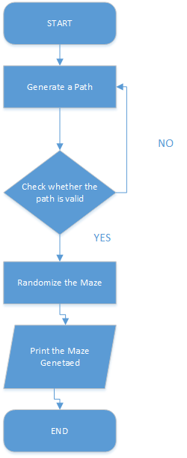

3.1.2 Main Source Codes of the Maze-Generating Function
Through “Generate” function we generate a path through the maze. The source codes are as follows:
//To guarantee there is a path in the generated maze
void Maze::Generate() {
grid[0][0] = 'S';
grid[MAZE_SIZE - 1][MAZE_SIZE - 1] = 'T';
int tempx = 0, tempy = 0;
bool is_true_flag;
while (true) {
is_true_flag = false;
bool directions[4] = { false,false,false,false };
int direction_plus[4][2] = { {-1,0},{0,-1},{1,0},{0,1} };
if (tempx - 1 >= 0) {
if (grid[tempx - 1][tempy] == 'T') {
Randomize();
return;
}
if (grid[tempx - 1][tempy] == 'X') {
int count = 0;
for (int i = 0; i < 4; ++i) {
if (is_in_bound(tempx - 1 + direction_plus[i][0], tempy + direction_plus[i][1]) && grid[tempx - 1 + direction_plus[i][0]][tempy + direction_plus[i][1]] == 'O') {
count++;
}
}
if (count <= 1) {
directions[0] = true;
is_true_flag = true;
}
}
}
if (tempy - 1 >= 0) {
if (grid[tempx][tempy - 1] == 'T') {
Randomize();
return;
}
if (grid[tempx][tempy - 1] == 'X') {
int count = 0;
for (int i = 0; i < 4; ++i) {
if (is_in_bound(tempx + direction_plus[i][0], tempy - 1 + direction_plus[i][1]) && grid[tempx + direction_plus[i][0]][tempy - 1 + direction_plus[i][1]] == 'O') {
count++;
}
}
if (count <= 1) {
directions[1] = true;
is_true_flag = true;
}
}
}
if (tempx + 1 <= MAZE_SIZE - 1) {
if (grid[tempx + 1][tempy] == 'T') {
Randomize();
return;
}
if (grid[tempx + 1][tempy] == 'X') {
int count = 0;
for (int i = 0; i < 4; ++i) {
if (is_in_bound(tempx + 1 + direction_plus[i][0], tempy + direction_plus[i][1]) && grid[tempx + 1 + direction_plus[i][0]][tempy + direction_plus[i][1]] == 'O') {
count++;
}
}
if (count <= 1) {
directions[2] = true;
is_true_flag = true;
}
}
}
if (tempy + 1 <= MAZE_SIZE - 1) {
if (grid[tempx][tempy + 1] == 'T') {
Randomize();
return;
}
if (grid[tempx][tempy + 1] == 'X') {
int count = 0;
for (int i = 0; i < 4; ++i) {
if (is_in_bound(tempx + direction_plus[i][0], tempy + 1 + direction_plus[i][1]) && grid[tempx + direction_plus[i][0]][tempy + 1 + direction_plus[i][1]] == 'O') {
count++;
}
}
if (count <= 1) {
directions[3] = true;
is_true_flag = true;
}
}
}
if (is_true_flag == false) {
tempx = 0, tempy = 0;
for (int i = 0; i < MAZE_SIZE; ++i) {
for (int j = 0; j < MAZE_SIZE; ++j) {
grid[i][j] = 'X';
}
}
grid[0][0] = 'S';
grid[MAZE_SIZE - 1][MAZE_SIZE - 1] = 'T';
continue;
}
int temp;
while (true) {
temp = std::rand() % 4;
if (directions[temp] == true) {
break;
}
}
tempx += direction_plus[temp][0];
tempy += direction_plus[temp][1];
grid[tempx][tempy] = 'O';
}
}
Through “Randomize” function we make the maze more random. Anyway, a maze with only a simple path is not a maze. The source codes are as follows:
//To make the maze more random
void Maze::Randomize() {
for (int i = 0; i < MAZE_SIZE; ++i) {
for (int j = 0; j < MAZE_SIZE; ++j) {
if (grid[i][j] == 'X') {
int temp = rand() % 4;
int direction_plus[4][2] = { {-1,0},{0,-1},{1,0},{0,1} };
int count = 0;
for (int k = 0; k < 4; ++k) {
if (is_in_bound(i + direction_plus[k][0], j + direction_plus[k][1]) && grid[i + direction_plus[k][0]][j + direction_plus[k][1]] == 'O') {
count++;
}
}
if (count < temp) {
grid[i][j] = 'O';
}
}
}
}
}

3.1.3 Demonstration of the Maze-Generating Function
Here are two examples the maze-generating function produces:
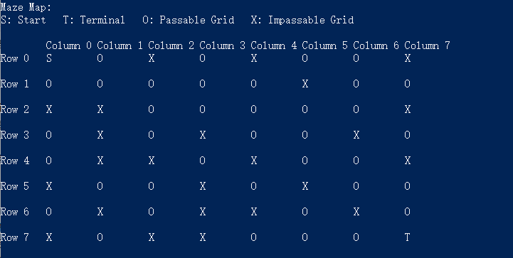
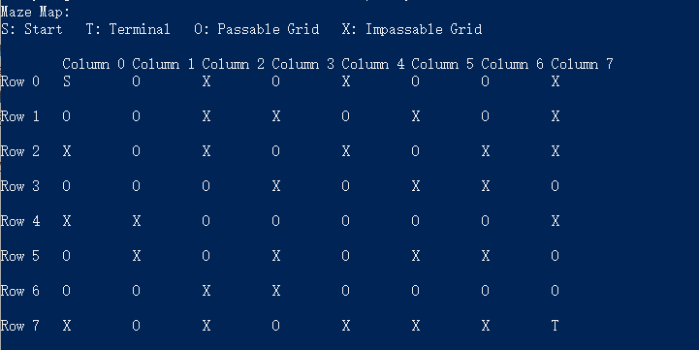

3.2 Implementation of the Maze-solving Function

3.2.1 Flow Chart of the Maze-solving Function
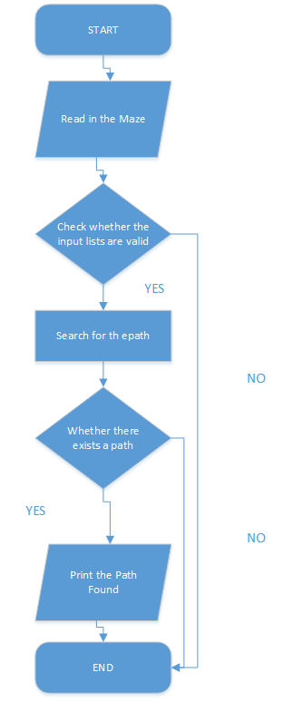

3.2.2 Main Source Codes of the Maze-solving Function
This program uses “judge_grid” function to check whether a grid should be searched. The source codes are as follows:
bool Maze::judge_grid(int x, int y) {
int directions[4][2] = { {-1,0},{0,-1},{1,0},{0,1} };
have_searched[x][y] = true;
for (int i = 0; i < 4; i++) {
int new_x = x + directions[i][0];
int new_y = y + directions[i][1];
if (is_in_bound(new_x, new_y) && !have_searched[new_x][new_y] && grid[new_x][new_y] != 'X') {
if (grid[new_x][new_y] == 'T') {
solution[length][0] = new_x;
solution[length][1] = new_y;
length++;
return true;
}
bool result = judge_grid(new_x, new_y);
if (result) {
solution[length][0] = new_x;
solution[length][1] = new_y;
length++;
return true;
}
}
}
have_searched[x][y] = false;
return false;
}
And the “Find_way” function to produce a path. The source codes are as follows:
//Find the path through the maze
void Maze::Find_way() {
int start_x, start_y;
bool is_find_start = false;
for (int i = 0; i < MAZE_SIZE; ++i) {
for (int j = 0; j < MAZE_SIZE; ++j) {
if (grid[i][j] == 'S') {
start_x = i;
start_y = j;
is_find_start = true;
break;
}
}
}
if (is_find_start == false) {
std::cout << "Wrong Maze: find no START!" << std::endl;
return;
}
bool result = judge_grid(start_x, start_y);
if (!result) {
std::cout << "No path found." << std::endl;
return;
}
std::cout << "An example path: " << std::endl;
std::cout << "<" << start_x << "," << start_y << "> " << "---> ";
for (int i = length - 1; i > 0; i--) {
std::cout << "<" << solution[i][0] << "," << solution[i][1] << "> " << "---> ";
}
std::cout << "<" << solution[0][0] << "," << solution[0][1] << "> " << std::endl;
std::cout << std::endl;
}

3.2.3 Demonstration of the Maze-solving Function
Here is an example:
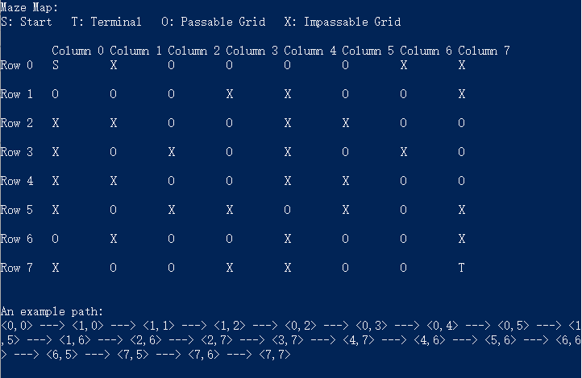

3.3 Overview Flow Chart
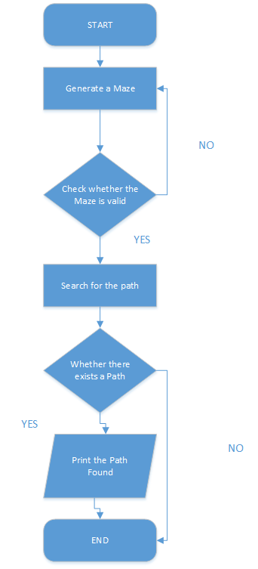

Ⅳ. Testing

4.1 Input Validity Testing

4.1.1 Incorrect Option Testing
Input Option:
Test Case 1: -1
Test Case 2: abc
Test Case 3: 100000000000000000000
Test Case 4: 6
Expected Result: Print “Non-existent option, please enter as required!”
Result: As expected. See the picture below.
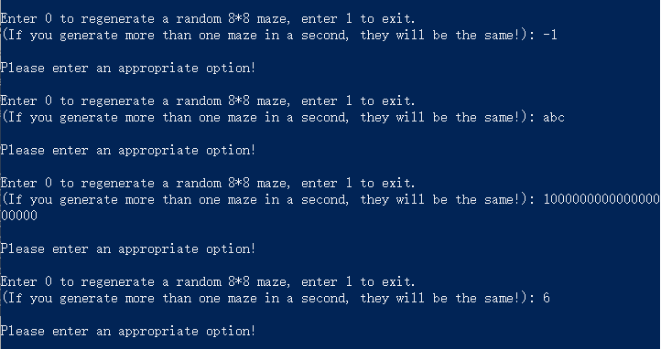
Test Case 5: 0
Expected Result: Re-generate the maze.
Result: As expected. See the picture below.
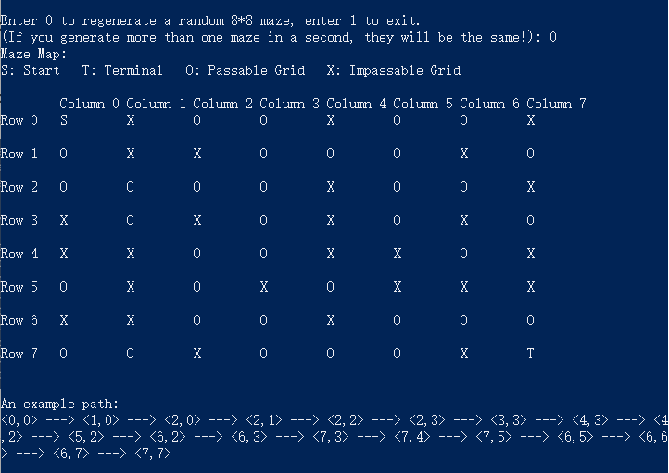

4.2 Boundary Testing

4.2.1 Exit Testing
Test Case 1: Ctrl+Z
Expected Result: The program continues to run.
Result: As expected. See the picture below.
Test Case 2: Ctrl+C
Test Case 3: Input option “1”
Expected Result: Exit normally.
Result: As expected. See the picture below.
