Project Document

Course Project of Data Structure
- Arithmetic Expressions Evaluation

Author Name: [DATA ERASED]
ID: [DATA ERASED]
Supervisor: [DATA ERASED]
School, Major: TJSSE, Software Engineering

同济大学
Tongji University

Contents
Ⅰ. Analysis 3
1.1 Background Analysis 3
1.2 Function Analysis 4
Ⅱ. Design 4
2.1 Design of the Data Structure 4
2.2 Design of the ICP (In-coming Priority) and ISP (In-stack Priority) 5
2.3 Design of the Main Function 6
Ⅲ. Implementation 8
3.1 Implementation of the Conversion Function 9
3.1.1 Flow Chart of the Conversion Function 9
3.1.2 Main Source Codes of the Conversion Function 9
3.1.3 Demonstration of the Conversion Function 11
3.2 Implementation of the Evaluation Function 12
3.2.1 Flow Chart of the Evaluation Function 12
3.2.2 Main Source Codes of the Evaluation Function 13
3.2.3 Demonstration of the Evaluation Function 17
3.3 Overview Flow Chart 18
Ⅳ. Testing 19
4.1 Function Testing 19
4.1.1 Six Binary Operators Testing 19
4.1.2 Two Unary Operators Testing 20
4.1.3 Nested Parentheses Testing 20
4.1.4 Multi-digital Number Testing 21
4.2 Input Validity Testing 21
4.2.1 Incorrect Expression Testing 21
4.3 Boundary Testing 22
4.3.1 Overflow Testing 22
4.3.2 Exit Testing 23

Ⅰ. Analysis

1.1 Background Analysis
Arithmetic expressions have the form of prefix expression, infix expression, and suffix expression. The arithmetic expressions used daily are infix notation, that is, the binary operator is located between two operands. However, computers require to use prefix expressions or suffix expressions for evaluation. In order for the computer to perform expression calculations, it is necessary to make the program convert infix expressions into suffix expressions and then evaluate the expression.

1.2 Function Analysis
As an expression evaluation program, we must first have the function of reading in expressions. According to the required format, there is no space between each operand. The input expression may have six types of operators, and the numbers may be negative or more than one digit integer, so the program must have the ability to correctly read in the input from the input stream. Then we need to be able to store the converted suffix expression. To convert an infix expression to a suffix expression, we need to use the stack. This program uses an array and an integer variable that stores the index of the number at the end of the array to implement the stack.
The program also needs to be able to evaluate the suffix expression correctly. This step also requires the stack. We need to output the result after evaluation, so the program is required to have the function to output the result correctly.

Ⅱ. Design

2.1 Design of the Data Structure
As described in the functional analysis above, the project requires operations that will make operators be pushed in or popped out of the stack, so we consider using the data structure of the stack. At the same time, because the number of input elements is not very large, for the sake of simplicity, the sequential stack implemented by array is used when evaluating the expression.
The std::string has pop_back() and push_back() function, which can also been used as a stack of chars. In this program, we use std::string as our stack when converting the infix expression to a suffix expression.

2.2 Design of the ICP (In-coming Priority) and ISP (In-stack Priority)
Usually when a operator come in the stack, its priority will be improved. However, the “^” (Power) operator’s priority will get reduced, as it is a right-to-left operator. The ICP and ISP sources codes are as follows:
//in coming priority
int icp(char tmp) {
switch (tmp) {
case '=':
return 0;
break;
case '(':
return 8;
break;
case '^':
return 7;
break;
case '*':
case '/':
case '%':
return 4;
break;
case '+':
case '-':
return 2;
break;
case ')':
return 1;
break;
}
return -1;
}

//in stack priority
int isp(char tmp) {
switch (tmp) {
case '=':
return 0;
break;
case '(':
return 1;
break;
case '^':
return 6;
break;
case '*':
case '/':
case '%':
return 5;
break;
case '+':
case '-':
return 3;
break;
case ')':
return 8;
break;
}
return -1;
}

2.3 Design of the Main Function
The main Function can be roughly divided into two parts: converting the infix expression to a suffix expression, and evaluate the suffix expression. These two parts will be introduced in the later part. In this part we just show the input and output functions. Here are the source codes for the input part:
int main() {
while (true) {
std::cout << "Please enter a infix arithmetic expression, this program will evaluate it for you. " << std::endl;
std::cout << "Example: -2*(3+5)+2^3/4=. Do not enter any space. Only enter integers. " << std::endl;
std::cout << "Supported operators: *, +, ^, /, %, (, ), -, and any other operator will result in a error. Overflows may result in errors or wrong answers. " << std::endl;
//Read the input expression
std::string expression;
while (true) {
std::cin >> expression;
bool is_expression_fail = false;
for (std::string::iterator i = expression.begin(); i != expression.end(); i++) {
if ((*i >= '0' && *i <= '9') || *i == '*' || *i == '+' || *i == '^' || *i == '/' || *i == '%' || *i == '(' || *i == ')' || *i == '-' || *i == '=') {
continue;
}
is_expression_fail = true;
}
if (std::cin.fail() != true && is_expression_fail == false) {
std::cin.clear();
std::cin.sync();
break;
}
//Reset and clear the input stream if input data is incorrect.
std::cin.clear();
std::cin.sync();
std::cout << std::endl;
std::cout << "Wrong expression, please re-enter a correct expression!" << std::endl;
}
And here are the source codes for the output part:
//Print the evaluation
if (stack_pointer == 1 && is_evaluation_fail == false) {
std::cout << stack_int[0] << std::endl;
}
else if (is_evaluation_fail == false) {
std::cout << "Ill-formed expression, please re-enter an accurate expression! " << std::endl;
}
char option;
while (true) {
std::cout << std::endl;
std::cout << "Do you want to evaluate another expression? (Y/N) ";
std::cin >> option;
if (std::cin.fail() != true && (option == 'N' || option == 'n' || option == 'Y' || option == 'y')) {
std::cin.clear();
std::cin.sync();
break;
}
//Reset and clear the input stream if input data is incorrect.
std::cin.clear();
std::cin.sync();
std::cout << std::endl;
std::cout << "Please enter Y or N !" << std::endl;
}
if (option == 'y' || option == 'Y') {
std::cout << std::endl;
continue;
}
return 0;
}
return 0;
}

Ⅲ. Implementation

3.1 Implementation of the Conversion Function

3.1.1 Flow Chart of the Conversion Function
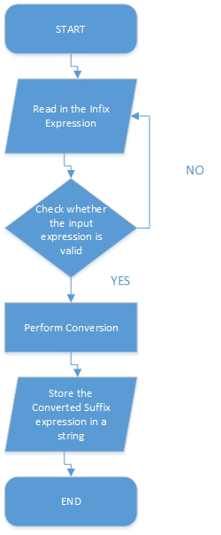

3.1.2 Main Source Codes of the Conversion Function
//Convert the input infix arithmetic expression into a suffix arithmetic expression
std::string string_stack = "="; //std::string can be used as Stack<char>, for there are pop_back() and push_back()
std::string result_expression;
bool is_reading_number = false;
bool unary_operator = true;
for (std::string::iterator i = expression.begin(); i != expression.end(); i++) {
if (*i >= '0' && *i <= '9') {
is_reading_number = true;
unary_operator = false;
result_expression.push_back(*i);
continue;
}
if (unary_operator == true) {
if (*i == '+') {
continue;
}
if (*i == '-') {
result_expression.push_back('.');
continue;
}
}
if (is_reading_number == true) {
is_reading_number = false;
result_expression.push_back('#');
}
if (unary_operator == false) {
if (*i != '(' && *i != ')') {
unary_operator = true;
}
}
char top = *(string_stack.end() - 1);
while (icp(*i) < isp(top)) {
result_expression.push_back(top);
string_stack.pop_back();
top = *(string_stack.end() - 1);
}
if (icp(*i) > isp(top)) {
string_stack.push_back(*i);
continue;
}
if (icp(*i) == isp(top)) {
string_stack.pop_back();
continue;
}
}

3.1.3 Demonstration of the Conversion Function
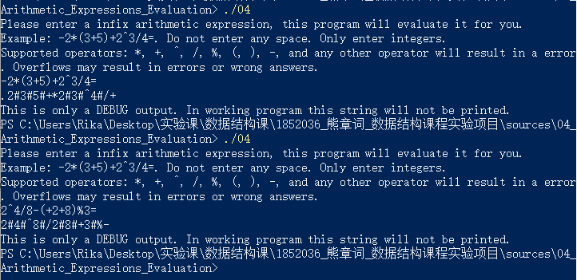

3.2 Implementation of the Evaluation Function

3.2.1 Flow Chart of the Evaluation Function
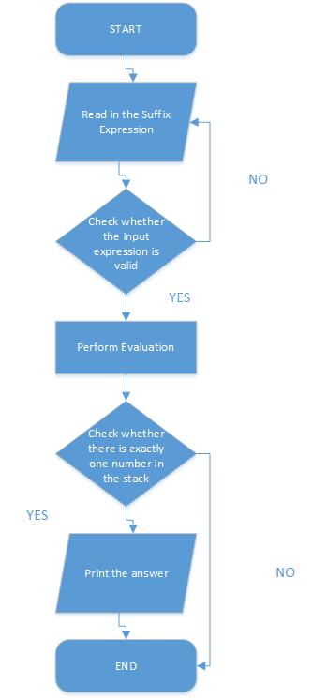

3.2.2 Main Source Codes of the Evaluation Function
//Evaluate the suffix arithmetic expression
int is_positive = 1;
long long stack_int[MAX_NUMBERS];
int stack_pointer = 0;
int current_number = 0;
int number_counter = 0;
bool is_evaluation_fail = false;
for (std::string::iterator i = result_expression.begin(); i != result_expression.end(); i++) {
if (*i == '.') {
is_positive = -is_positive;
continue;
}
if (*i >= '0' && *i <= '9') {
current_number = current_number * 10 + (*i - '0');
number_counter++;
if (number_counter >= 10) {
std::cout << "Too big integers! " << std::endl;
is_evaluation_fail = true;
break;
}
continue;
}
if (*i == '#') {
stack_int[stack_pointer] = (long long)current_number * is_positive;
current_number = 0;
number_counter = 0;
is_positive = 1;
stack_pointer++;
continue;
}
if (*i == '+') {
if (stack_pointer < 2) {
std::cout << "Ill-formed expression, please re-enter an accurate expression! " << std::endl;
is_evaluation_fail = true;
break;
}
stack_int[stack_pointer - 2] += stack_int[stack_pointer - 1];
if (stack_int[stack_pointer - 2] >= INT_MAX || stack_int[stack_pointer - 2] <= -INT_MAX) {
std::cout << "Math Overflow! " << std::endl;
is_evaluation_fail = true;
break;
}
stack_pointer--;
continue;
}
if (*i == '-') {
if (stack_pointer < 2) {
std::cout << "Ill-formed expression, please re-enter an accurate expression! " << std::endl;
is_evaluation_fail = true;
break;
}
stack_int[stack_pointer - 2] -= stack_int[stack_pointer - 1];
if (stack_int[stack_pointer - 2] >= INT_MAX || stack_int[stack_pointer - 2] <= -INT_MAX) {
std::cout << "Math Overflow! " << std::endl;
is_evaluation_fail = true;
break;
}
stack_pointer--;
continue;
}
if (*i == '*') {
if (stack_pointer < 2) {
std::cout << "Ill-formed expression, please re-enter an accurate expression! " << std::endl;
is_evaluation_fail = true;
break;
}
stack_int[stack_pointer - 2] *= stack_int[stack_pointer - 1];
if (stack_int[stack_pointer - 2] >= INT_MAX || stack_int[stack_pointer - 2] <= -INT_MAX) {
std::cout << "Math Overflow! " << std::endl;
is_evaluation_fail = true;
break;
}
stack_pointer--;
continue;
}
if (*i == '/') {
if (stack_pointer < 2) {
std::cout << "Ill-formed expression, please re-enter an accurate expression! " << std::endl;
is_evaluation_fail = true;
break;
}
if (stack_int[stack_pointer - 1] == 0) {
std::cout << "Math Error: Divided by 0! " << std::endl;
is_evaluation_fail = true;
break;
}
stack_int[stack_pointer - 2] /= stack_int[stack_pointer - 1];
if (stack_int[stack_pointer - 2] >= INT_MAX || stack_int[stack_pointer - 2] <= -INT_MAX) {
std::cout << "Math Overflow! " << std::endl;
is_evaluation_fail = true;
break;
}
stack_pointer--;
continue;
}
if (*i == '%') {
if (stack_pointer < 2) {
std::cout << "Ill-formed expression, please re-enter an accurate expression! " << std::endl;
is_evaluation_fail = true;
break;
}
stack_int[stack_pointer - 2] %= stack_int[stack_pointer - 1];
if (stack_int[stack_pointer - 2] >= INT_MAX || stack_int[stack_pointer - 2] <= -INT_MAX) {
std::cout << "Math Overflow! " << std::endl;
is_evaluation_fail = true;
break;
}
stack_pointer--;
continue;
}
if (*i == '^') {
if (stack_pointer < 2) {
std::cout << "Ill-formed expression, please re-enter an accurate expression! " << std::endl;
is_evaluation_fail = true;
break;
}
if (stack_int[stack_pointer - 1] >= 1) {
int temp = stack_int[stack_pointer - 2];
for (long long i = 1; i < stack_int[stack_pointer - 1]; i++) {
stack_int[stack_pointer - 2] *= temp;
if (stack_int[stack_pointer - 2] >= INT_MAX || stack_int[stack_pointer - 2] <= -INT_MAX) {
std::cout << "Math Overflow! " << std::endl;
is_evaluation_fail = true;
break;
}
}
}
else if (stack_int[stack_pointer - 1] == 0) {
if (stack_int[stack_pointer - 2] != 0) {
stack_int[stack_pointer - 2] = 1;
}
else {
std::cout << "Math Error: 0^0" << std::endl;
is_evaluation_fail = true;
break;
}
}
else {
std::cout << "Math Error: Powering by a Negative Integer(eg: 12^(-5))is NOT Supported! " << std::endl;
is_evaluation_fail = true;
break;
}
stack_pointer--;
continue;
}
}

3.2.3 Demonstration of the Evaluation Function
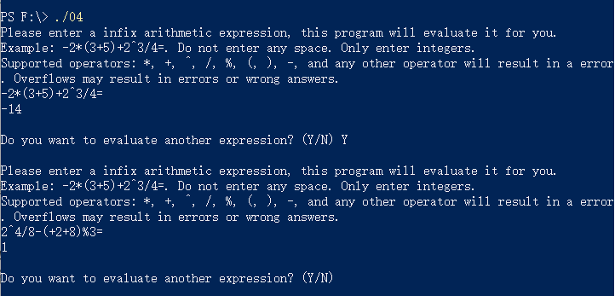

3.3 Overview Flow Chart
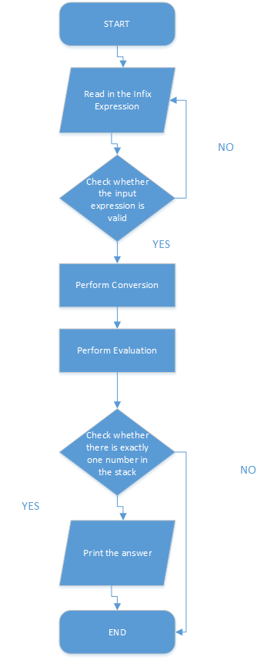

Ⅳ. Testing

4.1 Function Testing

4.1.1 Six Binary Operators Testing
Test Case 1: 3+3=
Test Case 2: 3-3=
Test Case 3: 3*3=
Test Case 4: 9/3=
Test Case 5: 11%3=
Test Case 6: 3^3=
Expected Result: Print the correct answer.
Result: As expected. See the picture below.
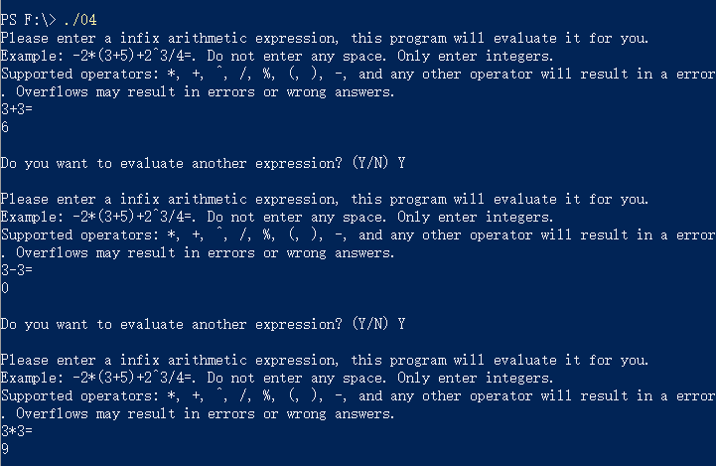
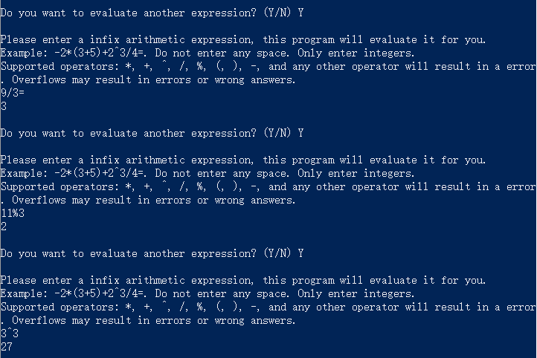

4.1.2 Two Unary Operators Testing
Test Case 1: +++3+++3=
Test Case 2: ---3--3=
Expected Result: Print the correct answer.
Result: As expected. See the picture below.
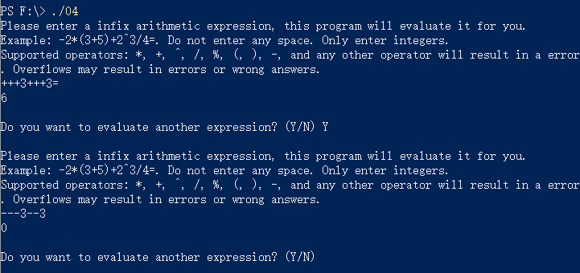

4.1.3 Nested Parentheses Testing
Test Case 1: ((+2))+(((2-3)))=
Test Case 2: (2*3)*(-2)+(+3)=
Expected Result: Print the correct answer.
Result: As expected. See the picture below.
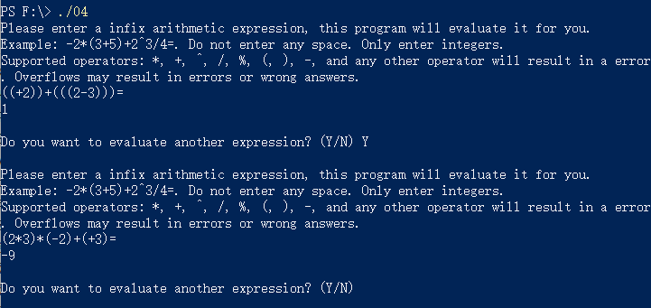

4.1.4 Multi-digital Number Testing
Test Case 1: (12+13-15)*10=
Test Case 2: 10^2+20/10=
Expected Result: Print the correct answer.
Result: As expected. See the picture below.
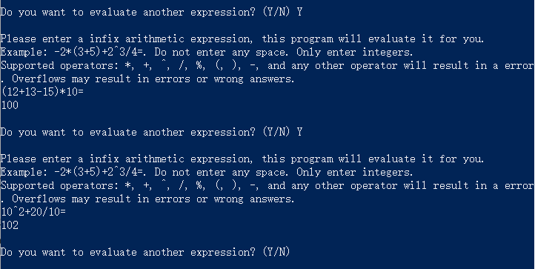

4.2 Input Validity Testing

4.2.1 Incorrect Expression Testing
Test Case 1: ((+2)=
Test Case 2: (+2))=
Expected Result: Print the correct answer.
Result: As expected. See the picture below.
Test Case 3: 1.5+2.5=
Test Case 4: (2+3i)*10=
Test Case 5: abcdefg=
Expected Result: Print “Wrong expression, please re-enter a correct expression!”
Result: As expected. See the picture below.
Test Case 6: 2+5/=
Expected Result: Print “Ill-formed expression, please re-enter a accurate expression!”
Result: As expected. See the picture below.
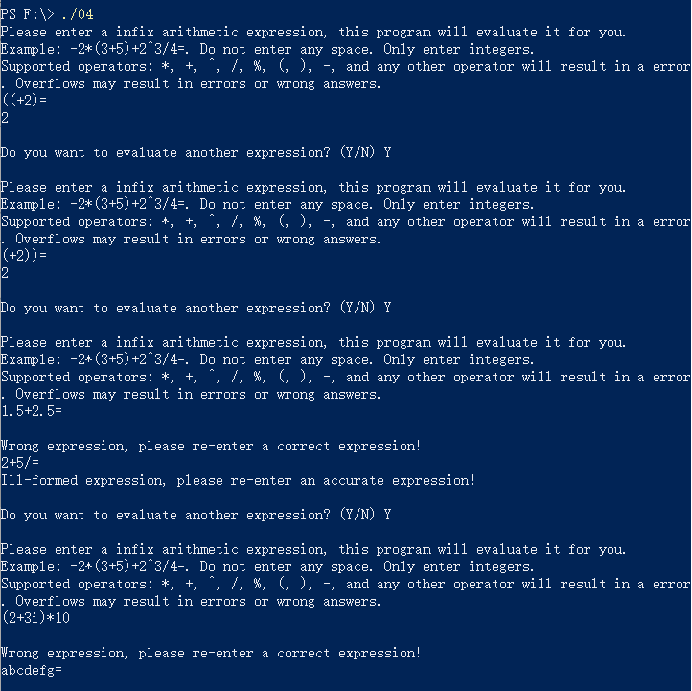

4.3 Boundary Testing

4.3.1 Overflow Testing
Test Case 1: 100000000000000+1000000000000000000000000=
Expected Result: Print “Too big integers!”
Result: As expected. See the picture below.
Test Case 2: 10^10^10=
Expected Result: Print “Math Overflow!”
Result: As expected. See the picture below.
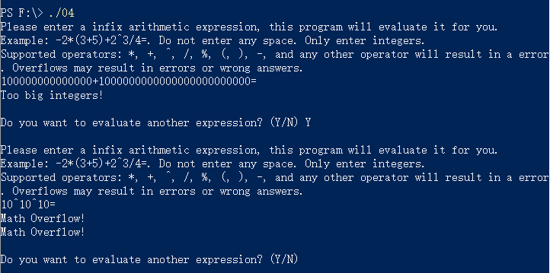

4.3.2 Exit Testing
Test Case 1: Ctrl+Z
Expected Result: Print “Wrong expression, please re-enter a correct expression!”
Result: As expected. See the picture below.
Test Case 2: Ctrl+C
Test Case 3: Input option “N”
Expected Result: Exit normally.
Result: As expected. See the picture below.
