Project Document

Course Project of Data Structure
- Bank Business

Author Name: [DATA ERASED]
ID: [DATA ERASED]
Supervisor: [DATA ERASED]
School, Major: TJSSE, Software Engineering

同济大学
Tongji University

Contents
Ⅰ. Analysis 3
1.1 Background Analysis 3
1.2 Function Analysis 4
Ⅱ. Design 4
2.1 Design of the Data Structure 4
2.2 Design of the Main Function 4
Ⅲ. Implementation 5
3.1 Implementation of the Input Function 6
3.1.1 Flow Chart of the Input Function 6
3.1.2 Main Source Codes of the Input Function 6
3.2 Implementation of the Output Function 8
3.2.1 Flow Chart of the Output Function 8
3.2.2 Main Source Codes of the Output Function 8
3.2.3 Demonstration of the Output Function 10
3.3 Overview Flow Chart 11
Ⅳ. Testing 12
4.1 Function Testing 12
4.1.1 Given Cases Testing 12
4.2 Input Validity Testing 12
4.2.1 Incorrect Input Testing 12
4.3 Boundary Testing 13
4.3.1 Input Testing 13
4.3.2 Exit Testing 14

Ⅰ. Analysis

1.1 Background Analysis
Suppose a bank has two business windows, A and B, and their speed of processing business is different. The processing speed of window A is twice that of window B. That is, when window A has processed 2 customers, window B processes only 1 customer. Given a sequence of customers arriving at the bank, print the sequence of customers in the order of which the business was completed. Assume that the time intervals between the customers arrive are not taken into account, and when two customers are processed in different windows at the same time, the customer in window A has priority to print. Now we need to implement the function described above by a program. Knowing the sequence of customer arrival, then print the sequence of business completion.

1.2 Function Analysis
According to the project function requirements of data structure course, the input shall be a line of positive integers, where the first number N (N <= 1000) is the total number of customers followed by the index of N customers. Customers with odd indexes need to go to window A for transactions, and customers with even indexes go to window B. Numbers are divided by spaces.
The output shall be customer indexes printed in the order which business transactions are completed. The indexes are divided by spaces, but the last number must not have extra spaces.
The test cases are as follows:
No. | Input | Output | Description
1 | 8 2 1 3 9 4 11 13 15 | 1 3 2 9 11 4 13 15 | A normal test, Window A has more customers
2 | 8 2 1 3 9 4 11 12 16 | 1 3 2 9 11 4 12 16 | A normal test, Window B has more customers
3 | 1 6 | 6 | Minimum N

Ⅱ. Design

2.1 Design of the Data Structure
As described in the function analysis above, this project requires a structure to implement first-in-first-out functions, and queues are data structures that perform first-in-first-out operations, so we consider using queue as the data structures.
Because N <= 1000 is given in the requirements, and the first number represents the total number of customers each time, so it is relatively simple to use an array to implement the data structure of the queue.

2.2 Design of the Main Function
The main Function can be roughly divided into two parts: read in the indexes, and print the answer. Both the parts are introduced in the later part, please see the later part.
The source codes to before those two parts above are as follows:
int main() {
std::cout << "Please enter your integers divided by a space, the first integer is to indicate the total number of following integers." << std::endl;
std::cout << "The first integer must be no more than 1000. " << std::endl;
//Read the input numbers
int N;
int queue_A[MAX_NUMBERS], queue_B[MAX_NUMBERS];
int A = 0, B = 0, a = 0, b = 0;
std::cin >> N;
The source codes to after those two parts above are as follows:
std::cout << std::endl;
std::cout << "Press any key to exit..." << std::endl;
std::cin.clear();
std::cin.sync();
getchar();
return 0;
}

Ⅲ. Implementation

3.1 Implementation of the Input Function

3.1.1 Flow Chart of the Input Function
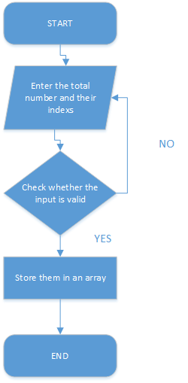

3.1.2 Main Source Codes of the Input Function
if (std::cin.fail() == true || N > MAX_NUMBERS || N <= 0) {
std::cout << "The First integer N must be 0<N<=1000!" << std::endl;
std::cout << "Press any key to exit..." << std::endl;
std::cin.clear();
std::cin.sync();
getchar();
return 0;
}
for (int i = 0; i < N; i++) {
int temp;
std::cin >> temp;
if (std::cin.fail() == true || N > MAX_NUMBERS || N <= 0) {
std::cout << "Please enter as required! " << std::endl;
std::cout << "Press any key to exit..." << std::endl;
std::cin.clear();
std::cin.sync();
getchar();
return 0;
}
if ((temp & 1) != 0) {
queue_A[A] = temp;
A++;
}
else {
queue_B[B] = temp;
B++;
}
}

3.2 Implementation of the Output Function

3.2.1 Flow Chart of the Output Function
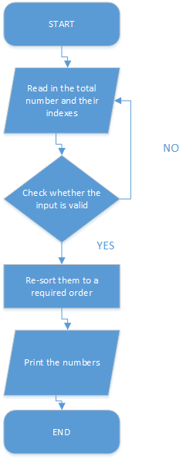

3.2.2 Main Source Codes of the Output Function
while (a < A && b < B) {
if (N != 1) {
std::cout << queue_A[a] << " ";
N--;
a++;
}
else {
//To make sure there is no extra space in the end of the line, the same below
std::cout << queue_A[a];
a++;
}
if (a < A) {
if (N != 1) {
std::cout << queue_A[a] << " ";
N--;
a++;
}
else {
std::cout << queue_A[a];
a++;
}
}
if (N != 1) {
std::cout << queue_B[b] << " ";
N--;
b++;
}
else {
std::cout << queue_B[b];
b++;
}
}
while (a < A) {
if (N != 1) {
std::cout << queue_A[a] << " ";
N--;
a++;
}
else {
std::cout << queue_A[a];
a++;
}
}
while (b < B) {
if (N != 1) {
std::cout << queue_B[b] << " ";
N--;
b++;
}
else {
std::cout << queue_B[b];
b++;
}
}

3.2.3 Demonstration of the Output Function
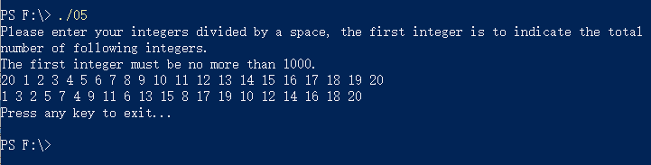

3.3 Overview Flow Chart
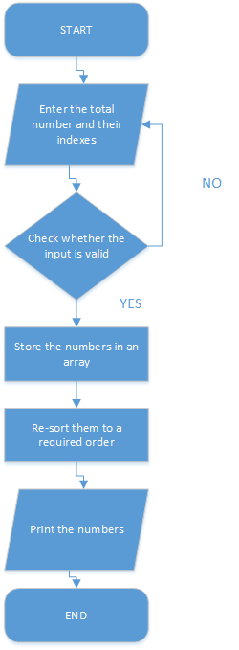

Ⅳ. Testing

4.1 Function Testing

4.1.1 Given Cases Testing
Test Case 1: 8 2 1 3 9 4 11 13 15
Test Case 2: 8 2 1 3 9 4 11 12 16
Test Case 3: 1 6
Expected Result: Print the correct answer.
Result: As expected. See the picture below.
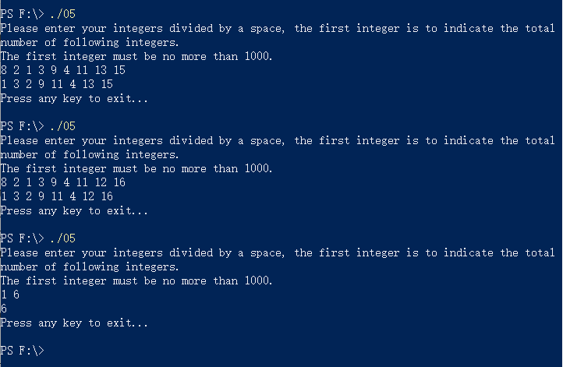

4.2 Input Validity Testing

4.2.1 Incorrect Input Testing
Test Case 1: -1
Test Case 2: abc
Test Case 3: 3 a b c
Expected Result: Print “The first integer must be no more than 1000”
Result: As expected. See the picture below.
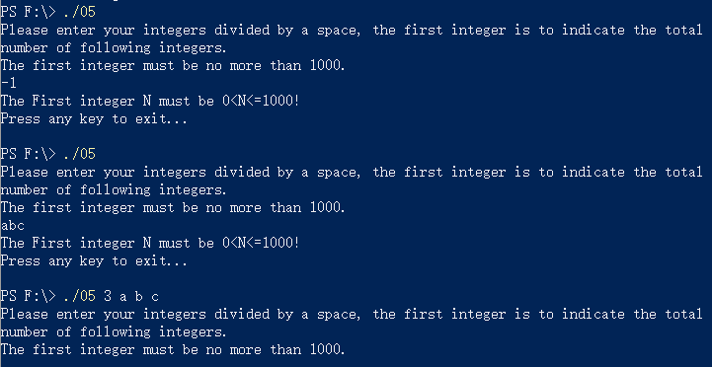

4.3 Boundary Testing

4.3.1 Input Testing
Test Case 1: Input 1000, follow by 1-1000
Expected Result: Print the correct answer.
Result: As expected. See the picture below.
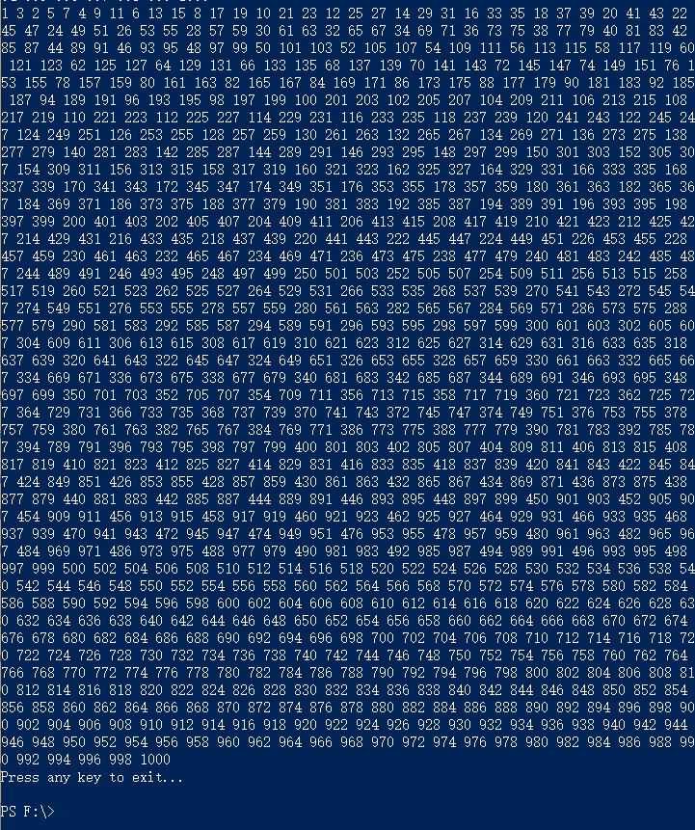

4.3.2 Exit Testing
Test Case 1: Ctrl+Z
Expected Result: The program continues to run.
Result: As expected. See the picture below.
Test Case 2: Ctrl+C
Expected Result: Exit normally.
Result: As expected. See the picture below.
