Project Document

Course Project of Data Structure
- Genealogy Book

Author Name: [DATA ERASED]
ID: [DATA ERASED]
Supervisor: [DATA ERASED]
School, Major: TJSSE, Software Engineering

同济大学
Tongji University

Contents
Ⅰ. Analysis 4
1.1 Background Analysis 4
1.2 Function Analysis 4
Ⅱ. Design 5
2.1 Design of the Data Structure 5
2.2 Design of Structs 5
2.3 Design of FamilyTree Class Members and Functions 5
2.4 Design of the Main Function 6
Ⅲ. Implementation 9
3.1 Implementation of the Insertion Function 9
3.1.1 Flow Chart of the Insertion Function 9
3.1.2 Main Source Codes of the Insertion Function 9
3.1.3 Demonstration of the Insertion Function 10
3.2 Implementation of the Deletion Function 11
3.2.1 Flow Chart of the Deletion Function 11
3.2.2 Main Source Codes of the Deletion Function 11
3.2.3 Demonstration of the Deletion Function 12
3.3 Implementation of the Family-Forming Function 13
3.3.1 Flow Chart of the Family-Forming Function 13
3.3.2 Main Source Codes of the Family-Forming Function 13
3.3.3 Demonstration of the Family-Forming Function 15
3.4 Implementation of the Modification Function 16
3.4.1 Flow Chart of the Modification Function 16
3.4.2 Main Source Codes of the Modification Function 16
3.4.3 Demonstration of the Modification Function 17
3.5 Implementation of the Printing Function 17
3.5.1 Main Source Codes of the Printing Function 17
3.5.2 Demonstration of the Printing Function 18
3.6 Overview Flow Chart 19
Ⅳ. Testing 20
4.1 Input Validity Testing 20
4.1.1 Incorrect Initialization Testing 20
4.1.2 Incorrect Option Testing 22
4.2 Boundary Testing 23
4.2.1 Blank Tree Testing 23
4.2.2 Deletion, Family-forming, Modification of Non-existent Member testing 24
4.2.3 Exit Testing 25

Ⅰ. Analysis

1.1 Background Analysis
Genealogy is a special document genre in the form of a book, which records a family's hereditary reproduction and important matters. Genealogy is a unique cultural heritage in China. It is one of the three major documents of the ancient China (the three major documents are national history, topography and genealogy). These are precious humanities, and they have their unique and irreplaceable features.
This project is a simple simulation of family tree management (or in other words, a genealogy book) to achieve the functions of viewing personal information of ancestors and offspring, inserting family members, and deleting family members.

1.2 Function Analysis
The essence of this project is to implement the functions of creating, querying, inserting, modifying, and deleting family member information. We can first define the family member data structure, and then use each function as a member function to implement the data operation. Finally, we need a main function to verify the work of each function and get the results.
In summary, a family tree management system should have at least the functions of input, output, insert, delete, modify, and exit.

Ⅱ. Design

2.1 Design of the Data Structure
As the above function analysis, in the use of the Genealogy book system, a large number of insertion and deletion operations can be expected. If we use a simple structure array, it will consume unnecessary storage and thus cause a waste of computer functionality. Therefore, this project uses the tree structure.
Considering that this project is only for learning purposes, and the performance requirements for query, modification and other functions are not very strict, this project chooses trees implemented by binary trees as the specific data structure, and the binary tree is implemented as the FamilyTree class. Each family member’s data is stored as the structure Member, and there are three pointers of Member, pointer type is used as private members of the Member class. In the whole running process, Member structure is generated dynamically and memory is allocated dynamically, which to a extent saves computer resources.

2.2 Design of Structs
Each family member’s data is stored in a Member structure, the source codes are as follows:
//A struct storing each family member
struct Member {
int layer = 0;
std::string name;
Member* parent = NULL, * leftChild = NULL, * rightChild = NULL, * fakeParent = NULL;
Member() = default;
Member(const std::string myname) : name(myname) {}
};

2.3 Design of FamilyTree Class Members and Functions
In order to facilitate operation and save storage space, the child-brother list is used to implement the tree.
We define a tree node structure (FamilyTree). The data field in each node is used to store the data of the current node. There are three other pointer fields that store pointer to its first child, pointer to its first brother and pointer to its parent.
The FamilyTree class has two public members: The Member root and the total layer to indicate how many generations there are in the tree. And this class has eight public methods, among them only six will implement a complete function, they are: search, add, change, remove, form and printing. The source codes are as follows:
//A struct storing genealogy information
class FamilyTree {
public:
int total_layer = 0;
Member root;
Member* Search(std::string name, Member* search_root);
Member* Print_Search(int temp_layer, Member* search_root);
Member* Remove_Search(Member* search_root);
FamilyTree(std::string first) {
root.name = first;
}
void Print();
void Form(Member* current, int number);
void Add(Member* current);
void Change(Member* current);
void Remove(Member* current);
};

2.4 Design of the Main Function
The main Function can be roughly divided into two parts: initialization of family tree and cyclic reading of user option. The second part is to call the public methods of the family tree class, please see the later part. The source codes to initialize the family tree are as follows:
int main() {
std::cout << "** Genealogy Information System **" << std::endl;
std::cout << "==============================================================" << std::endl;
std::cout << "** Please choose the option you would like to perform: **" << std::endl;
std::cout << "** A --- Form a new family **" << std::endl;
std::cout << "** B --- Add new family members **" << std::endl;
std::cout << "** C --- Remove family members **" << std::endl;
std::cout << "** D --- Change information **" << std::endl;
std::cout << "** E --- Print the tree **" << std::endl;
std::cout << "** F --- Exit **" << std::endl;
std::cout << "** Please notice that if there are duplicated names, **" << std::endl;
std::cout << "** the option will only take effect on the FIRST FOUND one. **" << std::endl;
std::cout << "==============================================================" << std::endl;
std::cout << "Firstly, please add a root for this system." << std::endl;
std::cout << "Please enter the name of an ancestor (entering more than one person is invalid!): ";
std::string root;
while (true) {
std::cin >> root;
if (std::cin.fail() != true) {
std::cin.clear();
std::cin.sync();
break;
}
//Reset and clear the input stream if input data is incorrect.
std::cin.clear();
std::cin.sync();
std::cout << std::endl;
std::cout << "Please enter as required! " << std::endl;
}
FamilyTree family(root);
std::cout << "The root of this system is: " << root << std::endl;
std::cout << std::endl;
while (true) {
std::cout << "Please choose the option you would like to perform: ";
char option;
while (true) {
std::cin >> option;
if (std::cin.fail() != true && option >= 'A' && option <= 'F') {
std::cin.clear();
std::cin.sync();
break;
}
//Reset and clear the input stream if input data is incorrect.
std::cin.clear();
std::cin.sync();
std::cout << std::endl;
std::cout << "Please enter as required! " << std::endl;
}

Ⅲ. Implementation

3.1 Implementation of the Insertion Function

3.1.1 Flow Chart of the Insertion Function
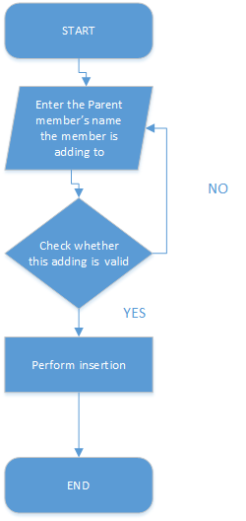

3.1.2 Main Source Codes of the Insertion Function
//Add new family members
void FamilyTree::Add(Member* current) {
std::cout << "Please enter the name of the child : ";
std::string name;
while (true) {
std::cin >> name;
if (std::cin.fail() != true) {
break;
}
//Reset and clear the input stream if input data is incorrect.
std::cin.clear();
std::cin.sync();
std::cout << std::endl;
std::cout << "Please enter as required! " << std::endl;
}
Member* tmp = new Member(name);
tmp->layer = current->layer + 1;
if (tmp->layer > total_layer) {
total_layer = tmp->layer;
}
tmp->rightChild = current->leftChild;
tmp->parent = current;
tmp->fakeParent = current;
current->leftChild = tmp;
if (tmp->rightChild != NULL) {
tmp->rightChild->fakeParent = tmp;
}
}

3.1.3 Demonstration of the Insertion Function
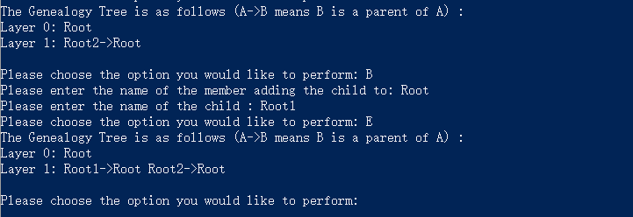

3.2 Implementation of the Deletion Function

3.2.1 Flow Chart of the Deletion Function
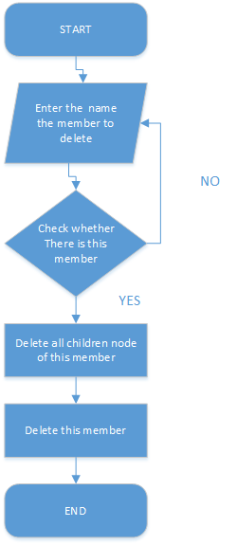

3.2.2 Main Source Codes of the Deletion Function
//Traverse part of the tree recursively
Member* FamilyTree::Remove_Search(Member* search_root) {
if (search_root != NULL) {
Remove_Search(search_root->leftChild);
Remove_Search(search_root->rightChild);
delete search_root;
return NULL;
}
return NULL;
}

//Remove family members
void FamilyTree::Remove(Member* current) {
if (current->leftChild != NULL) {
Remove_Search(current->leftChild);
}
if (current->fakeParent->leftChild == current) {
current->fakeParent->leftChild = current->rightChild;
}
else {
current->fakeParent->rightChild = current->rightChild;
}
delete current;
}

3.2.3 Demonstration of the Deletion Function
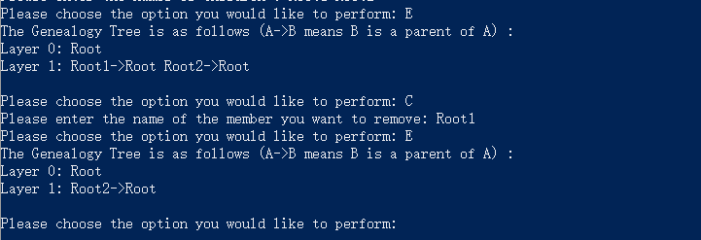

3.3 Implementation of the Family-Forming Function

3.3.1 Flow Chart of the Family-Forming Function
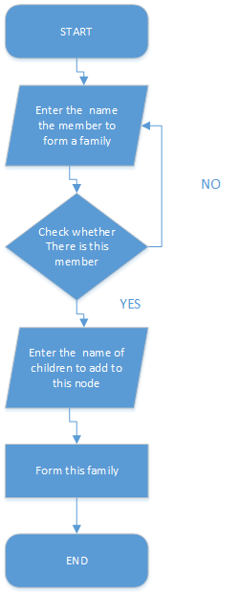

3.3.2 Main Source Codes of the Family-Forming Function
//Form a new family
void FamilyTree::Form(Member* current, int number) {
int temp_layer = current->layer + 1;
Member* temp_parent = current;
if (temp_layer > total_layer) {
total_layer = temp_layer;
}
std::cout << "Please enter the names of children : ";
for (int i = 0; i < number; i++) {
std::string name;
while (true) {
std::cin >> name;
if (std::cin.fail() != true) {
break;
}
//Reset and clear the input stream if input data is incorrect.
std::cin.clear();
std::cin.sync();
std::cout << std::endl;
std::cout << "Please enter as required! " << std::endl;
}
Member* tmp = new Member(name);
if (i == 0) {
current->leftChild = tmp;
}
else {
current->rightChild = tmp;
}
tmp->fakeParent = current;
tmp->parent = temp_parent;
tmp->layer = temp_layer;
current = tmp;
}
std::cin.clear();
std::cin.sync();
}

3.3.3 Demonstration of the Family-Forming Function
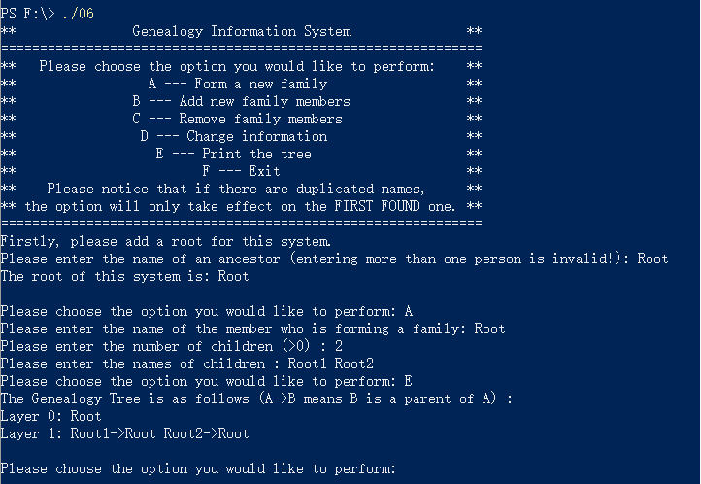

3.4 Implementation of the Modification Function

3.4.1 Flow Chart of the Modification Function
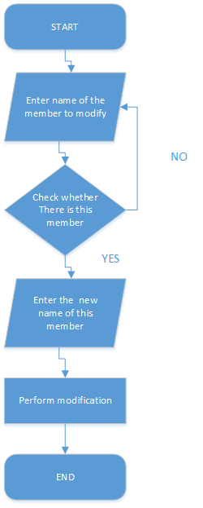

3.4.2 Main Source Codes of the Modification Function
//Change information
void FamilyTree::Change(Member* current) {
std::cout << "Please enter the new name: ";
std::string name;
while (true) {
std::cin >> name;
if (std::cin.fail() != true) {
break;
}
//Reset and clear the input stream if input data is incorrect.
std::cin.clear();
std::cin.sync();
std::cout << std::endl;
std::cout << "Please enter as required! " << std::endl;
}
current->name = name;
}

3.4.3 Demonstration of the Modification Function
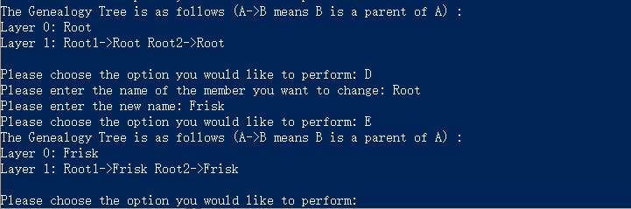

3.5 Implementation of the Printing Function

3.5.1 Main Source Codes of the Printing Function
//Traverse the tree recursively
Member* FamilyTree::Print_Search(int temp_layer, Member* search_root) {
if (search_root != NULL) {
if (search_root->layer == temp_layer) {
std::cout << search_root->name << "->" << search_root->parent->name << " ";
}
Print_Search(temp_layer, search_root->leftChild);
Print_Search(temp_layer, search_root->rightChild);
return NULL;
}
else {
return NULL;
}
}

//Print the tree
void FamilyTree::Print() {
std::cout << "The Genealogy Tree is as follows (A->B means B is a parent of A) : " << std::endl;
std::cout << "Layer 0: " << root.name << std::endl;
for (int i = 1; i <= total_layer; i++) {
std::cout << "Layer " << i << ": ";
Print_Search(i, &root);
std::cout << std::endl;
}
std::cout << std::endl;
}

3.5.2 Demonstration of the Printing Function
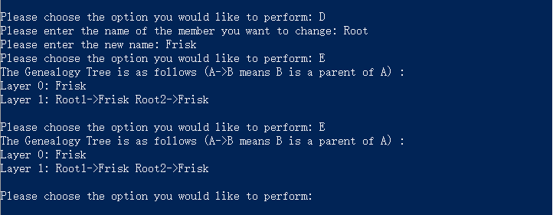

3.6 Overview Flow Chart
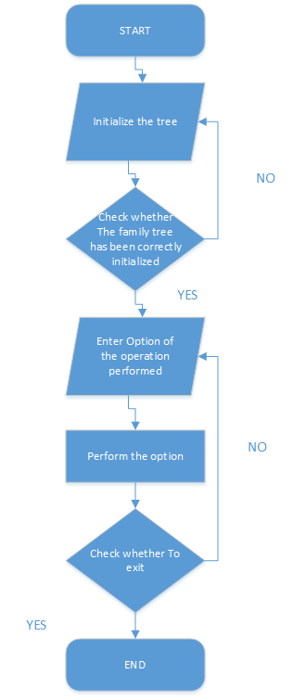

Ⅳ. Testing

4.1 Input Validity Testing

4.1.1 Incorrect Initialization Testing
For Information Entered during Initialization:
Test Case 1: A B C
Expected Result: Read in as A
Result: As expected. See the picture below.
Test Case 2: Cril+Z
Expected Result: Prompt re-enter
Result: As expected. See the picture below.
Test Case 3: Cril+A
Expected Result: Correct
Result: As expected. See the picture below.
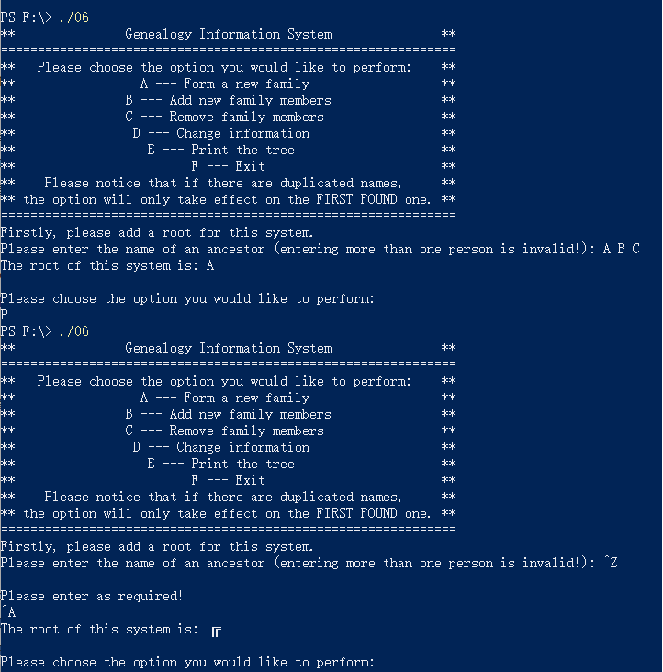
For Family Members:
Test Case 1: NENE (non-existent)
Test Case 2: Ctrl+Z
Expected Result: Print “Member not found! Please re-enter: ”
Result: As expected. See the picture below.
Test Case 3: ROOT (the root node)
Expected Result: Correct input.
Result: As expected. See the picture below.
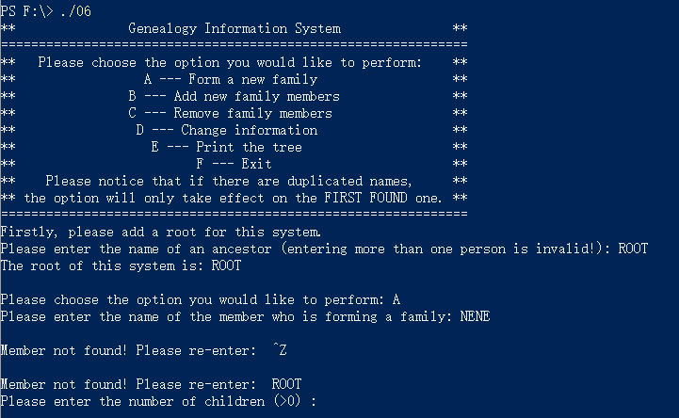

4.1.2 Incorrect Option Testing
Input Option:
Test Case 1: Z
Test Case 2: abc
Test Case 3: 100000000000000000000000000000000000000
Test Case 4: 1.2
Expected Result: Print “Please enter as required!”
Result: As expected. See the picture below.
Test Case 5: A
Expected Result: Perform Family-forming.
Result: As expected. See the picture below.
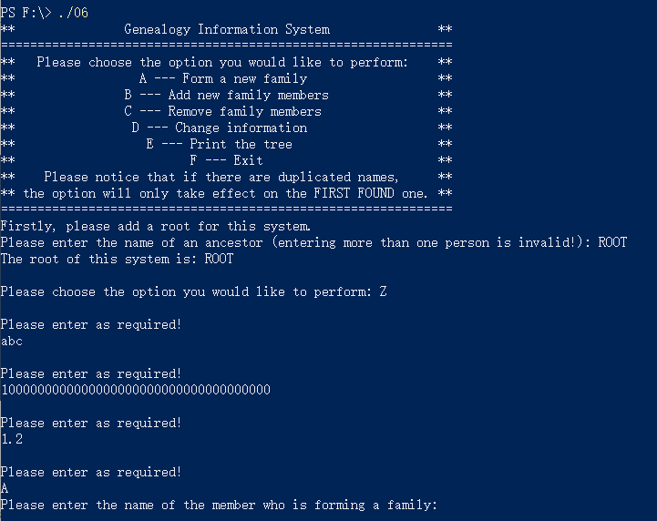

4.2 Boundary Testing

4.2.1 Blank Tree Testing
Enter Options to a Blank Tree:
Test Case 1: Delete the root node.
Expected Result: Prompt “You cannot delete the root node!”
Result: As expected. See the picture below.
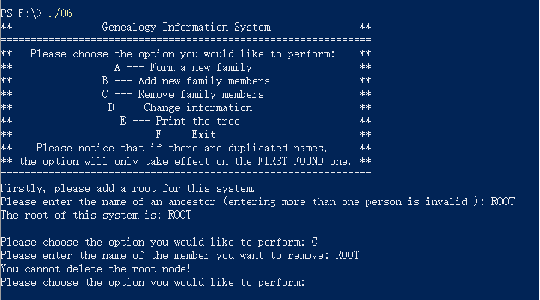

4.2.2 Deletion, Family-forming, Modification of Non-existent Member testing
Operations on Non-existent Member:
Test Case 1: Delete “Rika”
Test Case 2: Query “Rika”
Test Case 3: Modify “Rika”
Expected Result: Prompt member not found.
Result: As expected. See the picture below.
Test Case 4: Modify “ROOT”
Expected Result: Modification Success.
Result: As expected. See the picture below.
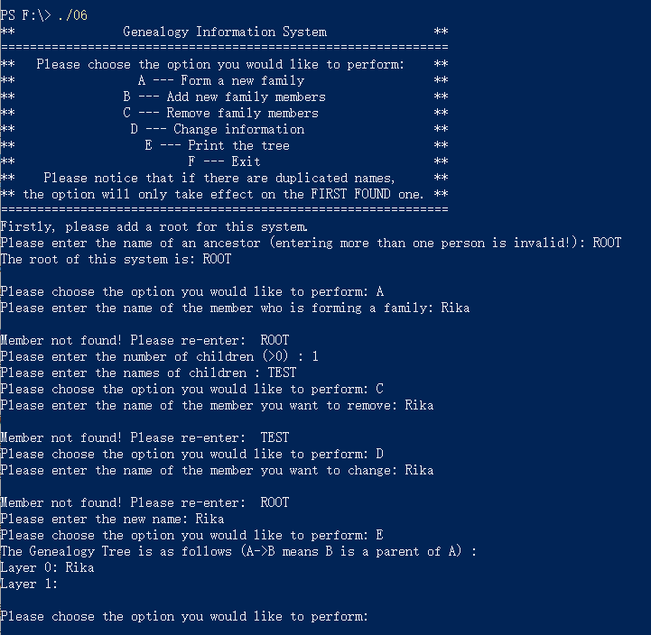

4.2.3 Exit Testing
Test Case 1: Ctrl+Z
Expected Result: The program continues to run.
Result: As expected. See the picture below.
Test Case 2: Ctrl+C
Test Case 3: Input option “F”
Expected Result: Exit normally.
Result: As expected. See the picture below.
