Project Document

Course Project of Data Structure
- Fix the Fence

Author Name: [DATA ERASED]
ID: [DATA ERASED]
Supervisor: [DATA ERASED]
School, Major: TJSSE, Software Engineering

同济大学
Tongji University

Contents
Ⅰ. Analysis 2
1.1 Background Analysis 3
1.2 Function Analysis 3
Ⅱ. Design 3
2.1 Design of the Data Structure 4
2.2 Design of the Main Function 4
Ⅲ. Implementation 5
3.1 Implementation of the Solution Function 6
3.1.1 Main Source Codes of the Solution Function 6
3.1.2 Demonstration of the Solution Function 6
3.2 Overview Flow Chart 7
Ⅳ. Testing 8
4.1 Input Validity Testing 8
4.1.1 Incorrect Input Testing 8
4.2 Boundary Testing 8
4.2.1 Input 1~1039 (it is inconvenient to input more numbers in the console) 8

Ⅰ. Analysis

1.1 Background Analysis
The farmer wants to repair a fence of the pasture. He measured the fence and found that N pieces of wood are needed. Each piece of wood’s length is an integer L_{i} unit. So, he bought a long piece of wood that can be sawn into N pieces, that is, the wood’s length is the sum of L_{i}.
But the farmer himself does not have a saw, and the reward for asking someone to saw the wood is proportional to the length of the wood. For the sake of simplicity, let us consider the remuneration equal to the length of the sawn wood. For example, to saw a piece of wood of length 20 into three sections of length 8, 7, and 5, the first sawn piece of wood will be sawn into 12 and 8, which costs 20; the second sawn piece of wood will be sawed to length 7 and 5, which cost 12, and totally cost 32 yuan. If the wood is sawn into 15 and 5 the first time, and the wood is sawed into 7 and 8 the second time, then the total cost is 35 (greater than 32).

1.2 Function Analysis
Input format: The first line of the input gives a positive integer N (N <10⁴), which means that the wood is to be sawn into N parts. The second line gives N positive integers, indicating the length of each piece of wood.
Output format: print an integer, the minimum cost of sawing wood into N blocks.
We can interpret the different lengths of wood as weights, and this problem is to combine the given data into Huffman trees. To build a Huffman tree, we need to implement a data structure that can quickly obtain the smallest data in the data. The priority queue is the easiest to think of. Therefore, this problem uses the priority queue to implement the Huffman algorithm.

Ⅱ. Design

2.1 Design of the Data Structure
As described in the function analysis above, a priority queue needs to be constructed firstly. The priority queue must be able to read data to build a priority queue and also has the function of deleting data. Using the priority queue, each time the two elements with the smallest weight in the queue are taken out, the weighted sum is calculated, and then it is returned to the priority queue as a new element until only one element remains in the priority queue. After add all the weight each calculation has made, we can get the answer to this question. For the sake of simplicity, we implement the priority queue with an array.

2.2 Design of the Main Function
The main function can be roughly divided into three parts: initialization, and calculating all the weight. The second part will be introduced in the later part. All because the input data is not very much (no more than 10⁴), we use bubble sort to construct the priority queue. The source codes to initialize the priority queue are as follows:
int main() {
int total_number;
int answer = 0;
//Read in N
while (true) {
std::cin >> total_number;
if (std::cin.fail() != true && total_number > 0 && total_number <= 10000) {
break;
}
//Reset and clear the input stream if input data is incorrect.
std::cin.clear();
std::cin.sync();
std::cout << std::endl;
std::cout << "Please enter as required! " << std::endl;
}
//Read in the numbers
int numbers[10000];
for (int i = 0; i < total_number; i++) {
int temp;
while (true) {
std::cin >> temp;
if (std::cin.fail() != true && temp > 0) {
break;
}
//Reset and clear the input stream if input data is incorrect.
std::cin.clear();
std::cin.sync();
std::cout << std::endl;
std::cout << "Please enter as required! " << std::endl;
}
numbers[i] = temp;
}
//Bubble Sort
for (int i = 0; i < total_number - 1; i++) {
for (int j = 0; j <= total_number - 1 - i; j++) {
if (numbers[j] < numbers[j + 1]) {
int tmp;
tmp = numbers[j + 1];
numbers[j + 1] = numbers[j];
numbers[j] = tmp;
}
}
}

Ⅲ. Implementation

3.1 Implementation of the Solution Function

3.1.1 Main Source Codes of the Solution Function
//Calculate the minimum total cost
for (int i = total_number - 1; i >= 1; i--) {
numbers[i - 1] = numbers[i] + numbers[i - 1];
answer += numbers[i - 1];
int j = i - 1;
while (j > 0 && numbers[j - 1] < numbers[j]) {
int tmp = numbers[j];
numbers[j] = numbers[j - 1];
numbers[j - 1] = tmp;
j--;
}
}
//Print the answer
std::cout << answer << std::endl;
std::cin.clear();
std::cin.sync();
std::cout << "Press any key to exit..." << std::endl;
getchar();
return 0;
}

3.1.2 Demonstration of the Solution Function
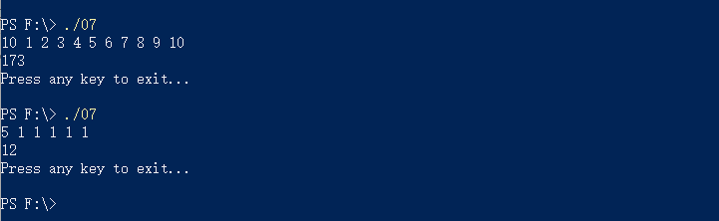

3.2 Overview Flow Chart
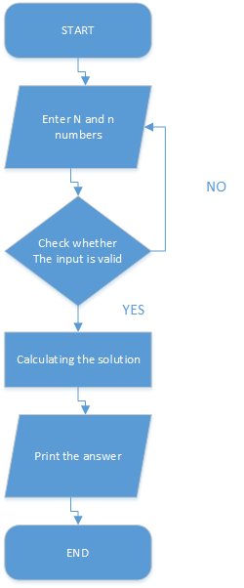

Ⅳ. Testing

4.1 Input Validity Testing

4.1.1 Incorrect Input Testing
Test Case 1: 10000000000000000000000000000000
Test Case 2: -1
Test Case 3: !@#$%^&*()
Expected Result: Print “Please enter as required!”
Result: As expected. See the picture below.
Test Case 4: 10 1 1 1 1 1 1 1 1 1 1
Expected Result: Print the Correct Answer.
Result: As expected. See the picture below.


4.2 Boundary Testing

4.2.1 Input 1~1039 (it is inconvenient to input more numbers in the console)
Test Case 1: 1039, followed by 1-1039
Expected Result: Print the Correct Answer.
Result: As expected. See the picture below.
