Project Document

Course Project of Data Structure
- Grid Simulating System

Author Name: [DATA ERASED]
ID: [DATA ERASED]
Supervisor: [DATA ERASED]
School, Major: TJSSE, Software Engineering

同济大学
Tongji University

Contents
Ⅰ. Analysis 3
1.1 Background Analysis 3
1.2 Function Analysis 3
Ⅱ. Design 4
2.1 Design of the Data Structure 4
2.2 Design of MST (Minimum Spanning Tree) Class Members and Functions 4
2.4 Design of the Main Function 5
Ⅲ. Implementation 6
3.1 Implementation of the Reading-in Points Function 6
3.1.1 Flow Chart of the Reading-in Points Function 6
3.1.2 Main Source Codes of the Reading-in Points Function 6
3.1.3 Demonstration of the Reading-in Points Function 8
3.2 Implementation of the Reading-in Paths Function 9
3.2.1 Flow Chart of the Reading-in Paths Function 9
3.2.2 Main Source Codes of the Reading-in Paths Function 9
3.3 Implementation of the Generating Function 12
3.3.1 Flow Chart of the Generating Function 12
3.3.2 Main Source Codes of the Generating Function 12
3.4 Implementation of the Printing Function 14
3.4.1 Main Source Codes of the Printing Function 14
3.4.2 Demonstration of the Printing Function 15
3.5 Overview Flow Chart 16
Ⅳ. Testing 17
4.1 Input Validity Testing 17
4.1.1 Incorrect Option Testing 17
4.2 Boundary Testing 17
4.2.1 Non-existent Element Testing 17
4.2.2 Exit Testing 18

Ⅰ. Analysis

1.1 Background Analysis
Assume that there are n communities in a city. To build the power grids between the n communities and make them connected to each other, it is necessary to construct the power grids between the n communities in this city while minimizing the total construction cost. Now we need to design a cost solution that can meet the requirements.

1.2 Function Analysis
A grid line can be set up between each community, but it has to pay a corresponding economic price. There can be at most n (n-1) / 2 lines between n communities, and choosing n-1 of them can minimize the total cost.
From the background analysis, it is easy to think of that the way to represent the communities in the entire city and the circuit connection between the communities is shown in a graph. Each cell can be regarded as a node in the graph. The grid lines between cells are regarded as edges of the graph, and the cost of laying grid lines is regarded as the weight of the edges. We need to find a way to complete the circuit laying with n-1 lines, while minimizing the cost, and it is easy to associate with the knowledge about the minimum spanning tree. Therefore, this question uses a graph structure to store the power grid laying cost information in the city. We will use the Kruskal algorithms of the tree to calculate the minimum cost and generate the lowest cost solution.

Ⅱ. Design

2.1 Design of the Data Structure
According to the above analysis, to complete the above operations, the data structure of the map needs to be used to store the power grid information. There are many ways to implement the data structure of the graph. In order to facilitate the operation of generating the minimum spanning tree later in this problem, two arrays are constructed, which represent the vertices and edges respectively. Every element has an array of all edges connected to it.

2.2 Design of MST (Minimum Spanning Tree) Class Members and Functions
According to the analysis above, this problem only needs to implement the Krustal algorithm and the array required to save the edges and points of the graph. Therefore, the main class structure of the program is the MST class.
The MST class has several private bools and arrays to store the graph and indicate whether an operation has been performed. The MST class has four public functions: read in the points, read in the edges, generate the minimum spanning tree and print the minimum spanning tree. The source codes are as follows:
class MST {
private:
int point_numbers = 0;
//Flags to show corresponding error messages
bool has_setup = false;
bool has_path = false;
bool has_generated = false;
std::string points[MAX_CITY_NUMBERS];
int paths[MAX_CITY_NUMBERS][MAX_CITY_NUMBERS] = { {0} };
int mst[MAX_CITY_NUMBERS][3] = { {0} };
public:
void Setup(int number);
void ReadinPath();
bool GenerateMST();
void Print();
};

2.4 Design of the Main Function
The main function can be roughly divided into two parts: print necessary information, and waiting for users to enter options. The second part is to call the public methods of the MST class, please see the later part. The source codes of the first part are as follows:
int main() {
MST mst;
std::cout << "** Power Grid Cost Simulating System **" << std::endl;
std::cout << "==============================================================" << std::endl;
std::cout << "** A --- Create the System **" << std::endl;
std::cout << "** B --- Add Grid Paths **" << std::endl;
std::cout << "** C --- Generate the Minimum Spanning Tree **" << std::endl;
std::cout << "** D --- Print the Minimum Spanning Tree **" << std::endl;
std::cout << "** E --- Exit **" << std::endl;
std::cout << "==============================================================" << std::endl << std::endl;
while (true) {
std::cout << "Please choose your option: ";
char option;

Ⅲ. Implementation

3.1 Implementation of the Reading-in Points Function

3.1.1 Flow Chart of the Reading-in Points Function
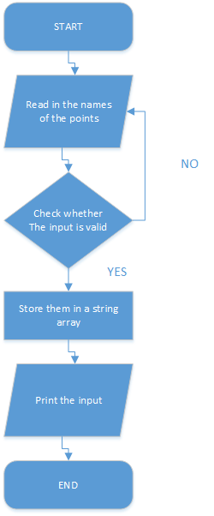

3.1.2 Main Source Codes of the Reading-in Points Function
Through “Generate” function we generate a path through the maze. The source codes are as follows:
////Create the System
void MST::Setup(int number) {
point_numbers = number;
std::cout << "Please enter names of the points: " << std::endl;
for (int i = 0; i < point_numbers; i++) {
std::string name;
while (true) {
bool is_duplicated = false;
bool is_break = false;
std::cin >> name;
for (int j = 0; j < i; j++) {
if (points[j] > name) {
int tmp = i;
while (j < tmp) {
points[tmp] = points[tmp - 1];
tmp--;
}
points[j] = name;
is_break = true;
break;
}
if (points[j] == name) {
is_duplicated = true;
break;
}
}
if (is_break == false) {
points[i] = name;
}
if (std::cin.fail() != true && is_duplicated == false) {
break;
}
//Reset and clear the input stream if input data is incorrect.
std::cin.clear();
std::cin.sync();
std::cout << std::endl;
if (is_duplicated == false) {
std::cout << "Please enter as required: ";
}
else {
std::cout << "Duplicated names are not supported, please re-enter: ";
}
}
}
std::cout << "There are " << point_numbers << " points named as: " << std::endl;
for (int i = 0; i < point_numbers; i++) {
std::cout << points[i] << " ";
}
std::cout << "in the system. " << std::endl << std::endl;
has_setup = true;
has_generated = false;
has_path = false;
}

3.1.3 Demonstration of the Reading-in Points Function
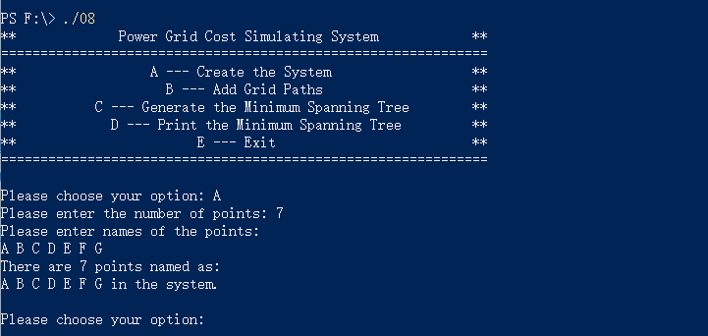

3.2 Implementation of the Reading-in Paths Function

3.2.1 Flow Chart of the Reading-in Paths Function
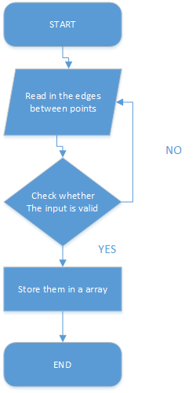

3.2.2 Main Source Codes of the Reading-in Paths Function
////Read in Grid Paths
void MST::ReadinPath() {
if (has_setup == false) {
std::cout << "No points input. " << std::endl;
return;
}
memset(paths, -1, sizeof(paths));
std::cout << "Please enter '? ? 0' to indicate the end of input. " << std::endl;
while (true) {
std::cout << "Please enter two points and the cost: ";
std::string name1, name2;
bool fail_flag = false;
int cost;
std::cin >> name1 >> name2 >> cost;
if (name1 == "?"&&name2 == "?") {
std::cin.clear();
std::cin.sync();
has_path = true;
has_generated = false;
return;
}
if (name1 < name2) {
std::string tmp;
tmp = name1;
name1 = name2;
name2 = tmp;
}
if (name1 == name2) {
fail_flag = true;
}
int tmp1 = 0, tmp2 = 0;
bool find1 = false, find2 = false;
for (int i = 0; i < point_numbers; i++) {
if (points[i] == name1) {
tmp1 = i;
find1 = true;
break;
}
}
for (int i = 0; i < point_numbers; i++) {
if (points[i] == name2) {
tmp2 = i;
find2 = true;
break;
}
}
if (find1 == false || find2 == false) {
fail_flag = true;
}
if (cost < 0) {
fail_flag = true;
}
if (std::cin.fail() == true || fail_flag == true) {
std::cin.clear();
std::cin.sync();
std::cout << "Your input do not meet the requirements. Please re-try! " << std::endl;
return;
}
paths[tmp1][tmp2] = cost;
}
}

3.3 Implementation of the Generating Function

3.3.1 Flow Chart of the Generating Function
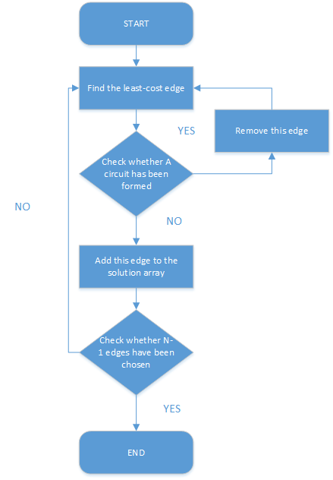

3.3.2 Main Source Codes of the Generating Function
//Generate the Minimum Spanning Tree
bool MST::GenerateMST() {
if (has_path == false) {
return false;
}
int path_counter = 0;
for (int k = 0; k < point_numbers * (point_numbers - 1) / 2; k++) {
int temp_min[3] = { 0,0,INT_MAX };
for (int i = 0; i < point_numbers; i++) {
for (int j = 0; j < i; j++) {
if (paths[i][j] >= 0 && temp_min[2] > paths[i][j]) {
temp_min[2] = paths[i][j];
temp_min[0] = i;
temp_min[1] = j;
}
}
}
if (temp_min[2] == INT_MAX) {
return false;
}
bool check1 = false, check2 = false;
for (int n = 0; n < path_counter; n++) {
if (mst[n][0] == temp_min[0] || mst[n][1] == temp_min[0]) {
check1 = true;
break;
}
}
for (int n = 0; n < path_counter; n++) {
if (mst[n][0] == temp_min[1] || mst[n][1] == temp_min[1]) {
check2 = true;
break;
}
}
if (check1 == false || check2 == false) {
mst[path_counter][0] = temp_min[0];
mst[path_counter][1] = temp_min[1];
mst[path_counter][2] = temp_min[2];
path_counter++;
}
if (path_counter == point_numbers - 1) {
has_generated = true;
return true;
}
paths[temp_min[0]][temp_min[1]] = -1;
}
return false;
}

3.4 Implementation of the Printing Function

3.4.1 Main Source Codes of the Printing Function
//Print the Minimum Spanning Tree
void MST::Print() {
if (has_generated == false) {
std::cout << "Your have not generated the Minimum Spanning Tree! " << std::endl;
return;
}
std::cout << "The Minimum Spanning Tree is: " << std::endl;
for (int i = 0; i < point_numbers - 1; i++) {
std::cout << points[mst[i][0]] << "--(" << mst[i][2] << ")--" << points[mst[i][1]] << " ";
}
std::cout << std::endl;
}

3.4.2 Demonstration of the Printing Function
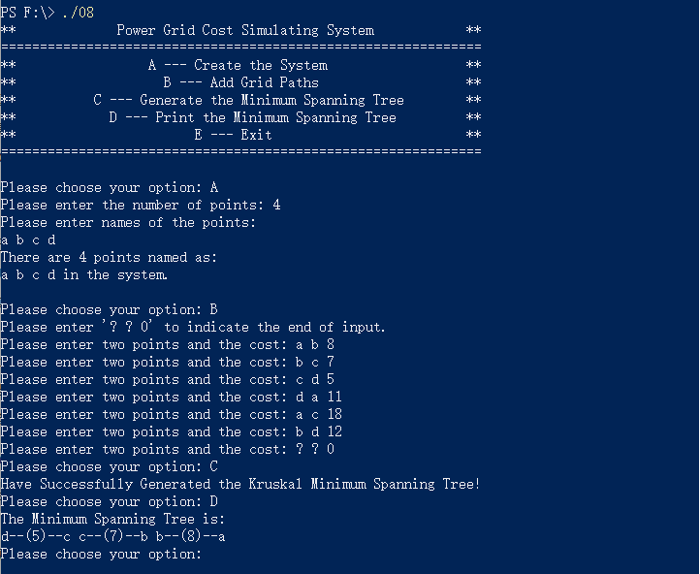

3.5 Overview Flow Chart
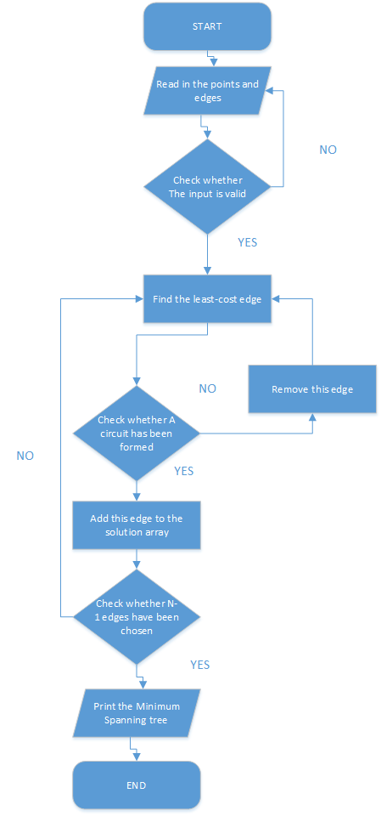

Ⅳ. Testing

4.1 Input Validity Testing

4.1.1 Incorrect Option Testing
Input Option:
Test Case 1: -1
Test Case 2: abc
Test Case 3: 100000000000000000000
Test Case 4: Z
Expected Result: Print “Non-existent option, please enter as required!”
Result: As expected. See the picture below.
Test Case 5: A
Expected Result: The program run normally.
Result: As expected. See the picture below.
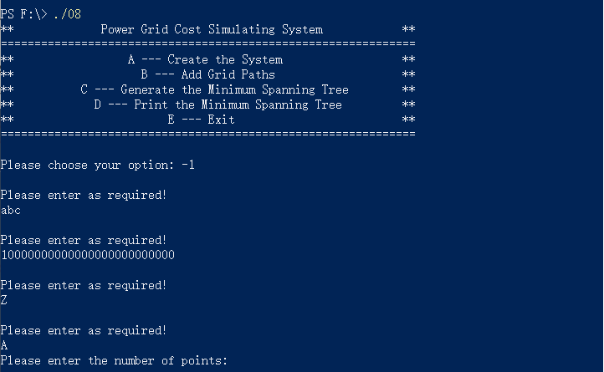

4.2 Boundary Testing

4.2.1 Non-existent Element Testing
Test Case 1: Non-existent points
Expected Result: Print “Your input do not meet the requirements. Please re-try!”
Result: As expected. See the picture below.
Test Case 2: Non-existent Minimum Spanning Tree
Expected Result: Print “Generation Failed!”
Result: As expected. See the picture below.
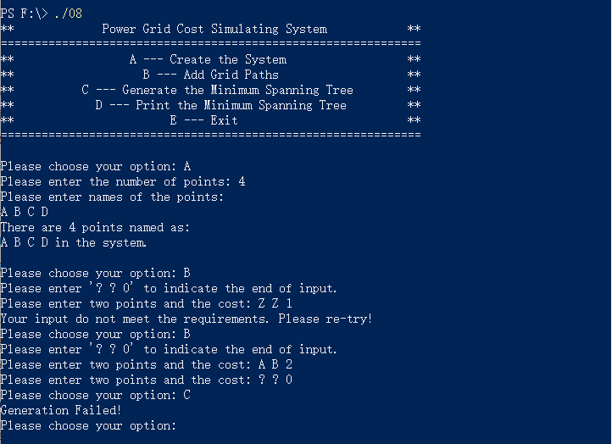

4.2.2 Exit Testing
Test Case 1: Ctrl+Z
Expected Result: The program continues to run.
Result: As expected. See the picture below.
Test Case 2: Ctrl+C
Test Case 3: Input option “E”
Expected Result: Exit normally.
Result: As expected. See the picture below.
