Project Document

Course Project of Data Structure
- Course Scheduling

Author Name: [DATA ERASED]
ID: [DATA ERASED]
Supervisor: [DATA ERASED]
School, Major: TJSSE, Software Engineering

同济大学
Tongji University

Contents
Ⅰ. Analysis 3
1.1 Background Analysis 3
1.2 Function Analysis 3
Ⅱ. Design 4
2.1 Design of the Data Structure 4
2.2 Design of Course Struct 4
2.3 Design of The Graph Class Members and functions 5
2.4 Design of the Main Function 5
Ⅲ. Implementation 8
3.1 Implementation of the Course-adding Function 8
3.1.1 Main Source Codes of the Course-adding Function 8
3.2 Implementation of the Edge-adding Function 8
3.2.1 Main Source Codes of the Edge-adding Function 8
3.3 Implementation of the Course Scheduling Function 9
3.3.1 Flow Chart of the Course Scheduling Function 9
3.3.2 Main Source Codes of the Course Scheduling Function 9
3.3.3 Demonstration of the Course Scheduling Function 10
3.4 Implementation of the Topological Sort Function 11
3.4.1 Flow Chart of the Topological Sort Function 11
3.4.2 Main Source Codes of the Topological Sort Function 11
3.5 Overview Flow Chart 13
Ⅳ. Testing 14
4.1 Input Validity Testing 14

Ⅰ. Analysis

1.1 Background Analysis
Every major need course scheduling at the university. Assume that any major has a fixed study period. Each academic year contains two semesters. The courses offered by each major are determined, and the schedule of the courses must meet the prerequisite relationship. The prerequisites for each course are determined. Each course takes exactly one semester, assuming that there are five lessons each morning and afternoon. On this premise, design a course scheduling preparation program.

1.2 Function Analysis
The input data will include: the number of courses designed in a semester (the sum of the number of courses designed in each semester must be equal to the total number of courses), the course id, the course name, the number of weekly class hours, the designated semester, the prerequisites. If the designated semester is 0, it means that the program may designate the semester.
If the input data is not reasonable, such as the number of courses assigned in each semester is not equal to the total number of courses, appropriate prompt information should be printed.
Assume that there are classes from Monday to Friday. There are 10 lessons per day. The first session is 1-2. The second session is 3-5. The third session is 6-7. The 4 sections are 8-10 lessons. When arranging lessons, if there are 3 lessons in a course, 3 consecutive lessons will be given priority; if a course needs to be arranged for two days, for better teaching results, it is best not to arrange it for two consecutive days
Also, we need to store the input data in a text file and load it into the memory, and use text files to store the lesson schedules for each semester printed as well.
It is easy to see we need sort the courses to a proper order, and then place them in the scheduling while meeting many requirements above.

Ⅱ. Design

2.1 Design of the Data Structure
As described in the function analysis above, to sort the courses to a proper order, we need a topological sort function to do the job. And we need a graph structure to store the courses and prerequisites we read in, the courses are stored as points in the graph and the prerequisites relations are stored as edges in the graph.
To do the course scheduling, we also need many if-clauses to meet the demands of this project. And we also need to see that these demands are not compulsory, so even if we cannot meet all of the demands, the program should still continue to run, not just exit with an error message.

2.2 Design of Course Struct
According to the analysis above, this problem need a Course structure to store each course input into the program. Prerequisites are ignored in this part of the programs as courses are stored as points in the graph, wile prerequisites are edges. The operator “>>” is overloaded to better implement the function of printing the scheduling.
//The Course Class
class Course {
public:
Course() = default;
Course(const Course& course) {
id = course.id;
name = course.name;
class_hours = course.class_hours;
specified_term = course.specified_term;
}
std::string id;
std::string name;
int class_hours = 0;
int specified_term = 0;
friend std::istream& operator>>(std::istream& stream, Course& course);
};

std::istream& operator>>(std::istream& stream, Course& course) {
stream >> course.id;
stream >> course.name;
stream >> course.class_hours;
stream >> course.specified_term;
return stream;
}

2.3 Design of The Graph Class Members and functions
The Graph class includes several member variables and four member functions. The courses array is to store the course information input into the program. And the totalCourses and currentCourse are variables to indicate the current state of the Graph. The plan std::string arrat is to store the course scheduling generated.
For the four public functions, please see later part.
//The Graph Class
class Graph {
private:
Course courses[MAX_COURSE_NUMBER];
public:
int totalCourses = 0;
int currentCourse = 0;
std::string plan[TERMS][5][10];
void AddCourse(const Course& course);
void AddEdges(const std::string& pre);
bool CourseScheduling(const Course& course);
void TopologicalSort();

2.4 Design of the Main Function
The main function can be roughly divided into three parts: read in the courses, do the course scheduling and print our scheduling. The second part is to call the public methods of the Maze class, please see the later part. The rest source codes of the main function are as follows:
The first part source codes of the main function are as follows:
int main() {
std::string location = R"(./09_Input.txt)"; //Read in the Input files
std::ifstream Input(location);
if (!Input.is_open()) {
std::cout << "Failed to open " << location << ". " << std::endl;
std::cin.clear();
std::cin.sync();
getchar();
exit(0);
}
Graph graph;
Course course;
std::string line;
getline(Input, line);
while (getline(Input, line)) { //Read in the Points and Edges of the graph
std::stringstream stream(line);
stream >> course;
graph.AddCourse(course);
}
Input.close();
std::ifstream InputEdges(location);
getline(InputEdges, line);
while (getline(InputEdges, line)) {
std::stringstream stream(line);
stream >> course;
std::string tmp;
while (stream >> tmp) {
graph.AddEdges(tmp);
}
graph.currentCourse++;
}
std::cout << "Course information is stored in " << location << ", the output is stored in ./Output.txt. " << std::endl;
std::cout << "Enter 0 to decide numbers of courses in each term by default, enter 1 to input them manually: ";
The third part source codes of the main function are as follows:
std::string destination = R"(./09_Output.txt)"; //Print the Schedule
std::ofstream Output(destination);
for (int term = 0; term < TERMS; term++) {
Output << "Term " << 1 + term << std::endl;
Output << "\t" << "\t" << " ";
for (int day = 0; day < 5; day++) {
Output << "Day " << 1 + day << "\t" << "\t";
}
Output << std::endl;
for (int class_ = 0; class_ < 10; class_++) {
if (class_ <= 8) {
Output << "Class " << 1 + class_ << " " << "\t";
}
else {
Output << "Class " << 1 + class_ << "\t";
}
for (int day = 0; day < 5; day++) {
if (graph.plan[term][day][class_].empty()) {
Output << "None" << "\t" << "\t";
}
else {
Output << graph.plan[term][day][class_] << "\t" << "\t";
}
}
Output << std::endl;
}
Output << std::endl;
}
std::cout << "Please Check ./09_Output.txt for the Scheduling! " << std::endl;
std::cout << "Press any key to exit... " << std::endl;
std::cin.clear();
std::cin.sync();
getchar();
return 0;
}

Ⅲ. Implementation

3.1 Implementation of the Course-adding Function

3.1.1 Main Source Codes of the Course-adding Function
void AddCourse(const Course& course) { //Add a point to the graph
courses[totalCourses] = course;
totalCourses++;
}

3.2 Implementation of the Edge-adding Function

3.2.1 Main Source Codes of the Edge-adding Function
void AddEdges(const std::string& pre) { //Add a edge to the graph
for (int i = 0; i < totalCourses; i++) {
if (courses[i].id == pre) {
edges[currentCourse][i] = true;
return;
}
}
std::cout << "Prerequisites Non-existent!" << std::endl;
exit(0);
}

3.3 Implementation of the Course Scheduling Function

3.3.1 Flow Chart of the Course Scheduling Function
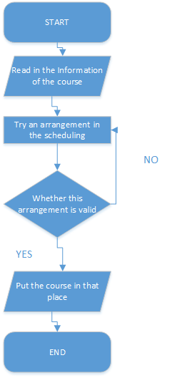

3.3.2 Main Source Codes of the Course Scheduling Function
bool CourseScheduling(const Course& course) { //Course Scheduling
int hours = course.class_hours;
int terms = course.specified_term;
if (hours <= 2 || hours >= 7) {
std::cout << "Sorry. Course Scheduling for Class Hours<=2 or >=7 have not been implemented. " << std::endl;
exit(0);
}
for (int term = 0; term < 8; term++) {
bool break_flag = false;
if (terms != 0) {
term = terms - 1;
break_flag = true;
}
if (courses_each_term[term] <= 0) {
if (break_flag == false) {
continue;
}
else {
break;
}
}
for (int day = 0; day < 5; day++) {
(The part of numerous if-clause is omitted.)
if (break_flag == true) {
break;
}
}
return false;
}

3.3.3 Demonstration of the Course Scheduling Function
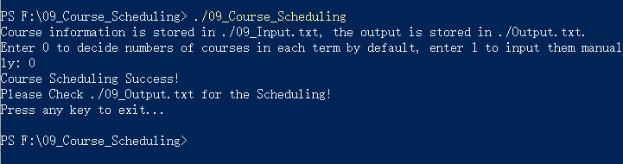

3.4 Implementation of the Topological Sort Function

3.4.1 Flow Chart of the Topological Sort Function
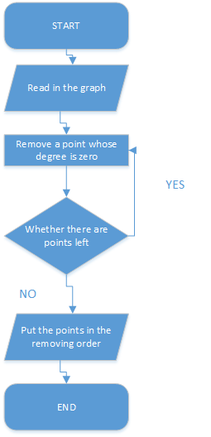

3.4.2 Main Source Codes of the Topological Sort Function
void TopologicalSort() { //Sort the Courses to a proper order
int temp_course = 0;
bool chosen[MAX_COURSE_NUMBER] = { false };
for (int k = 0; k < totalCourses; k++) {
for (int i = 0; i < totalCourses; i++) {
if (chosen[i] == false) {
bool break_flag = false;
for (int j = 0; j < totalCourses; j++) {
if (edges[i][j] != false) {
break_flag = true;
break;
}
}
if (break_flag == true) {
continue;
}
for (int j = 0; j < totalCourses; j++) {
edges[j][i] = false;
}
if (!CourseScheduling(courses[i])) {
continue;
}
chosen[i] = true;
temp_course++;
break;
}
}
}
if (temp_course < totalCourses) {
std::cout << "Topological Sort Failed!" << std::endl;
exit(0);
}
}

3.5 Overview Flow Chart
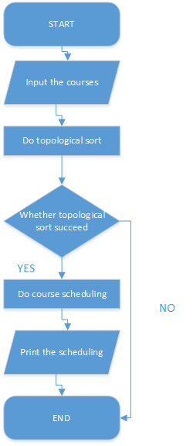

Ⅳ. Testing

4.1 Input Validity Testing
Test Case 1: Topological Sort Loop
Expected Result: Print “Topological Sort Failed!”
Result: As expected. See the picture below.
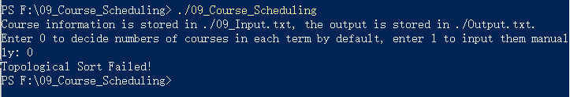
Test Case 2: The numbers of courses each term do not match the total courses
Expected Result: Print “Please enter as required!”
Result: As expected. See the picture below.
