Project Document

Course Project of Data Structure
- Sorting Algorithm Comparison

Author Name: [DATA ERASED]
ID: [DATA ERASED]
Supervisor: [DATA ERASED]
School, Major: TJSSE, Software Engineering

同济大学
Tongji University

Contents
Ⅰ. Analysis 4
1.1 Background Analysis 4
1.2 Function Analysis 4
Ⅱ. Design 5
2.1 Design of the Data Structure 5
2.2 Design of the Main Function 5
Ⅲ. Implementation 7
3.1 Implementation of Bubble Sort 7
3.1.1 Flow Chart of Bubble Sort 7
3.1.2 Main Source Codes of Bubble Sort 7
3.1.3 Demonstration of Bubble Sort 8
3.2 Implementation of Selection Sort 9
3.2.1 Flow Chart of Selection Sort 9
3.2.2 Main Source Codes of Selection Sort 9
3.2.3 Demonstration of Selection Sort 11
3.3 Implementation of Insertion Sort 12
3.3.1 Flow Chart of Insertion Sort 12
3.3.2 Main Source Codes of Insertion Sort 12
3.3.3 Demonstration of Insertion Sort 13
3.4 Implementation of Shell Sort 14
3.4.1 Flow Chart of Shell Sort 14
3.4.2 Main Source Codes of Shell Sort 15
3.4.3 Demonstration of Shell Sort 16
3.5 Implementation of Quick Sort 17
3.5.1 Flow Chart of Quick Sort 17
3.5.2 Main Source Codes of Quick Sort 17
3.5.3 Demonstration of Quick Sort 19
3.6 Implementation of Heap Sort 20
3.6.1 Flow Chart of Heap Sort 20
3.6.2 Main Source Codes of Heap Sort 20
3.6.3 Demonstration of Heap Sort 22
3.7 Implementation of Merge Sort 23
3.7.1 Flow Chart of Merge Sort 23
3.7.2 Main Source Codes of Merge Sort 24
3.7.3 Demonstration of Merge Sort 25
3.8 Implementation of Radix Sort 26
3.8.1 Flow Chart of Radix Sort 26
3.8.2 Main Source Codes of Radix Sort 27
3.8.3 Demonstration of Radix Sort 28
Ⅳ. Testing 28
4.1 Function Testing 28
4.2 Boundary Testing 32
4.2.1 Incorrect Total Number Testing 32
Ⅴ. Summary 34
5.1 Time Complexity Comparison Between Sorting Algorithms Above 34
5.2 Space Complexity Comparison Between Sorting Algorithms Above 34
5.3 Advantages and Disadvantages Each Sorting Algorithm Above 34

Ⅰ. Analysis

1.1 Background Analysis
In practical applications, sorting algorithms are widely used, so it is necessary to conduct a systematic study on the performance, implementation, number of exchanges, and time consumption of various sorting algorithms.
The random function generates one hundred, one thousand, ten thousand, and one hundred thousand random numbers, and sorts them using sorting methods such as quick sort, direct insert sort, bubble sort, and select sort, then counts the sorting time and number of exchanges for each sorting. The number of random numbers is given by the user, and the system generates random numbers, and show their comparison times.

1.2 Function Analysis
To achieve the comparison of various sorting algorithms, we first need to generate a number of random numbers. According to the requirements of the project, we must also have the function of randomly generating a given number of random numbers. Then, each sorting algorithm needs to be implemented as a function, and then the generated random number sequence is called by these functions to sort, and the number of exchanges and time consumption are counted and printed.
According to the requirements of the project, at least 100,000 random numbers must be able to be sorted. At the same time, it should be able to record the time and number of operations of each algorithm.

Ⅱ. Design

2.1 Design of the Data Structure
As described in the function analysis above, we need a array to store the generated random numbers. And we need a copy of this array, so we can let each sorting algorithm sorts the same array. Although rand() in C++ is an implementation-defined function, it is usually random enough for sorting purpose. So we will simply use rand() to generate random numbers. And we will read in the number our users entered to decided how many random numbers we should generate (no more than 100,000).

2.2 Design of the Main Function
The main function can be roughly divided into three parts: initialization, and read in the option. The second part will be introduced in the later part. The source codes to initialize the random numbers’ array are as follows:
int main() {
std::cout << "** Sorting Algorithm Comparison **" << std::endl;
std::cout << "==============================================================" << std::endl;
std::cout << "** 1 --- Bubble sort **" << std::endl;
std::cout << "** 2 --- Selection sort **" << std::endl;
std::cout << "** 3 --- Insertion sort **" << std::endl;
std::cout << "** 4 --- Shellsort **" << std::endl;
std::cout << "** 5 --- Quicksort **" << std::endl;
std::cout << "** 6 --- Heapsort **" << std::endl;
std::cout << "** 7 --- Merge sort **" << std::endl;
std::cout << "** 8 --- Radix sort **" << std::endl;
std::cout << "** 9 --- Exit **" << std::endl;
std::cout << "==============================================================" << std::endl << std::endl;
std::cout << "Please enter how many random number you want to generate (no more than 100000) : ";
int number;
while (true) {
std::cin >> number;
if (std::cin.fail() != true && number > 0 && number <= 100000) {
std::cin.clear();
std::cin.sync();
break;
}
//Reset and clear the input stream if input data is incorrect.
std::cin.clear();
std::cin.sync();
std::cout << std::endl;
std::cout << "Please enter as required: ";
}
srand(time(0));
for (int i = 0; i < number; i++) {
numbers[i] = rand();
}

Ⅲ. Implementation

3.1 Implementation of Bubble Sort

3.1.1 Flow Chart of Bubble Sort
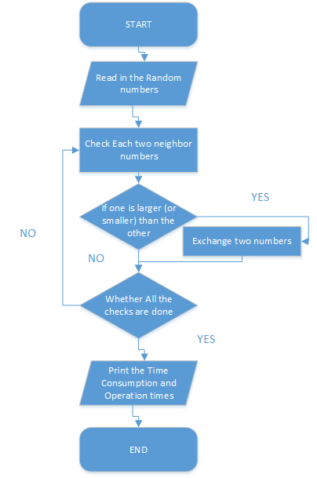

3.1.2 Main Source Codes of Bubble Sort
void bubble_sort(int number) {
for (int i = 0; i < number; i++) {
working_numbers[i] = numbers[i];
}
clock_t time_start = clock();
int tmp;
long long operation_times = 0;
for (int i = 0; i < number; i++) {
for (int j = 0; j < number - i - 1; j++) {
operation_times++;
if (working_numbers[j] > working_numbers[j + 1]) {
tmp = working_numbers[j];
working_numbers[j] = working_numbers[j + 1];
working_numbers[j + 1] = tmp;
}
}
}
clock_t time_end = clock();
double time_passed = (float)(time_end - time_start) / CLOCKS_PER_SEC;
std::cout << "Bubble Sort Time Cost: " << time_passed << "s" << std::endl;
std::cout << "Bubble Sort Operation Times: " << operation_times << std::endl;
}

3.1.3 Demonstration of Bubble Sort
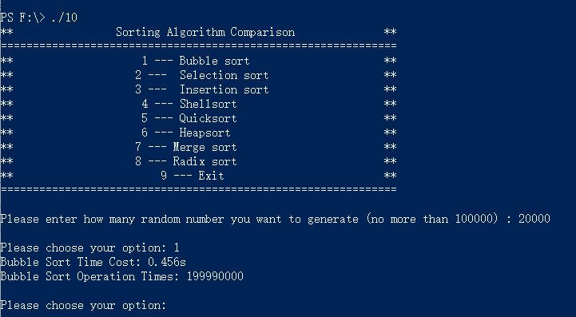

3.2 Implementation of Selection Sort

3.2.1 Flow Chart of Selection Sort
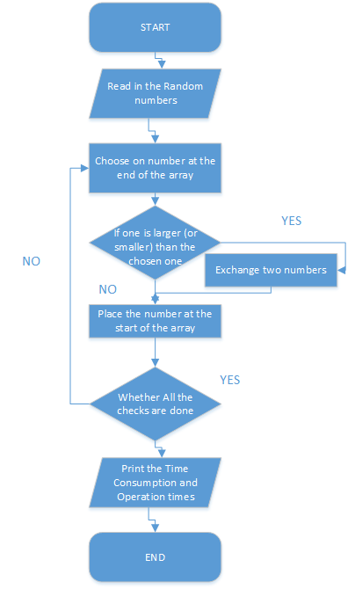

3.2.2 Main Source Codes of Selection Sort
void selection_sort(int number) {
for (int i = 0; i < number; i++) {
working_numbers[i] = numbers[i];
}
clock_t time_start = clock();
int tmp, max;
long long operation_times = 0;
for (int i = 0; i < number; i++) {
max = 0;
for (int j = 0; j < number - i - 1; j++) {
operation_times++;
if (working_numbers[j] > working_numbers[max]) {
max = j;
}
}
operation_times++;
if (working_numbers[number - i - 1] < working_numbers[max]) {
tmp = working_numbers[max];
working_numbers[max] = working_numbers[number - i - 1];
working_numbers[number - i - 1] = tmp;
}
}
clock_t time_end = clock();
double time_passed = (float)(time_end - time_start) / CLOCKS_PER_SEC;
std::cout << "Selection Sort Time Cost: " << time_passed << "s" << std::endl;
std::cout << "Selection Sort Operation Times: " << operation_times << std::endl;
}

3.2.3 Demonstration of Selection Sort
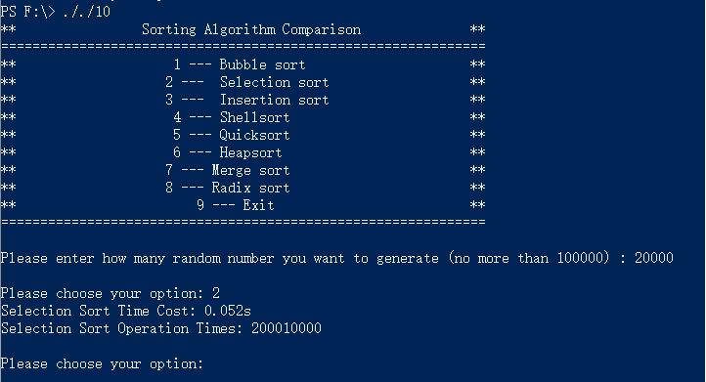

3.3 Implementation of Insertion Sort

3.3.1 Flow Chart of Insertion Sort
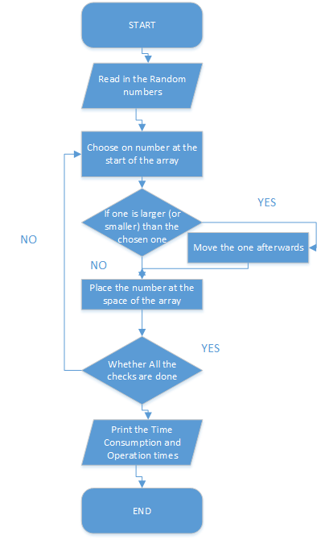

3.3.2 Main Source Codes of Insertion Sort
void insertion_sort(int number) {
for (int i = 0; i < number; i++) {
working_numbers[i] = numbers[i];
}
clock_t time_start = clock();
int tmp;
long long operation_times = 0;
for (int i = 0; i < number; i++) {
int j = i - 1;
tmp = working_numbers[i];
while (j >= 0 && tmp < working_numbers[j]) {
working_numbers[j + 1] = working_numbers[j];
operation_times++;
j--;
}
working_numbers[j + 1] = tmp;
}
clock_t time_end = clock();
double time_passed = (float)(time_end - time_start) / CLOCKS_PER_SEC;
std::cout << "Insertion Sort Time Cost: " << time_passed << "s" << std::endl;
std::cout << "Insertion Sort Operation Times: " << operation_times << std::endl;
}

3.3.3 Demonstration of Insertion Sort
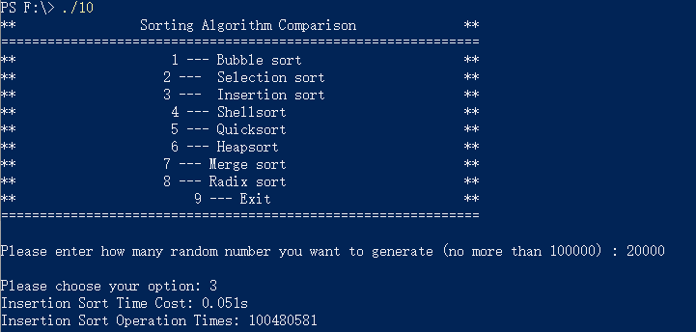

3.4 Implementation of Shell Sort

3.4.1 Flow Chart of Shell Sort
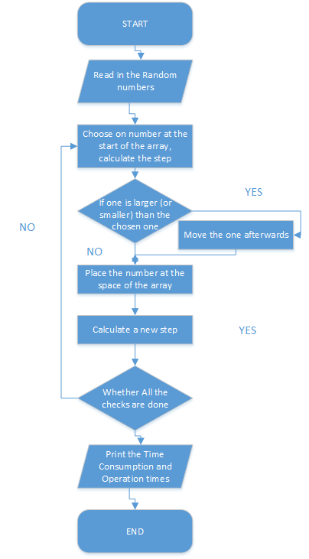

3.4.2 Main Source Codes of Shell Sort
void shellsort(int number) {
for (int i = 0; i < number; i++) {
working_numbers[i] = numbers[i];
}
clock_t time_start = clock();
int step = number >> 1;
int tmp, j;
long long operation_times = 0;
while (step > 0) {
for (int i = step; i < number; i++) {
tmp = working_numbers[i];
for (j = i - step; j >= 0 && working_numbers[j] > tmp; j -= step) {
operation_times++;
working_numbers[j + step] = working_numbers[j];
}
working_numbers[j + step] = tmp;
}
step >>= 1;
}
clock_t time_end = clock();
double time_passed = (float)(time_end - time_start) / CLOCKS_PER_SEC;
std::cout << "Shellsort Time Cost: " << time_passed << "s" << std::endl;
std::cout << "Shellsort Operation Times: " << operation_times << std::endl;
}

3.4.3 Demonstration of Shell Sort
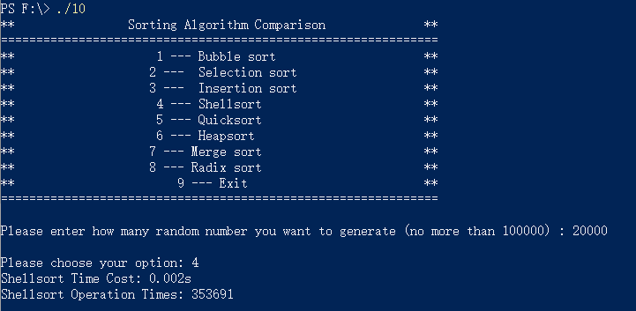

3.5 Implementation of Quick Sort

3.5.1 Flow Chart of Quick Sort
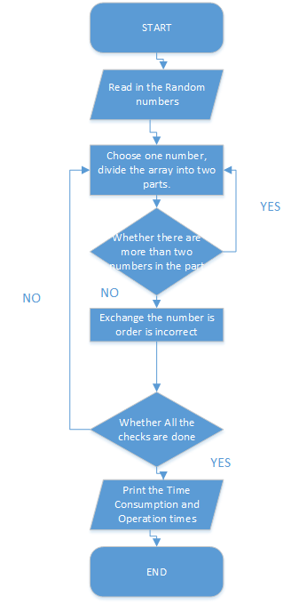

3.5.2 Main Source Codes of Quick Sort
//Quicksort
int part_sort(const int low, const int high, long long* operation_times) {
int temp = low;
int temp_number = working_numbers[low];
for (int i = low + 1; i <= high; i++) {
if (working_numbers[i] < temp_number) {
temp++;
(*operation_times)++;
if (temp != i) {
int temp_swap;
temp_swap = working_numbers[i];
working_numbers[i] = working_numbers[temp];
working_numbers[temp] = temp_swap;

}
}
}
working_numbers[low] = working_numbers[temp];
working_numbers[temp] = temp_number;
return temp;
}

//Quicksort
void Quicksort(const int low, const int high, long long* operation_times) {
if (low < high) {
int temp = part_sort(low, high, operation_times);
Quicksort(low, temp - 1, operation_times);
Quicksort(temp + 1, high, operation_times);
}
}

//Quicksort
void quicksort(int number) {
for (int i = 0; i < number; i++) {
working_numbers[i] = numbers[i];
}
clock_t time_start = clock();
long long operation_times = 0;
Quicksort(0, number - 1, &operation_times);
clock_t time_end = clock();
double time_passed = (float)(time_end - time_start) / CLOCKS_PER_SEC;
std::cout << "Quicksort Time Cost: " << time_passed << "s" << std::endl;
std::cout << "Quicksort Operation Times: " << operation_times << std::endl;
}

3.5.3 Demonstration of Quick Sort
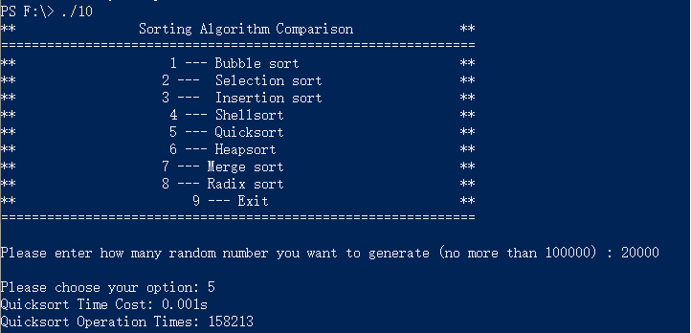

3.6 Implementation of Heap Sort

3.6.1 Flow Chart of Heap Sort
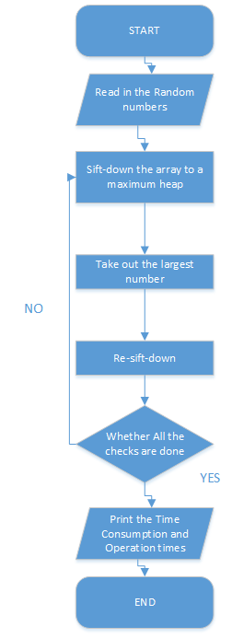

3.6.2 Main Source Codes of Heap Sort
//Heapsort
void siftDown(int start, int end, long long* times) {
int m = start;
int n = m * 2 + 1;
int temp = working_numbers[m];
while (n <= end) {
if (n + 1 <= end && working_numbers[n] < working_numbers[n + 1]) {
n++;
}
if (temp > working_numbers[n]) {
break;
}
else {
working_numbers[m] = working_numbers[n];
m = n;
n = m * 2 + 1;
(*times)++;
}
}
working_numbers[m] = temp;
}

//Heapsort
void heapsort(int number) {
for (int i = 0; i < number; i++) {
working_numbers[i] = numbers[i];
}
clock_t time_start = clock();
long long operation_times = 0;
for (int i = number / 2 - 1; i >= 0; i--) {
siftDown(i, number - 1, &operation_times);
}
for (int i = number - 1; i >= 0; i--)
{
int tmp = working_numbers[0];
working_numbers[0] = working_numbers[i];
working_numbers[i] = tmp;
siftDown(0, i - 1, &operation_times);
}
clock_t time_end = clock();
double time_passed = (float)(time_end - time_start) / CLOCKS_PER_SEC;
std::cout << "Heapsort Time Cost: " << time_passed << "s" << std::endl;
std::cout << "Heapsort Operation Times: " << operation_times << std::endl;
}

3.6.3 Demonstration of Heap Sort
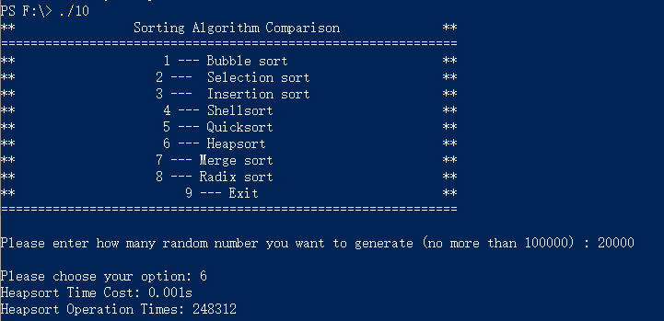

3.7 Implementation of Merge Sort

3.7.1 Flow Chart of Merge Sort
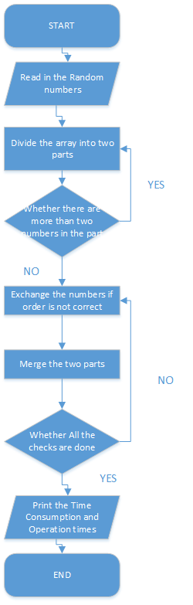

3.7.2 Main Source Codes of Merge Sort
//Merge Sort
void Merge(int left, int mid, int right, long long* operation_times) {
for (int i = left; i <= right; i++) {
(*operation_times)++;
merge_working_numbers[i] = working_numbers[i];
}
int m = left, n = mid + 1, t = left;
while (m <= mid && n <= right) {
(*operation_times)++;
if (merge_working_numbers[m] <= merge_working_numbers[n]) {
working_numbers[t] = merge_working_numbers[m];
t++;
m++;
}
else {
working_numbers[t] = merge_working_numbers[n];
t++;
n++;
}
}
while (m <= mid) {
(*operation_times)++;
working_numbers[t] = merge_working_numbers[m];
t++;
m++;
}
while (n <= right) {
(*operation_times)++;
working_numbers[t] = merge_working_numbers[n];
t++;
n++;
}
}

//Merge Sort
void Merge_sort(int left, int right, long long* operation_times) {
if (left >= right) {
return;
}
(*operation_times)++;
int mid = (left + right) / 2;
Merge_sort(left, mid, operation_times);
Merge_sort(mid + 1, right, operation_times);
Merge(left, mid, right, operation_times);
};

//Merge Sort
void merge_sort(int number) {
for (int i = 0; i < number; i++) {
working_numbers[i] = numbers[i];
}
clock_t time_start = clock();
long long operation_times = 0;
Merge_sort(0, number - 1, &operation_times);
clock_t time_end = clock();
double time_passed = (float)(time_end - time_start) / CLOCKS_PER_SEC;
std::cout << "Merge sort Time Cost: " << time_passed << "s" << std::endl;
std::cout << "Merge sort Operation Times: " << operation_times << std::endl;
}

3.7.3 Demonstration of Merge Sort
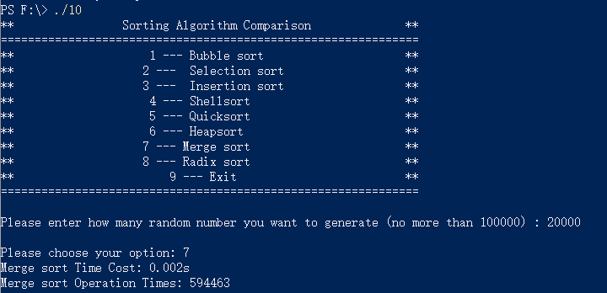

3.8 Implementation of Radix Sort

3.8.1 Flow Chart of Radix Sort
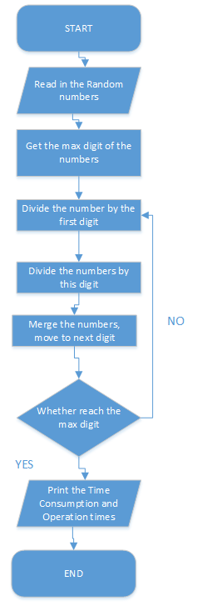

3.8.2 Main Source Codes of Radix Sort
//Radix Sort
int maxdigit(int number, long long* operation_times) {
int maxData = working_numbers[0];
for (int i = 1; i < number; ++i) {
(*operation_times)++;
if (maxData < working_numbers[i])
maxData = working_numbers[i];
}
int digit = 1;
int p = 10;
while (maxData >= p) {
p *= 10;
digit++;
}
return digit;

}

//Radix Sort
void radix_sort(int number) {
for (int i = 0; i < number; i++) {
working_numbers[i] = numbers[i];
}
clock_t time_start = clock();
long long operation_times = 0;
int max_digit = maxdigit(number, &operation_times);
int buckets[10] = { 0 };
int radix = 1;
for (int i = 1; i <= max_digit; i++) {
for (int j = 0; j < 10; j++) {
buckets[j] = 0;
}
for (int j = 0; j < number; j++) {
int tmp = (working_numbers[j] / radix) % 10;
buckets[tmp]++;
}
for (int j = 1; j < 10; j++) {
buckets[j] = buckets[j - 1] + buckets[j];
}
for (int j = number - 1; j >= 0; j--) {
operation_times++;
int tmp = (working_numbers[j] / radix) % 10;
radix_working_numbers[buckets[tmp] - 1] = working_numbers[j];
buckets[tmp]--;
}
for (int j = 0; j < number; j++) {
working_numbers[j] = radix_working_numbers[j];
}
radix *= 10;
}
clock_t time_end = clock();
double time_passed = (float)(time_end - time_start) / CLOCKS_PER_SEC;
std::cout << "Radix sort Time Cost: " << time_passed << "s" << std::endl;
std::cout << "Radix sort Operation Times: " << operation_times << std::endl;
}

3.8.3 Demonstration of Radix Sort
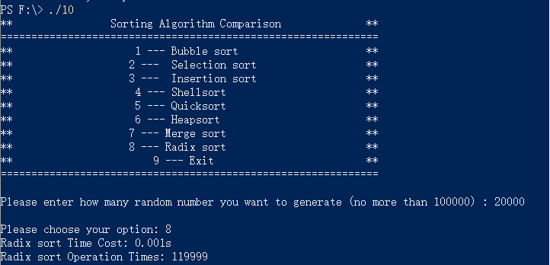

Ⅳ. Testing

4.1 Function Testing
Test Case 1: 100 random numbers
Expected Result: Print the Correct Answer.
Result: As expected. See the picture below.
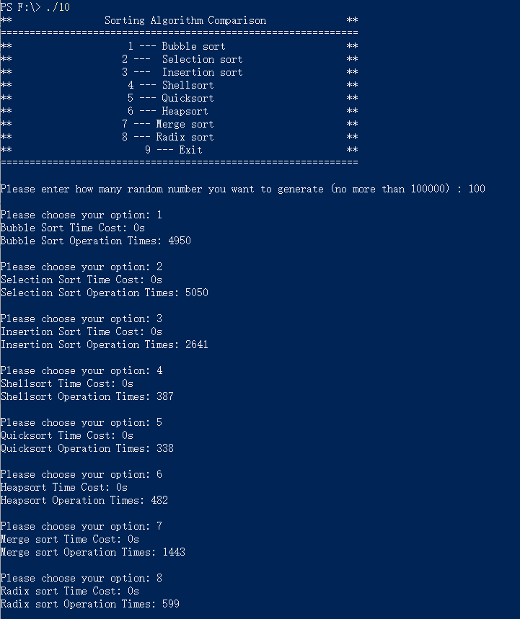
Test Case 2: 1000 random numbers
Expected Result: Print the Correct Answer.
Result: As expected. See the picture below.
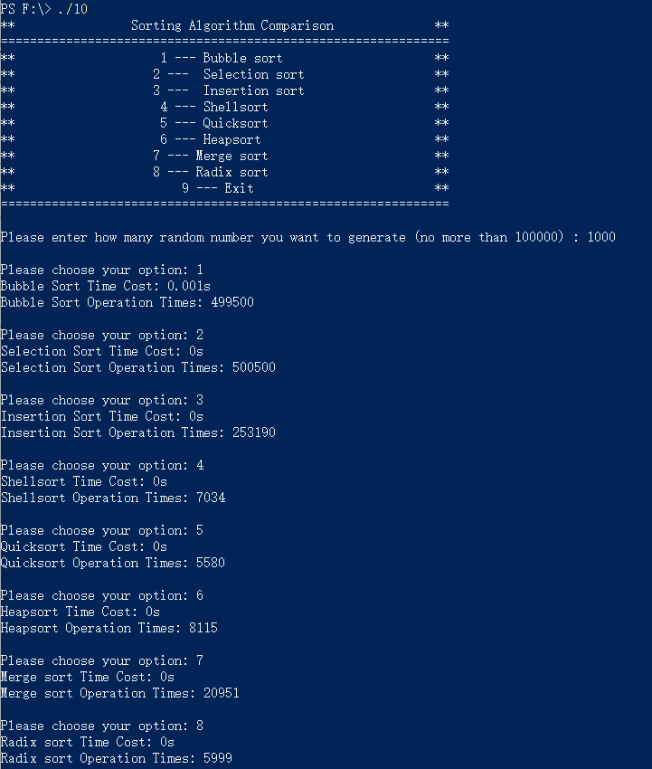
Test Case 3: 10000 random numbers
Expected Result: Print the Correct Answer.
Result: As expected. See the picture below.
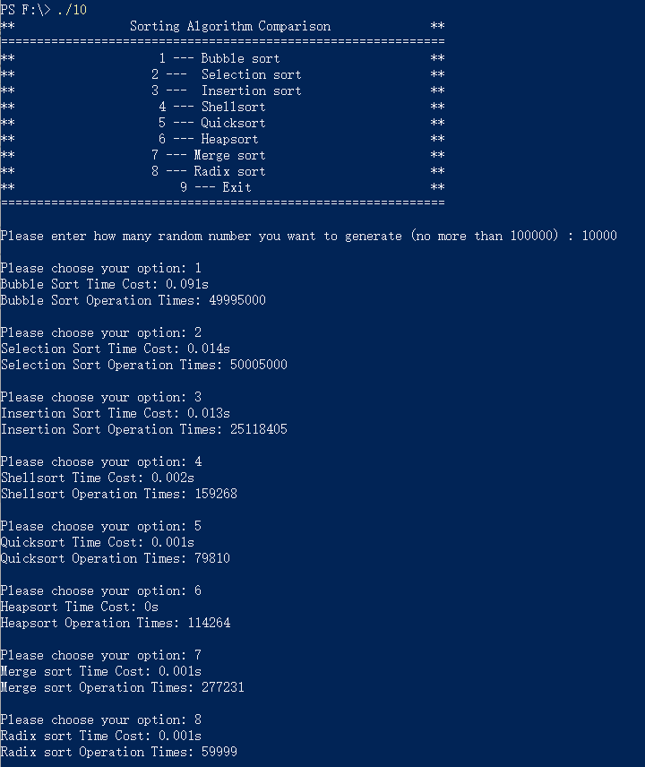
Test Case 4: 100000 random numbers
Expected Result: Print the Correct Answer.
Result: As expected. See the picture below.
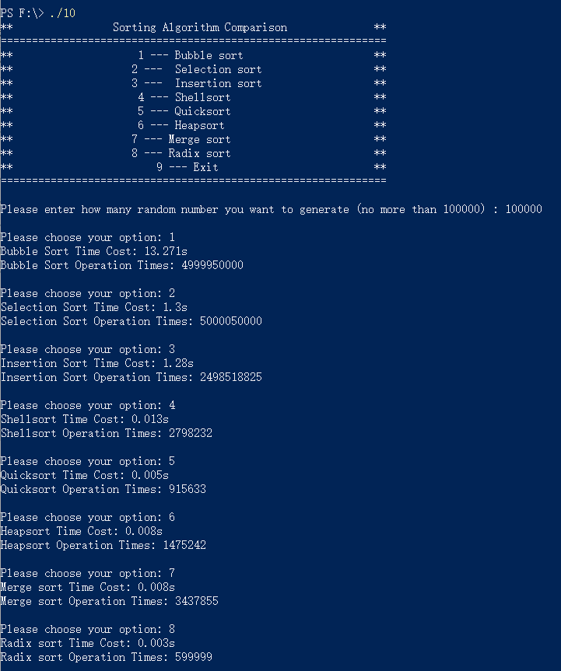

4.2 Boundary Testing

4.2.1 Incorrect Total Number Testing
Test Case 1: -1
Test Case 1: 1000000
Expected Result: Print “Please enter as required: ”
Result: As expected. See the picture below.
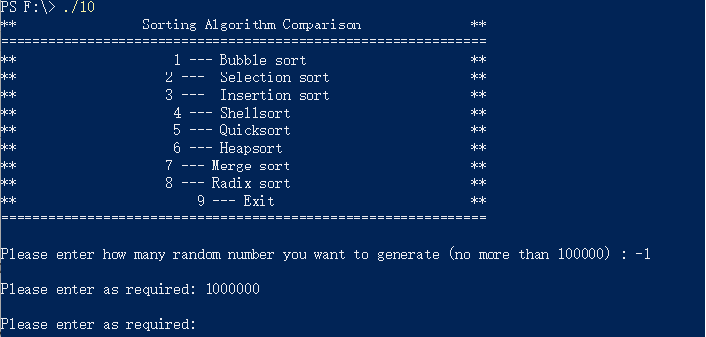

Ⅴ. Summary

5.1 Time Consumption Comparison Between Sorting Algorithms Above
Please view the pictures in Part Ⅳ.

5.2 Space Complexity Comparison Between Sorting Algorithms Above
Suppose there are N numbers:
1. Bubble sort: size of N
2. Selection sort: size of N
3. Insertion sort: size of N
4. Shell sort: size of N
5. Quick sort: size of N + stack occupied by recursion
6. Heap sort: size of N
7. Merge sort: size of 2N + stack occupied by recursion
8. Radix sort: size of 2N

5.3 Advantages and Disadvantages Each Sorting Algorithm Above
1. Bubble sort: The advantage is that the implementation is simple, the disadvantage is that the number of exchanges is too large, and only two adjacent data can be moved at a time, which is very slow.
2. Selection sort: The advantage is that the sequence with large element size but small indexes is fast and easy to implement. The disadvantage is that the comparison is more frequent and the speed is slower.
3. Insertion sort: The advantage is that the implementation is simple, the speed is fast when the sequence is basically ordered, and it is a stable algorithm. The disadvantage is that the element moves more times and the speed is slower.
4. Shell sort: The advantage is that the implementation is not complicated, the number of element movements and comparisons is much less than the previous algorithms, and the speed is significantly improved. The disadvantage is that it is not a stable sorting algorithm.
5. Quick sorting: the most commonly used sorting algorithm. The advantage is that it is fast when the amount of data is large. The disadvantage is that the efficiency is low when the sequence is basically ordered, and the recursive method is used to occupy the stack. The efficiency is low when the number of elements is small, can be even as good as a simple sorting algorithm.
6. Heap sorting: the advantage is fast; the worst average time complexity is faster than quick sorting. The disadvantage is that the data is moved too far during the sorting process, and it is not a stable algorithm.
7. Merging sorting: The advantage is that it is not sensitive to the order of the sequence and is faster. The disadvantage is that it takes up extra space and is an unstable algorithm.
8. Radix sorting: The advantage is that it is fast and has linear time complexity. The disadvantage is that it takes up extra space.

