

IT342-[Section]
System Integration and Architecture

System Design Document (SDD)

Project Title: CampusCare
Prepared By: Morre, Lyndon Luke

Version: 4.1
Date: 5/14/2026
Status: Final

REVISION HISTORY TABLE
Version | Date | Author | Changes Made | Status
1.0 | 2/18/2026 | Lyndon Luke Morre | Added and updated the Executive requirements, 1.0 Introduction, 2.0 Functional requirements specifications, 3.0 Non functional requirements | Draft
1.1 | 2/25/2026 | Lyndon Luke Morre | Added some ui/ux designs for login and registration, partially done with 4.0 needs some revisions | Review
2.0 | 3/3/2026 | Lyndon Luke Morre | Added and updated the 4.0 section, completed the 5.0 section as well as the 6.0 and 8.0. For the UI/UX added all the designs for web and mobile. | Draft
3.0 | 5/9/2026 | Lyndon Luke Morre | Updated and removed the Unnecessary tables on the database design, added new end points | Draft
4.0 | 5/10/2026 | Lyndon Luke Morre | Refactored to Vertical Slice Architecture, added password change, profile management, combined auth, file upload, email notifications, refresh tokens, exception handling, automated testing | Draft
4.1 | 5/12/2 | Lyndon Luke Morre | Updated the system Architecture diagram | Final

TABLE OF CONTENTS
Contents
EXECUTIVE SUMMARY 4
1.0 INTRODUCTION 5
2.0 FUNCTIONAL REQUIREMENTS SPECIFICATION 5
3.0 NON-FUNCTIONAL REQUIREMENTS 9
4.0 SYSTEM ARCHITECTURE 11
5.0 API CONTRACT & COMMUNICATION 12
6.0 DATABASE DESIGN 17
7.0 UI/UX DESIGN 18
8.0 PLAN 21

EXECUTIVE SUMMARY
1.1 Project Overview
CampusCare is a simple campus healthcare appointment system that allows students to register, log in, and book clinic appointments online. The system provides a centralized platform for managing appointments, helping reduce long queues and manual scheduling at the campus clinic.

1.2 Objectives
- Develop a functional appointment booking system for campus clinic services
- Implement secure user authentication (register, login, logout, Google OAuth)
- Allow students to book, view, and track clinic appointments
- Provide clinic staff with tools to approve, reject, and manage appointments
- Enable profile management with password change functionality
- Support file uploads for medical documents
- Send email notifications for appointments and approvals
- Design a responsive user interface for web and mobile

1.3 Scope
Included Features:
- User registration and login (email/password + Google OAuth)
- Student dashboard with upcoming and history appointments
- Profile management (update name, change password)
- Password strength indicator
- Appointment booking system with status tracking
- Admin dashboard with appointment management (approve/reject/complete)
- File upload for medical documents
- Email notifications (welcome, booking confirmation, status updates)
- JWT authentication with refresh tokens
- Responsive web interface (React)
- Mobile application (Android/Kotlin)
- Vertical Slice Architecture
Excluded Features:
- Online payment processing
- Video consultations
- Multi-clinic support
- Advanced reporting and analytics

1.0 INTRODUCTION
1.1 Purpose
This document serves as the design and requirements specification for the CampusCare system. It outlines the functional and non-functional requirements, system architecture, API contracts, database design, and testing strategy to guide the development of the application and ensure that students and clinic staff can efficiently manage clinic appointments.

2.0 FUNCTIONAL REQUIREMENTS SPECIFICATION
2.1 Project Overview
Project Name: CampusCare
Domain: Healthcare / Campus Services
Primary Users: Students and Clinic Staff (Administrator)
Problem Statement: Students need an easy way to schedule clinic appointments without long queues or manual booking.
2.2 Core User Journeys
Journey 1: First-time Student Appointment Booking
- Student visits the CampusCare web/mobile application
- Clicks "Register" and creates an account (or uses Google OAuth)
- Receives welcome email
- Logs in using registered credentials
- Views dashboard with upcoming appointments
- Navigates to "Book Appointment"
- Selects date, time, and reason
- Books an appointment
- Receives booking confirmation email
Journey 2: Returning Student Appointment Booking
- Student logs in to existing account
- Views dashboard with upcoming appointments and history
- Can book new appointments, view status, upload files
- Can update profile and change password
Journey 3: Clinic Staff Appointment Management
- Clinic staff logs in as administrator
- Views all appointments with filter options
- Can approve, reject, cancel, or mark appointments as completed
- Student receives email notification on status change
2.3 Feature List (MoSCoW)
MUST HAVE
- User authentication (register, login, logout)
- Google OAuth login
- Student dashboard (appointments overview + history)
- Profile management (update name, change password)
- Password strength indicator
- Appointment booking system
- Admin appointment management (approve/reject)
- Role-based access control
- JWT authentication with refresh tokens
SHOULD HAVE
- Appointment status tracking (PENDING/APPROVED/COMPLETED/CANCELLED)
- Input validation and error feedback
- Responsive design (web + mobile)
- Appointment history for students
- File upload for medical documents
- Email notifications
- Global exception handling
COULD HAVE
- Appointment cancellation by student
- Clinic announcements
- Basic reports for clinic staff
- Password reset via email
WON'T HAVE
- Online payment processing
- Video consultation
- Multi-clinic support
2.4 Detailed Feature Specifications
Feature: User Authentication
- Screens: Combined Auth Page (Login + Register tabs)
- Fields: First Name, Last Name, Email, Password, Confirm Password
- Validation: Required fields, email format, password strength indicator
- API Endpoints: POST /auth/register, POST /auth/login, POST /auth/google, POST /auth/refresh, POST /auth/logout
- Security: JWT access + refresh tokens, BCrypt password hashing, Google OAuth 2.0
- Error Handling: JSON error responses with proper HTTP status codes
Feature: Student Dashboard
- Screens: Dashboard
- Display: Welcome banner, upcoming appointments, appointment history
- Functions: View appointments, book new appointment, view status badges
- API Endpoints: GET /appointments/my
- Status Badges: PENDING (yellow), APPROVED (green), COMPLETED (grey), CANCELLED (red)
Feature: Appointment Booking (Transactional Function)
- Screens: Appointment Booking Form
- Functions: Reason, Date, Time
- Process: Validate availability → Save appointment → Display confirmation → Send email
- API Endpoints: POST /appointments, GET /appointments/my
- Validation: Prevent past date booking, required fields
Feature: Profile Management
- Screens: Profile Page
- Functions: View/update first name and last name, change password, view role and email
- API Endpoints: GET /profile, PUT /profile, PUT /profile/change-password
- Security: Current password verification, password strength indicator
Feature: Admin Panel
- Screens: Admin Dashboard
- Functions: View all appointments, filter by status, approve/reject/cancel/complete
- Access Control: Admin role only
- API Endpoints: GET /appointments/all, PUT /appointments/{id}/status
Feature: File Upload
- Functions: Upload medical documents, link to appointments
- API Endpoints: POST /files/upload, GET /files
- Validation: File type checking, size limit (5MB)
Feature: Email Notifications
- Triggers: Registration, appointment booking, admin approval
- Service: JavaMailSender (SMTP/Gmail)
- Error Handling: Graceful failure, system does not crash

2.5 Acceptance Criteria
AC-1: Successful Student Registration
- Given I am a new student
- When I enter valid registration details and submit
- Then my account should be created, JWT token returned, and welcome email sent
AC-2: Appointment Booking
- Given I am logged in as a student
- When I select a date, time, and reason and confirm
- Then the appointment is saved with PENDING status and confirmation email sent
AC-3: Admin Appointment Management
- Given I am logged in as admin
- When I approve/reject an appointment
- Then the status updates and student receives notification email
AC-4: Password Change
- Given I am on the Profile page
- When I enter correct current password and new password
- Then password is updated and I can login with new password
AC-5: Invalid Login Handling
- Given I enter wrong credentials
- When I submit the login form
- Then I receive a JSON error: "Invalid credentials" with 401 status

3.0 NON-FUNCTIONAL REQUIREMENTS
3.1 Performance Requirements
- API response time ≤ 2 seconds
- Page load time ≤ 3 seconds
- Support at least 100 concurrent users
- Appointment booking transaction ≤ 2 seconds
- Email delivery ≤ 30 seconds
3.2 Security Requirement
- HTTPS for all communications
- JWT authentication with access + refresh tokens
- BCrypt password hashing
- Role-based access control (STUDENT, ADMIN)
- Global exception handling (no stack traces in responses)
- Protection against SQL injection and XSS
- Token expiry and refresh mechanism
3.3 Compatibility Requirements
- Web Browsers: Chrome, Firefox, Edge (latest versions)
- Devices: Mobile, Tablet, Desktop
- Operating Systems: Windows, macOS, Linux, android
- Backend: Java 17, Spring Boot 3.3
3.4 Usability Requirements
- Booking an appointment within 3 minutes
- Simple and consistent navigation
- Clear validation and error messages
- Mobile-friendly responsive design
- Password strength visual indicator

4.0 SYSTEM ARCHITECTURE
4.1 Architecture Overview
Layer | Description | Example
Security | JWT filter, role verification | Blocks /admin if role is STUDENT
Controller | REST endpoints, request/response | POST /auth/login
Service | Business logic | Validates credentials, generates token
Repository | Database access | userRepository.findByEmail()
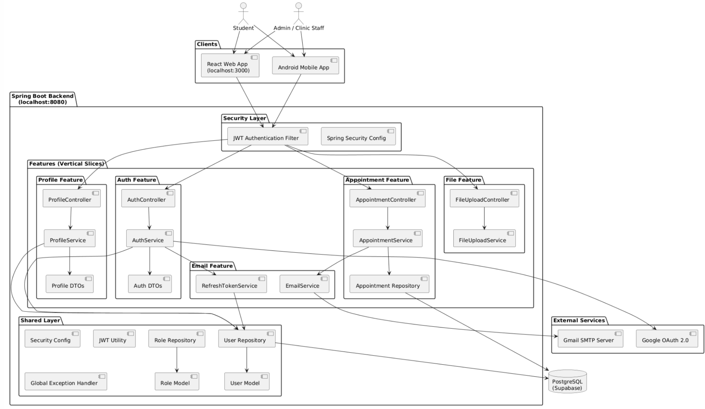
4.2 Component Diagram

- 401 Unauthorized (invalid/missing token)
- 403 Forbidden (insufficient role)
- 404 Not Found
- 500 Internal Server Error
Error Response Format:
{
"message": "Invalid credentials"
}

6.0 DATABASE DESIGN
6.1 Entity Relationship Diagram
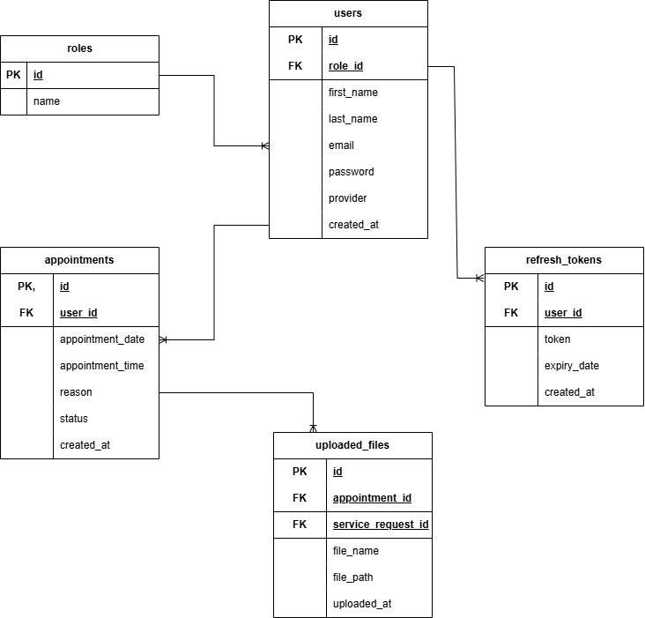

Detailed Relationships:

One-to-Many: Role → Users
One role can have multiple users.

One-to-Many: User → Appointments
A user can book multiple clinic appointments (free).

One-to-Many: Appointment → UploadedFiles
An appointment can have multiple attached medical documents.

One-to-Many: User → RefreshTokens
A user can have multiple active JWT refresh tokens (multi-device login support).
Key Tables:
- roles – User role definitions (ADMIN, STUDENT)
- users – User accounts and authentication
- appointments – Free clinic bookings
- uploaded_files – Stored file metadata
- refresh_tokens – JWT refresh token storage

Table Structure Summary:
- roles: id(PK), name
- users: id(PK), first_name, last_name, email(UNIQUE), password_hash, provider, role_id(FK → roles.id), created_at
- appointments: id(PK), user_id(FK → users.id), appointment_date, appointment_time, reason, status(PENDING / APPROVED / COMPLETED / CANCELLED), created_at
- Uploaded_files: id(PK), appointment_id(FK, nullable), service_request_id(FK, nullable), file_name, file_path, uploaded_at
- refresh_tokens: id, user_id(FK → users.id), token, expiry_date, created_at

7.0 UI/UX DESIGN
7.1 Web Application Wireframes
Login page
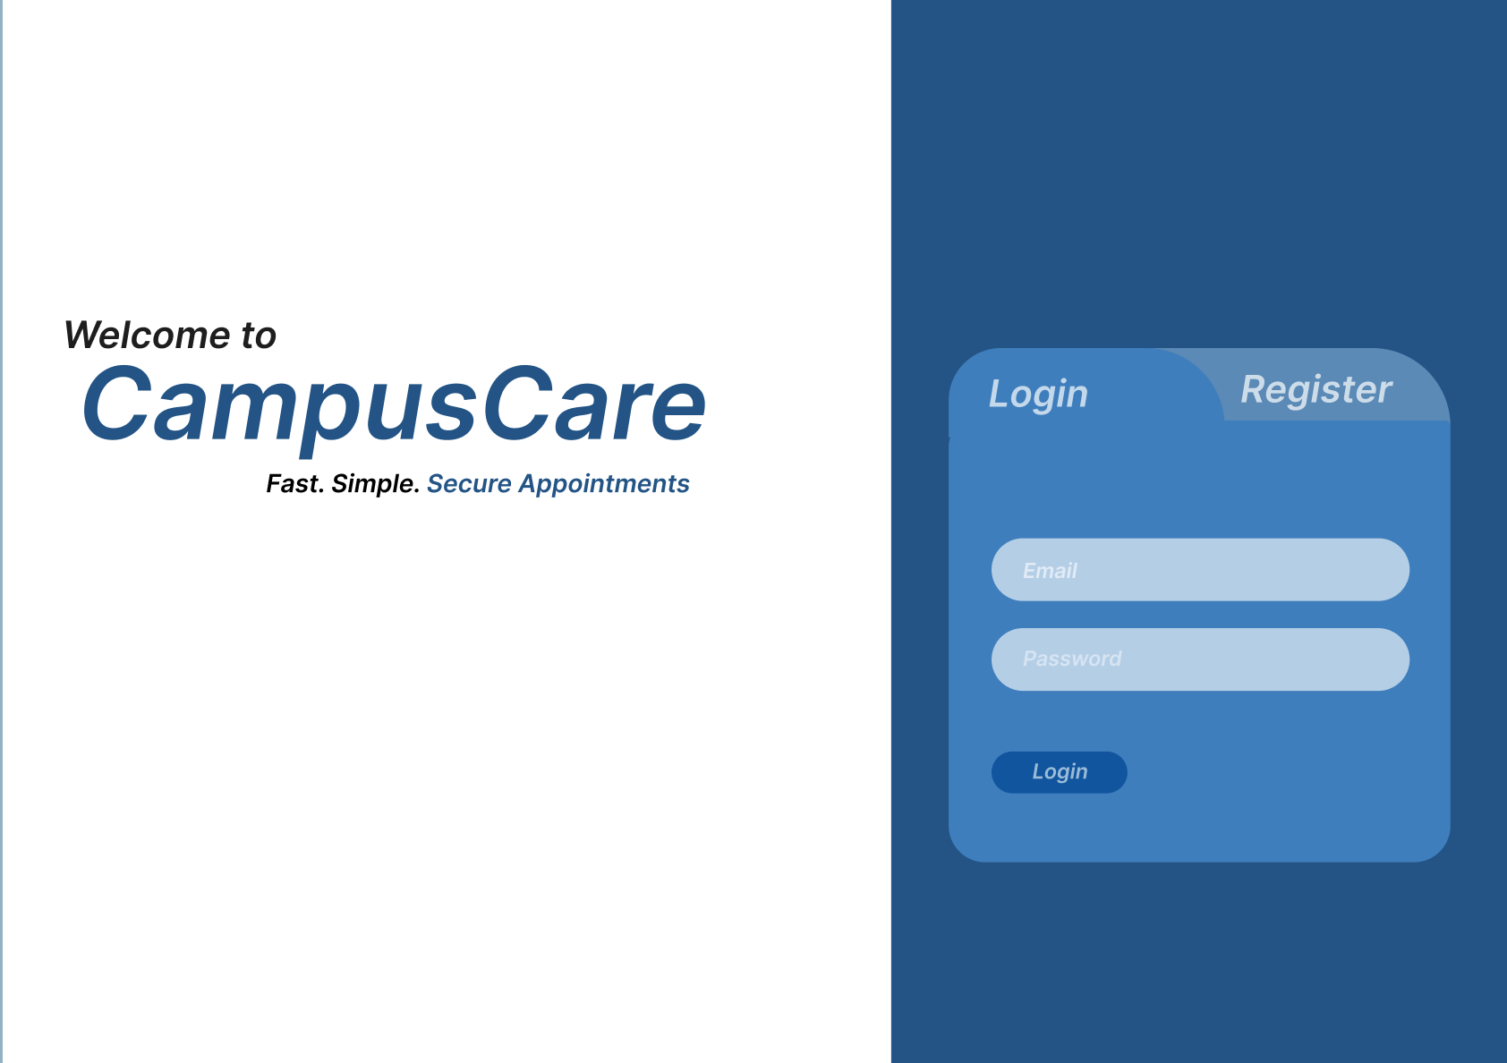
Register Page
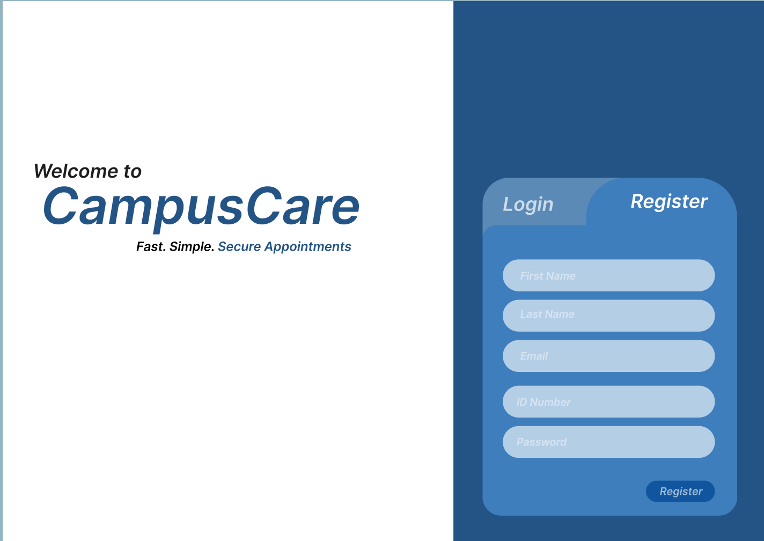
Student Dashboard
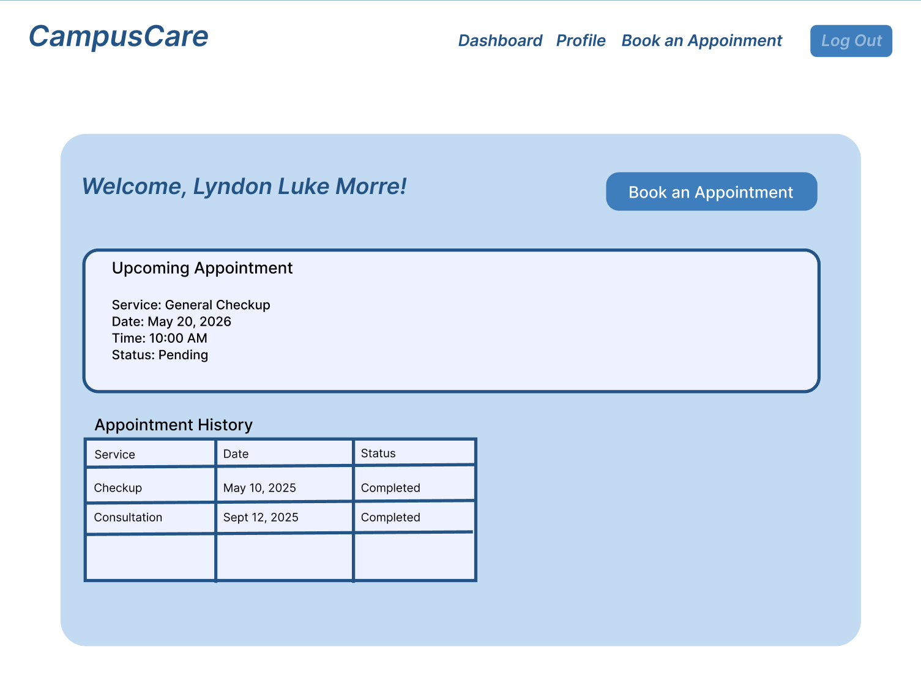

Booking Page
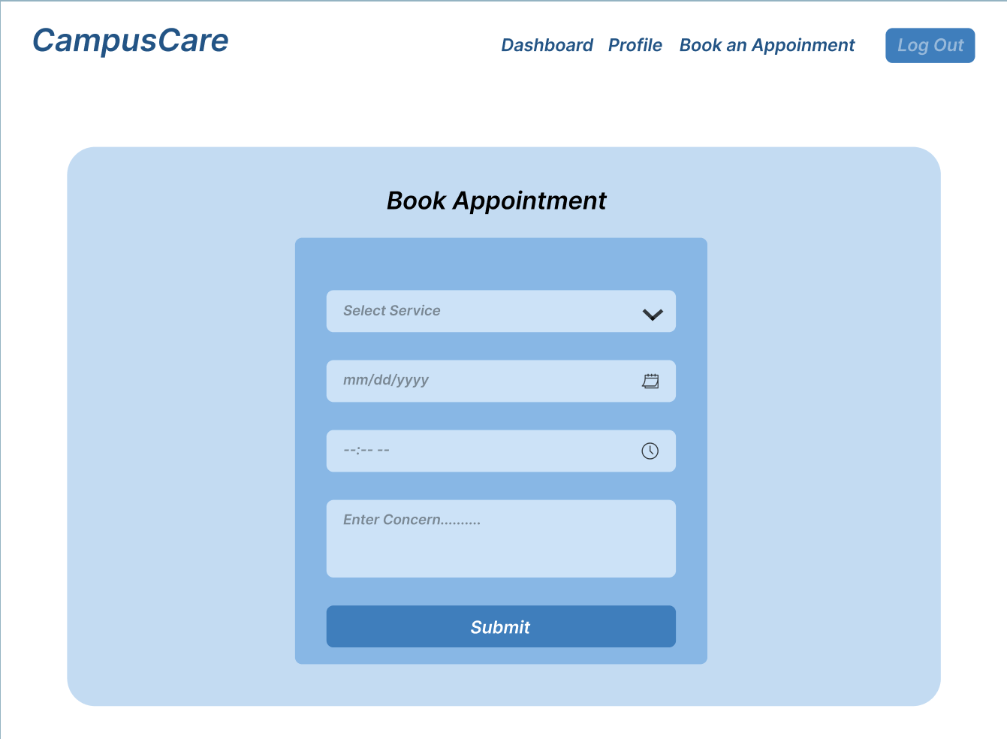

Booking Confirmation Page
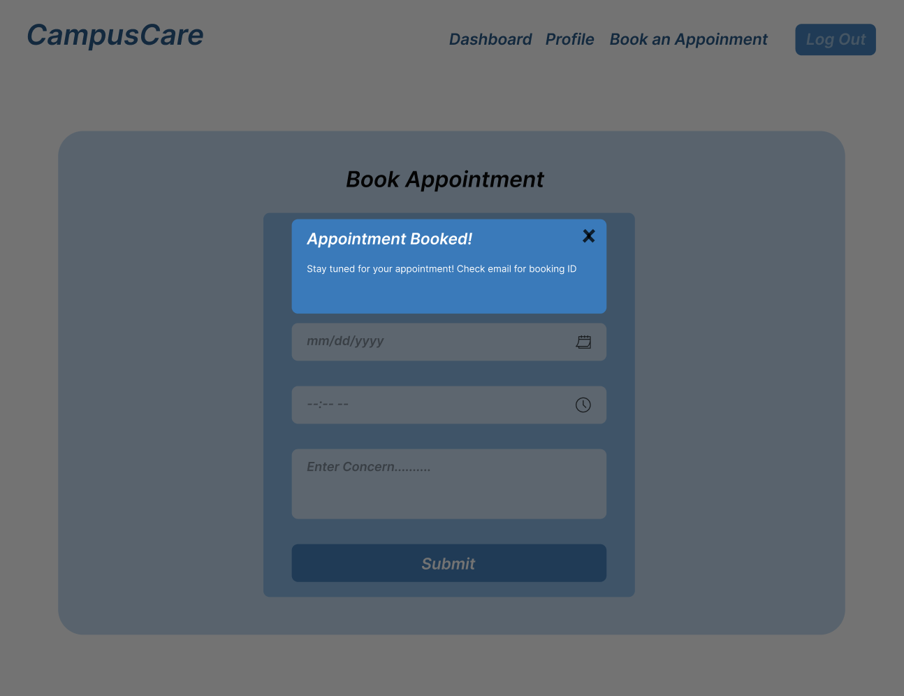
Profile Page
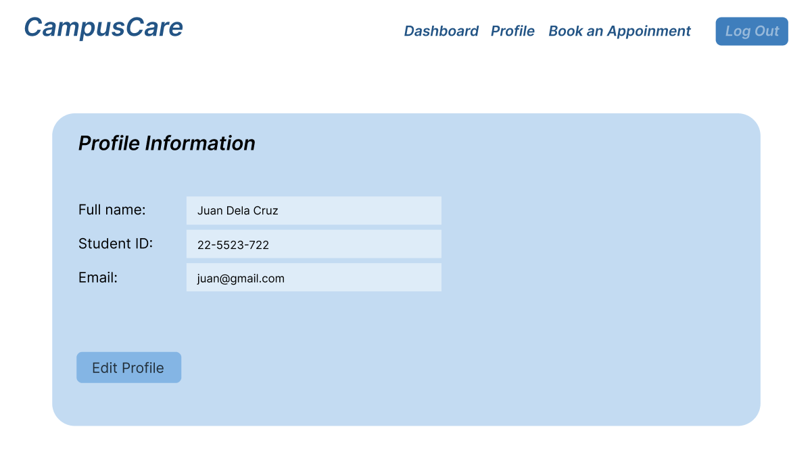
Profile Edit Page
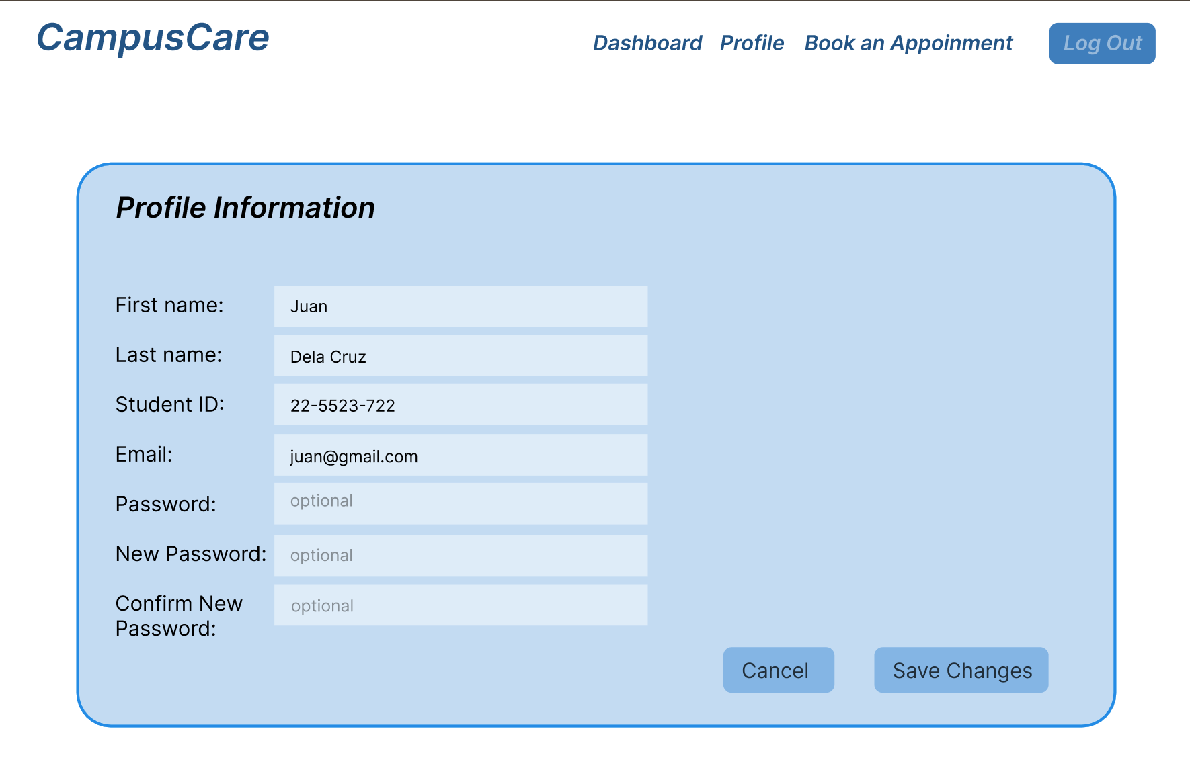

Admin Dashboard Page
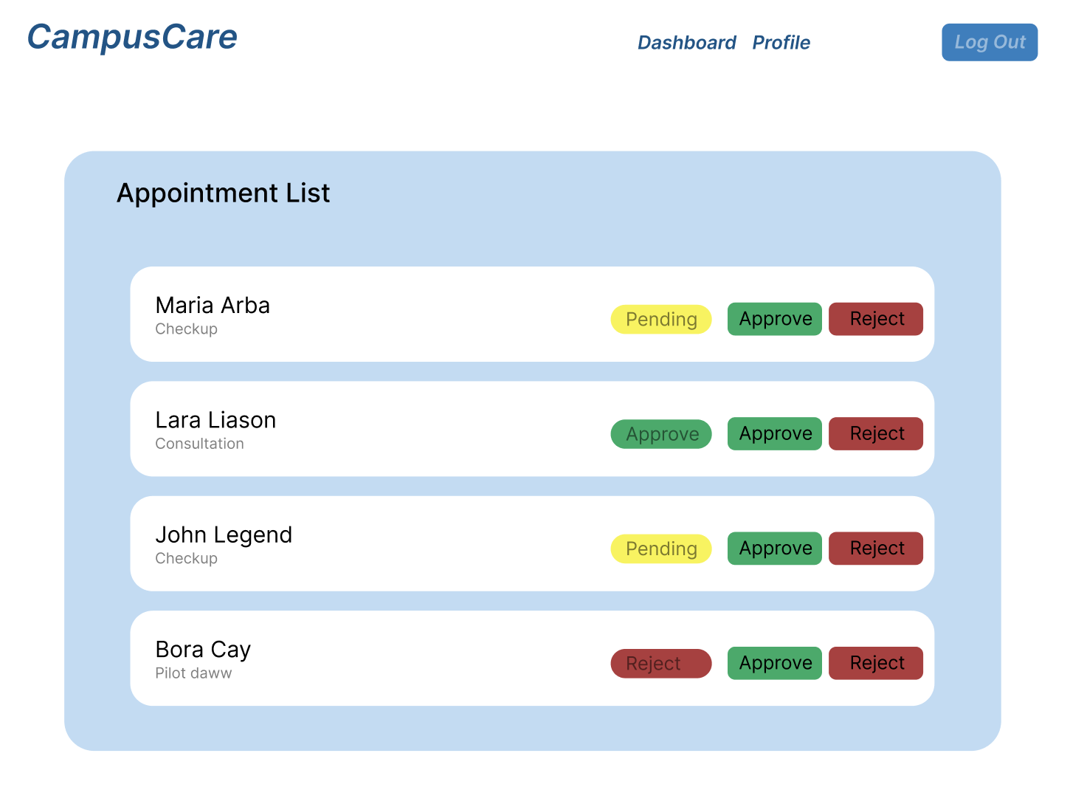
7.2 Mobile Application Wireframes
Login And Register Page
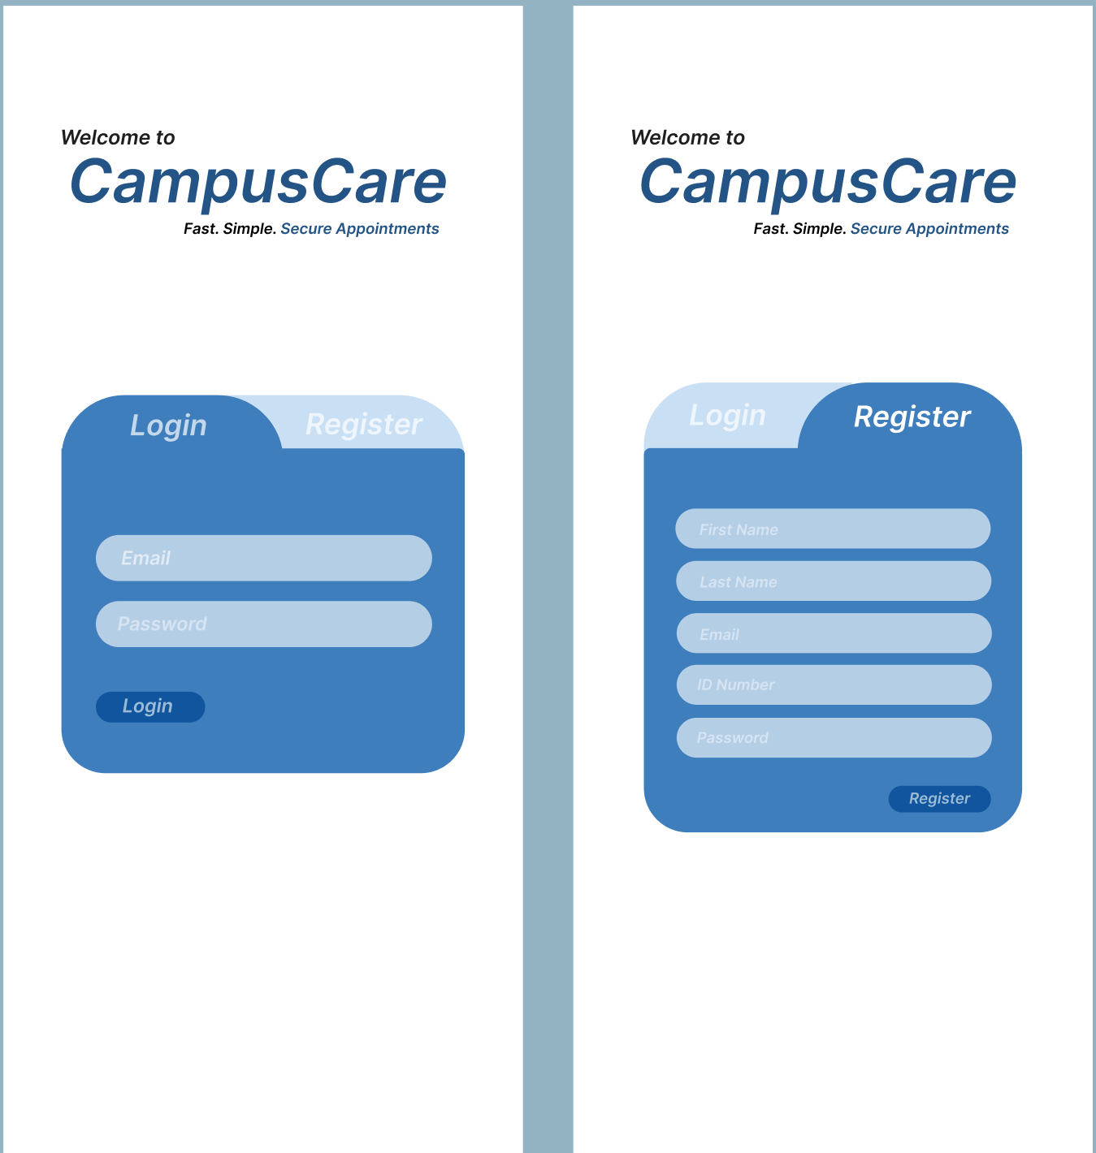

Student Dashboard
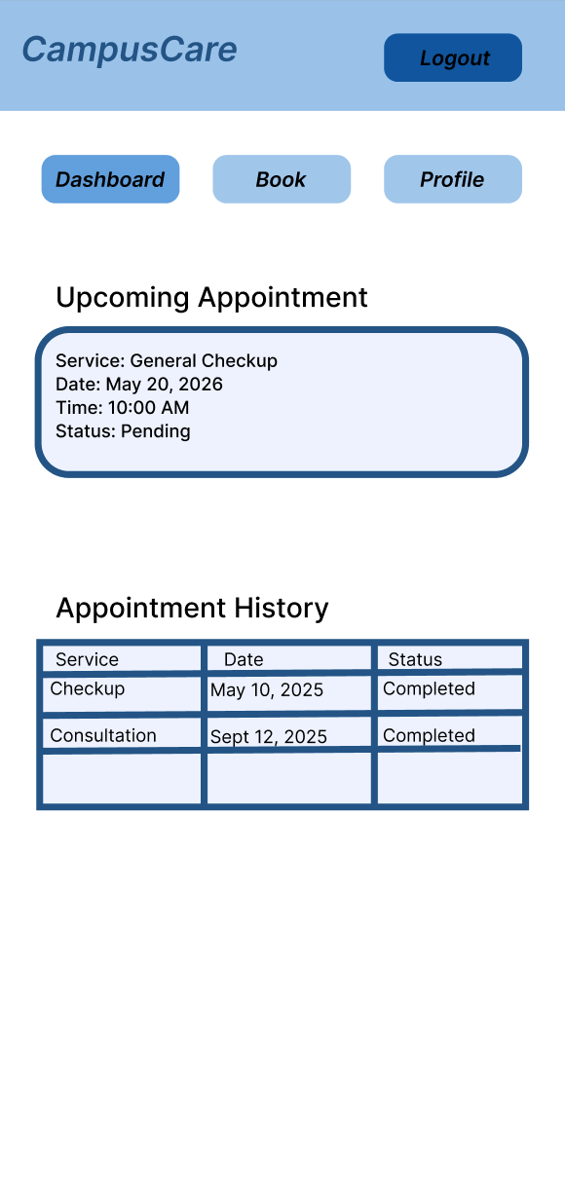

Booking Page
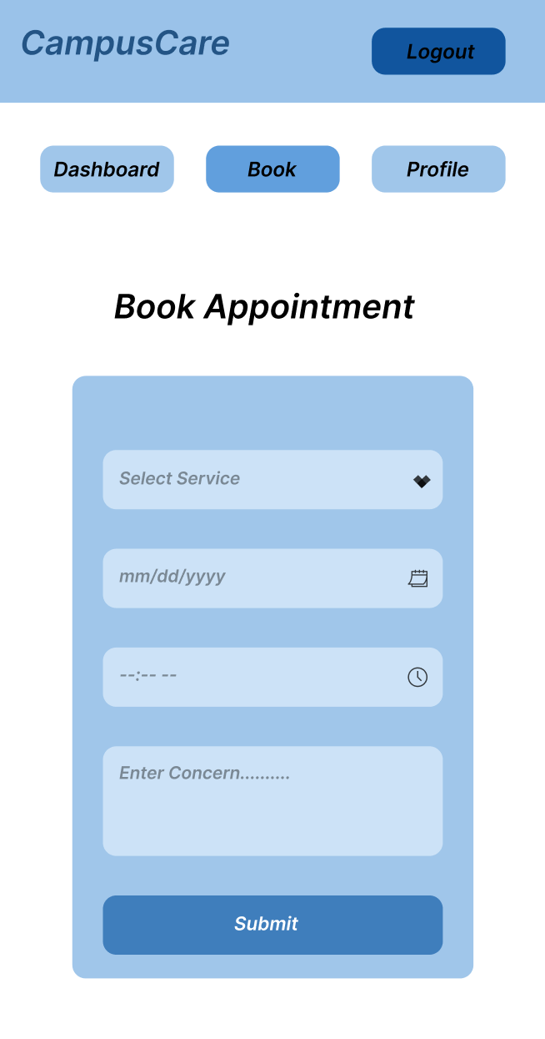

Booking Confirmation Page
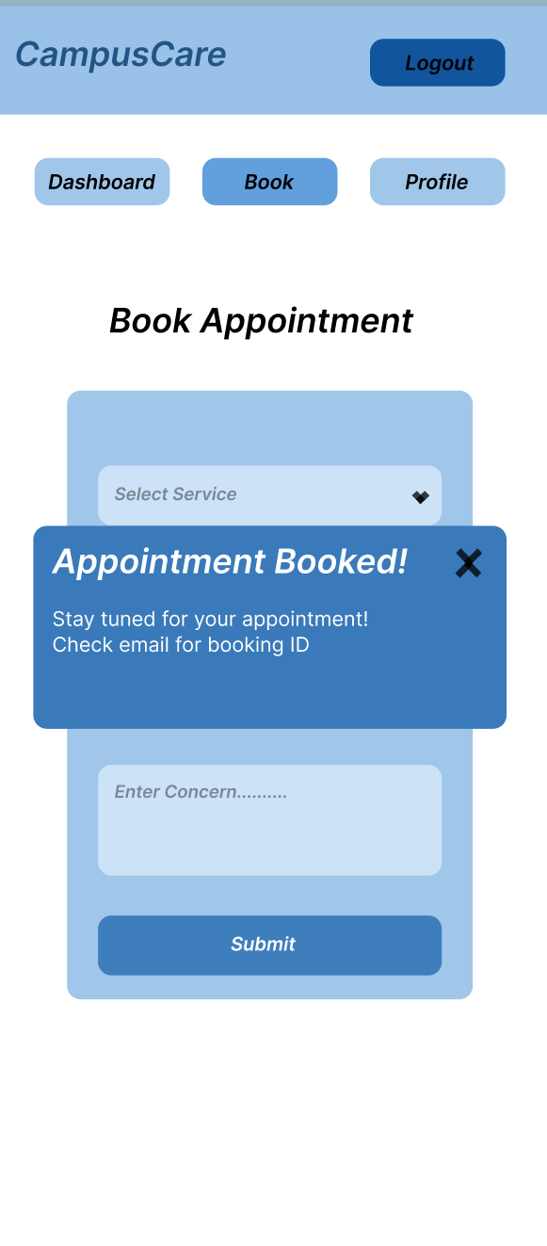

Profile Page
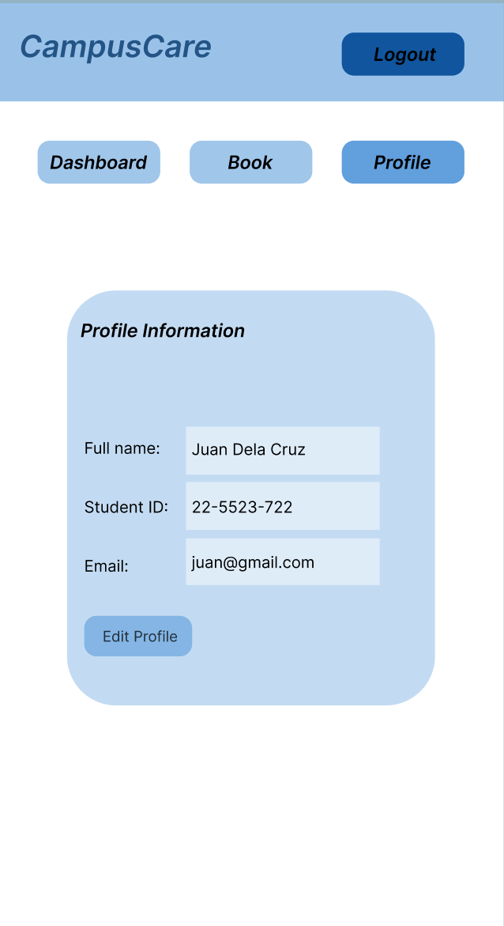

Profile Edit Page
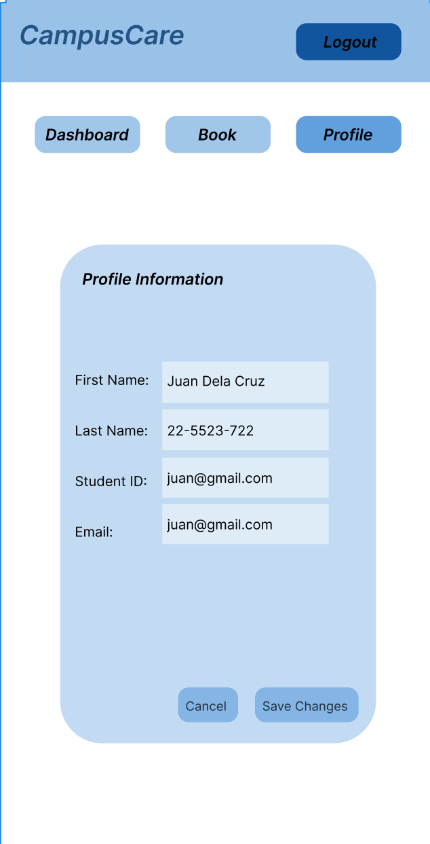

Admin Dashboard Page
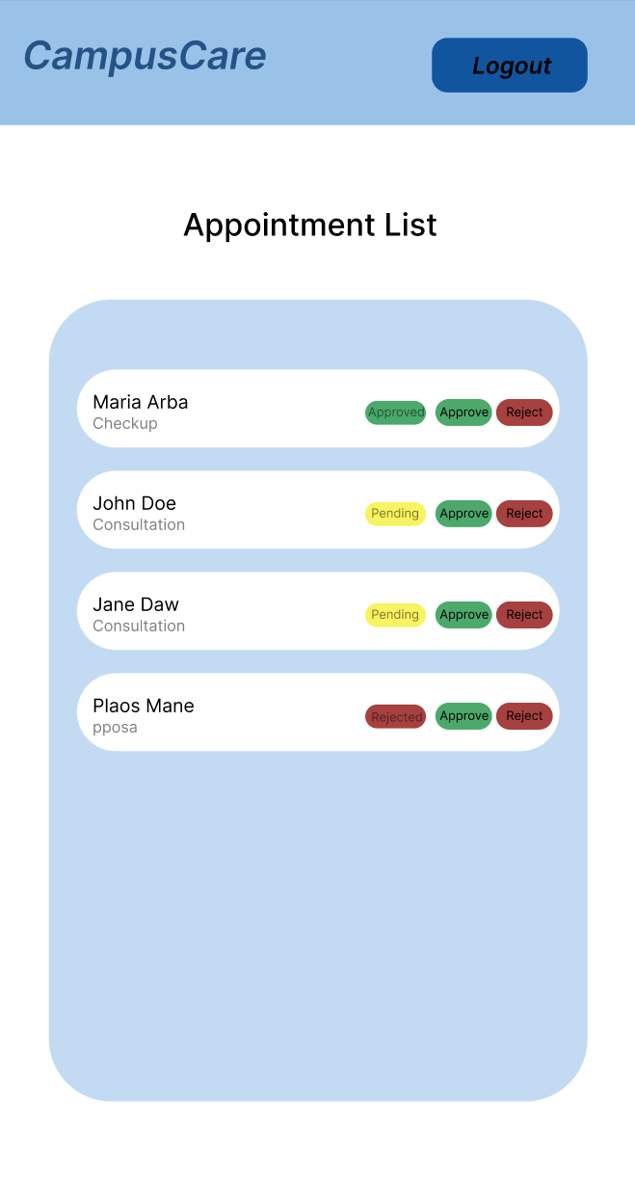

8.0 PLAN
8.1 Project Timeline

Week 1: Requirements & Architecture
Day 1–2
- Project setup
- Initial documentation
- Define project scope
Day 3–4
- Complete Functional Requirements Specification (FRS)
- Complete Non-Functional Requirements (NFR)
Day 5–7
- System architecture design
- Tech stack finalization
- Database planning draft

Week 2: Detailed Design
Day 1–2
- API specification (Auth, Appointments, Profile, Admin)
Day 3–4
- Final database design
  - User table
  - Appointment table
  - Roles (Student/Admin)
Day 5–6
- UI/UX wireframes
  - Dashboard
  - Book Appointment
  - Admin Panel
Day 7
- Implementation plan finalization

Phase 2: Backend Development (Week 3–4)

Week 3: Foundation
Day 1
- Spring Boot setup with dependencies
Day 2
- Database configuration and entity creation
Day 3
- JWT authentication implementation
Day 4
- User registration & login endpoints
Day 5
- Role-based access control (Student / Admin)
Week 4: Core Features
Day 1
- Appointment booking API
Day 2
- Appointment status update API (Admin)
Day 3
- Dashboard endpoints
Day 4
- Input validation and error handling
Day 5
- API testing (Postman) and documentation

Phase 3: Web Application (Week 5–6)

Week 5: Frontend Foundation
Day 1
- React setup
Day 2
- Authentication pages (Login, Register)
Day 3
- Student Dashboard page
Day 4
- Appointment Booking page
Day 5
- Profile page

Week 6: Complete Web Features
Day 1
- Admin dashboard
Day 2
- Appointment status update functionality
Day 3
- API integration (connect frontend to backend)
Day 4
- Responsive design improvements
Day 5
- Full frontend testing
Phase 4: Integration & Testing (Week 7)
Day 1
- End-to-end system testing
Day 2
- Bug fixes
Day 3
- Security review (JWT protection testing)
Day 4
- Performance testing
Day 5
- Documentation update
Phase 5: Deployment & Finalization (Week 8)
Day 1
- Backend deployment (Railway/Render)
Day 2
- Web app deployment (Vercel)
Day 3
- Final testing on live system
Day 4
- Prepare final documentation
Day 5
- Project submission

Updated Milestones
- M1 (End Week 2): All design documents complete
- M2 (End Week 4): Backend API fully functional
- M3 (End Week 6): Web application complete
- M4 (End Week 7): Full system tested
- M5 (End Week 8): System deployed and ready

Updated Critical Path
- Authentication system (Week 3)
- Appointment booking API (Week 4)
- Admin appointment management (Week 4–6)
- Frontend API integration (Week 6)
- End-to-end testing (Week 7)

Risk Mitigation
- Develop authentication first (foundation of system)
- Implement minimal working booking system early
- Test backend endpoints before frontend integration
- Use version control (Git) consistently
- Prioritize MUST-HAVE features before enhancements

