**MY SQL**

1. MySQL is an open-source relational database management system (RDBMS) known for its speed, reliability, and scalability.

2. It supports multiple storage engines, allowing users to choose the most suitable engine for their specific requirements.

3. MySQL follows the client-server architecture, where the database server handles data storage, retrieval, and management, while clients connect to the server to interact with the database.

4. It provides comprehensive features for data definition, manipulation, and control, including creating databases, tables, indexes, views, and managing user permissions.

5. MySQL offers powerful querying capabilities through SQL, enabling users to perform complex operations like filtering, joining, grouping, and sorting data.

**Initialising My SQL**

1. mysql -u root -p
2. Enter Password

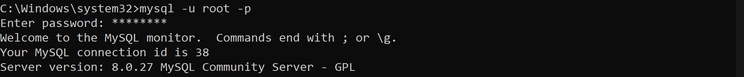

**CRUD**

1. CRUD stands for Create, Read, Update, and Delete, which are the fundamental operations used to manipulate data in a database.

2. Create (INSERT): Used to add new data or records to a database table.

3. Read (SELECT): Used to retrieve or fetch data from a database table.

4. Update (UPDATE): Used to modify or update existing data in a database table.

5. Delete (DELETE): Used to remove or delete data from a database table.

These operations form the basic foundation for interacting with a database and allow you to perform essential data manipulation tasks.

**1- create:**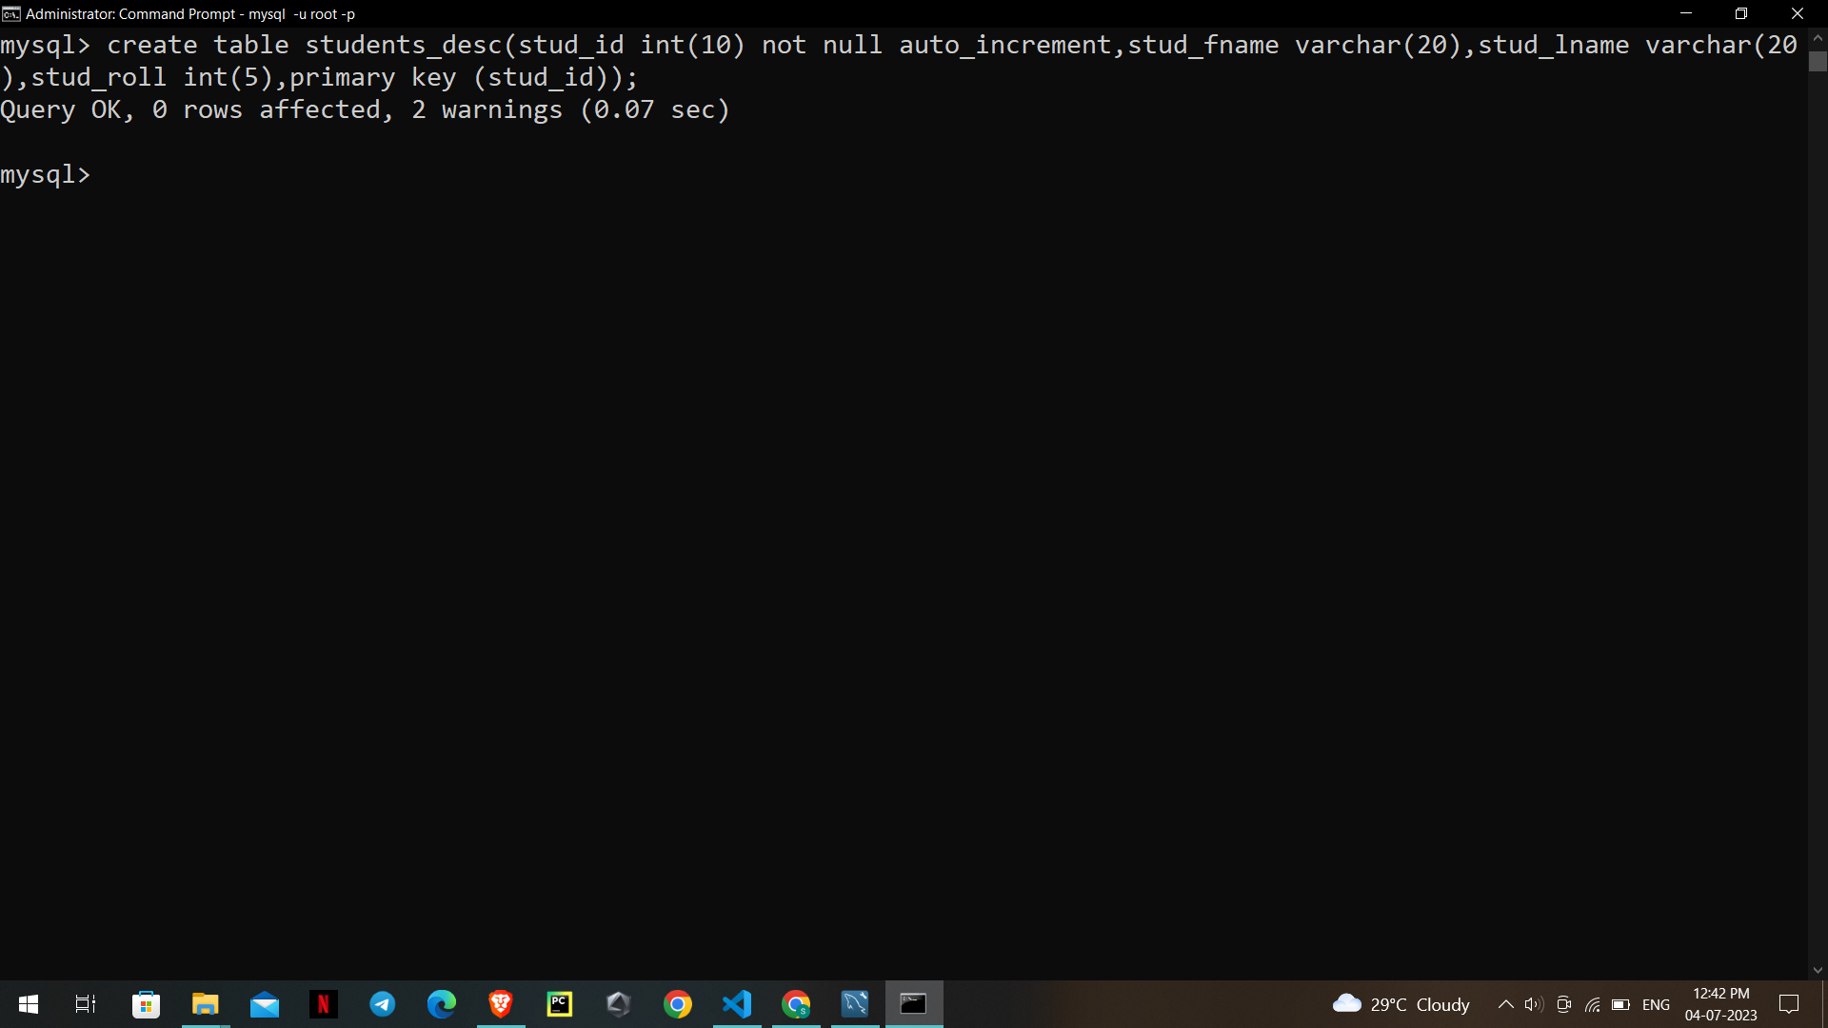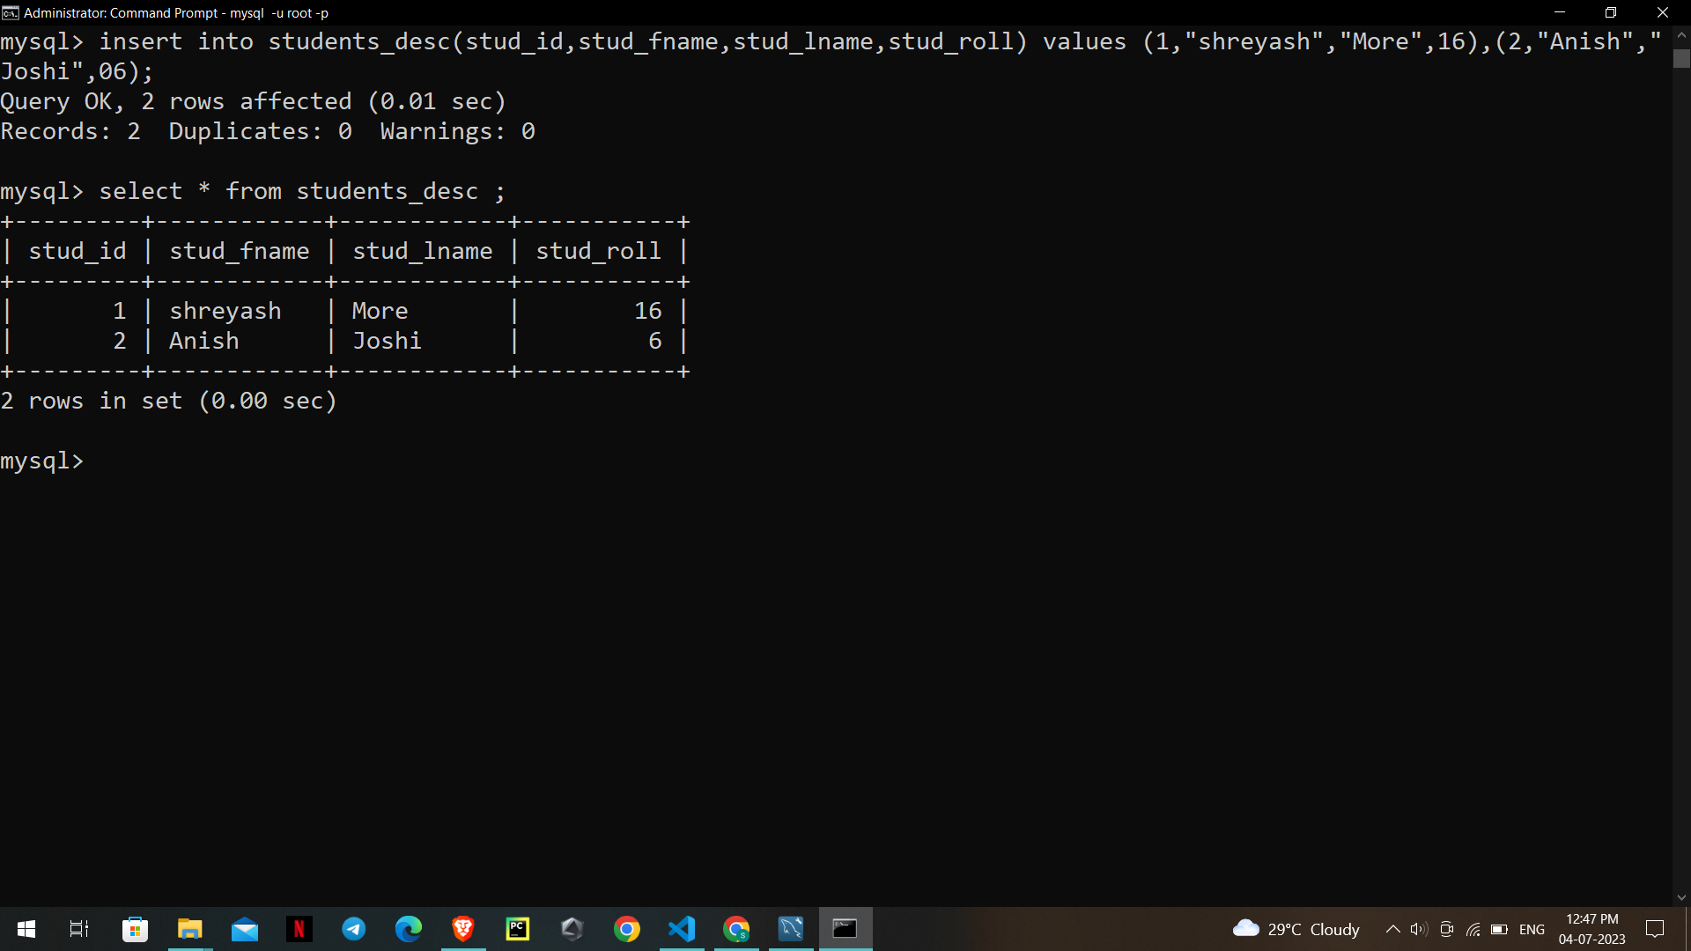

**2- Read :**



**3-Update:**

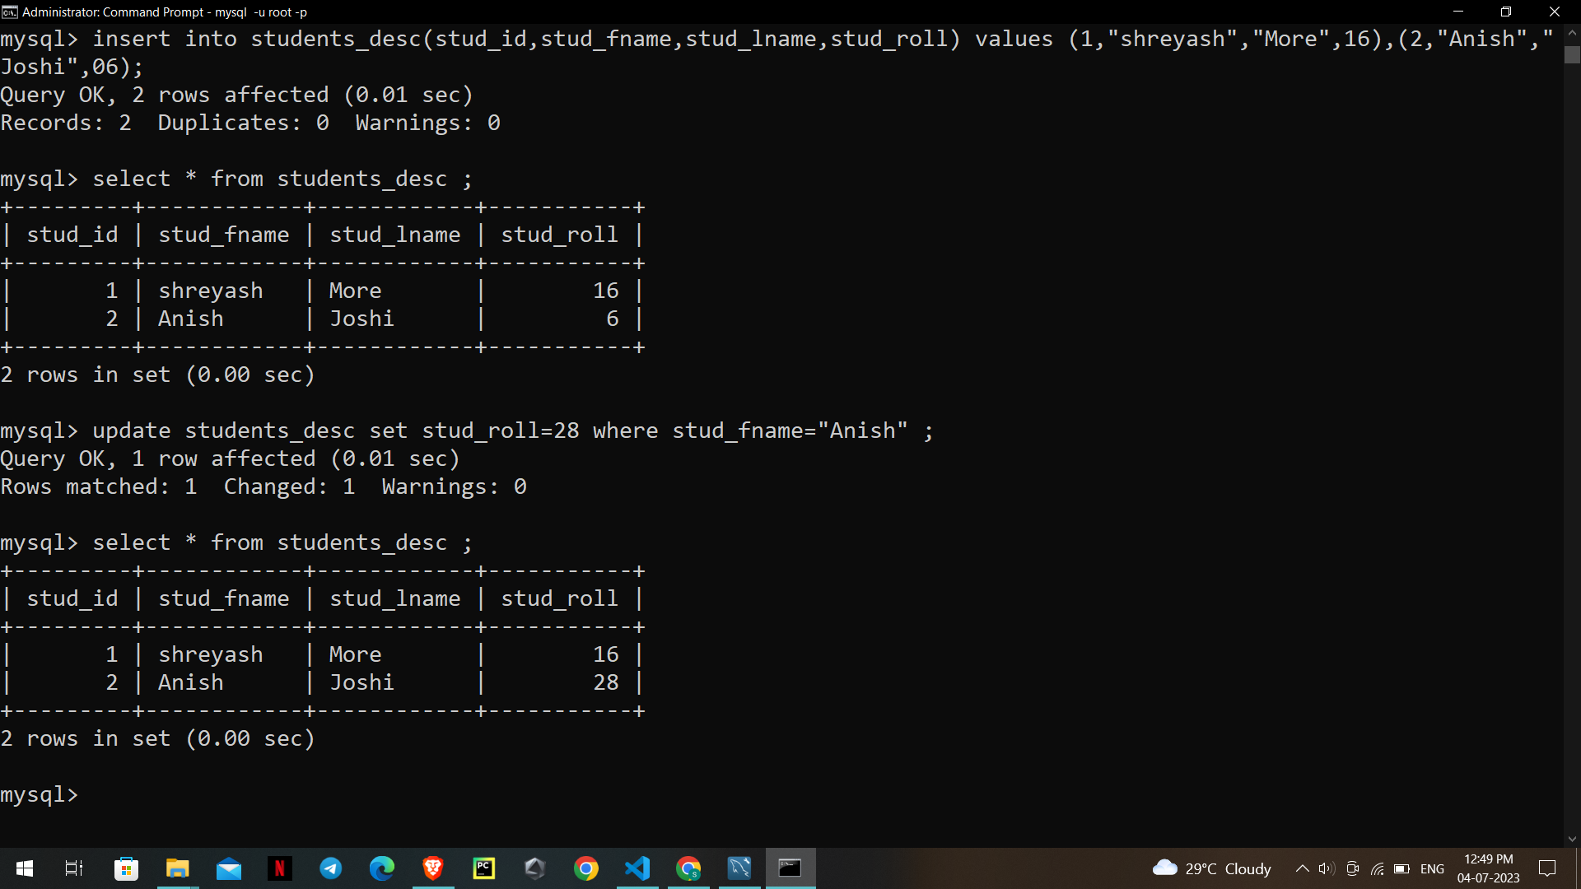

**4-Delete:**

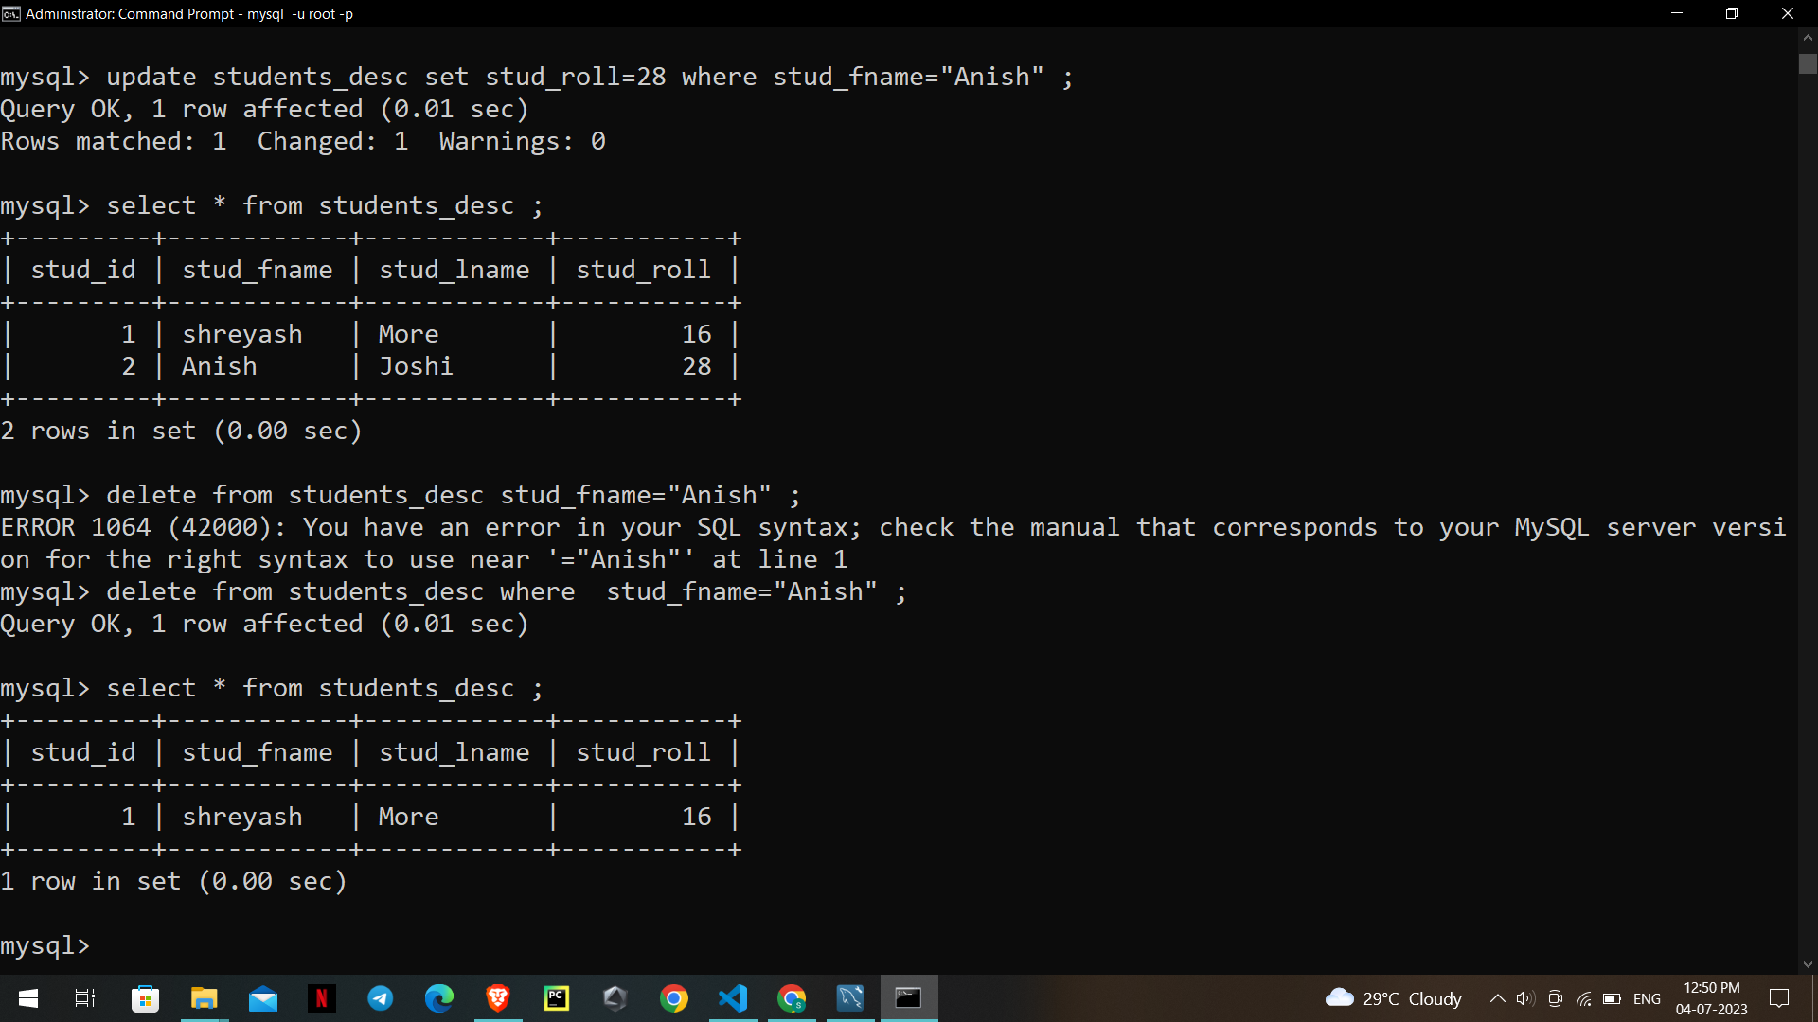

**Exporting SQL DataBase:**

For Exporting the command is:

**mysqldump -u ‘username’ -p ‘database’ > ‘output_file.sql’**

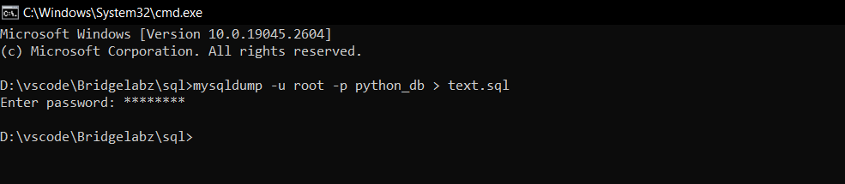

**Importing SQL DataBase:**

For importing the sql database

**mysqldump -u ‘username’ -p ‘database’ <‘input_file.sql’**

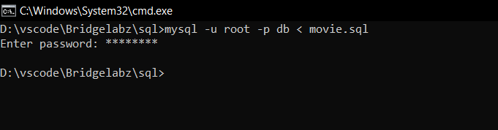

**Exporting Table:**

For importing the sql database

**mysqldump -u ‘username’ -p ‘database’ ‘table_name’ <‘input_file.sql’**

