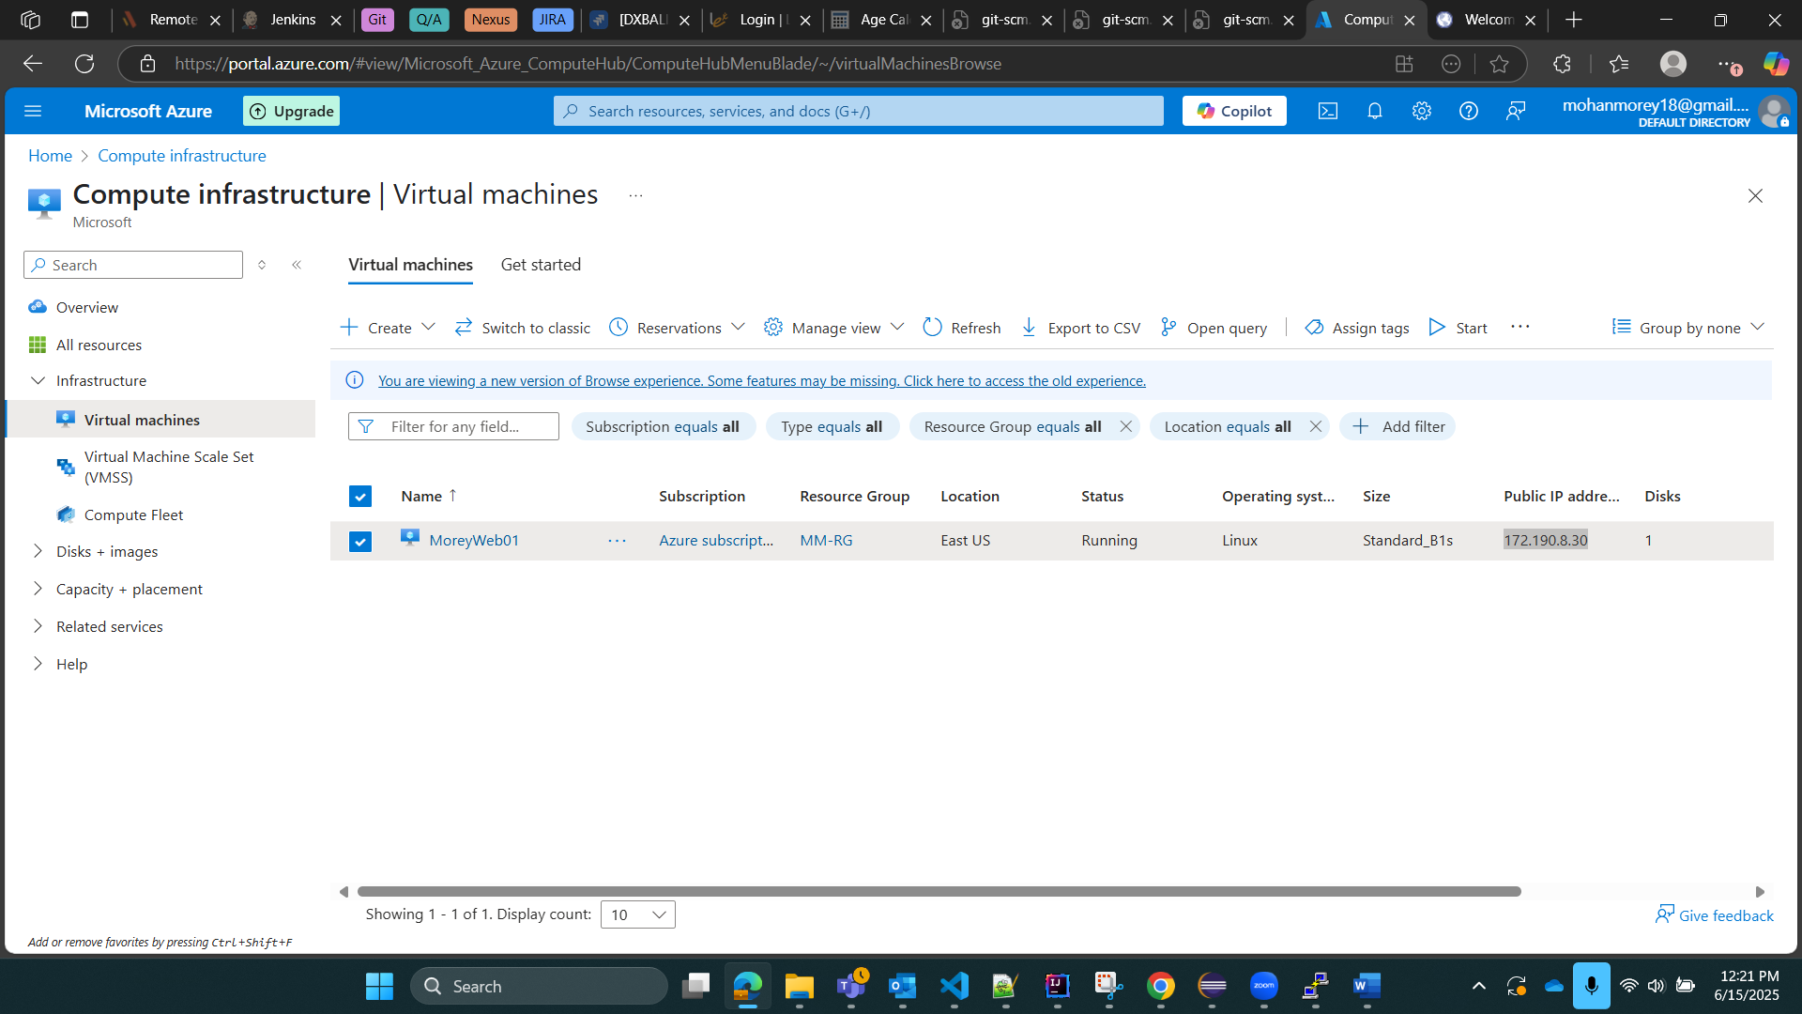  
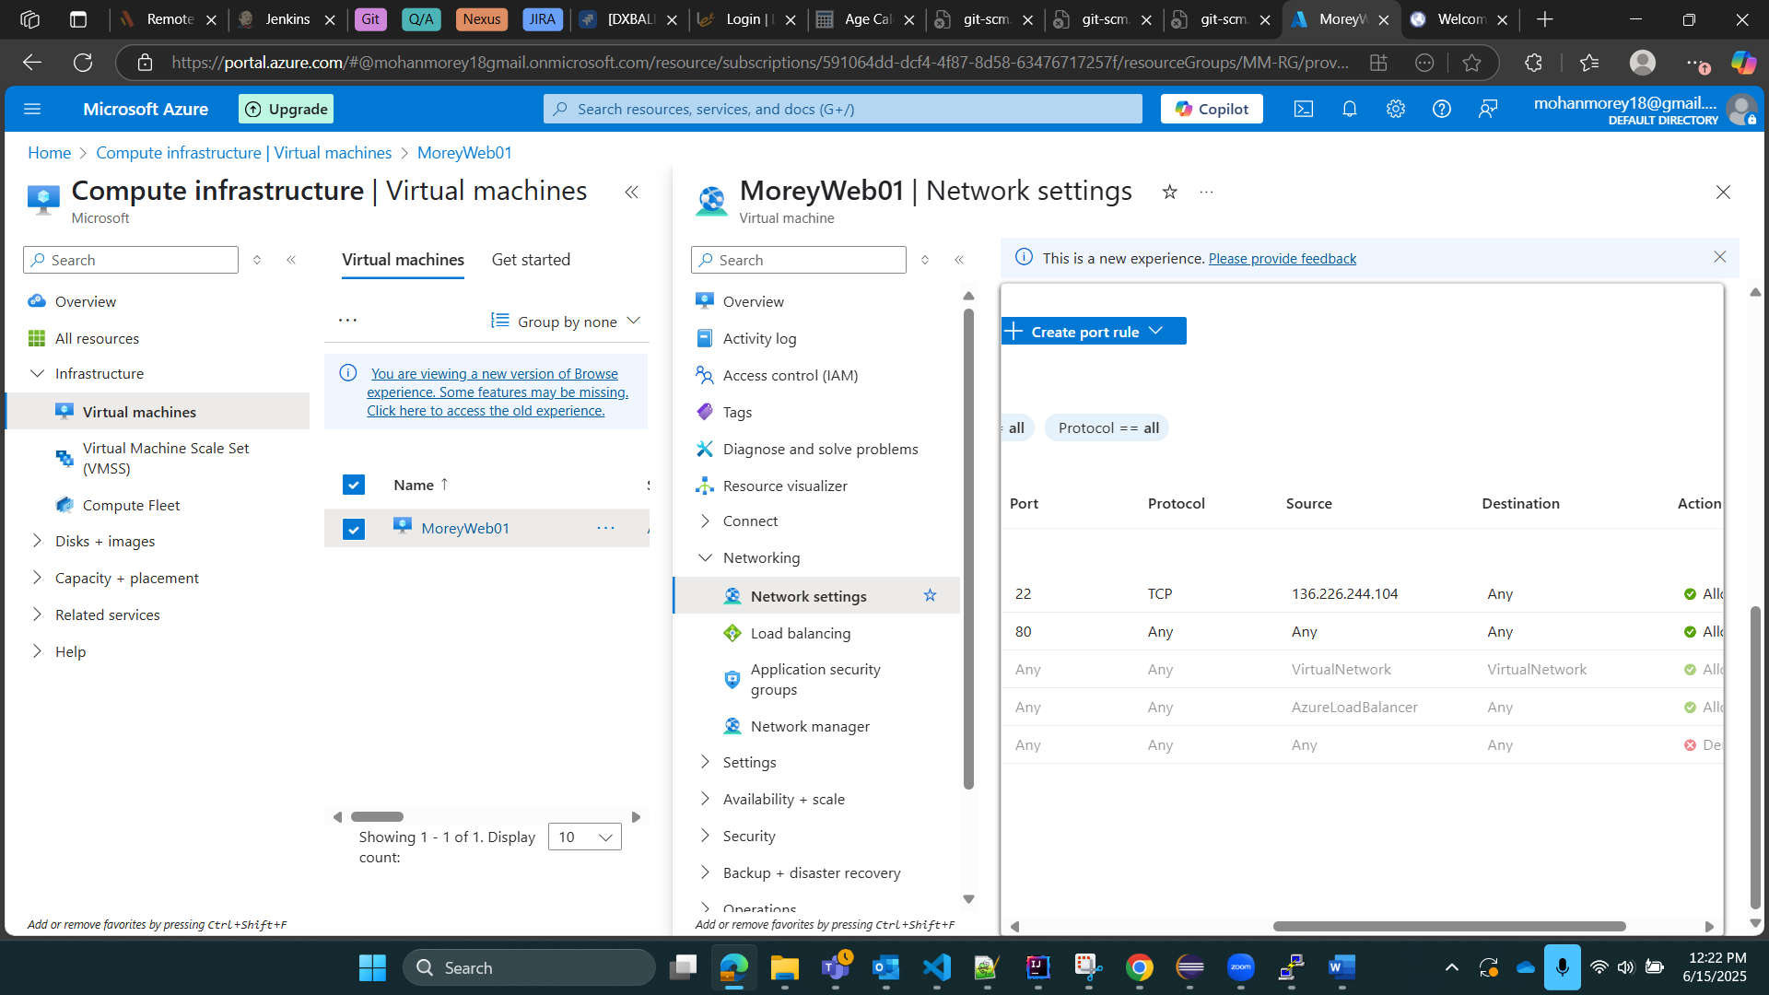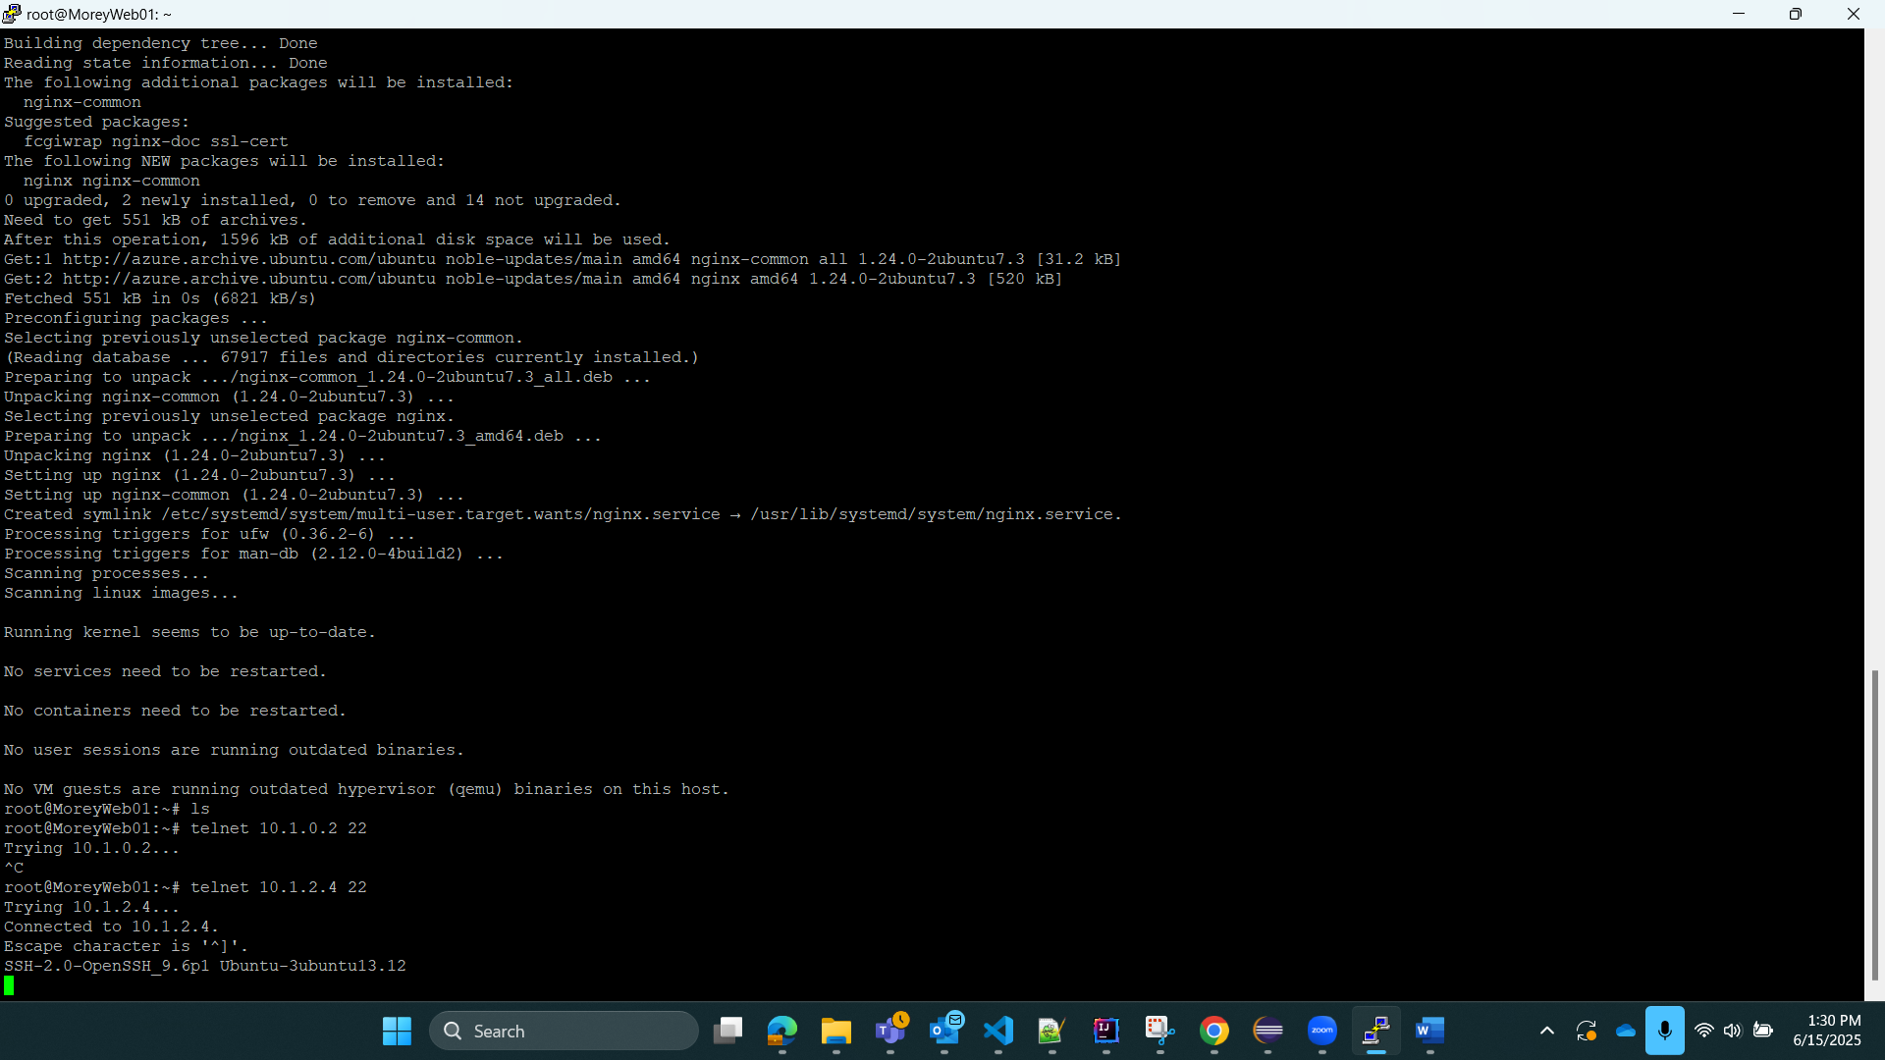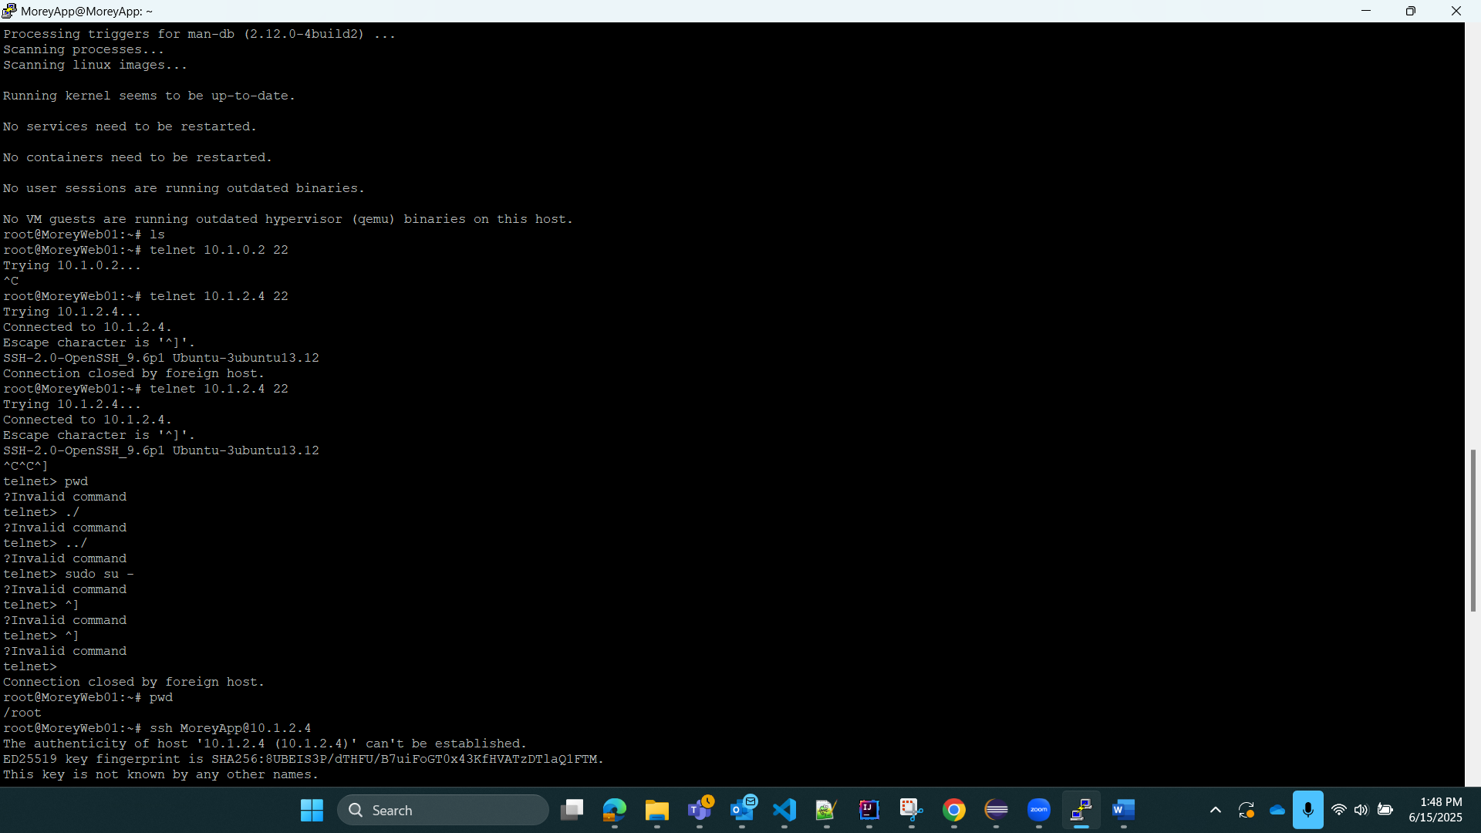  
DB Vm NSG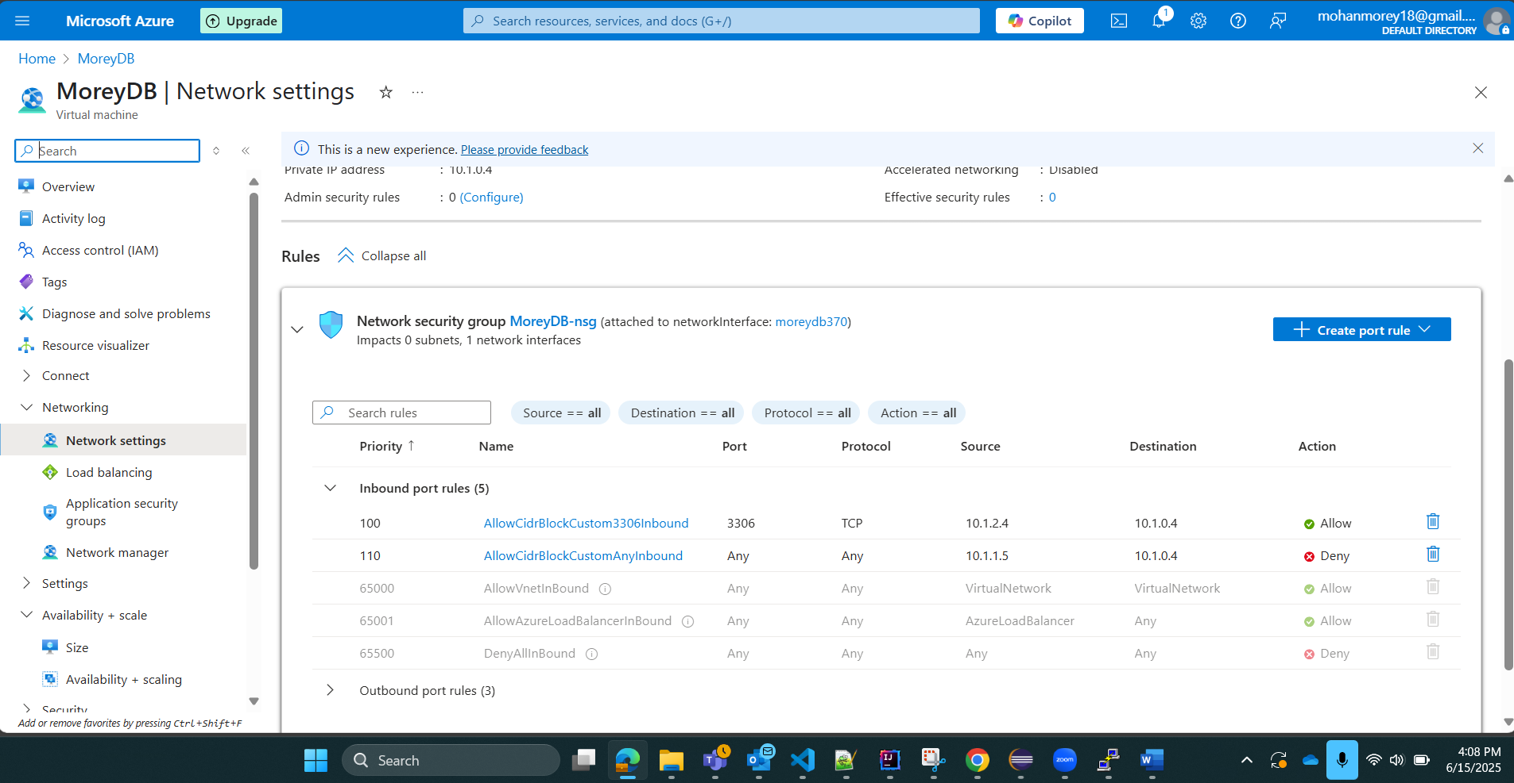  
log in from App to DB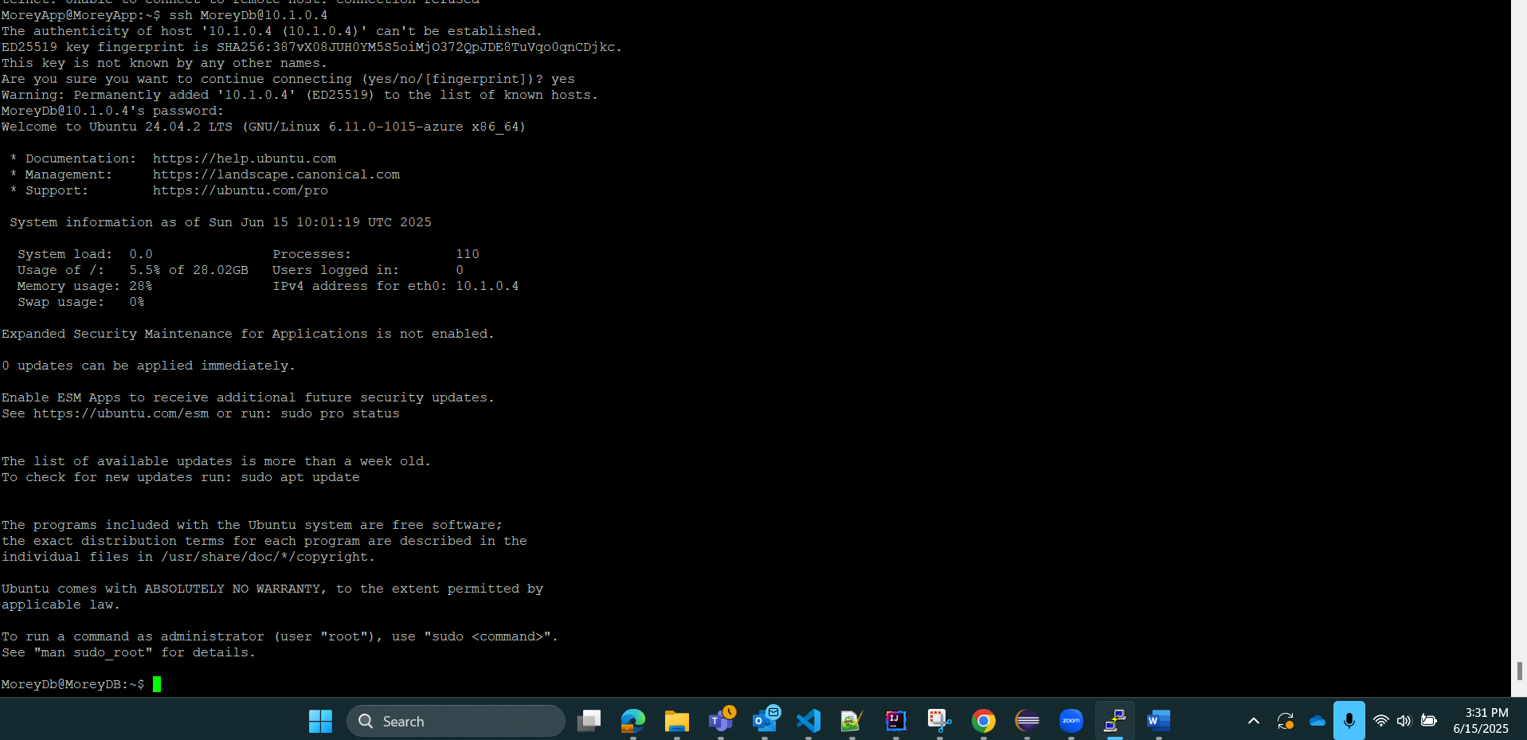  
DB to App connection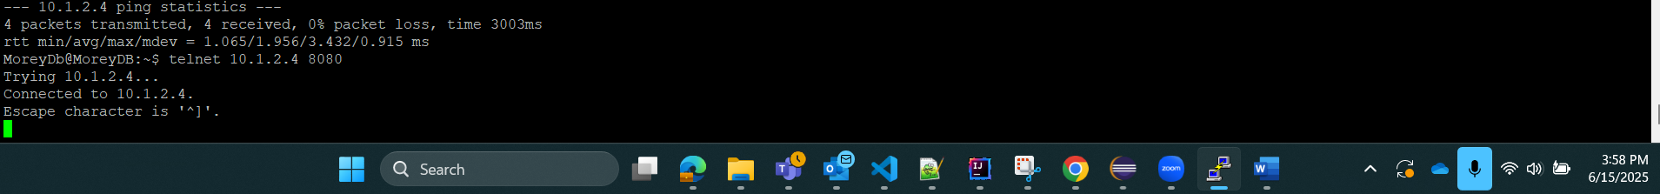  
Web to DB connection  
App to DB connection 

