**CS Projects – Fall 2021**

**Weekly Updates**

(must fill-in your info with blue color or in CAPITAL LETTERS)

Student “Class Key”: __C-S21 – 20____ Weekly Update # ___03___ Date: __02__ /_11_ /2021

Student Name: ____________MATTHEW MORFEA___________________

Company/Unit internship site) ____________SUNY NEW PALTZ: CPS485-01 - PROJECTS___________________

Short Description of the Problem/Task _WEEK 3 DESIGN OF WEB FRAMEWORK AND FURTHER JAVASCRIPT ANIMATION RESEARCH AND IMPLEMENTATION_

a) PROGRESS during the week, what you have been working on and/or accomplished (by area, if applicable):

* Problem Study/Discovery:

This week we were assigned the specific areas of algorithms we would be visualizing in our code for OS Visualizations. I was tasked with disk scheduling algorithms. I studied these algorithms further as well as shifting my focus to how to implement visualizations in JavaScript to the web framework. Using basic animation techniques in JavaScript I practiced writing code in JavaScript based on W3 schools JavaScript animations page as a starting point.

* Design:

I designed a basic cookie cutter Web Framework that could be used in housing the animations of the algorithms in later weeks. This design was done through an online shape design shown below in Microsoft PowerPoint. I also started designs on how the algorithms should appear through JavaScript code.

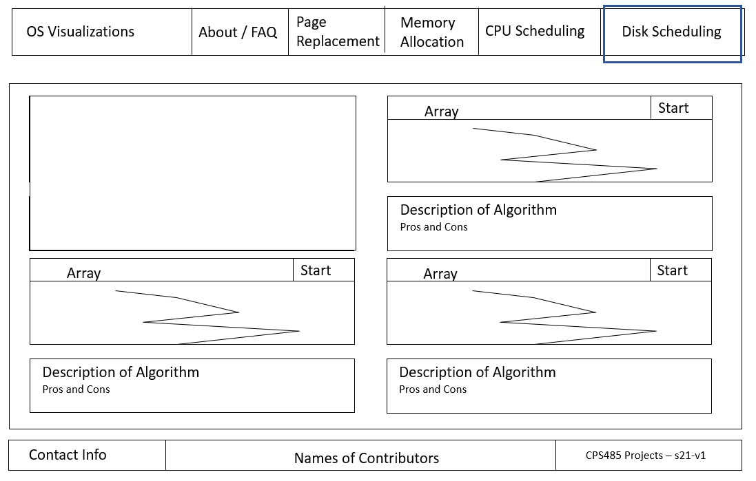

* Implementation:

I implemented the cookie cutter Web Framework to the web server for my groupmates to use. This framework was built out of html, CSS, and Bootstrap, which includes comments on where to add the scripts of animations to help organize the layout of the project.

* Test:
* Documentation:
* Other (any other activities, such as talking to customers, attended a meeting, …):

Attended Weekly class meeting to determine the algorithm group we would be choosing / assigned to. During the meeting we also talked about how we would design and implement certain Web Frameworks / Layouts and how we could animate our algorithms.

b) Technology/Skills/Methods LEARNED or LEARNING:

Used previous knowledge to get a better understanding of Light web design of front-end applications, mainly through bootstrap, html, and CSS. Learning how to work with JavaScript, more tailored to animation in order to create and practice implementation of OS visualizations of disk scheduling.

c) PLAN for next week:

Next week, I plan to continue practicing my learning on JavaScript animation techniques as well as hopefully having disk scheduling animation designs complete. Furthermore, I wish to have these designs in the works as real code in order to implement the first rough version onto the Web framework uploaded during this week.